NSTS Webpage

Red circles show the path to get to the 748 Form. (Note: Licensees already use these links to get the 748 form).

Main Page:

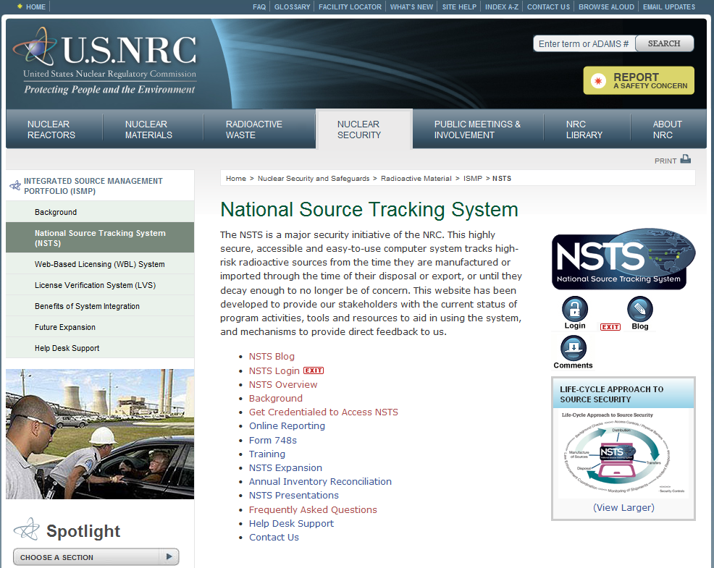

Link will go to a page that will include the following information:
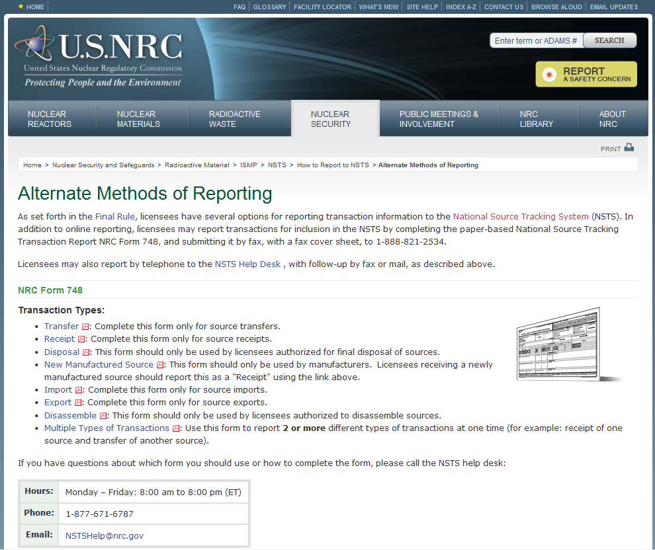
The hyperlinks take the licensee directly to the form for the transaction type they wish to report.
Example: In order to report a Receipt, the licensee will click on the “Receipt” hyperlink and be taken directly to a PDF of the Receipt short form.

The hyperlinks take the licensee directly to the form for the transaction type they wish to report.
Example: In order to report a Receipt, the licensee will click on the “Receipt” hyperlink and be taken directly to a PDF of the Receipt short form.
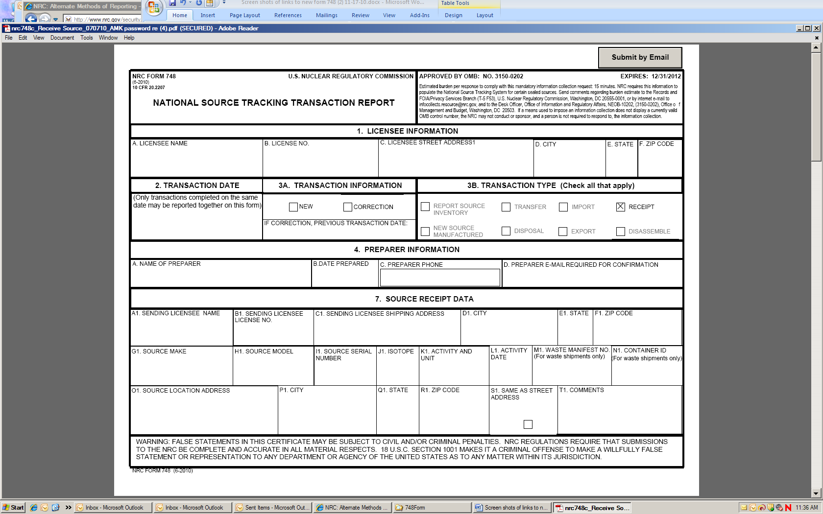
All forms include instructions for filling out and submitting the form:
