NSTS Webpage

Users can access the online NSTS by either going directly to https://nsts.nrc-gateway.gov/nsts/welcome.do or by going to the NSTS webpage and clicking on “Login”. Red circles show the path to get to the online NSTS.

Main Page:

Users will have already had to go through the credentialing process and obtained a smartcard and smartcard reader. The smartcard must be in the smartcard reader prior to logging in. The system will then prompt the user to enter their password.

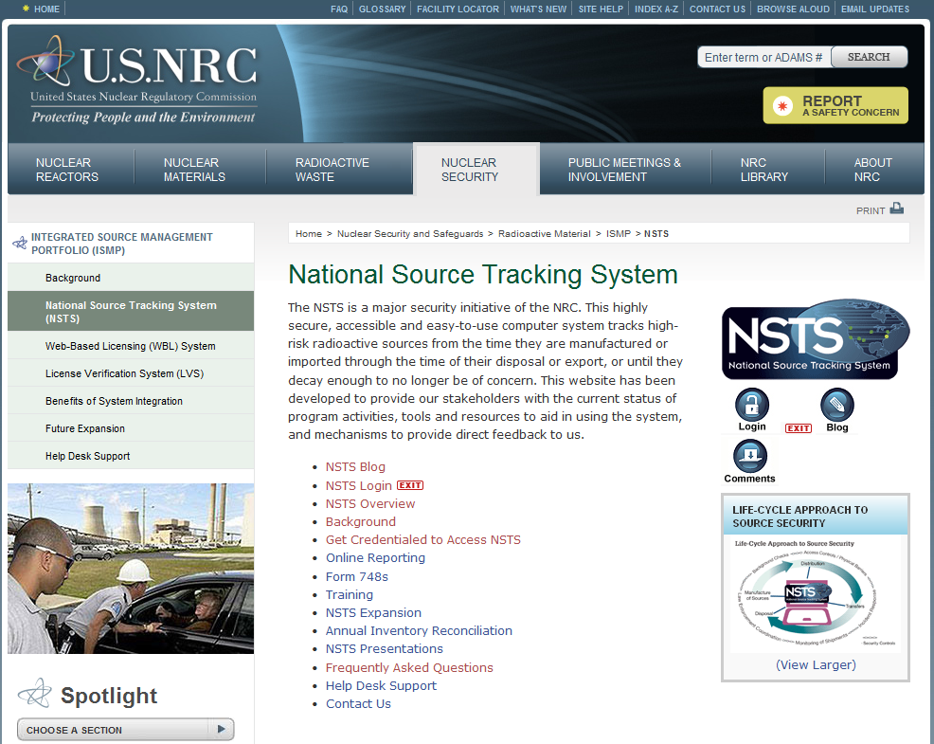

Following login, users will be taken to the online NSTS main menu page.

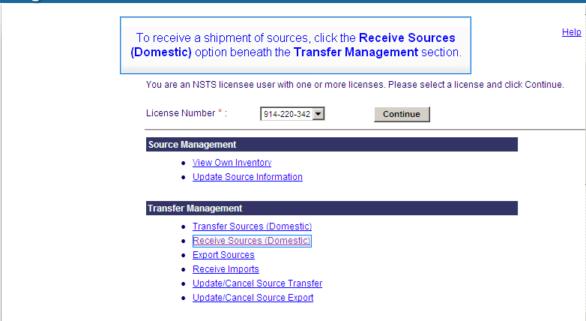
Under the section labeled “Transfer Management”, the links take the licensee directly to the transaction type they wish to report.
Example: In order to report a Receipt, the licensee will click on the “Receive Sources (Domestic)” link and be taken to additional screens to enter the necessary information to report the transaction.

