Appendix 5: Screenshots of Data Entry Screens

- Adult Data Entry Screens
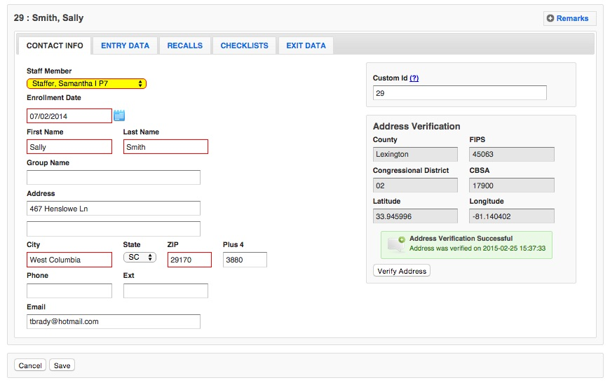

According to the Paperwork Reduction Act of 1995, an agency may not conduct or sponsor, and a person is not required to respond to, a collection of information unless it displays a valid OMB control number. The valid OMB control number for this information collection is 0524-0044. The time required to complete this information collection is estimated to average 1158 hours per response, including the time for reviewing instructions, searching existing data sources, gathering and maintaining the data needed, and completing and reviewing the collection of information.

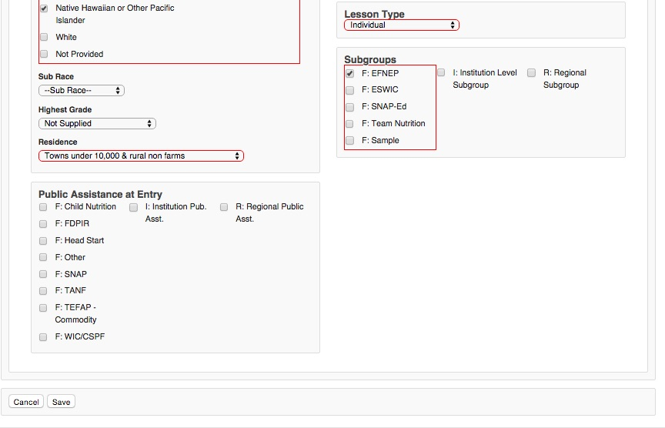
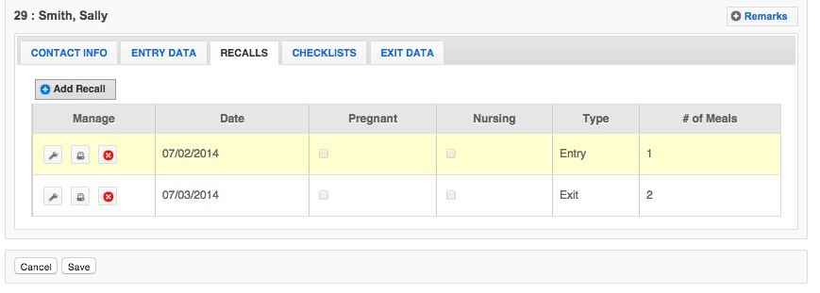

According to the Paperwork Reduction Act of 1995, an agency may not conduct or sponsor, and a person is not required to respond to, a collection of information unless it displays a valid OMB control number. The valid OMB control number for this information collection is 0524-0044. The time required to complete this information collection is estimated to average 1158 hours per response, including the time for reviewing instructions, searching existing data sources, gathering and maintaining the data needed, and completing and reviewing the collection of information.

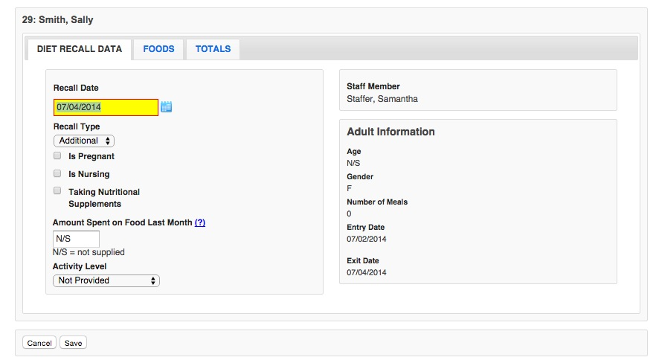

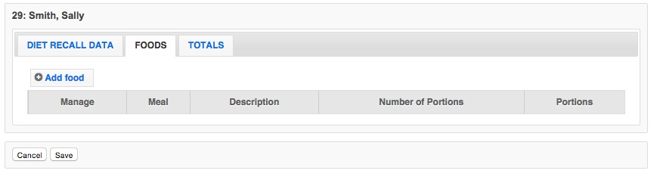
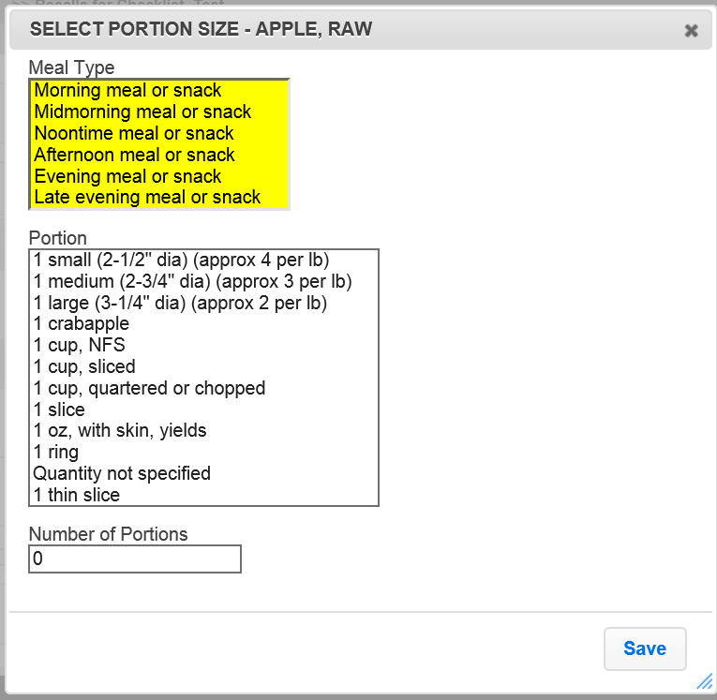

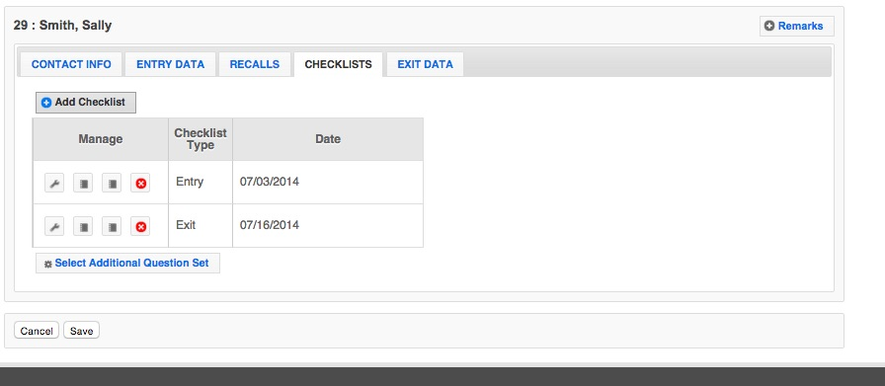
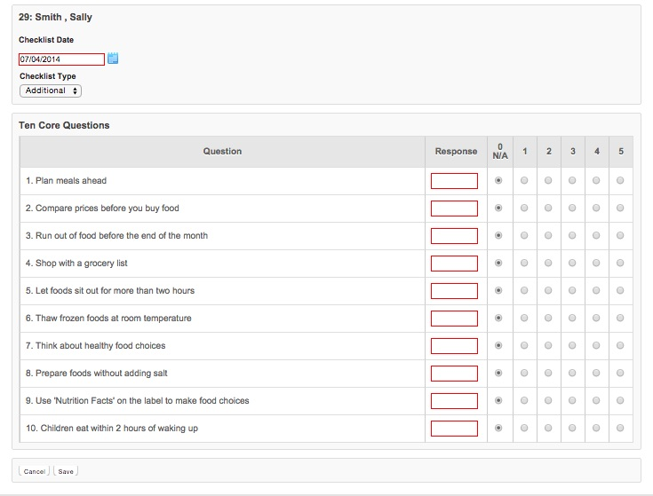

According to the Paperwork Reduction Act of 1995, an agency may not conduct or sponsor, and a person is not required to respond to, a collection of information unless it displays a valid OMB control number. The valid OMB control number for this information collection is 0524-0044. The time required to complete this information collection is estimated to average 1158 hours per response, including the time for reviewing instructions, searching existing data sources, gathering and maintaining the data needed, and completing and reviewing the collection of information.

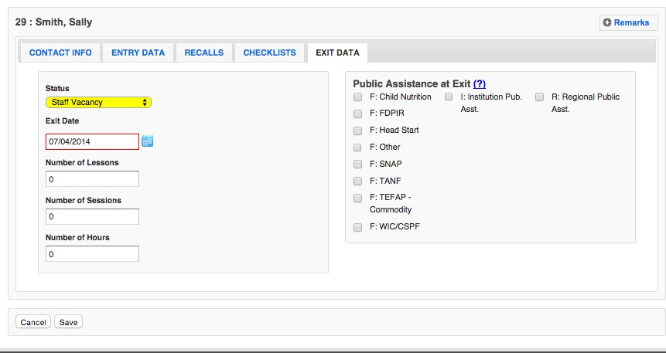

According to the Paperwork Reduction Act of 1995, an agency may not conduct or sponsor, and a person is not required to respond to, a collection of information unless it displays a valid OMB control number. The valid OMB control number for this information collection is 0524-0044. The time required to complete this information collection is estimated to average 1158 hours per response, including the time for reviewing instructions, searching existing data sources, gathering and maintaining the data needed, and completing and reviewing the collection of information.

- Youth Data Entry Screens
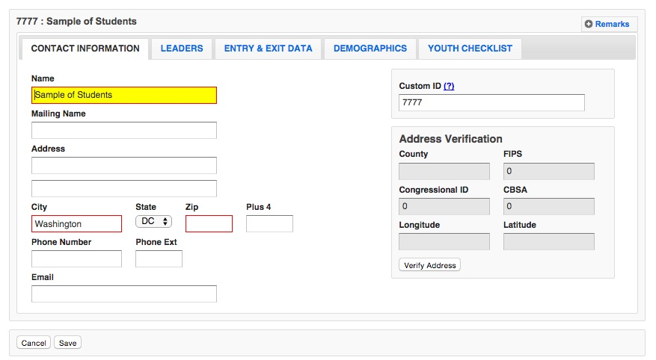

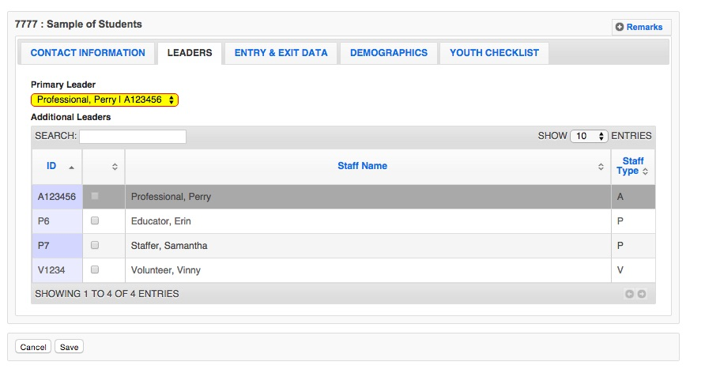

According to the Paperwork Reduction Act of 1995, an agency may not conduct or sponsor, and a person is not required to respond to, a collection of information unless it displays a valid OMB control number. The valid OMB control number for this information collection is 0524-0044. The time required to complete this information collection is estimated to average 1158 hours per response, including the time for reviewing instructions, searching existing data sources, gathering and maintaining the data needed, and completing and reviewing the collection of information.

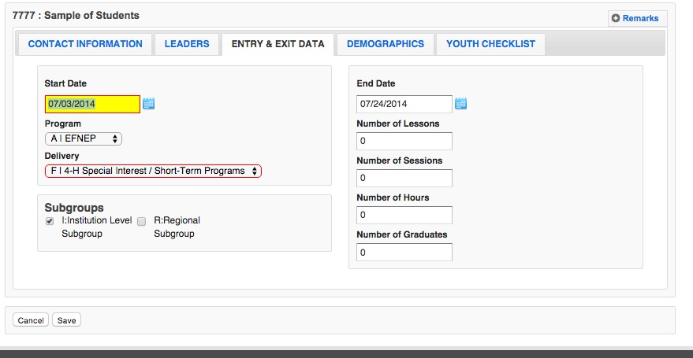

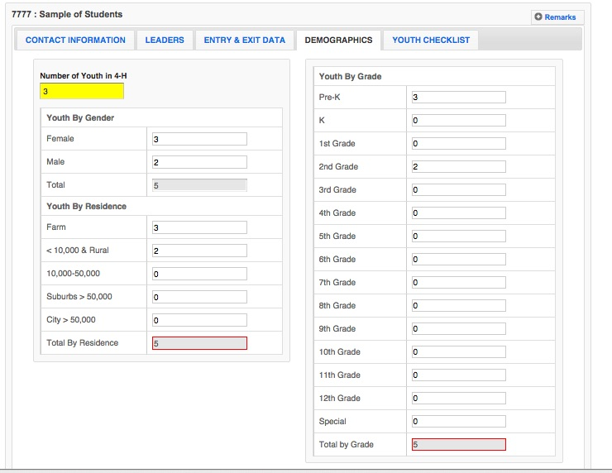

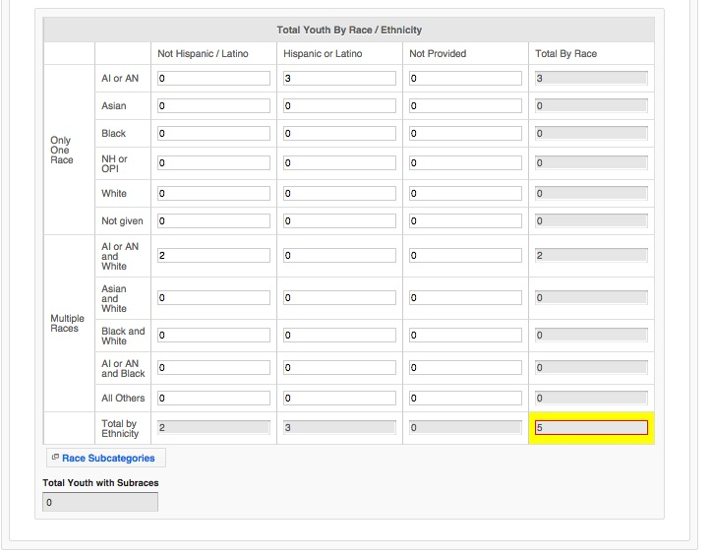 According to the Paperwork Reduction Act of 1995, an agency may not conduct or sponsor, and a person is not required to respond to, a collection of information unless it displays a valid OMB control number. The valid OMB control number for this information collection is 0524-0044. The time required to complete this information collection is estimated to average 1158 hours per response, including the time for reviewing instructions, searching existing data sources, gathering and maintaining the data needed, and completing and reviewing the collection of information.

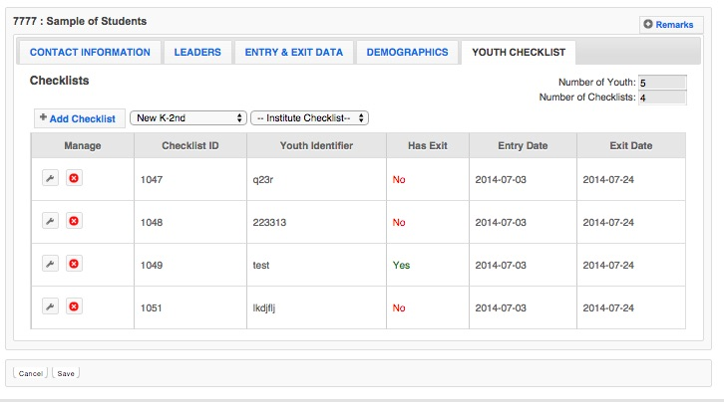

Note: Only one Checklist type is used per youth participant. The screenshots below show each survey type – K-2nd, 3rd-5th, 6th-8th, and 9th-12th

According to the Paperwork Reduction Act of 1995, an agency may not conduct or sponsor, and a person is not required to respond to, a collection of information unless it displays a valid OMB control number. The valid OMB control number for this information collection is 0524-0044. The time required to complete this information collection is estimated to average 1158 hours per response, including the time for reviewing instructions, searching existing data sources, gathering and maintaining the data needed, and completing and reviewing the collection of information.

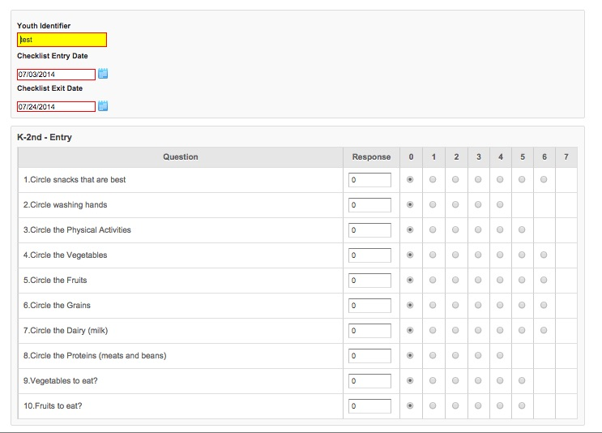

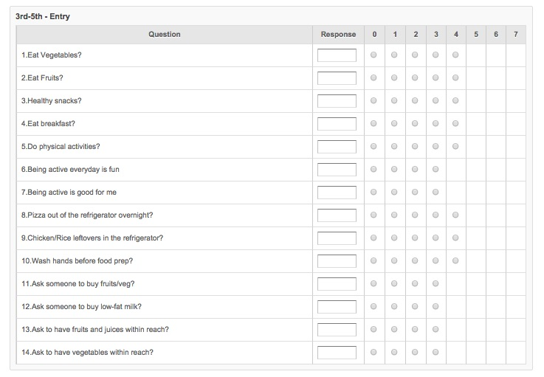

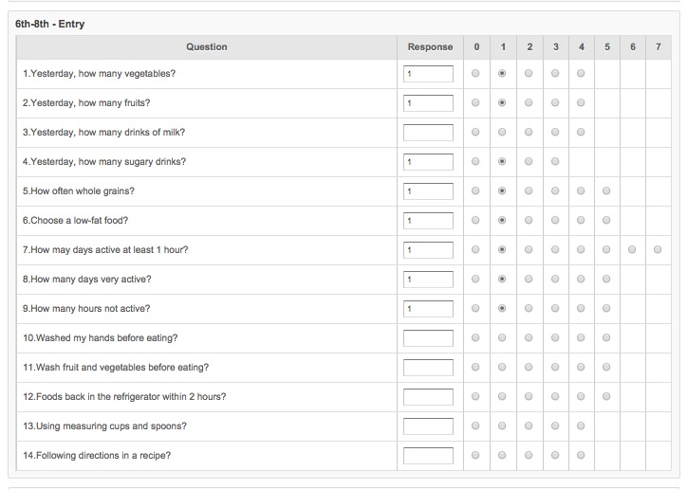

According to the Paperwork Reduction Act of 1995, an agency may not conduct or sponsor, and a person is not required to respond to, a collection of information unless it displays a valid OMB control number. The valid OMB control number for this information collection is 0524-0044. The time required to complete this information collection is estimated to average 1158 hours per response, including the time for reviewing instructions, searching existing data sources, gathering and maintaining the data needed, and completing and reviewing the collection of information.
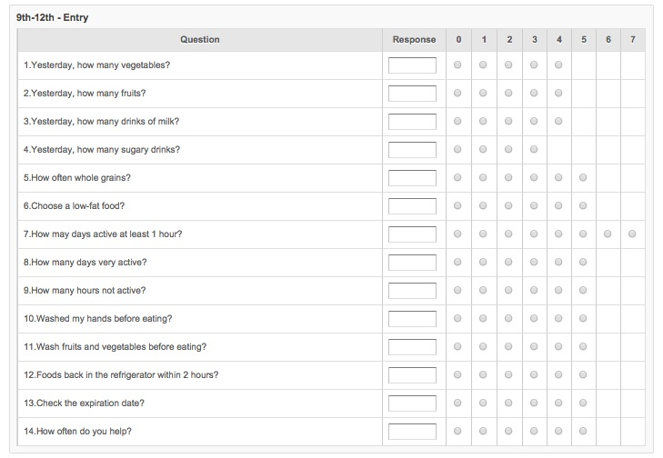

According to the Paperwork Reduction Act of 1995, an agency may not conduct or sponsor, and a person is not required to respond to, a collection of information unless it displays a valid OMB control number. The valid OMB control number for this information collection is 0524-0044. The time required to complete this information collection is estimated to average 1158 hours per response, including the time for reviewing instructions, searching existing data sources, gathering and maintaining the data needed, and completing and reviewing the collection of information.

- Staff Data Entry Screens
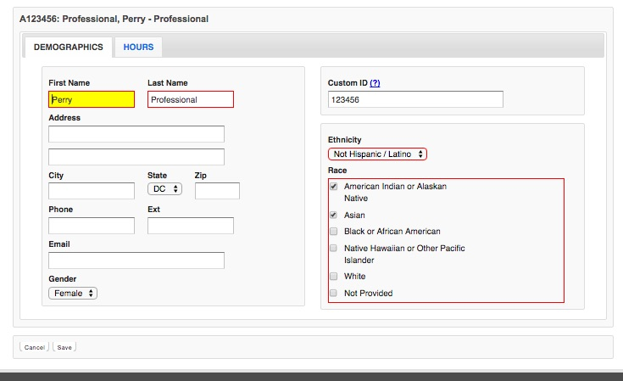
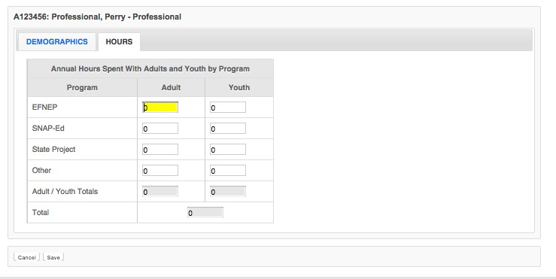

According to the Paperwork Reduction Act of 1995, an agency may not conduct or sponsor, and a person is not required to respond to, a collection of information unless it displays a valid OMB control number. The valid OMB control number for this information collection is 0524-0044. The time required to complete this information collection is estimated to average 1158 hours per response, including the time for reviewing instructions, searching existing data sources, gathering and maintaining the data needed, and completing and reviewing the collection of information.

- Annual Budgets Data Entry Screens

Note: Budget sheet is not a data entry screen. It is filled out in an excel spreadsheet, signed, and uploaded as a PDF into WebNEERS.

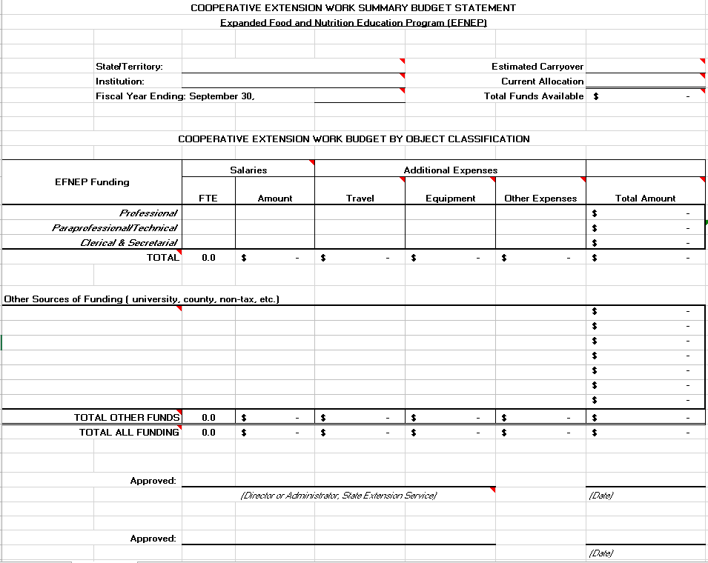

According to the Paperwork Reduction Act of 1995, an agency may not conduct or sponsor, and a person is not required to respond to, a collection of information unless it displays a valid OMB control number. The valid OMB control number for this information collection is 0524-0044. The time required to complete this information collection is estimated to average 1158 hours per response, including the time for reviewing instructions, searching existing data sources, gathering and maintaining the data needed, and completing and reviewing the collection of information.
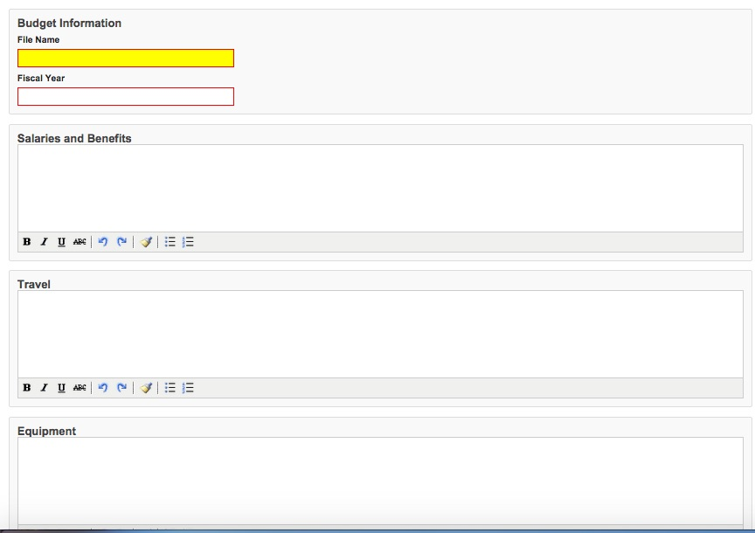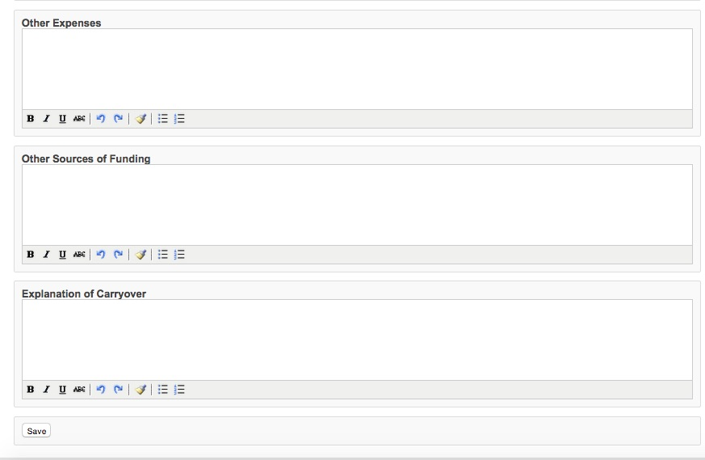
According to the Paperwork Reduction Act of 1995, an agency may not conduct or sponsor, and a person is not required to respond to, a collection of information unless it displays a valid OMB control number. The valid OMB control number for this information collection is 0524-0044. The time required to complete this information collection is estimated to average 1158 hours per response, including the time for reviewing instructions, searching existing data sources, gathering and maintaining the data needed, and completing and reviewing the collection of information.

- Annual Program Plans Data Entry Screens
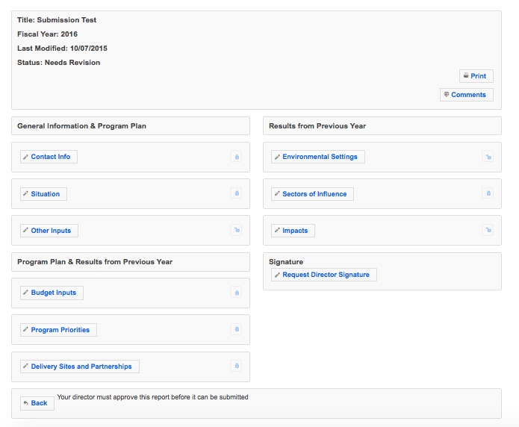

According to the Paperwork Reduction Act of 1995, an agency may not conduct or sponsor, and a person is not required to respond to, a collection of information unless it displays a valid OMB control number. The valid OMB control number for this information collection is 0524-0044. The time required to complete this information collection is estimated to average 1158 hours per response, including the time for reviewing instructions, searching existing data sources, gathering and maintaining the data needed, and completing and reviewing the collection of information.
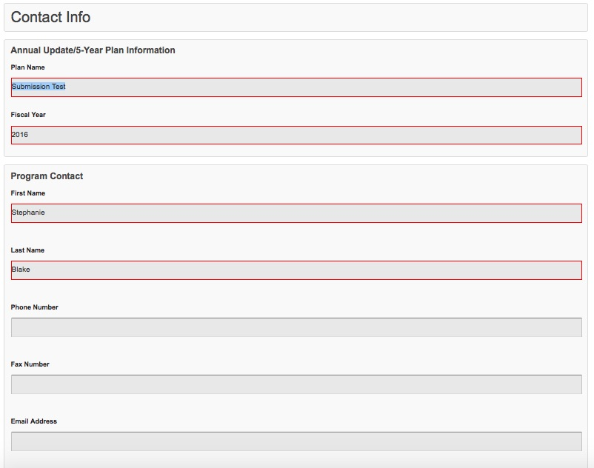

According to the Paperwork Reduction Act of 1995, an agency may not conduct or sponsor, and a person is not required to respond to, a collection of information unless it displays a valid OMB control number. The valid OMB control number for this information collection is 0524-0044. The time required to complete this information collection is estimated to average 1158 hours per response, including the time for reviewing instructions, searching existing data sources, gatherinand maintaining the data needed, and completing and reviewing the collection of information.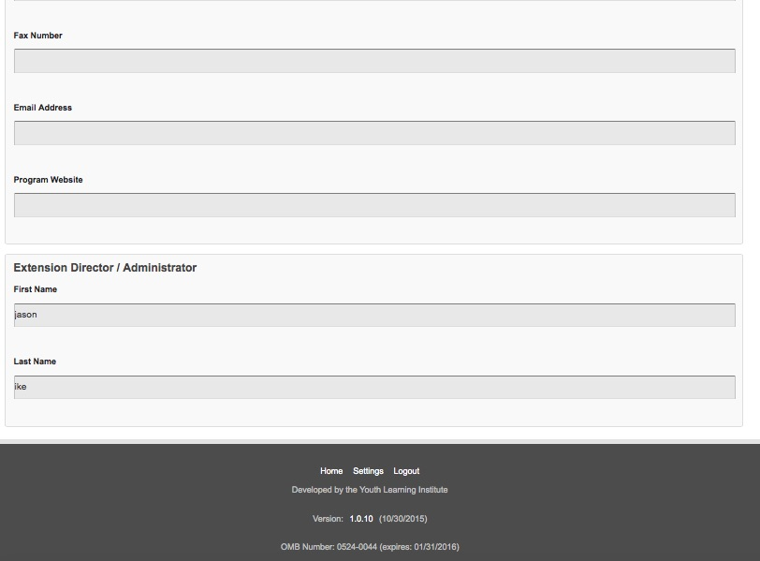
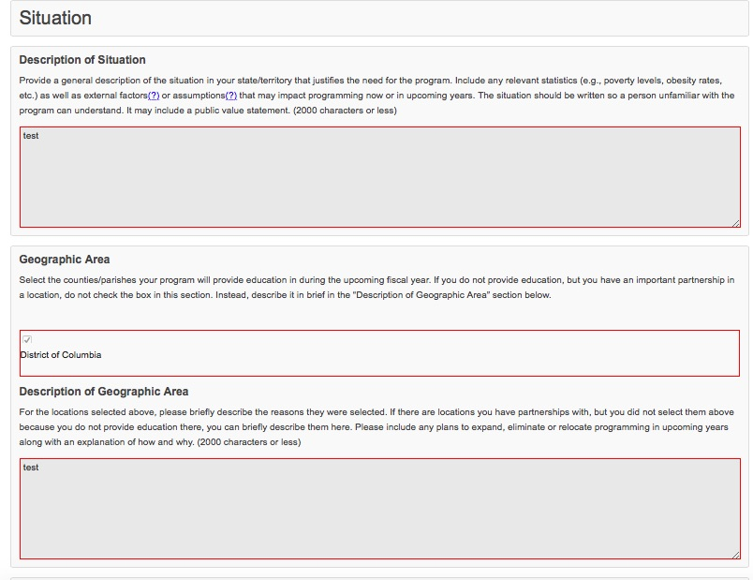
According to the Paperwork Reduction Act of 1995, an agency may not conduct or sponsor, and a person is not required to respond to, a collection of information unless it displays a valid OMB control number. The valid OMB control number for this information collection is 0524-0044. The time required to complete this information collection is estimated to average 1158 hours per response, including the time for reviewing instructions, searching existing data sources, gathering and maintaining the data needed, and completing and reviewing the collection of information.

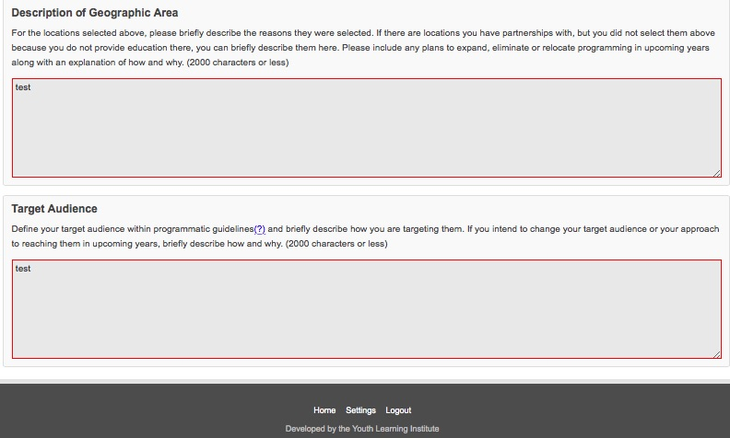

According to the Paperwork Reduction Act of 1995, an agency may not conduct or sponsor, and a person is not required to respond to, a collection of information unless it displays a valid OMB control number. The valid OMB control number for this information collection is 0524-0044. The time required to complete this information collection is estimated to average 1158 hours per response, including the time for reviewing instructions, searching existing data sources, gathering and maintaining the data needed, and completing and reviewing the collection of information.
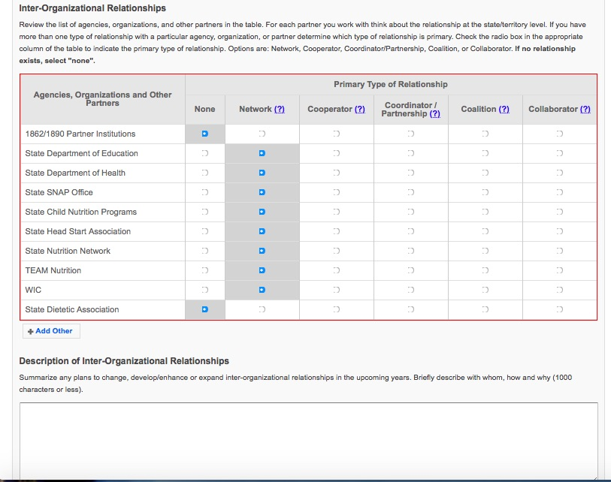

According to the Paperwork Reduction Act of 1995, an agency may not conduct or sponsor, and a person is not required to respond to, a collection of information unless it displays a valid OMB control number. The valid OMB control number for this information collection is 0524-0044. The time required to complete this information collection is estimated to average 1158 hours per response, including the time for reviewing instructions, searching existing data sources, gathering and maintaining the data needed, and completing and reviewing the collection of information.
Note: On the Budget Inputs Screen, the Federal Budget Sheet and Budget Justification are simply quick links to the budget and justification submitted through the budget section of WebNEERS. These are not additional data entry points.

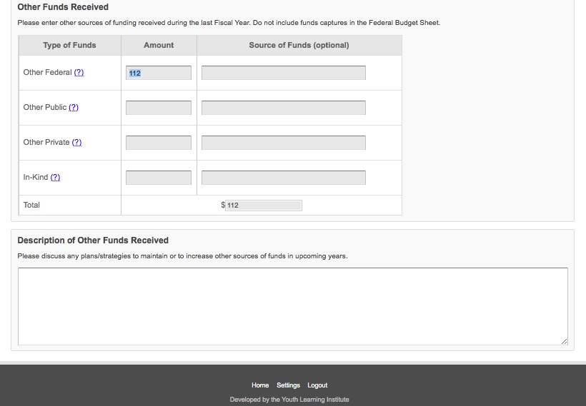

According to the Paperwork Reduction Act of 1995, an agency may not conduct or sponsor, and a person is not required to respond to, a collection of information unless it displays a valid OMB control number. The valid OMB control number for this information collection is 0524-0044. The time required to complete this information collection is estimated to average 1158 hours per response, including the time for reviewing instructions, searching existing data sources, gathering and maintaining the data needed, and completing and reviewing the collection of information.

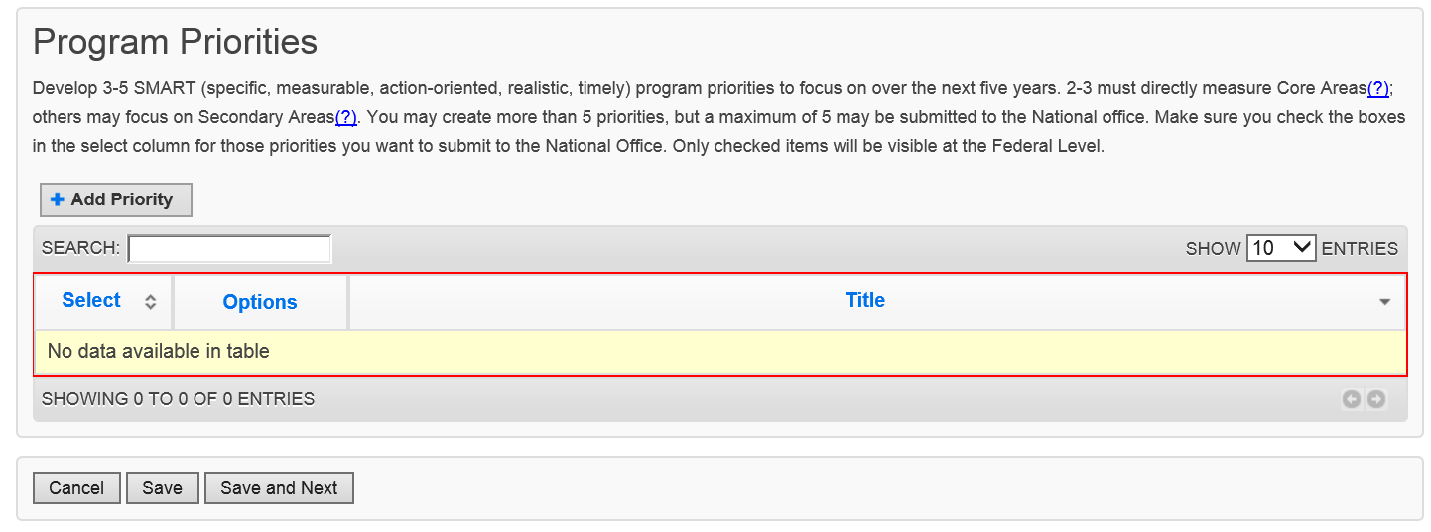

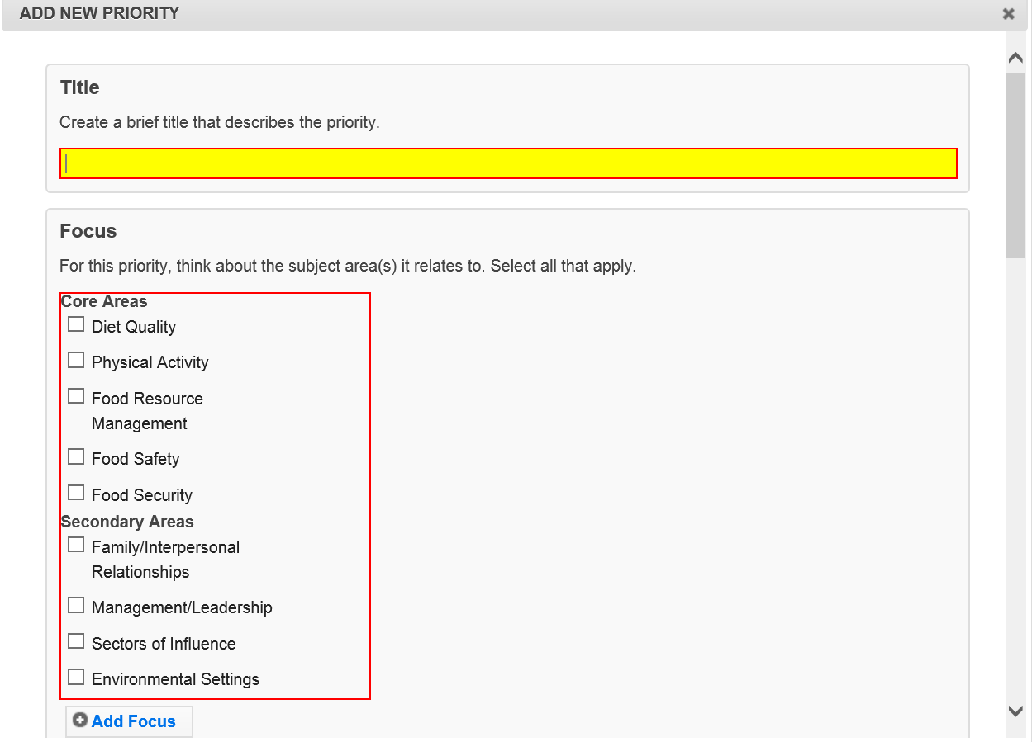

According to the Paperwork Reduction Act of 1995, an agency may not conduct or sponsor, and a person is not required to respond to, a collection of information unless it displays a valid OMB control number. The valid OMB control number for this information collection is 0524-0044. The time required to complete this information collection is estimated to average 1158 hours per response, including the time for reviewing instructions, searching existing data sources, gathering and maintaining the data needed, and completing and reviewing the collection of information.
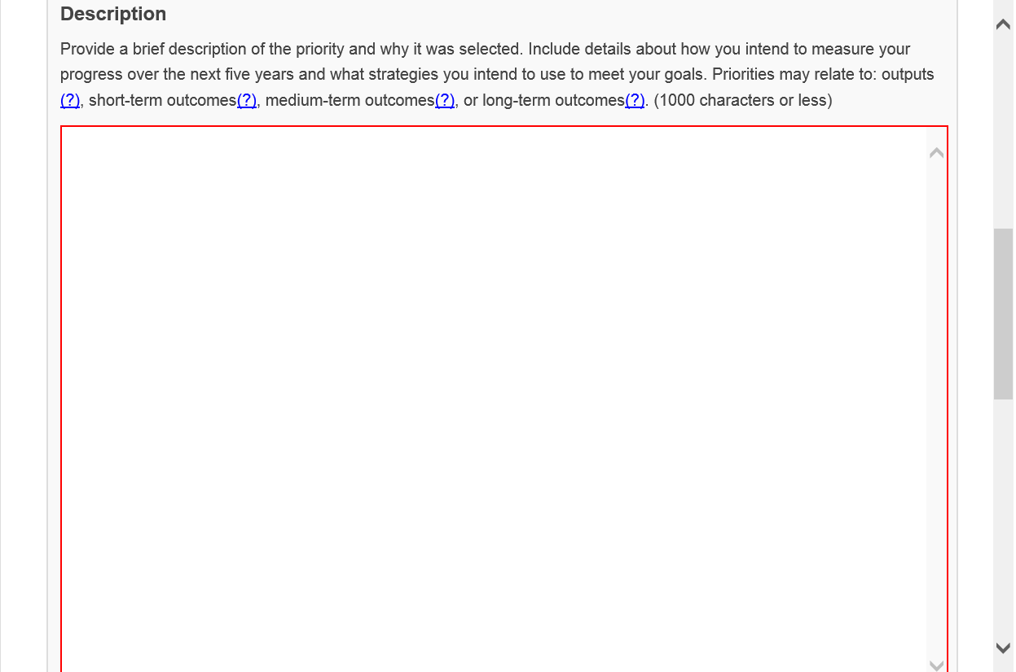
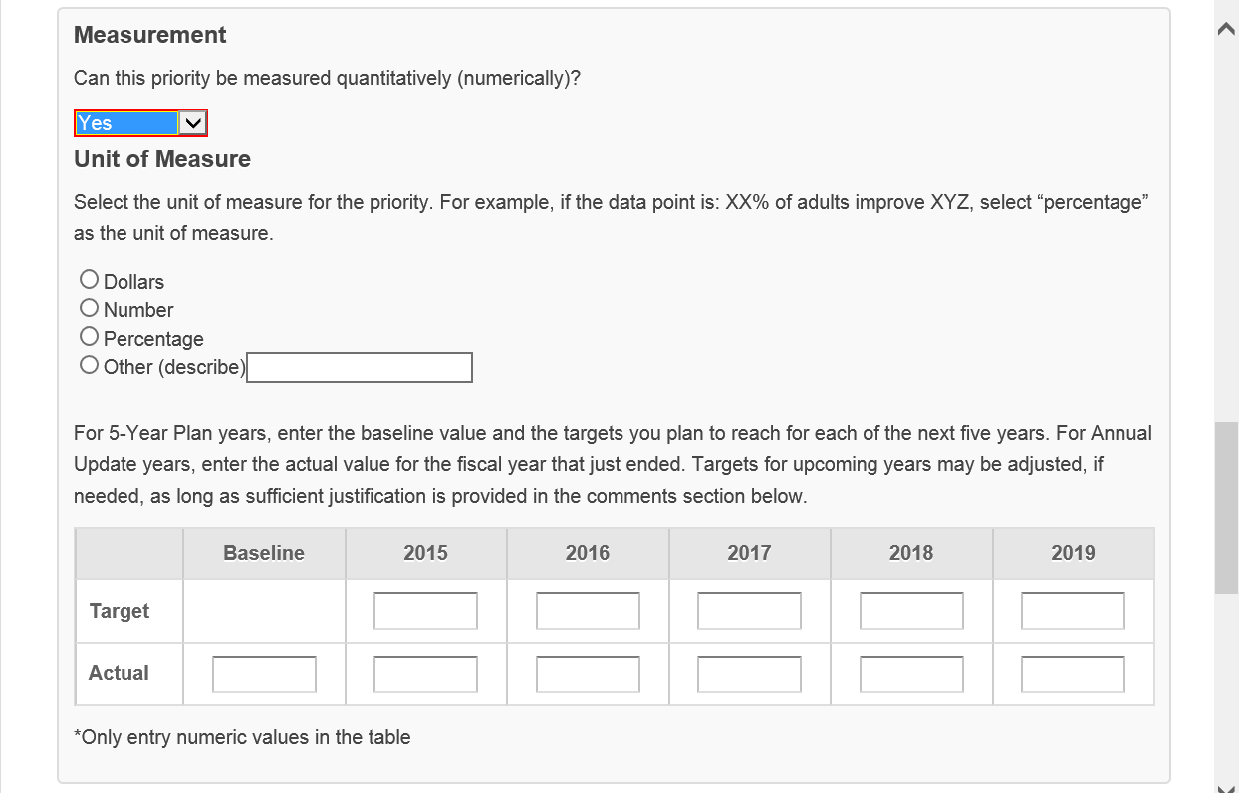

According to the Paperwork Reduction Act of 1995, an agency may not conduct or sponsor, and a person is not required to respond to, a collection of information unless it displays a valid OMB control number. The valid OMB control number for this information collection is 0524-0044. The time required to complete this information collection is estimated to average 1158 hours per response, including the time for reviewing instructions, searching existing data sources, gathering and maintaining the data needed, and completing and reviewing the collection of information.

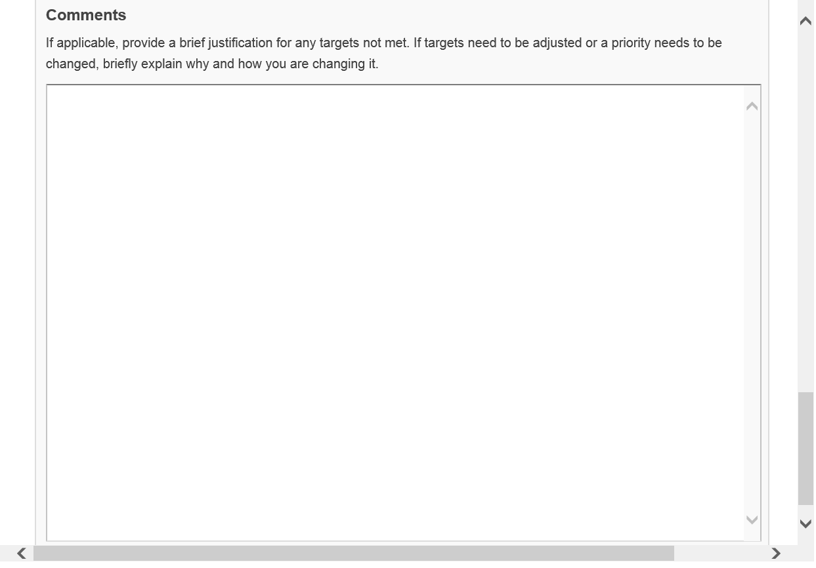

According to the Paperwork Reduction Act of 1995, an agency may not conduct or sponsor, and a person is not required to respond to, a collection of information unless it displays a valid OMB control number. The valid OMB control number for this information collection is 0524-0044. The time required to complete this information collection is estimated to average 1158 hours per response, including the time for reviewing instructions, searching existing data sources, gathering and maintaining the data needed, and completing and reviewing the collection of information.

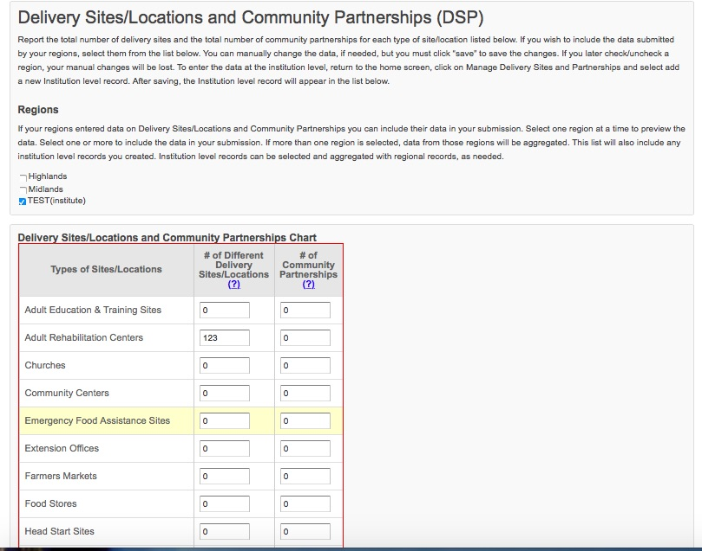
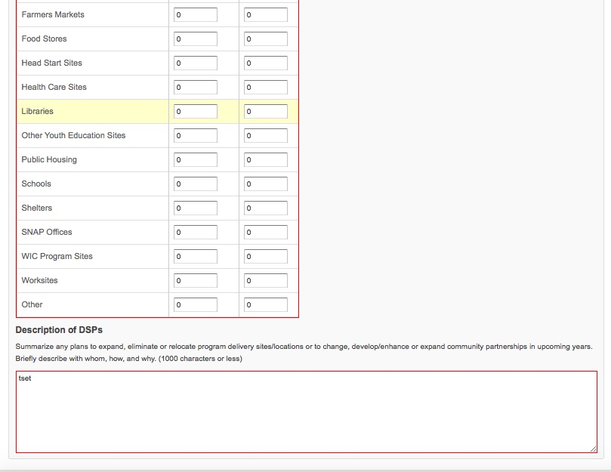
According to the Paperwork Reduction Act of 1995, an agency may not conduct or sponsor, and a person is not required to respond to, a collection of information unless it displays a valid OMB control number. The valid OMB control number for this information collection is 0524-0044. The time required to complete this information collection is estimated to average 1158 hours per response, including the time for reviewing instructions, searching existing data sources, gathering and maintaining the data needed, and completing and reviewing the collection of information.

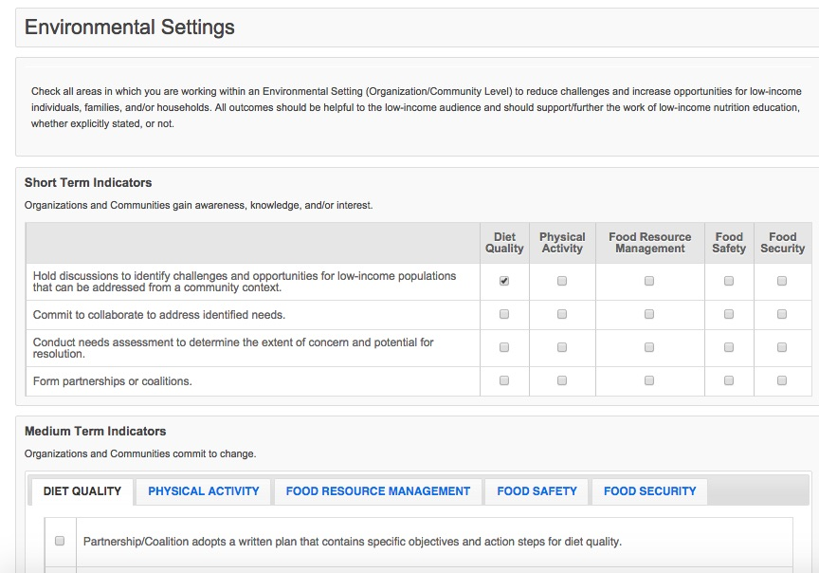

According to the Paperwork Reduction Act of 1995, an agency may not conduct or sponsor, and a person is not required to respond to, a collection of information unless it displays a valid OMB control number. The valid OMB control number for this information collection is 0524-0044. The time required to complete this information collection is estimated to average 1158 hours per response, including the time for reviewing instructions, searching existing data sources, gathering and maintaining the data needed, and completing and reviewing the collection of information.

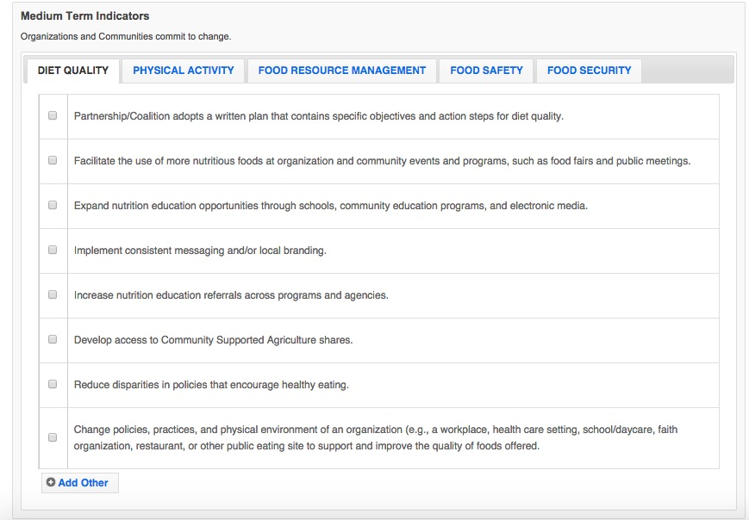

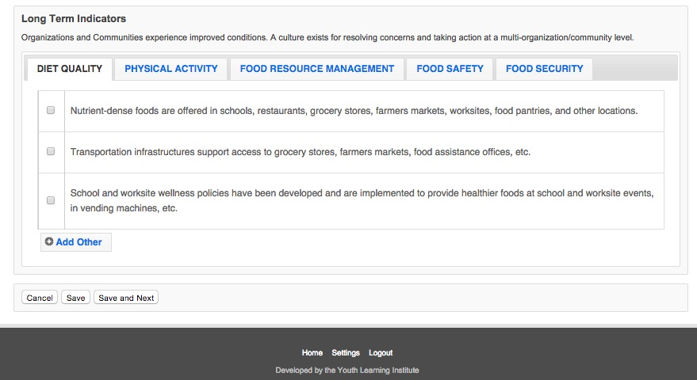 According to the Paperwork Reduction Act of 1995, an agency may not conduct or sponsor, and a person is not required to respond to, a collection of information unless it displays a valid OMB control number. The valid OMB control number for this information collection is 0524-0044. The time required to complete this information collection is estimated to average 1158 hours per response, including the time for reviewing instructions, searching existing data sources, gathering and maintaining the data needed, and completing and reviewing the collection of information.

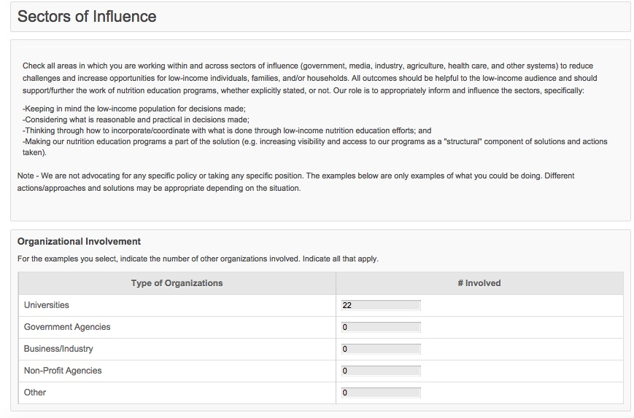

According to the Paperwork Reduction Act of 1995, an agency may not conduct or sponsor, and a person is not required to respond to, a collection of information unless it displays a valid OMB control number. The valid OMB control number for this information collection is 0524-0044. The time required to complete this information collection is estimated to average 1158 hours per response, including the time for reviewing instructions, searching existing data sources, gathering and maintaining the data needed, and completing and reviewing the collection of information.

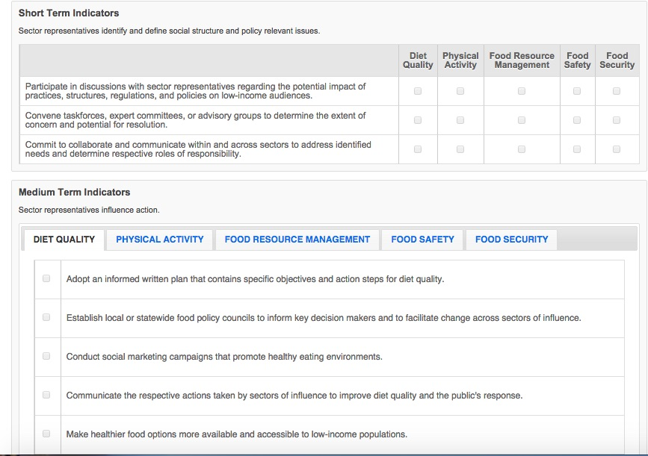

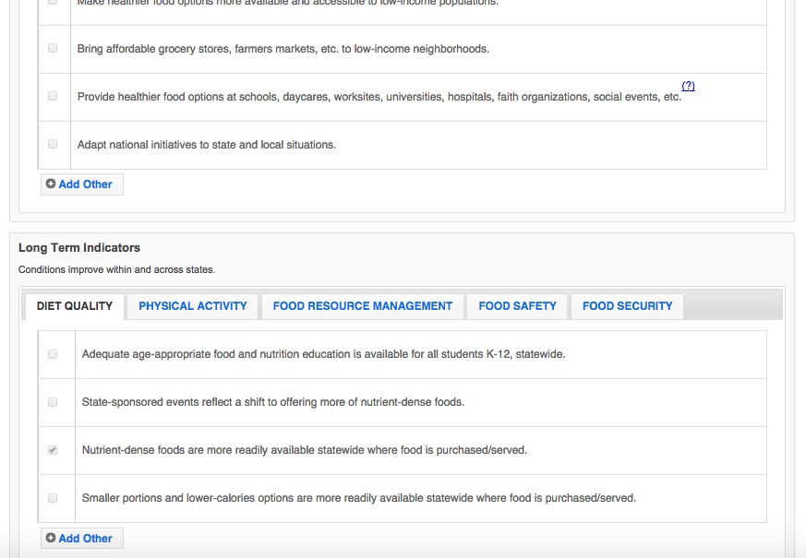

According to the Paperwork Reduction Act of 1995, an agency may not conduct or sponsor, and a person is not required to respond to, a collection of information unless it displays a valid OMB control number. The valid OMB control number for this information collection is 0524-0044. The time required to complete this information collection is estimated to average 1158 hours per response, including the time for reviewing instructions, searching existing data sources, gathering and maintaining the data needed, and completing and reviewing the collection of information.

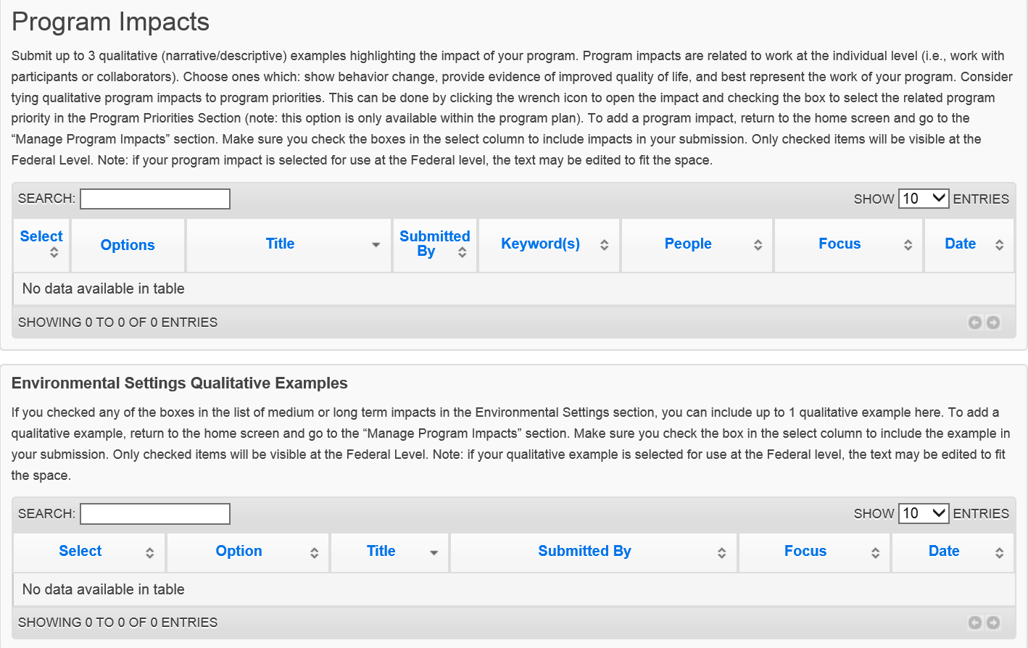

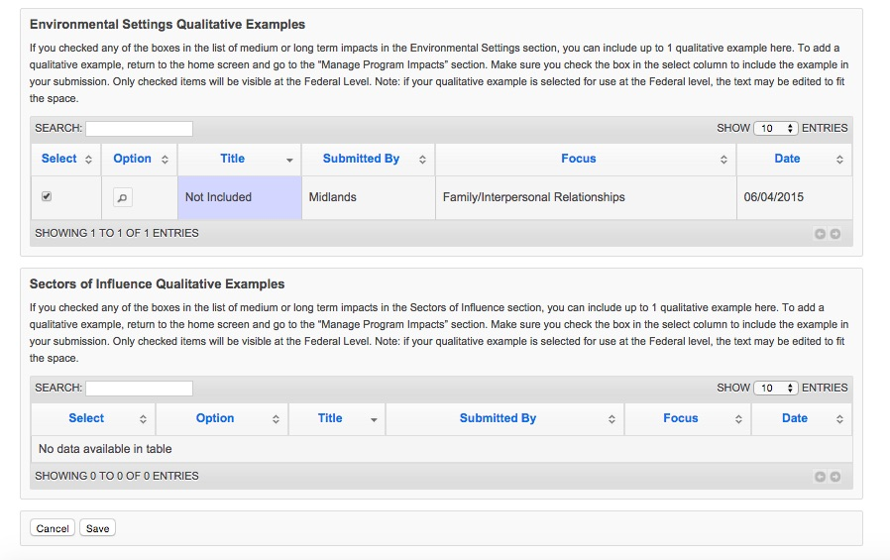

According to the Paperwork Reduction Act of 1995, an agency may not conduct or sponsor, and a person is not required to respond to, a collection of information unless it displays a valid OMB control number. The valid OMB control number for this information collection is 0524-0044. The time required to complete this information collection is estimated to average 1158 hours per response, including the time for reviewing instructions, searching existing data sources, gathering and maintaining the data needed, and completing and reviewing the collection of information.

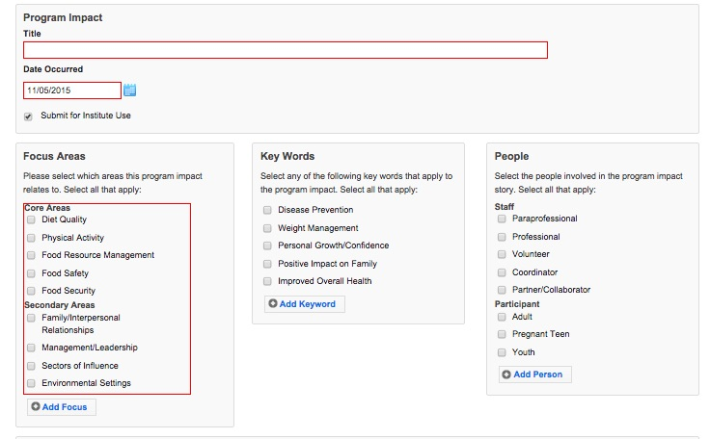

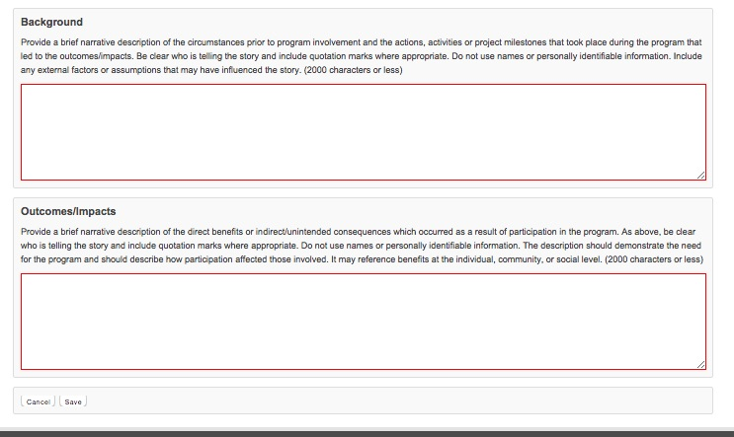

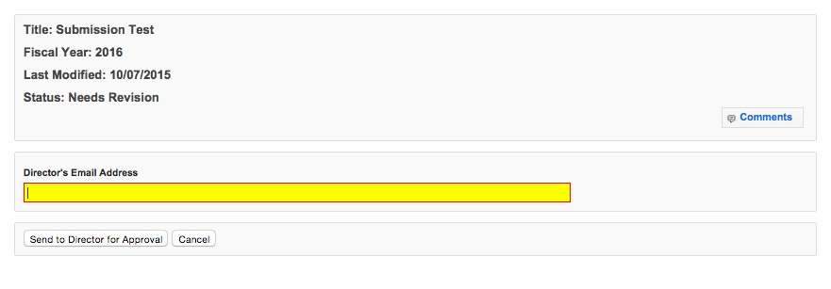

According to the Paperwork Reduction Act of 1995, an agency may not conduct or sponsor, and a person is not required to respond to, a collection of information unless it displays a valid OMB control number. The valid OMB control number for this information collection is 0524-0044. The time required to complete this information collection is estimated to average 1158 hours per response, including the time for reviewing instructions, searching existing data sources, gathering and maintaining the data needed, and completing and reviewing the collection of information.

