Appendix E: Parent and Child Data Collection Instruments

E.1a Child Food Diary Non-Child Care Day (English)

Abt IRB Approval No.: 0804
OMB Control No: 0584-XXXX
OMB Approval Expiration Date: XX/XX/XXXX

LOGO

Study of Nutrition and Activity in Child Care Settings (SNACS)

Child Food Diary—Non-Child Care Day

Respondent ID
Respondent Name
Other Name/Contact Info

START recording food on: _____ / _____ / 2016 at _____ : _____ am/ pm
Month Day Time (circle one)

STOP recording food on: _____ / _____ / 2016 at _____ : _____ am/ pm
Month Day Time (circle one)

According to the Paperwork Reduction Act of 1995, an agency may not conduct or sponsor, and a person is not required to respond to, a collection of information unless it displays a valid OMB control number. The valid OMB control number for this information collection is 0584-XXXX The time required to complete this information collection is estimated to average 40 minutes per response, including the time for reviewing instructions, searching existing data sources, gathering and maintaining the data needed, and completing and reviewing the collection of information.

Thank you for agreeing to be part of the Study of Nutrition and Activity in Child Care Settings. As we explained when you signed up for the study, parents are being asked to complete this Child Food Diary.

About this Diary: The Child Food Diary will take approximately 40 minutes to complete. The Child Food Diary will gather information about everything your child had to eat and drink for the time frame indicated on the first page of this diary. This will include food preparation details and portion sizes on all foods and drinks.

Everything you report in the food diary will be kept private and used for research purposes according to state and federal law. We will not include your name or your child’s name in any of our reports – we will be reporting overall results for all children and parents participating in the study.

Questions. If you have any questions about the study please call our toll-free study number at 1- 844-808-4777 or email SNACS@abtassoc.com. We will be happy to answer your questions and to help you in any way we can. For questions or concerns about your rights as a research participant, call Teresa Doksum at the Abt Associates Institutional Review Board at toll-free 877-520-6835.

Thank you for participating in the Study of Nutrition and Activity in Child Care Settings (SNACS).

OMB Control No: 0584-XXXX
OMB Approval Expiration Date: XX/XX/XXXX

Abt IRB Approval No.: 0804

Food diary for a day your child DOES NOT
attend child care

Please write down EVERYTHING your child eats and drinks on , starting when he/she wakes up, until he/she goes to bed. Refer to the front cover of this booklet for the day and date to begin and stop recording.

Include all meals, snacks, tastes, and bites of food and all drinks, including water. Keep this booklet with you and write down items immediately after each meal and snack. If your child is going to be in the care of someone else during this day, please ask them to keep note of what food and drinks your child consumes for you to record in this booklet. There are no right or wrong answers; we just want to know what your child ate. Don’t include foods that your child leaves on his/her plate; we only want to know what he/she ate. Please write only one food per line. Please write neatly and record as much information about the foods and meals as you can. Thank you for your help in this important project!

We have included portion estimators and pictures at the back of this booklet. Please use them to help you estimate the portion size of what he/she ate OR you can use standard measuring tools that may be available in the kitchen (measuring cups/spoons, food scales). We have also included examples of the correct ways to record meals and mixed dishes opposite from every meal tab.

When you write down each food and drink on the form, please remember the following:
- Did you write down the brand of the food (if it was store bought)?
- Did you include details about the type of food? (e.g. low fat, whole grain, reduced salt)
- Did you include any additions to a food? (e.g. ketchup on a sandwich, gravy on meat, milk on cereal, butter or margarine on bread)
- Did you use appropriate numbers and measurements? (e.g. fun-size candy bar, 1 oz bag of chips, ½ cup of milk)
- Did you write down how the food was prepared? (e.g. baked chicken, raw broccoli, breaded and fried chicken nuggets)
- Did you describe mixed dishes? (e.g. casseroles, soups, salads).

BLANK

MEAL OR SNACK #1

Please use portion estimators and pictures in the back of this booklet to help you estimate the amounts eaten.

Instructions and examples of the correct way to record a meal and mixed dish:

When you write down each food and drink on the form, please remember the following:
- Did you write down the brand of the food (if it was store bought)?
- Did you include details about the type of food? (e.g. low fat, whole grain, reduced salt)
- Did you include any additions to a food? (e.g. ketchup on a sandwich, gravy on meat, milk on cereal, butter or margarine on bread)
- Did you use appropriate numbers and measurements? (e.g. fun-size candy bar, 1 oz bag of chips, ½ cup of milk)
- Did you write down how the food was prepared? (e.g. baked chicken, raw broccoli, breaded and fried chicken nuggets)
- Did you describe mixed dishes? (e.g. casseroles, soups, salads).

MEAL OR SNACK EXAMPLE:
What TYPE of meal is this?  (check one) | WHERE was this meal eaten?  (check one) |  | What TIME was this meal eaten?
Breakfast | Home | Traveling (car, bus, etc)
Lunch | Other person’s house | Party or other social event | 06 : 30
Dinner/Supper | Restaurant/deli/fast food (Name?)__________________ |  | (check one)
Snack | Other (please describe) ___________________________ |  | am pm
WHAT did your child eat or drink? (list one item per line) | DESCRIBE the item completely. What is the brand? How was it prepared? What was the flavor or type? Did you add anything to the food? |  | HOW MUCH did your child eat or drink? (cups, oz, inches)
Pasta casserole | See Mixed Dish details below |  | 1 cup
Garlic bread | Pepperidge Farm Garlic Texas Toast from frozen |  | 1 piece (1x 2 inches, ½ inch thick)
Broccoli | Steamed with added butter and salt |  | ¼ cup
Milk | 2% white milk |  | ½ cup
Cupcake | Little Debbie chocolate cupcake, cream filled |  | ¼ cupcake
This is correct because it gave lots of detail and we know exactly how much your child ate.

MIXED DISH EXAMPLE:
What is the name of the dish you wrote above (use the same name as you wrote it in the meal above)?

pasta casserole

What foods are in this dish?

White elbow macaroni

85% fat ground beef

Mozzarella cheese – part skim

Green peppers - fresh

Canned diced tomatoes

Meal or Snack #1
What TYPE of meal is this?  (check one) | WHERE was this meal eaten?  (check one) |  | What TIME was this meal eaten?
Breakfast | Home | Traveling (car, bus, etc)
Lunch | Other person’s house | Party or other social event | ___ : ___
Dinner/Supper | Restaurant/deli/fast food (Name?)__________________ |  | (check one)
Snack | Other (please describe) ___________________________ |  | am pm
WHAT did your child eat or drink? (list one item per line) | DESCRIBE the item completely. What is the brand? How was it prepared? What was the flavor or type? |  | HOW MUCH did your child eat or drink? (cups, oz, inches)

If you listed any mixed dishes in the meals eaten above, please tell us more about them in the spaces below. The more information you can provide, the better, but you don’t need to write out the recipe. It is ok to include more than one mixed dish.

- What is the name of the mixed dish you wrote above?

_______________________________________

What foods are in this dish?
_______________________________________

_______________________________________

_______________________________________

_______________________________________

_______________________________________

_______________________________________
- What is the name of the dish you wrote above?

_______________________________________

What foods are in this dish?
_______________________________________

_______________________________________

_______________________________________

_______________________________________

_______________________________________

_______________________________________

Continue to next page or go to pink page at end if no more meals or snacks.

BLANK
MEAL OR SNACK #2

Please use portion estimators and pictures in the back of this booklet to help you estimate the amounts eaten.

Instructions and examples of the correct way to record a meal and mixed dish:

When you write down each food and drink on the form, please remember the following:
- Did you write down the brand of the food (if it was store bought)?
- Did you include details about the type of food? (e.g. low fat, whole grain, reduced salt)
- Did you include any additions to a food? (e.g. ketchup on a sandwich, gravy on meat, milk on cereal, butter or margarine on bread)
- Did you use appropriate numbers and measurements? (e.g. fun-size candy bar, 1 oz bag of chips, ½ cup of milk)
- Did you write down how the food was prepared? (e.g. baked chicken, raw broccoli, breaded and fried chicken nuggets)
- Did you describe mixed dishes? (e.g. casseroles, soups, salads).

MEAL OR SNACK EXAMPLE:
What TYPE of meal is this?  (check one) | WHERE was this meal eaten?  (check one) |  | What TIME was this meal eaten?
Breakfast | Home | Traveling (car, bus, etc)
Lunch | Other person’s house | Party or other social event | 06 : 30
Dinner/Supper | Restaurant/deli/fast food (Name?)__________________ |  | (check one)
Snack | Other (please describe) ___________________________ |  | am pm
WHAT did your child eat or drink? (list one item per line) | DESCRIBE the item completely. What is the brand? How was it prepared? What was the flavor or type? Did you add anything to the food? |  | HOW MUCH did your child eat or drink? (cups, oz, inches)
Pasta casserole | See Mixed Dish details below |  | 1 cup
Garlic bread | Pepperidge Farm Garlic Texas Toast from frozen |  | 1 piece (1x 2 inches, ½ inch thick)
Broccoli | Steamed with added butter and salt |  | ¼ cup
Milk | 2% white milk |  | ½ cup
Cupcake | Little Debbie chocolate cupcake, cream filled |  | ¼ cupcake
This is correct because it gave lots of detail and we know exactly how much your child ate.

MIXED DISH EXAMPLE:
What is the name of the dish you wrote above (use the same name as you wrote it in the meal above)?

pasta casserole

What foods are in this dish?

White elbow macaroni

85% fat ground beef

Mozzarella cheese – part skim

Green peppers - fresh

Canned diced tomatoes

Meal or Snack #2
What TYPE of meal is this?  (check one) | WHERE was this meal eaten?  (check one) |  | What TIME was this meal eaten?
Breakfast | Home | Traveling (car, bus, etc)
Lunch | Other person’s house | Party or other social event | ___ : ___
Dinner/Supper | Restaurant/deli/fast food (Name?)__________________ |  | (check one)
Snack | Other (please describe) ___________________________ |  | am pm
WHAT did your child eat or drink? (list one item per line) | DESCRIBE the item completely. What is the brand? How was it prepared? What was the flavor or type? |  | HOW MUCH did your child eat or drink? (cups, oz, inches)

If you listed any mixed dishes in the meals eaten above, please tell us more about them in the spaces below. The more information you can provide, the better, but you don’t need to write out the recipe. It is ok to include more than one mixed dish.

- What is the name of the mixed dish you wrote above?

_______________________________________

What foods are in this dish?
_______________________________________

_______________________________________

_______________________________________

_______________________________________

_______________________________________

_______________________________________
- What is the name of the dish you wrote above?

_______________________________________

What foods are in this dish?
_______________________________________

_______________________________________

_______________________________________

_______________________________________

_______________________________________

_______________________________________

Continue to next page or go to pink page at end if no more meals or snacks.

BLANK
MEAL OR SNACK #3

Please use portion estimators and pictures in the back of this booklet to help you estimate the amounts eaten.

Instructions and examples of the correct way to record a meal and mixed dish:

When you write down each food and drink on the form, please remember the following:
- Did you write down the brand of the food (if it was store bought)?
- Did you include details about the type of food? (e.g. low fat, whole grain, reduced salt)
- Did you include any additions to a food? (e.g. ketchup on a sandwich, gravy on meat, milk on cereal, butter or margarine on bread)
- Did you use appropriate numbers and measurements? (e.g. fun-size candy bar, 1 oz bag of chips, ½ cup of milk)
- Did you write down how the food was prepared? (e.g. baked chicken, raw broccoli, breaded and fried chicken nuggets)
- Did you describe mixed dishes? (e.g. casseroles, soups, salads).

MEAL OR SNACK EXAMPLE:
What TYPE of meal is this?  (check one) | WHERE was this meal eaten?  (check one) |  | What TIME was this meal eaten?
Breakfast | Home | Traveling (car, bus, etc)
Lunch | Other person’s house | Party or other social event | 06 : 30
Dinner/Supper | Restaurant/deli/fast food (Name?)__________________ |  | (check one)
Snack | Other (please describe) ___________________________ |  | am pm
WHAT did your child eat or drink? (list one item per line) | DESCRIBE the item completely. What is the brand? How was it prepared? What was the flavor or type? Did you add anything to the food? |  | HOW MUCH did your child eat or drink? (cups, oz, inches)
Pasta casserole | See Mixed Dish details below |  | 1 cup
Garlic bread | Pepperidge Farm Garlic Texas Toast from frozen |  | 1 piece (1x 2 inches, ½ inch thick)
Broccoli | Steamed with added butter and salt |  | ¼ cup
Milk | 2% white milk |  | ½ cup
Cupcake | Little Debbie chocolate cupcake, cream filled |  | ¼ cupcake
This is correct because it gave lots of detail and we know exactly how much your child ate.

MIXED DISH EXAMPLE:
What is the name of the dish you wrote above (use the same name as you wrote it in the meal above)?

pasta casserole

What foods are in this dish?

White elbow macaroni

85% fat ground beef

Mozzarella cheese – part skim

Green peppers - fresh

Canned diced tomatoes

Meal or Snack #3
What TYPE of meal is this?  (check one) | WHERE was this meal eaten?  (check one) |  | What TIME was this meal eaten?
Breakfast | Home | Traveling (car, bus, etc)
Lunch | Other person’s house | Party or other social event | ___ : ___
Dinner/Supper | Restaurant/deli/fast food (Name?)__________________ |  | (check one)
Snack | Other (please describe) ___________________________ |  | am pm
WHAT did your child eat or drink? (list one item per line) | DESCRIBE the item completely. What is the brand? How was it prepared? What was the flavor or type? |  | HOW MUCH did your child eat or drink? (cups, oz, inches)

If you listed any mixed dishes in the meals eaten above, please tell us more about them in the spaces below. The more information you can provide, the better, but you don’t need to write out the recipe. It is ok to include more than one mixed dish.

- What is the name of the mixed dish you wrote above?

_______________________________________

What foods are in this dish?
_______________________________________

_______________________________________

_______________________________________

_______________________________________

_______________________________________

_______________________________________

- What is the name of the dish you wrote above?

_______________________________________

What foods are in this dish?
_______________________________________

_______________________________________

_______________________________________

_______________________________________

_______________________________________

_______________________________________
Continue to next page or go to pink page at end if no more meals or snacks.

BLANK
MEAL OR SNACK #4

Please use portion estimators and pictures in the back of this booklet to help you estimate the amounts eaten.

Instructions and examples of the correct way to record a meal and mixed dish:

When you write down each food and drink on the form, please remember the following:
- Did you write down the brand of the food (if it was store bought)?
- Did you include details about the type of food? (e.g. low fat, whole grain, reduced salt)
- Did you include any additions to a food? (e.g. ketchup on a sandwich, gravy on meat, milk on cereal, butter or margarine on bread)
- Did you use appropriate numbers and measurements? (e.g. fun-size candy bar, 1 oz bag of chips, ½ cup of milk)
- Did you write down how the food was prepared? (e.g. baked chicken, raw broccoli, breaded and fried chicken nuggets)
- Did you describe mixed dishes? (e.g. casseroles, soups, salads).

MEAL OR SNACK EXAMPLE:
What TYPE of meal is this?  (check one) | WHERE was this meal eaten?  (check one) |  | What TIME was this meal eaten?
Breakfast | Home | Traveling (car, bus, etc)
Lunch | Other person’s house | Party or other social event | 06 : 30
Dinner/Supper | Restaurant/deli/fast food (Name?)__________________ |  | (check one)
Snack | Other (please describe) ___________________________ |  | am pm
WHAT did your child eat or drink? (list one item per line) | DESCRIBE the item completely. What is the brand? How was it prepared? What was the flavor or type? Did you add anything to the food? |  | HOW MUCH did your child eat or drink? (cups, oz, inches)
Pasta casserole | See Mixed Dish details below |  | 1 cup
Garlic bread | Pepperidge Farm Garlic Texas Toast from frozen |  | 1 piece (1x 2 inches, ½ inch thick)
Broccoli | Steamed with added butter and salt |  | ¼ cup
Milk | 2% white milk |  | ½ cup
Cupcake | Little Debbie chocolate cupcake, cream filled |  | ¼ cupcake
This is correct because it gave lots of detail and we know exactly how much your child ate.

MIXED DISH EXAMPLE:
What is the name of the dish you wrote above (use the same name as you wrote it in the meal above)?

pasta casserole

What foods are in this dish?

White elbow macaroni

85% fat ground beef

Mozzarella cheese – part skim

Green peppers - fresh

Canned diced tomatoes

Meal or Snack #4
What TYPE of meal is this?  (check one) | WHERE was this meal eaten?  (check one) |  | What TIME was this meal eaten?
Breakfast | Home | Traveling (car, bus, etc)
Lunch | Other person’s house | Party or other social event | ___ : ___
Dinner/Supper | Restaurant/deli/fast food (Name?)__________________ |  | (check one)
Snack | Other (please describe) ___________________________ |  | am pm
WHAT did your child eat or drink? (list one item per line) | DESCRIBE the item completely. What is the brand? How was it prepared? What was the flavor or type? |  | HOW MUCH did your child eat or drink? (cups, oz, inches)

If you listed any mixed dishes in the meals eaten above, please tell us more about them in the spaces below. The more information you can provide, the better, but you don’t need to write out the recipe. It is ok to include more than one mixed dish.

- What is the name of the mixed dish you wrote above?

_______________________________________

What foods are in this dish?
_______________________________________

_______________________________________

_______________________________________

_______________________________________

_______________________________________

_______________________________________

- What is the name of the dish you wrote above?

_______________________________________

What foods are in this dish?
_______________________________________

_______________________________________

_______________________________________

_______________________________________

_______________________________________

_______________________________________

Continue to next page or go to pink page at end if no more meals or snacks.

BLANK

MEAL OR SNACK #5

Please use portion estimators and pictures in the back of this booklet to help you estimate the amounts eaten.

Instructions and examples of the correct way to record a meal and mixed dish:

When you write down each food and drink on the form, please remember the following:
- Did you write down the brand of the food (if it was store bought)?
- Did you include details about the type of food? (e.g. low fat, whole grain, reduced salt)
- Did you include any additions to a food? (e.g. ketchup on a sandwich, gravy on meat, milk on cereal, butter or margarine on bread)
- Did you use appropriate numbers and measurements? (e.g. fun-size candy bar, 1 oz bag of chips, ½ cup of milk)
- Did you write down how the food was prepared? (e.g. baked chicken, raw broccoli, breaded and fried chicken nuggets)
- Did you describe mixed dishes? (e.g. casseroles, soups, salads).

MEAL OR SNACK EXAMPLE:
What TYPE of meal is this?  (check one) | WHERE was this meal eaten?  (check one) |  | What TIME was this meal eaten?
Breakfast | Home | Traveling (car, bus, etc)
Lunch | Other person’s house | Party or other social event | 06 : 30
Dinner/Supper | Restaurant/deli/fast food (Name?)__________________ |  | (check one)
Snack | Other (please describe) ___________________________ |  | am pm
WHAT did your child eat or drink? (list one item per line) | DESCRIBE the item completely. What is the brand? How was it prepared? What was the flavor or type? Did you add anything to the food? |  | HOW MUCH did your child eat or drink? (cups, oz, inches)
Pasta casserole | See Mixed Dish details below |  | 1 cup
Garlic bread | Pepperidge Farm Garlic Texas Toast from frozen |  | 1 piece (1x 2 inches, ½ inch thick)
Broccoli | Steamed with added butter and salt |  | ¼ cup
Milk | 2% white milk |  | ½ cup
Cupcake | Little Debbie chocolate cupcake, cream filled |  | ¼ cupcake
This is correct because it gave lots of detail and we know exactly how much your child ate.

MIXED DISH EXAMPLE:
What is the name of the dish you wrote above (use the same name as you wrote it in the meal above)?

pasta casserole

What foods are in this dish?

White elbow macaroni

85% fat ground beef

Mozzarella cheese – part skim

Green peppers - fresh

Canned diced tomatoes

Meal or Snack #5
What TYPE of meal is this?  (check one) | WHERE was this meal eaten?  (check one) |  | What TIME was this meal eaten?
Breakfast | Home | Traveling (car, bus, etc)
Lunch | Other person’s house | Party or other social event | ___ : ___
Dinner/Supper | Restaurant/deli/fast food (Name?)__________________ |  | (check one)
Snack | Other (please describe) ___________________________ |  | am pm
WHAT did your child eat or drink? (list one item per line) | DESCRIBE the item completely. What is the brand? How was it prepared? What was the flavor or type? |  | HOW MUCH did your child eat or drink? (cups, oz, inches)

If you listed any mixed dishes in the meals eaten above, please tell us more about them in the spaces below. The more information you can provide, the better, but you don’t need to write out the recipe. It is ok to include more than one mixed dish.

- What is the name of the mixed dish you wrote above?

_______________________________________

What foods are in this dish?
_______________________________________

_______________________________________

_______________________________________

_______________________________________

_______________________________________

_______________________________________

- What is the name of the dish you wrote above?

_______________________________________

What foods are in this dish?
_______________________________________

_______________________________________

_______________________________________

_______________________________________

_______________________________________

_______________________________________

Continue to next page or go to pink page at end if no more meals or snacks.

BLANK

MEAL OR SNACK #6

Please use portion estimators and pictures in the back of this booklet to help you estimate the amounts eaten.

Instructions and examples of the correct way to record a meal and mixed dish:

When you write down each food and drink on the form, please remember the following:
- Did you write down the brand of the food (if it was store bought)?
- Did you include details about the type of food? (e.g. low fat, whole grain, reduced salt)
- Did you include any additions to a food? (e.g. ketchup on a sandwich, gravy on meat, milk on cereal, butter or margarine on bread)
- Did you use appropriate numbers and measurements? (e.g. fun-size candy bar, 1 oz bag of chips, ½ cup of milk)
- Did you write down how the food was prepared? (e.g. baked chicken, raw broccoli, breaded and fried chicken nuggets)
- Did you describe mixed dishes? (e.g. casseroles, soups, salads).

MEAL OR SNACK EXAMPLE:
What TYPE of meal is this?  (check one) | WHERE was this meal eaten?  (check one) |  | What TIME was this meal eaten?
Breakfast | Home | Traveling (car, bus, etc)
Lunch | Other person’s house | Party or other social event | 06 : 30
Dinner/Supper | Restaurant/deli/fast food (Name?)__________________ |  | (check one)
Snack | Other (please describe) ___________________________ |  | am pm
WHAT did your child eat or drink? (list one item per line) | DESCRIBE the item completely. What is the brand? How was it prepared? What was the flavor or type? Did you add anything to the food? |  | HOW MUCH did your child eat or drink? (cups, oz, inches)
Pasta casserole | See Mixed Dish details below |  | 1 cup
Garlic bread | Pepperidge Farm Garlic Texas Toast from frozen |  | 1 piece (1x 2 inches, ½ inch thick)
Broccoli | Steamed with added butter and salt |  | ¼ cup
Milk | 2% white milk |  | ½ cup
Cupcake | Little Debbie chocolate cupcake, cream filled |  | ¼ cupcake
This is correct because it gave lots of detail and we know exactly how much your child ate.

MIXED DISH EXAMPLE:
What is the name of the dish you wrote above (use the same name as you wrote it in the meal above)?

pasta casserole

What foods are in this dish?

White elbow macaroni

85% fat ground beef

Mozzarella cheese – part skim

Green peppers - fresh

Canned diced tomatoes

Meal or Snack #6
What TYPE of meal is this?  (check one) | WHERE was this meal eaten?  (check one) |  | What TIME was this meal eaten?
Breakfast | Home | Traveling (car, bus, etc)
Lunch | Other person’s house | Party or other social event | ___ : ___
Dinner/Supper | Restaurant/deli/fast food (Name?)__________________ |  | (check one)
Snack | Other (please describe) ___________________________ |  | am pm
WHAT did your child eat or drink? (list one item per line) | DESCRIBE the item completely. What is the brand? How was it prepared? What was the flavor or type? |  | HOW MUCH did your child eat or drink? (cups, oz, inches)

If you listed any mixed dishes in the meals eaten above, please tell us more about them in the spaces below. The more information you can provide, the better, but you don’t need to write out the recipe. It is ok to include more than one mixed dish.

- What is the name of the mixed dish you wrote above?

_______________________________________

What foods are in this dish?
_______________________________________

_______________________________________

_______________________________________

_______________________________________

_______________________________________

_______________________________________

- What is the name of the dish you wrote above?

_______________________________________

What foods are in this dish?
_______________________________________

_______________________________________

_______________________________________

_______________________________________

_______________________________________

_______________________________________

Continue to next page or go to pink page at end if no more meals or snacks.

BLANK

MEAL OR SNACK #7

Please use portion estimators and pictures in the back of this booklet to help you estimate the amounts eaten.

Instructions and examples of the correct way to record a meal and mixed dish:

When you write down each food and drink on the form, please remember the following:
- Did you write down the brand of the food (if it was store bought)?
- Did you include details about the type of food? (e.g. low fat, whole grain, reduced salt)
- Did you include any additions to a food? (e.g. ketchup on a sandwich, gravy on meat, milk on cereal, butter or margarine on bread)
- Did you use appropriate numbers and measurements? (e.g. fun-size candy bar, 1 oz bag of chips, ½ cup of milk)
- Did you write down how the food was prepared? (e.g. baked chicken, raw broccoli, breaded and fried chicken nuggets)
- Did you describe mixed dishes? (e.g. casseroles, soups, salads).

MEAL OR SNACK EXAMPLE:
What TYPE of meal is this?  (check one) | WHERE was this meal eaten?  (check one) |  | What TIME was this meal eaten?
Breakfast | Home | Traveling (car, bus, etc)
Lunch | Other person’s house | Party or other social event | 06 : 30
Dinner/Supper | Restaurant/deli/fast food (Name?)__________________ |  | (check one)
Snack | Other (please describe) ___________________________ |  | am pm
WHAT did your child eat or drink? (list one item per line) | DESCRIBE the item completely. What is the brand? How was it prepared? What was the flavor or type? Did you add anything to the food? |  | HOW MUCH did your child eat or drink? (cups, oz, inches)
Pasta casserole | See Mixed Dish details below |  | 1 cup
Garlic bread | Pepperidge Farm Garlic Texas Toast from frozen |  | 1 piece (1x 2 inches, ½ inch thick)
Broccoli | Steamed with added butter and salt |  | ¼ cup
Milk | 2% white milk |  | ½ cup
Cupcake | Little Debbie chocolate cupcake, cream filled |  | ¼ cupcake
This is correct because it gave lots of detail and we know exactly how much your child ate.

MIXED DISH EXAMPLE:
What is the name of the dish you wrote above (use the same name as you wrote it in the meal above)?

pasta casserole

What foods are in this dish?

White elbow macaroni

85% fat ground beef

Mozzarella cheese – part skim

Green peppers - fresh

Canned diced tomatoes

Meal or Snack #7
What TYPE of meal is this?  (check one) | WHERE was this meal eaten?  (check one) |  | What TIME was this meal eaten?
Breakfast | Home | Traveling (car, bus, etc)
Lunch | Other person’s house | Party or other social event | ___ : ___
Dinner/Supper | Restaurant/deli/fast food (Name?)__________________ |  | (check one)
Snack | Other (please describe) ___________________________ |  | am pm
WHAT did your child eat or drink? (list one item per line) | DESCRIBE the item completely. What is the brand? How was it prepared? What was the flavor or type? |  | HOW MUCH did your child eat or drink? (cups, oz, inches)

If you listed any mixed dishes in the meals eaten above, please tell us more about them in the spaces below. The more information you can provide, the better, but you don’t need to write out the recipe. It is ok to include more than one mixed dish.

- What is the name of the mixed dish you wrote above?

_______________________________________

What foods are in this dish?
_______________________________________

_______________________________________

_______________________________________

_______________________________________

_______________________________________

_______________________________________

- What is the name of the dish you wrote above?

_______________________________________

What foods are in this dish?
_______________________________________

_______________________________________

_______________________________________

_______________________________________

_______________________________________

_______________________________________

Continue to next page or go to pink page at end if no more meals or snacks.

BLANK

MEAL OR SNACK #8

Please use portion estimators and pictures in the back of this booklet to help you estimate the amounts eaten.

Instructions and examples of the correct way to record a meal and mixed dish:

When you write down each food and drink on the form, please remember the following:
- Did you write down the brand of the food (if it was store bought)?
- Did you include details about the type of food? (e.g. low fat, whole grain, reduced salt)
- Did you include any additions to a food? (e.g. ketchup on a sandwich, gravy on meat, milk on cereal, butter or margarine on bread)
- Did you use appropriate numbers and measurements? (e.g. fun-size candy bar, 1 oz bag of chips, ½ cup of milk)
- Did you write down how the food was prepared? (e.g. baked chicken, raw broccoli, breaded and fried chicken nuggets)
- Did you describe mixed dishes? (e.g. casseroles, soups, salads).

MEAL OR SNACK EXAMPLE:
What TYPE of meal is this?  (check one) | WHERE was this meal eaten?  (check one) |  | What TIME was this meal eaten?
Breakfast | Home | Traveling (car, bus, etc)
Lunch | Other person’s house | Party or other social event | 06 : 30
Dinner/Supper | Restaurant/deli/fast food (Name?)__________________ |  | (check one)
Snack | Other (please describe) ___________________________ |  | am pm
WHAT did your child eat or drink? (list one item per line) | DESCRIBE the item completely. What is the brand? How was it prepared? What was the flavor or type? Did you add anything to the food? |  | HOW MUCH did your child eat or drink? (cups, oz, inches)
Pasta casserole | See Mixed Dish details below |  | 1 cup
Garlic bread | Pepperidge Farm Garlic Texas Toast from frozen |  | 1 piece (1x 2 inches, ½ inch thick)
Broccoli | Steamed with added butter and salt |  | ¼ cup
Milk | 2% white milk |  | ½ cup
Cupcake | Little Debbie chocolate cupcake, cream filled |  | ¼ cupcake
This is correct because it gave lots of detail and we know exactly how much your child ate.

MIXED DISH EXAMPLE:
What is the name of the dish you wrote above (use the same name as you wrote it in the meal above)?

pasta casserole

What foods are in this dish?

White elbow macaroni

85% fat ground beef

Mozzarella cheese – part skim

Green peppers - fresh

Canned diced tomatoes

Meal or Snack #8
What TYPE of meal is this?  (check one) | WHERE was this meal eaten?  (check one) |  | What TIME was this meal eaten?
Breakfast | Home | Traveling (car, bus, etc)
Lunch | Other person’s house | Party or other social event | ___ : ___
Dinner/Supper | Restaurant/deli/fast food (Name?)__________________ |  | (check one)
Snack | Other (please describe) ___________________________ |  | am pm
WHAT did your child eat or drink? (list one item per line) | DESCRIBE the item completely. What is the brand? How was it prepared? What was the flavor or type? |  | HOW MUCH did your child eat or drink? (cups, oz, inches)

If you listed any mixed dishes in the meals eaten above, please tell us more about them in the spaces below. The more information you can provide, the better, but you don’t need to write out the recipe. It is ok to include more than one mixed dish.

- What is the name of the mixed dish you wrote above?

_______________________________________

What foods are in this dish?
_______________________________________

_______________________________________

_______________________________________

_______________________________________

_______________________________________

_______________________________________

- What is the name of the dish you wrote above?

_______________________________________

What foods are in this dish?
_______________________________________

_______________________________________

_______________________________________

_______________________________________

_______________________________________

_______________________________________

Continue to next page or go to pink page at end if no more meals or snacks.

BLANK

Please answer the following question, thinking about your child.
- Think about the amount of food your child ate on the day recorded on the diary, how does this amount compare to what your child usually eats? Would you say this was: (check one)
A lot more (please answer question 1a)
Close to usual
A lot less (please answer question 1a)

1a. If a lot more or a lot less, why?

BLANK

SERVING SIZE | FOODS | VISUAL AIDE |  | HAND SYMBOL
1 cup | Rice  Pasta  Fruit  Veggies | Baseball | 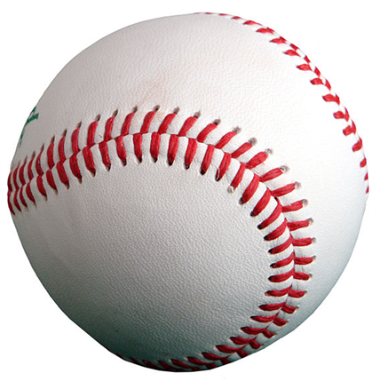 | 1 Fist | 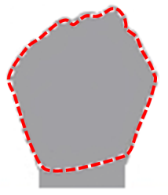
3/4 cup | Rice  Pasta  Fruit  Veggies | Tennis Ball | 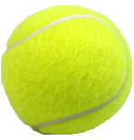 | ¾ Fist | 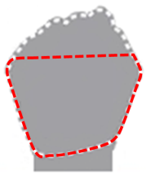
1/2 cup | Rice  Pasta  Fruit  Veggies | Light Bulb | 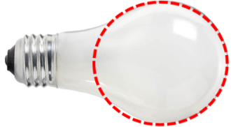 | ½ Fist | 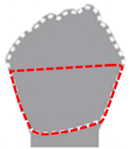
3 ounces | Meat  Fish  Poultry | Deck of Cards | 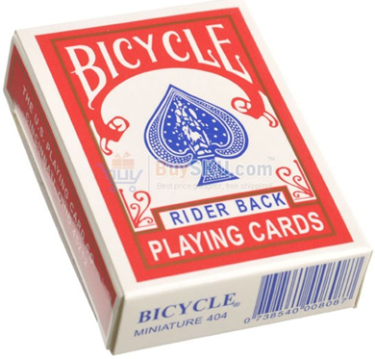 | Palm | 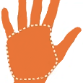
1 ounce | Nuts  Dried Fruit  (e.g. raisins) | 1 Handful | 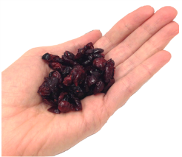 | 1 Handful | 
1 ounce | Chips  Popcorn  Pretzels | 2 Handfuls | 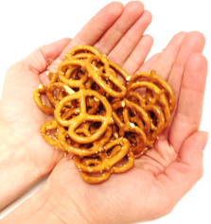 | 2 Handfuls | 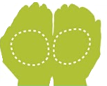
2 tablespoons | Peanut Butter  Cheese | Golf Ball | 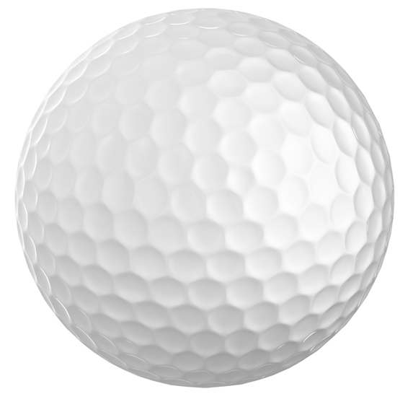 | 2 Thumbs | 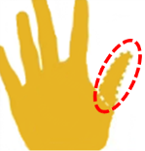
1 tablespoon | Peanut Butter  Cheese | ½ Golf Ball | 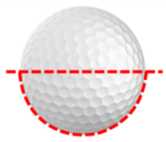 | 1 Thumb
1 teaspoon | Cooking Oil  Mayonnaise  Butter  Sugar | 4 Stacked Dimes | 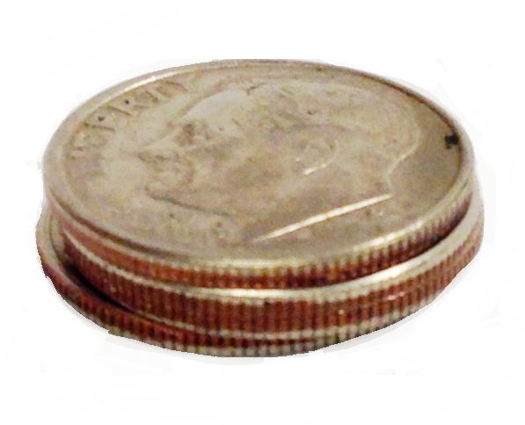 | Thumb Tip | 