*DRAFT*

### 2014

### Southwest Alaska Fisheries Data Collection Project

**CONFIDENTIAL**

### Personal Interview Worksheet for

### *Supplier and Support Businesses*



### Conducted by

### NOAA Fisheries

### Alaska Fisheries Science Center

OMB Approval No. XXXX-XXXX

Expiration Date YYYY

**Instructions**

This worksheet contains the information we will be asking you about in the interview. Please examine the worksheet and have it available during the interview. The interviewer will answer any questions and help fill out the worksheet during the interview. You do not need to fill out or return a completed worksheet prior to the interview. **your responses ARE VOLUNTARY AND will be strictly confidential and used only to estimate the economic contributions of sw alaska fisheries to southwest alaska and other u.s. regions.**

**Confidentiality**

**Per Section 402(b) of the Magnuson-Stevens Act (16 U.S.C. 1801, et seq.), all individual survey responses are confidential and will be held by only a limited number of researchers at Alaska Fisheries Science Center and contractors who are authorized to work with the data. After the data have been entered in an electronic format, only those researchers will have (password-protected) access to the data. Individual survey forms and electronic responses will be destroyed upon completion of the study. Your name, business name, and address will be used only for mailing and survey administration purposes. Only summary results of this survey will be reported to the public. NOAA Fisheries and other agencies will see only aggregate results in summary form, not individual responses.**

**YOUR RESPONSES AND THE DATA COLLECTED FROM THIS SURVEY WILL NOT BE SEEN OR USED FOR ANY OTHER PURPOSE BY NOAA FISHERIES, OTHER FEDERAL GOVERNMENT AGENCIES, THE STATE OF ALASKA OR OTHER PARTIES.**

**Paperwork Reduction Act Statement**

**Public reporting burden for this collection of information is estimated to average 45 minutes per response, including the time for reviewing instructions, gathering the data needed, and completing and reviewing the form. Please send comments regarding this burden estimate or any other suggestions for reducing this burden to Chang Seung, Alaska Fisheries Science Center (Address: 7600 Sand Point Way NE Seattle WA 98115-6349), Phone: 206-526-4250 Email:** [**chang.seung@noaa.gov**](mailto:chang.seung@noaa.gov)

**Notwithstanding any other provisions of the law, no person is required to respond to, nor shall any person be subjected to a penalty for failure to comply with, a collection of information subject to the requirements of the Paperwork Reduction Act, unless that collection of information displays a currently valid U.S. Office of Management and Budget Approval Number. This collection of information has been approved by the U.S. Office of Management and Budget (Approval Number XXXX-XXXX expiration date yyyy).**

**Content**

This worksheet is designed to ask pertinent questions needed to characterize the role of commercial fishing and related businesses in the Southwest Alaska (SW Alaska) economy and elsewhere. For purposes of this survey, the SW Alaska economy includes the following boroughs and census areas (BCAs): Aleutians West Census Area (AW), Aleutians East Borough (AE), Bristol Bay Borough (BB), Dillingham Census Area (DH), Lake and Peninsula Borough (LP), and Kodiak Island Borough (KI).

The worksheet contains three sections. Section A contains business contact information, which we have pre-filled. Section B asks for information about your customer base and where you sell products and services. Section C asks where your primary business operating expenditures are made.

Please record your responses to the following questions so as to reflect your business operations.

**Section A: Contact Information** (Please make any corrections.)

|  |  |  |
| --- | --- | --- |
|  | Information on Record | Corrections, if any |
| Supplier Name: | *New Nets Co.* |  |
|  |  |  |
| Address: |  |  |
|  | *Kodiak AK 99615* |  |
| Contact Pson: | *Perchis Erman* |  |
| Phone: | *555-555-1234* |  |
| Email: | [hello@newnets.com](mailto:hello@newnets.com) |  |
| Interview Date: | *Jan. aa, 20XX* |  |

**Section B: Customer base and products and services sold**

1. **Who are your customers?** (e.g., vessels, processors, other commercial fishing industry businesses, recreational fishing businesses, repair yards, other)
   1. Primary: ____________________________________________________
   2. Secondary: _________________________________________________
   3. Other: _____________________________________________________
2. **What products and services do you offer?**
   1. ________________________________
   2. ________________________________
   3. ________________________________
   4. ________________________________
   5. ________________________________
   6. ________________________________
3. **What proportion of those products and services are sold to buyers in the following regions?**

| **Item** | **Approximate Percentage of Item Sales to Buyers in:** | | | | | | | | | | |
| --- | --- | --- | --- | --- | --- | --- | --- | --- | --- | --- | --- |
| **Southwest Alaska BCAs\*** | | | | | | **Other Alaska** | **West Coast** | **Other US** | **Outside the US** | **Total** |
| **AW** | **AE** | **BB** | **DH** | **LP** | **KI** |
| **a.** |  |  |  |  |  |  |  |  |  |  | **100%** |
| **b.** |  |  |  |  |  |  |  |  |  |  | **100%** |
| **c.** |  |  |  |  |  |  |  |  |  |  | **100%** |
| **d.** |  |  |  |  |  |  |  |  |  |  | **100%** |
| **e.** |  |  |  |  |  |  |  |  |  |  | **100%** |
| **f.** |  |  |  |  |  |  |  |  |  |  | **100%** |
|  |  |  |  |  |  |  |  |  |  |  | **100%** |
| *Southwest Alaska BCAs: **AW**=Aleutians West Census Area, **AE**=Aleutians East Borough, **BB**=Bristol Bay Borough, **DH**=Dillingham Census Area, **LP**=Lake and Peninsula Borough, and **KI**=Kodiak Island Borough (see map). | | | | | | | | | | | |

**Section C: Regional distribution of business operating expenditures?**

1. **Where were your purchases and primary business operating expenditures made? (Including where do your employees reside?). (“I” = inventory item).**

| **Item** | **Approximate Percentage of Item Purchases Made in:** | | | | | | | | | | |
| --- | --- | --- | --- | --- | --- | --- | --- | --- | --- | --- | --- |
| **Southwest Alaska BCAs\*** | | | | | | **Other Alaska** | **West Coast** | **Other US** | **Outside the US** | **Total** |
| **AW** | **AE** | **BB** | **DH** | **LP** | **KI** |
| **Labor** |  |  |  |  |  |  |  |  |  |  | **100%** |
| **Utilities** |  |  |  |  |  |  |  |  |  |  | **100%** |
| **Accounting** |  |  |  |  |  |  |  |  |  |  | **100%** |
| **Other** |  |  |  |  |  |  |  |  |  |  | **100%** |
| **I1:** |  |  |  |  |  |  |  |  |  |  | **100%** |
| **I2:** |  |  |  |  |  |  |  |  |  |  | **100%** |
| **I3:** |  |  |  |  |  |  |  |  |  |  | **100%** |
| **I4:** |  |  |  |  |  |  |  |  |  |  | **100%** |
| *Southwest Alaska BCAs: **AW**=Aleutians West Census Area, **AE**=Aleutians East Borough, **BB**=Bristol Bay Borough, **DH**=Dillingham Census Area, **LP**=Lake and Peninsula Borough, and **KI**=Kodiak Island Borough (see map). | | | | | | | | | | | |

**Map of Southwest Alaska BCAs and Associated Communities**

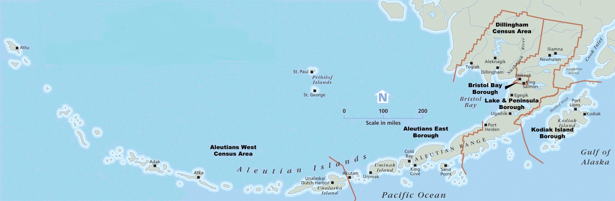

|  |  |
| --- | --- |
| **SW Alaska Boroughs & Census Areas** | **Associated Communities** |
| Aleutian West Census Area (**AW**) | Atak, Adak, Nikolski, St. Paul, St. George, Unalaska (Dutch Harbor) |
| Aleutian East Borough (**AE**) | Akutan, Belkofski Village,  Cold Bay, False Pass, King Cove, Nelson Lagoon, Pauloff Harbor, Sand Point, Unga |
| Bristol Bay Borough (**BB**) | King Salmon, Naknek, South Naknek |
| Dillingham Census Area (**DH**) | Aleknagik, Clarks Point, Dillingham, Ekwok, Ekuk, Koliganek, Manokotak, New Stuyahok, Portage Creek, Twin Hills, Togiak |
| Lake and Peninsula Borough (**LP**) | Chignik Lake, Chignik Lagoon, Chignik, Egegik, Ivanoff Bay, Iliamna, Igiugig, Kokhanok, Levelock, Nondalton, Newhalen, Port Heiden, Port Alsworth, Pilot Point, Perrysville, Pedro Bay, Ugashik |
| Kodiak Island Borough (**KI**) | Akhiok, Afognak, Kodiak, Karluk, Larsen Bay, Ouzinkie, Old Harbor, Port Lions |

**Comments:**

Customer Base Comments

Products and Services Sold Comments

Regional Distribution of Expenditures Comments

Comments on Interview Questions and Other Comments

**THANK YOU FOR YOUR PARTICIPATION!**