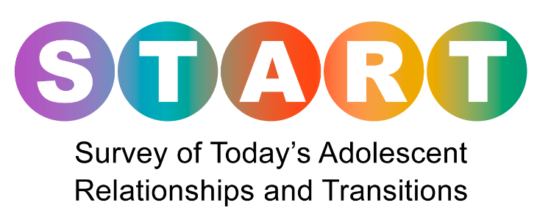

**Welcome to the Survey of Today’s Adolescent Relationships and Transitions**

NORC at the University of Chicago is conducting a survey sponsored by the Centers for Disease Control and Prevention. This survey is to learn about knowledge, attitudes, and behaviors related to HIV prevention. You taking the survey will help us to identify aspects of sexual identity and behavior, and HIV prevention preferences. It will also help to improve services and programs aimed at decreasing HIV risk.

The interview will take about 20 to 30 minutes to complete. The survey will include general demographics and questions related to sexual health.

Any information you provide will be maintained in a secure manner. No one will know how you answered the questions. Only project staff will have access to the study data. The data we collect from you will be combined with data from other participants.

Taking the survey is your choice. You may skip questions you do not want to answer and you can stop the survey at any time. Eligible participants will receive a $10 electronic gift card   
at the end of the survey.

If you have any questions about the survey, you can call the NORC IRB Administrator toll-free at:

866-309-0542.

**Your opinions are very important to us,**

**and we appreciate your help**.

*<PROGRAMMER: Please provide a “Start Survey” button.>*