AMSM ADS

AD EXAMPLE #2: Black Couple 2 (Stocksy)

Survey opportunity! We are interested in your thoughts about sexual identity, relationships, and HIV. Eligible participants will receive a small gift. Click the link to participate: http://norc.org/survey

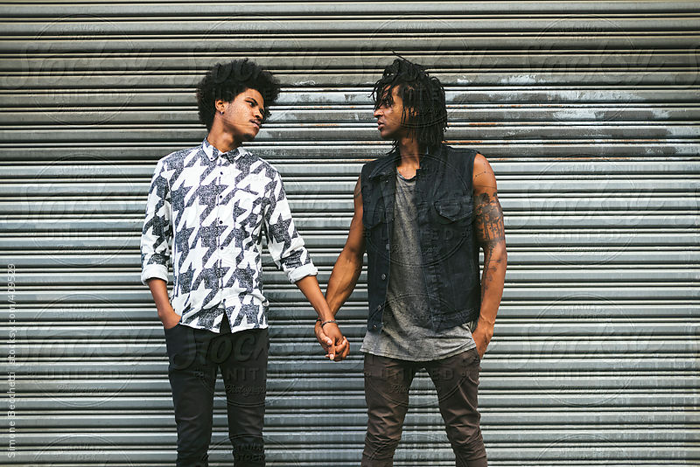
Who is eligible to participate?

Males age 13-18 attracted to other males
&
Transgender individuals age 13-24

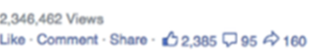

AD EXAMPLE #3: Black Couple 3 (Stocksy)

Survey opportunity! We are interested in your thoughts about sexual identity, relationships, and HIV. Eligible participants will receive a small gift. Click the link to participate: http://norc.org/survey

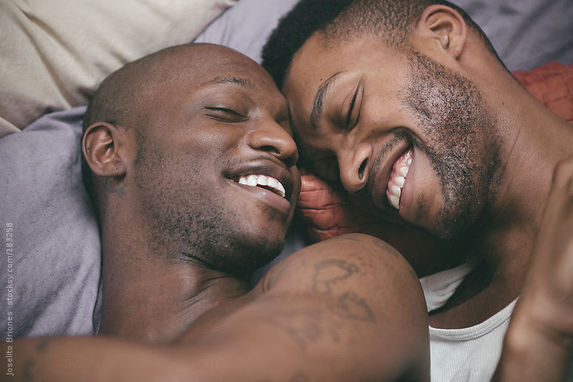
Who is eligible to participate?

Males 13-18 who are attracted to other males
&
Transgender individuals 13-24

AD EXAMPLE #4: White Couple (Stocksy)
Survey opportunity! We are interested in your thoughts about sexual identity, relationships, and HIV. Eligible participants will receive a small gift. Click the link to participate: http://norc.org/survey
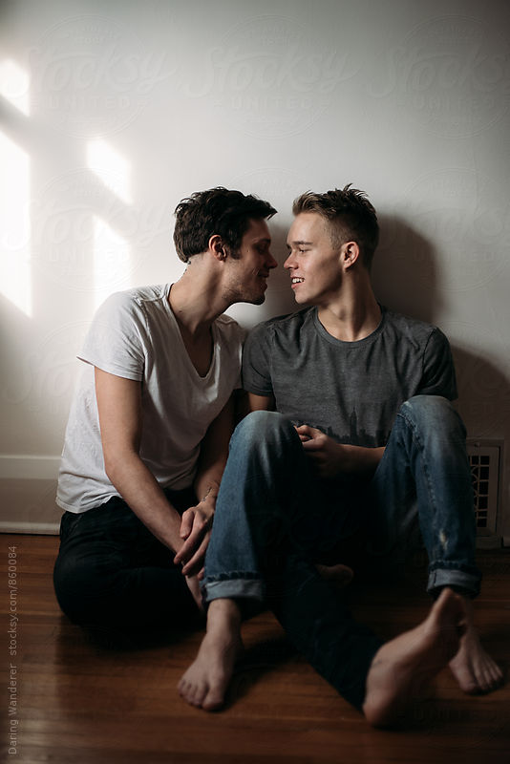
Who is eligible to participate?

Males 13-18 who are attracted to other males
&
Transgender individuals 13-24

AD EXAMPLE #5: “Ugh, Millennials” (…are the future!)

Survey opportunity! We are interested in your thoughts about sexual identity, relationships, and HIV. Eligible participants will receive a small gift. Click the link to participate: http://norc.org/survey


Who is eligible to participate?
Males 13-18 who are attracted to other males &
Transgender individuals 13-24

AD EXAMPLE #6: Interracial Couple 1 (Stocksy)

Survey opportunity! We are interested in your thoughts about sexual identity, relationships, and HIV. Eligible participants will receive a small gift. Click the link to participate: http://norc.org/survey


Who is eligible to participate?
Males 13-18 who are attracted to other males &
Transgender individuals 13-24

AD EXAMPLE #7: Colliding Structures (Genderqueer) (Flickr)

Survey opportunity! We are interested in your thoughts about sexual identity, relationships, and HIV. Eligible participants will receive a small gift. Click the link to participate: http://norc.org/survey


Who is eligible to participate?

Males 13-18 who are attracted to other males
&
Transgender individuals 13-24

AD EXAMPLE #8: Highschool is hard (Genderqueer) (Stocksy)

Survey opportunity! We are interested in your thoughts about sexual identity, relationships, and HIV. Eligible participants will receive a small gift. Click the link to participate: http://norc.org/survey


Who is eligible to participate?

Males 13-18 who are attracted to other males
&
Transgender individuals 13-24

AD EXAMPLE #9: Interracial Couple 2

Survey opportunity! We are interested in your thoughts about sexual identity, relationships, and HIV. Eligible participants will receive a small gift. Click the link to participate: http://norc.org/survey


Who is eligible to participate?
Males 13-18 who are attracted to other males &
Transgender individuals 13-24

AD EXAMPLE #10: Pleasant Distractions

Survey opportunity! We are interested in your thoughts about sexual identity, relationships, and HIV. Eligible participants will receive a small gift. Click the link to participate: http://norc.org/survey

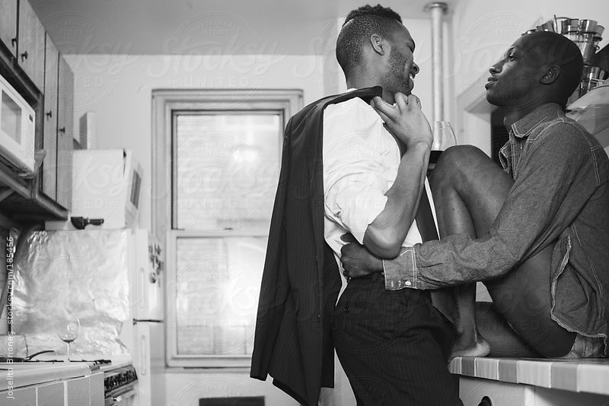
Who is eligible to participate?

Males 13-18 who are attracted to other males
&
Transgender individuals 13-24

AD EXAMPLE #11: Asian Couple

Survey opportunity! We are interested in your thoughts about sexual identity, relationships, and HIV. Eligible participants will receive a small gift. Click the link to participate: http://norc.org/survey

Who is eligible to participate?
Males 13-18 who are attracted to other males
&
Transgender individuals 13-24



“Like” ads
AD EXAMPLE 12: South Side (Chicago)

Survey opportunity! We are interested in your thoughts about sexual identity, relationships, and HIV. Eligible participants will receive a small gift. Click the link to participate: http://norc.org/survey
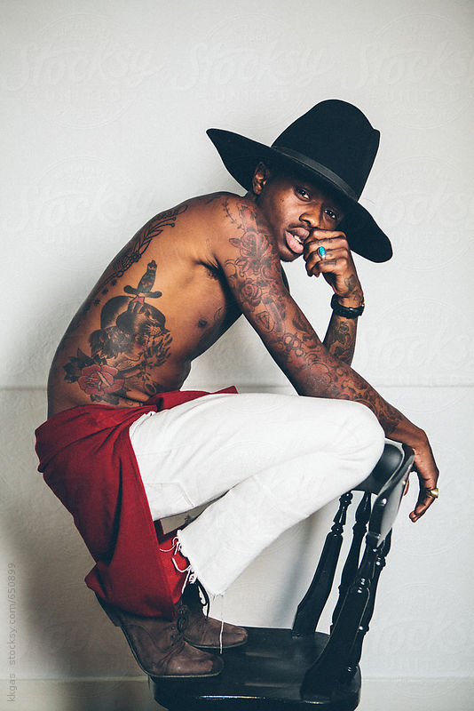
Who is eligible to participate?

Males 13-18 who are attracted to other males
&
Transgender individuals 13-24

AD EXAMPLE #13: LGBT Dog 1

Survey opportunity! We are interested in your thoughts about sexual identity, relationships, and HIV. Eligible participants will receive a small gift. Click the link to participate: http://norc.org/survey


Who is eligible to participate?

Males 13-18 who are attracted to other males
&
Transgender individuals
13-24

AD EXAMPLE 14: Domestic4Lyfe

Important survey opportunity! We are interested in your thoughts about sexual identity, relationships, and HIV. Eligible participants will receive a small token of appreciation. Click the link to participate: http://norc.org/survey


Who is eligible to participate?

Males age 13-18 attracted to other males
&
Transgender individuals age 13-24

AD EXAMPLE #15: Biomedicalization of the Gay Male Community

Survey opportunity! We are interested in your thoughts about sexual identity, relationships, and HIV. Eligible participants will receive a small gift. Click the link to participate: http://norc.org/survey

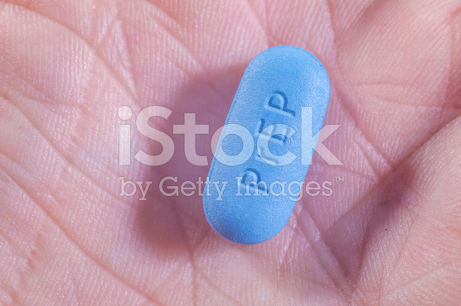
Who is eligible to participate?

Males 13-18 who are attracted to other males
&
Transgender individuals 13-24

AD EXAMPLE #16: Fondly Remembering Highschool, 10 years later

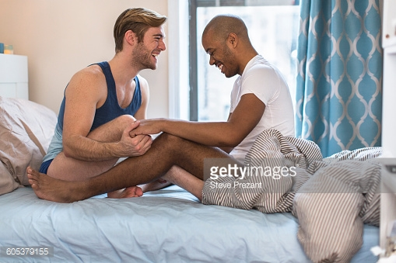
Survey opportunity! We are interested in your thoughts about sexual identity, relationships, and HIV. Eligible participants will receive a small gift. Click the link to participate: http://norc.org/survey

AD EXAMPLE #17: Holding Hands

Survey opportunity! We are interested in your thoughts about sexual identity, relationships, and HIV. Eligible participants will receive a small gift. Click the link to participate: http://norc.org/survey
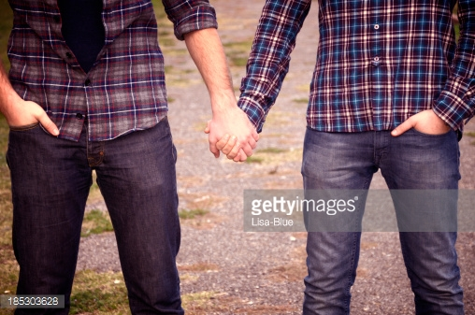

AD EXAMPLE #18: Genuine, Carefree

Survey opportunity! We are interested in your thoughts about sexual identity, relationships, and HIV. Eligible participants will receive a small gift. Click the link to participate: http://norc.org/survey
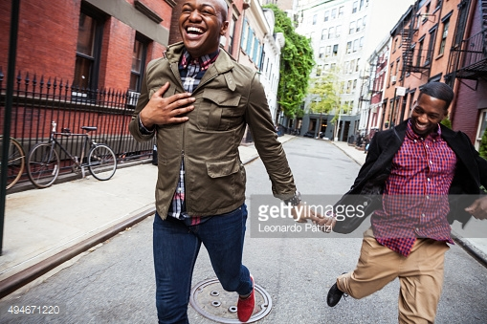
Who is eligible to participate?
Men ages 13 to 18 who are attracted to men

AD EXAMPLE #19: Morality for Whom?

Survey opportunity! We are interested in your thoughts about sexual identity, relationships, and HIV. Eligible participants will receive a small gift. Click the link to participate: http://norc.org/survey
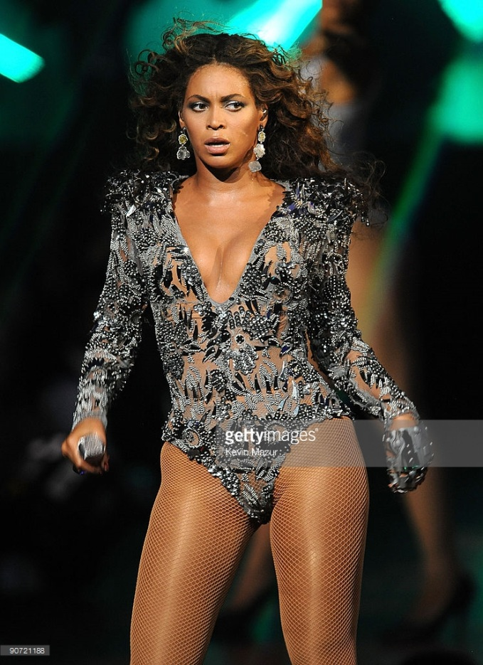
That look you give when…
You find out 1 in 2 black gay men will be diagnosed with HIV in their lifetime

Survey opportunity!
We are interested in your thoughts about sexual identity, relationships, and HIV.
Eligible participants will receive a small gift.
Click the link to participate: http://norc.org/survey

Survey opportunity!

Earn a small gift by giving us your thoughts on relationships, sexual identity, and health.

Click the link to participate: http://norc.org/survey


Survey opportunity! We are interested in your thoughts about sexual identity, relationships, and health. Eligible participants will receive a small gift. Click the link to participate: http://norc.org/survey

Who is eligible to participate?

Males 13-18 who are attracted to other males
&
Transgender individuals
13-24

TRANS/Genderqueer ADS
“LOVE” ads
AD EXAMPLE 20: Black Transfemale 2

Survey opportunity! We are interested in your thoughts about sexual identity, relationships, and HIV. Eligible participants will receive a small gift. Click the link to participate: http://norc.org/survey
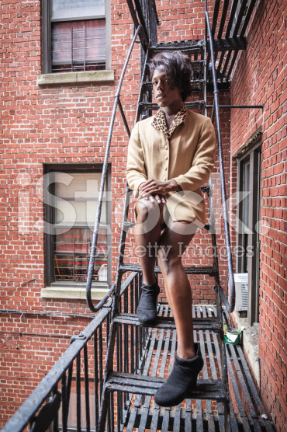
Who is eligible to participate?

Males age 13-18 attracted to other males
&
Transgender individuals age 13-24

AD EXAMPLE #21: Asian Transfemale 1 (Stocksy)
Survey opportunity! We are interested in your thoughts about sexual identity, relationships, and HIV. Eligible participants will receive a small gift. Click the link to participate: http://norc.org/survey

Who is eligible to participate?

Males 13-18 who are attracted to other males
&
Transgender individuals
13-24

“Like” ads
AD EXAMPLE #22: White Transfemale 2

Survey opportunity! We are interested in your thoughts about sexual identity, relationships, and HIV. Eligible participants will receive a small gift. Click the link to participate: http://norc.org/survey


Who is eligible to participate?

Males age 13-18 attracted to other males
&
Transgender individuals age 13-24

AD EXAMPLE #23: Asian Transfemale 2

Survey opportunity! We are interested in your thoughts about sexual identity, relationships, and HIV. Eligible participants will receive a small gift. Click the link to participate: http://norc.org/survey


Who is eligible to participate?

Males age 13-18 attracted to other males
&
Transgender individuals age 13-24

AD EXAMPLE #24: Summer days

Survey opportunity! We are interested in your thoughts about sexual identity, relationships, and HIV. Eligible participants will receive a small gift. Click the link to participate: http://norc.org/survey
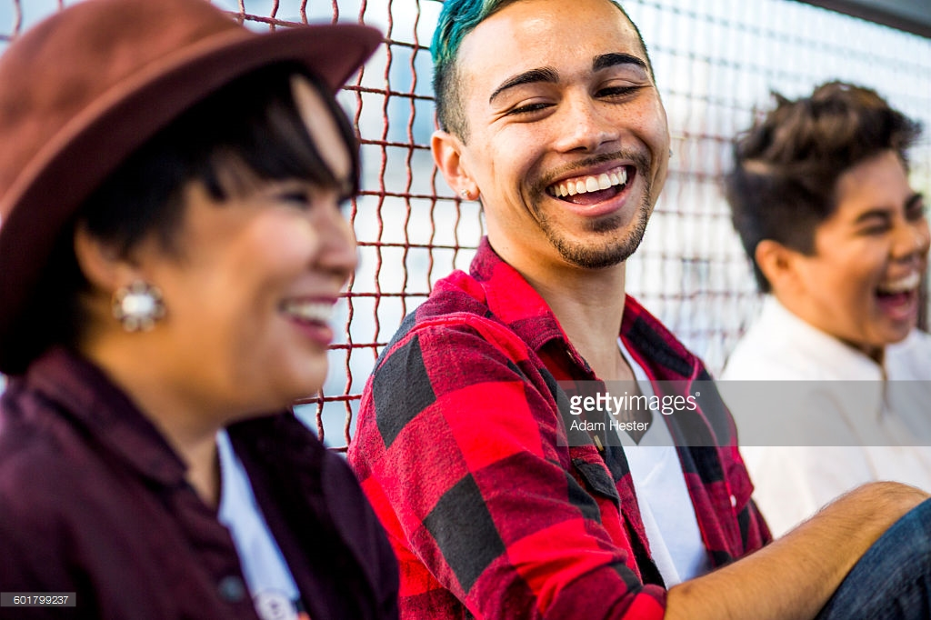
Who is eligible to participate?
Transgender youth ages 13-24
&
Men ages 13 to 18 who are attracted to men

AD EXAMPLE #25: Here to stay

Survey opportunity! We are interested in your thoughts about sexual identity, relationships, and HIV. Eligible participants will receive a small gift. Click the link to participate: http://norc.org/survey
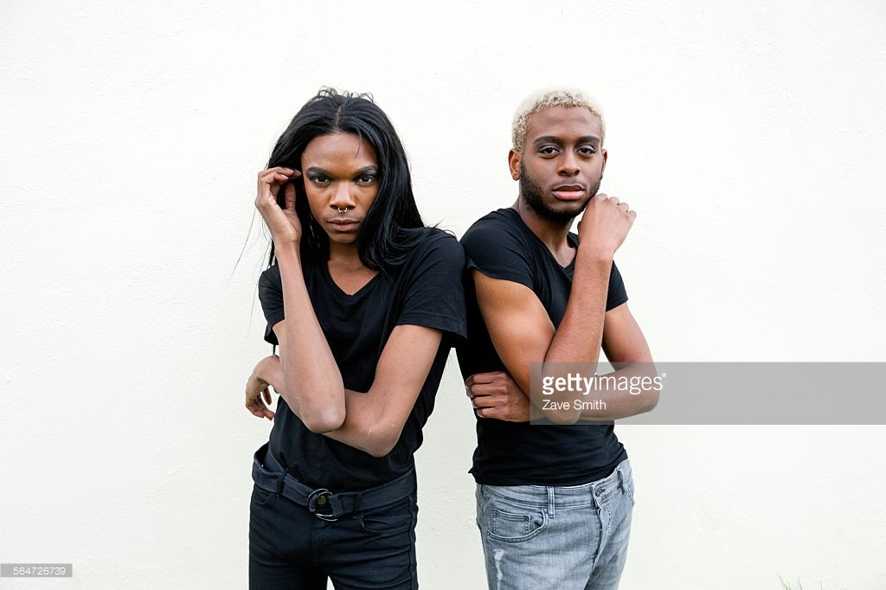

AD EXAMPLE #27: transgender-symbol

Survey opportunity! We are interested in your thoughts about sexual identity, relationships, and HIV. Eligible participants will receive a small gift. Click the link to participate: http://norc.org/survey



AD EXAMPLE #28: Rainbow Wristband

Important survey opportunity! We are interested in your thoughts about sexual identity, relationships, and HIV. Eligible participants will receive a small token of appreciation. Click the link to participate: http://norc.org/survey
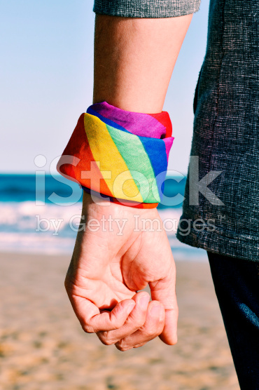
Who is eligible to participate?

Males 13-18 who are attracted to other males
&
Transgender individuals
13-24

GENERAL POP ADS
“Like” ads
AD EXAMPLE #29: Teens, Cash, Survey 1

Survey opportunity! We are interested in your thoughts about sexual identity, relationships, and HIV. Eligible participants will receive a small gift. Click the link to participate: http://norc.org/survey


AD EXAMPLE #30: Teens, Cash, Survey 2

Survey opportunity! We are interested in your thoughts about sexual identity, relationships, and HIV. Eligible participants will receive a small gift. Click the link to participate: http://norc.org/survey


AD EXAMPLE #31: Came in like a Wrecking Ball…

Survey opportunity! We are interested in your thoughts about sexual identity, relationships, and HIV. Eligible participants will receive a small gift. Click the link to participate: http://norc.org/survey
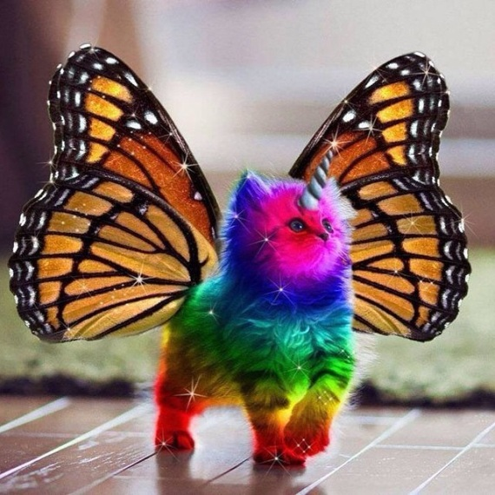
RIGHT MEOW
HIV PREVENTION NEEDS OUR GENERATION’S ATTENTION

AD EXAMPLE #32: All Hands on Deck, Superheros

Survey opportunity! We are interested in your thoughts about sexual identity, relationships, and HIV. Eligible participants will receive a small gift. Click the link to participate: http://norc.org/survey

We need superheroes like you to help inform the fight for an HIV-free generation!

Get a gift! We are interested in your thoughts about relationships and health. Click the link to participate: http://norc.org/survey.
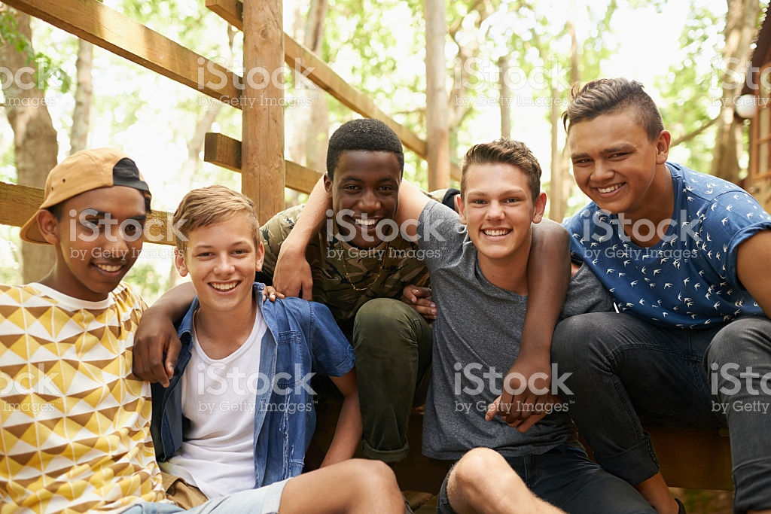

Want a gift? Give us your thoughts about relationships, sexual identity, and health. Click the link to participate: http://norc.org/survey.
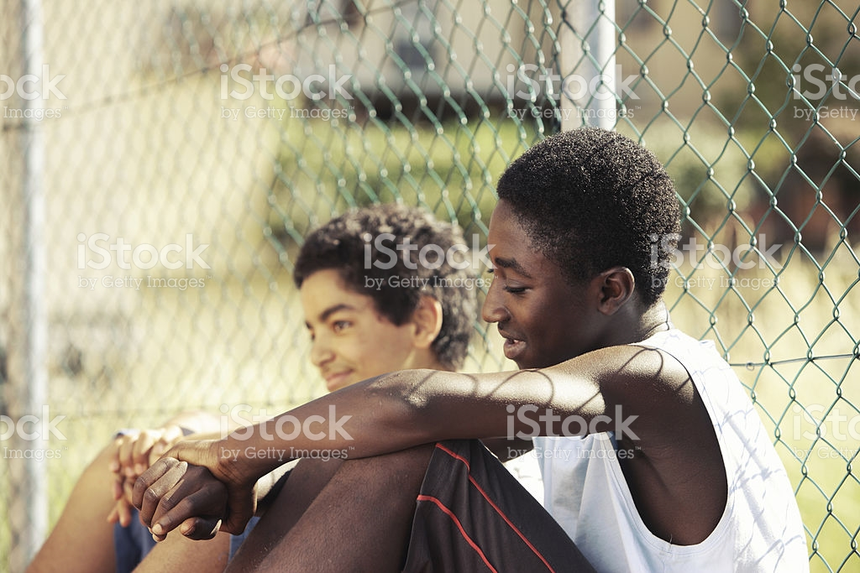

Earn a gift! We are interested in your thoughts about relationships and health. Click the link to participate: http://norc.org/survey.


Get your gift today! We are interested in your thoughts about relationships and health. Eligible participants receive a small gift. Click the link to participate: http://norc.org/survey.
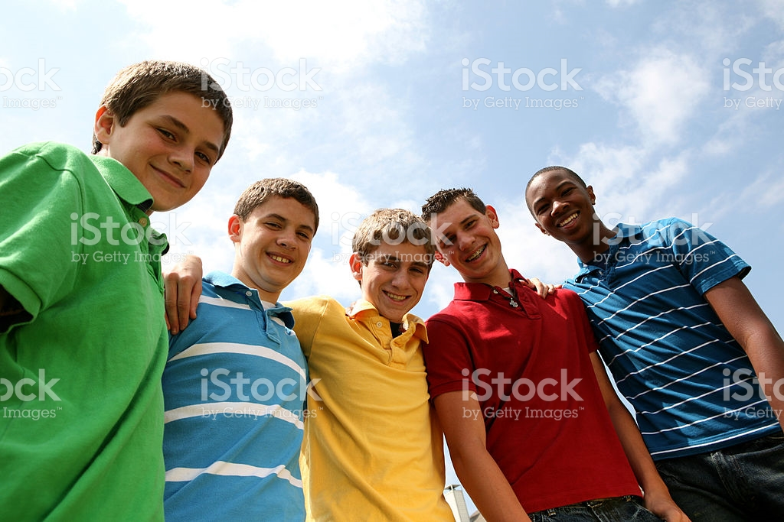

Important survey opportunity! We are interested in your thoughts about sexual identity, relationships, and HIV. Eligible participants will receive a small token of appreciation. Click the link to participate: http://norc.org/survey
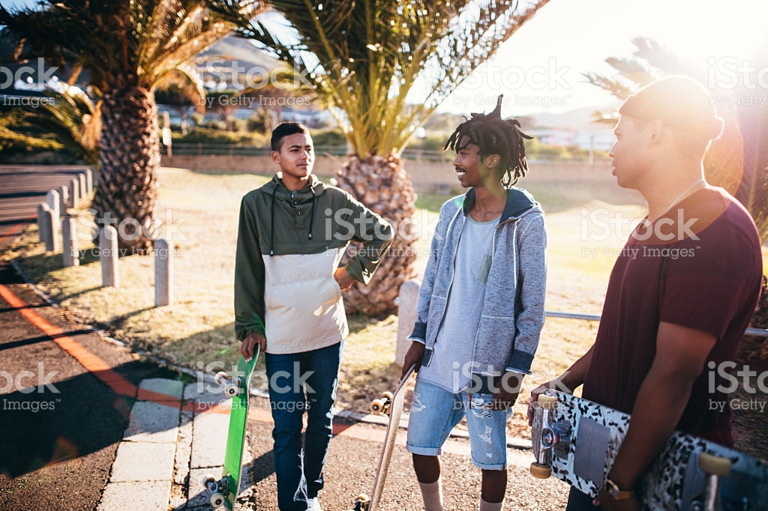

We are interested in your thoughts about sexual identity, relationships, and HIV. Eligible participants will receive a small gift. Click the link to participate: http://norc.org/survey


Survey opportunity!

Survey opportunity! We are interested in your thoughts about sexual identity, relationships, and HIV. Eligible participants will receive a small gift. Click the link to participate: http://norc.org/survey
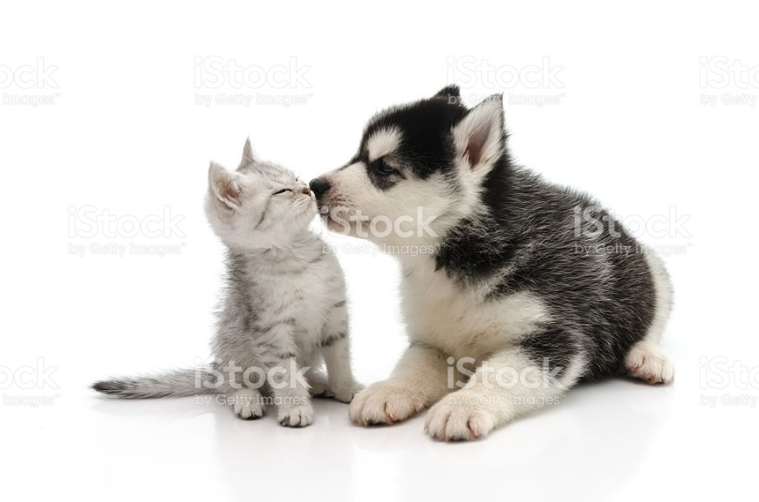

Survey opportunity! We are interested in your thoughts about sexual identity, relationships, and HIV. Eligible participants will receive a small gift. Click the link to participate: http://norc.org/survey
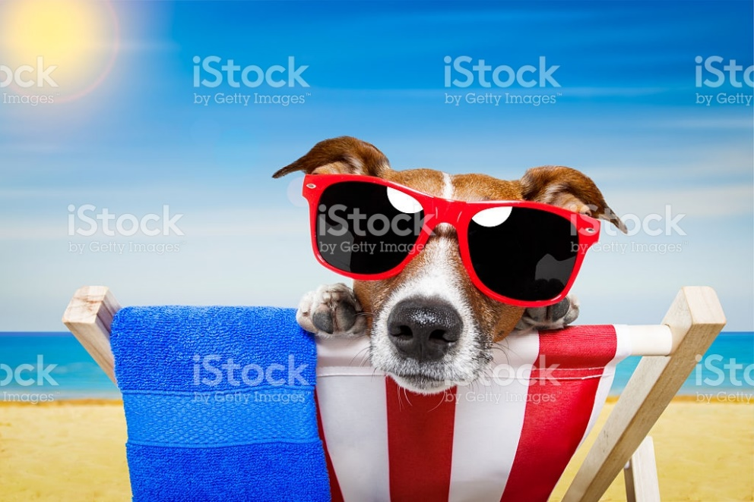

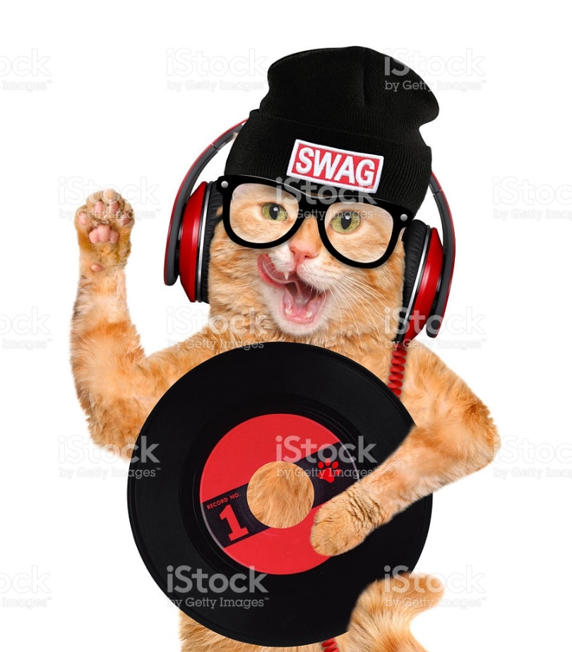

We know you got swag! Earn a gift by giving us your thoughts on relationships, sexual identity, and health.
Click the link to participate: http://norc.org/survey.

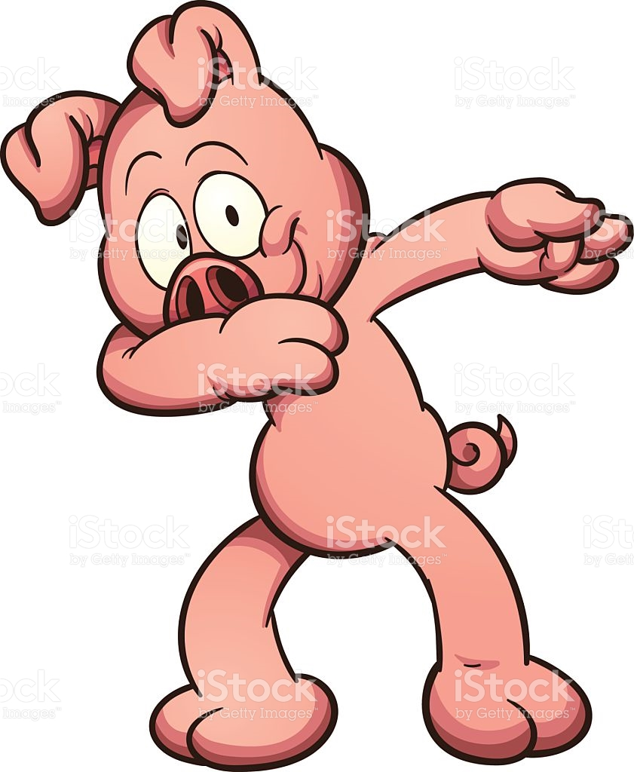

Mo’ Money Mo’ Stuff. Earn a gift by giving us your thoughts on relationships, sexual identity, and health.

Click the link to participate: http://norc.org/survey.

Got swag? Get a gift by giving us your thoughts about relationships, sexual identity, and health.

Click the link to participate: http://norc.org/survey.

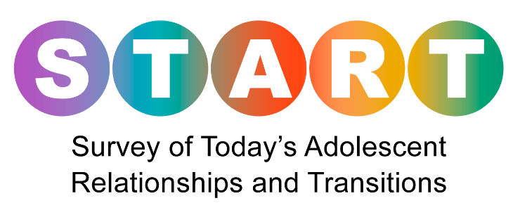
Get your gift today! We are interested in your thoughts about relationships and health. Eligible participants receive a small gift. Click the link to participate: http://norc.org/survey.

