The University of New Mexico Health Sciences Center Mother’s Consent/Assent to Participate in Research

The Navajo Birth Cohort Study
06/20/2012
Introduction
Based on community input, and input from Navajo Nation officials and researchers conducting studies on uranium health impacts on the Navajo Nation, Centers for Disease Control and Prevention/Agency for Toxic Substances and Disease Registry (CDC/ATSDR) determined that the greatest need was research on the effects of uranium exposures on reproductive and developmental outcomes on the Navajo Nation. In September 2010, CDC/ATSDR selected the University of New Mexico (UNM) to develop, coordinate and conduct, in partnership with the Navajo Area Indian Health Service (NAIHS) and Navajo Nation Division of Health (NNDOH), and Navajo Nation Environmental Protection Agency (NNEPA), a prospective birth cohort study ― called the Navajo Birth Cohort Study (NBCS) ― to investigate the effects of environmental exposures to uranium and other toxicants on
pregnancies and child development on the Navajo Nation over a three-year period. Direct funding has been provided to UNM, NAIHS and the NNDOH. NAIHS in turn will fund the key medical facilities identified as necessary to answer the communities’ questions, based on the number of deliveries and the potential for exposure to uranium wastes: Northern Navajo Medical Center, Chinle Comprehensive Health Care Facility, Gallup Indian Medical Center, Tuba City Regional Health Care Corporation and Tséhootsooí Medical Center. Kayenta Health Center is also funded to participate in the pre- and post-natal care phases of the study.
The principal investigator for the Navajo Birth Cohort Study is Johnnye Lewis, Ph.D., D.A.B.T., who is the director of the Community Environmental Health Program (CEHP) at the UNM Health Sciences Center (UNMHSC) in Albuquerque. Dr. Lewis is assisted by David Begay, Ph.D., co-investigator, who is also with UNM-CEHP; coinvestigator Adrienne Ettinger, ScD., MPH, from Yale University; and Christopher Shuey, MPH, with Southwest Research and Information Center (SRIC). You (or your child) are eligible to participate in this study because you are (or your child is) pregnant and will be delivering at Northern Navajo Medical Center, Chinle Comprehensive Health Care Facility, Gallup Indian Medical Center, Tuba City Regional Health-Care Corporation, or Tséhootsooí Medical Center, and are willing to have your baby enrolled in the study during the baby’s first year. An estimated total of 1600 mothers and fathers, and their children living on the Navajo Nation will take part in this study.
This form will explain the research study, and will also explain the possible risks as well as the possible benefits to you. You will be asked to consent for both yourself and your child if you are 18 years of age or older. If you are under 18, you will be asked to assent to your interest in participating in the study, to consent for the participation of your child, and we will need the consent of your parent or guardian to include you in the study.
HRPO #: 11-310 Page 1 of 10 Version: 06/20/2012
What will happen if I decide to participate?
If you agree to participate, the following things will happen:
While you are pregnant we will

    - Interview you in a culturally appropriate and sensitive manner to identify any contact you might have had with
environmental chemicals through work or other activities, your health and reproductive history, demographic
information (age, income, education, and where you have lived), how you use the land and water around you, your
diet, medicines you use, and your smoking and drug-use history.

Determine exposure risks in and around your home by
    - Asking questions in the survey about your home. We will use existing information when it is available, collect air and dust samples and perform radiation scans in and around your home, as well as look around for anything in the home that might pose a health concern.
    - If you move while you are in the study, we will ask the same questions about your new home.

Conduct a health and exposure assessment:
    - We will collect blood and urine to look for uranium and other contaminants that you may have come in contact with
in your environment, as well as other contaminants related to oil and gas production, household chemicals, burning of
coal or wood in your home. (Some of the blood and urine may be stored for later testing as additional funding
becomes available.);
    - We will collect about 1 tablespoon of blood and 3 tablespoons of urine from you at enrollment and/or at delivery.
(Note: all blood will be drawn by licensed health care professionals, whether in the home or the clinic.);
    - We will encourage you to have regular prenatal examinations with your healthcare provider;
    - We will collect information from your medical records for this pregnancy and delivery, any previous pregnancies,
and your general health history to look at things that might affect birth outcomes;
    - We will place a note in your medical record to identify you as a research participant for the duration of this study;
    - We will also look for changes or damage to your health that may be related to the contaminants, such as uranium;
        - We will ask if you have discussed your participation in the study with the baby’s father, and if he is willing to
        - participate in the study. You will be asked if you are willing to provide the name of the father of your baby so that
        - we may contact him and, with his consent, interview him to determine similar exposure and health history.
    - Your participation does not require identification or participation of the baby’s father.
    - We will conduct follow-up visits and work with your healthcare provider to learn about your pregnancy through your
medical record.

When the baby is born:
        - Approximately 1 tablespoon of cord blood will be collected from the baby (cord blood is collected after birth from
        - the end of the cord still attached to the placenta);
    - 1 tablespoon of blood will be collected from you;
    - Approximately 2 tablespoons of urine will be collected from the baby in the nursery;
    - Approximately 1 tablespoon of urine will be collected from you
    - With your permission, we will collect about 2 quarter-size amounts of meconium (baby’s first stool), if it is available.

In some of the participants, we will test meconium for signs of contact during the pregnancy with radioactive materials and/or alcohol. You may refuse the meconium tests and still remain in the study.
□  Yes, I consent for you to analyze baby’s first stool ______(Initial here if checked)
□ No, I do not consent for you to analyze baby’s first stool _____(Initial here if checked)

At 2 months to one year of age:

• We will do four home visits to conduct shorter surveys in your home to study your health and general feelings, your home environment and baby-feeding activities, and see how you and your baby act together when the baby is 2 months, 6 months, 9 months and 12 months old. Your home environment may need to be assessed again if you have moved since the first enrollment survey. Each visit will take about 1 hour.

• During the home visits we will study the baby’s development with short, in-home observations done by you (or a caregiver) and one of our staff. We will assess your baby’s growth and progress on gross and fine motor skills, communication, personal social, and problem solving skills. These observations will help to find any delays in development at the earliest time when additional care and services are most helpful. Should any possible problems be identified, referrals to Navajo Nation’s Growing in Beauty Program will be made to ensure your family is provided with all available support and services.

• At one year after birth, an additional questionnaire, the Mullen Scales of Early Learning (MSEL), will be administered by a trained professional in a location out of the home but close by.

• We will collect about 1 tablespoon of urine and less than 1 teaspoon of blood during the baby’s 2-6 month and one-year visits to clinics to study possible effects of exposures to the same environmental contaminants discussed earlier.

• We will inform you (or the caregiver at your request), in writing, of the results of the developmental observations. The results will also be provided to the baby’s primary care physician.

• We will use samples of blood and urine from you and your baby to look for evidence of environmental exposures as well as biological changes in the immune system, circulation system, kidney and DNA repair mechanisms that may be related to exposures. To ensure compliance with the Navajo Nation Human Research Review Board moratorium on genetic analyses, no genetic analyses will be done in this research.
Your records at the healthcare facility, as well as any records through Growing in Beauty, will note your participation in the study and your willingness to be contacted for continuation of this study and for any future follow-up research. If you choose not to be contacted for continuation of this study and future studies, it will not affect your participation in this study.
Please initial here if you ARE willing to be contacted for continuation of this study or future studies.
Please initial here if you are NOT willing to be contacted for continuation of this study or future studies. ____________
If you turn 18 while in the study, we will ask you to sign another consent form to remain in the study.
How long will I be in this study?
Participation in this study is estimated to take about 10 to 20 hours over a 2-year period beyond routine pre- and post-natal and delivery visits.
What are the risks or side effects of being in this study?
You may experience stress and emotional distress when learning about environmental exposures and how they may affect health. There may be a possible loss of privacy and some inconvenience with participating in a research study
All precautions will be taken when your blood is drawn. Blood samples will be drawn using the same procedures used in standard hospital testing procedures. The most common risks of having a blood sample taken are temporary discomfort or pain from the needle stick site, occasional bruising, sweating, light-headiness, and in rare cases, faintness or infection.
There are no risks or discomfort associated with giving a urine sample.
For more information about risks and side effects, please contact Beverly Becenti-Pigman, chairperson of the Navajo Nation Human Research Review Board, at 928-871-6650, and the Principal Investigator, Dr. Johnnye Lewis, at 877-545-6775.
What are the benefits to being in this study?
You may benefit directly by the information gained from the environmental assessments conducted in and around your home, and from the results of tests performed on the blood and urine samples you and your baby will provide.
With respect to environmental monitoring, we will provide you with our results and note any concerns about known risks to health. We will provide you with information on reducing risks. We will also provide you with referrals to any programs or interventions that may address environmental risks. With your permission, we will provide your results to our partners at Navajo EPA to aid in their understanding of environmental concerns on the Navajo Nation and in their planning to address those concerns. Also, with your permission, Navajo EPA will share with the NBCS research team environmental assessment results they may have for your home. Please indicate your permission below:
□ Yes, I consent to allowing the Navajo Birth Cohort Study and the Navajo Nation Environmental Protection Agency to share results of the environmental assessments they have conducted or will conduct at my home.
□ No, I do not consent to allowing the Navajo Birth Cohort Study and the Navajo Nation Environmental Protection Agency to share results of the environmental assessments they have conducted or will conduct at my home.

Tests of blood and urine samples collected from you and your baby will give us two sets of results. One set comes from the usual examinations that take place in a doctor’s office, clinic or hospital during pregnancy, at delivery and after the birth of your baby. These results will automatically be reported to your clinicians; your results will go into your medical record and your baby’s results will go into her or his medical record.
The second set of results (1) measures you and your baby’s exposures to heavy metals and other contaminants (called “biomonitoring”) and (2) indicates any biological changes related to exposure (called “biomarkers”). You will be informed of any biomonitoring or biomarker levels that indicate health risks to you or your child, if that information is known. While there may not be particular interventions suggested by the biomonitoring results, the information may help you in identifying exposure sources and reducing them to prevent potential health effects. The biomarker results are experimental and their interpretation is the focus of this research. The results of the study should help us interpret how biomarker results are related to exposure and can serve as early indicators of diseases.
With your permission, the biomonitoring and biomarker results will be placed in your medical record, and that of your baby, so they are available to be discussed with your doctor in the context of your health care. Please indicate your permission below:
□ Yes, include my biomonitoring and biomarker results in my medical record, and include those results for my baby is his or her medical record.
□ No, do not include my biomonitoring and biomarker results in my medical record, and do not include those results for my baby is his or her medical record.

Finally, during the infant’s development, should any indications of developmental delays be observed, you will be referred to early intervention programs, such as Navajo Nation’s Growing in Beauty, to ensure you are linked to available services. Results will also be provided to your pediatrician. Early recognition and intervention has been shown to improve health and maximize development potential. Summary results that do not identify you or any other study participant will be provided to the Navajo Nation and Navajo Area Indian Health Service to inform policy and treatment, reduce identified risks, and improve birth and developmental health across the Navajo Nation. Please indicate your permission below:
□  Yes, include results of the developmental assessments in my baby’s medical record.
□ No, do not include results of the development assessments in my baby’s medical record.

What other choices do I have if I do not want to be in this study?
You do not have to participate in this study to receive pre- and post-natal care. Participation is voluntary and can be ended at any point.
How will my information be kept confidential?
We will take measures to protect the security of all your personal information, but we cannot guarantee confidentiality of all study data.
HRPO #: 11-310 Page 5 of 10 Version: 06/20/2012
Information and /or specimens collected as part of the study will be labeled with an assigned study number. Collected information (without your name) will be entered into a secure computer database maintained at CDC. The list that links your name to the study number, as well as any paper copies of data will be stored in a locked file in the office of Dr. Johnnye Lewis (Principal Investigator) at the University of New Mexico (UNM). Dr. Lewis and her research associates will maintain access to participants’ study information by study number, with Dr. Lewis having the only access to information linking participant’s names to their study numbers. At certain times during the study, other members of the research team will need identified information either to clarify discrepancies in the data or to schedule appointments. This information will be provided in a limited manner sufficient to accomplish the task, and destroyed once the task is complete. Data will be stored for 3 years following conclusion of the study, and then de-identified data (without names) will be turned over to the Navajo Nation pursuant to the Navajo Nation Human Research Code (1996). A copy of this consent form will be kept in your medical record.
All biological specimens will be stored in secure, temperature regulated facilities at CDC until analysis. Samples will be kept for 3 years beyond the end of the study to allow for any reanalysis to clarify results. Any remaining biological samples after the analyses will be destroyed by standard procedures. If you would like, the remaining samples can be returned to you as choose below.
□ Please return any remaining portion of my specimen once the project is completed.
□ Do not return any remaining portion of my specimen once the project is completed.
What are the costs of taking part in this study?
There will be no costs to you associated with your participation in this study. All clinical visits will be performed under your existing healthcare coverage.
What will happen if I am injured or become sick because I took part in this study?
Taking part in this research is your choice. You may refuse to take part. You can withdraw from the research study at any time, for any reason, even after you have started the study. The principal investigator may take you out of the project at any time without regard to your consent, if you do not follow the project schedule, if you have a study-related injury or if doctors involved in the study feel it would be unsafe for you to continue in the study or for administrative reasons. Even if you do not want to join the study, or if you withdraw from the study for any reason, you will still receive the same quality of medical care to which you are entitled.
You should ask the principal investigator listed below any questions you may have about this research study. You may ask him/her questions in the future if you do not understand something that is being done. The study staff will share with you any new findings that may develop while you are participating in this study.
If you have any questions about these issues, or believe that you have been treated carelessly in the study, please contact Beverly Becenti-Pigman at the Navajo Nation Human Research Review Board at (928) 871-6650 or toll free at (877) 873-4356 and the Human Research Review Committee (HRRC) at the University of New Mexico Health Sciences Center, Albuquerque, New Mexico 87131, (505) 272-1129 for more information. It is important for you to
HRPO #: 11-310 Page 6 of 10 Version: 06/20/2012
call the principal investigator immediately at 877-545-6775 if you have been injured or become sick because of taking part in this study.
Will I be paid for taking part in this study?
Upon enrollment, you will receive a small gift. You will also receive a Participant Identification Card that will be initialed at completion of each of the participant activities (such as enrollment survey, sample collection at delivery, and post-birth child surveys as noted in the “Participant Timeline” brochure). When you turn in your completed Participant Identification Card at delivery and at the baby’s 12-month visit, you will receive a gift as a token of our appreciation for your participation in the study.
How will I know if you learn something new that may change my mind about participating?
You will be informed of any significant new findings that become available during the course of the study, such as changes in the risks or benefits resulting from participating in the research or new alternatives to participation that might change your mind about participating.
Can I stop being in the study once I begin?
Your participation in this study is completely voluntary. You have the right to choose not to participate or to withdraw your participation at any point in this study without affecting your future health care or other services to which you are entitled.
You may choose to withdraw at any time by contacting Ms. Becenti-Pigman at the Navajo Nation Human Research Review Board office at (928) 871-6650 or toll free at (877) 873-4356 and by contacting Dr. Lewis’s office at (877) 545-6775. A member of the research staff will contact you for a signature confirming your withdrawal and no future contact will be made. Information collected at that point will be used confidentially in the overall analysis of study data.
Whom can I call with questions or complaints about this study?
If you would like to speak with someone other than the research team, you may call Ms. Becenti-Pigman at the Navajo Navajo Human Research Review Board office at (928) 871-6650 or toll free at (877) 873-4356 and you may also call the UNMHSC HRRC at (505) 272-1129.
If you have any questions, concerns or complaints at any time about the research study, Dr. Lewis or her research associates will be glad to answer them at (505) 272-4853 or (877) 545-6775.
If you need to contact someone after business hours or on weekends, please call one of the numbers listed above, leave a message and your call will be returned as soon as possible.
HRPO #: 11-310 Page 7 of 10 Version: 06/20/2012
Whom can I call with questions about my rights as a research subject?
If you have questions regarding your rights as a research subject, you may call Ms. Becenti-Pigman at the Navajo Nation Human Research Review Board (NNHRRB) office at (928) 871-6650 or toll free at (877) 873-4356 and the UNMHSC HRRC at (505) 272-1129. The Navajo Nation Human Research Review Board and UNM HSC Human Research Review Committee are groups of people from the Navajo Nation, UNM, and their respective communities who provide independent oversight of safety and ethical issues related to research involving human subjects. For more information, you may also access their websites at http://www.nnhrrb.navajo-nsn.gov/index.htm (NNHRRB) and http://hsc.unm.edu/som/research/hrrc/ (UNM HSC HRRC).
HRPO #: 11-310 Page 8 of 10 Version: 06/20/2012
CONSENT/ASSENT
You are making a decision to participate (or to have your child participate) in this study. Your signature below indicates that you/your child read the information (or the information was read to you/your child) and the information was explained to you. By signing this consent form, you are not waiving any of your (your child's) legal rights as a research subject.
If Participant is 18 or OVER, complete this section: Consent of Adult Participant:
I have had an opportunity to ask questions and all questions have been answered to my satisfaction. By signing this consent form, I agree to participate and allow my child to participate in this study. I acknowledge that a copy of this consent form has been provided to me.
Adult Participant Name (print) Signature of Adult Participant Date
If Participant is UNDER 18, complete this section:
Consent of Parent/Guardian for Minor Participant:
I have had an opportunity to ask questions and all questions have been answered to my satisfaction. By signing this consent form, I agree to let my child participate in this study. I acknowledge that a copy of this consent form has been provided to me.
_________________________ | ________________________ | ___________
Parent/Guardian Name (print) | Signature of Parent/Guardian of | Date
 | Minor Participant
Assent of Minor Participant:

I have had an opportunity to ask questions and all questions have been answered to my satisfaction. By signing this assent form, I agree that I am interested in and willing to participate in this study. I acknowledge that a copy of this consent form has been provided to me.
Minor Participant Name (print) Signature of Minor Participant Date
Consent of Minor Participant for Child’s Participation:
I have had an opportunity to ask questions and all questions have been answered to my satisfaction. By signing this consent form, I agree to allow my child to participate in this study as outlined in this consent form. I acknowledge that a copy of this consent form has been provided to me.
Minor Participant Name (print) Signature of Minor Participant Date
HRPO #: 11-310 Page 9 of 10 Version: 06/20/2012
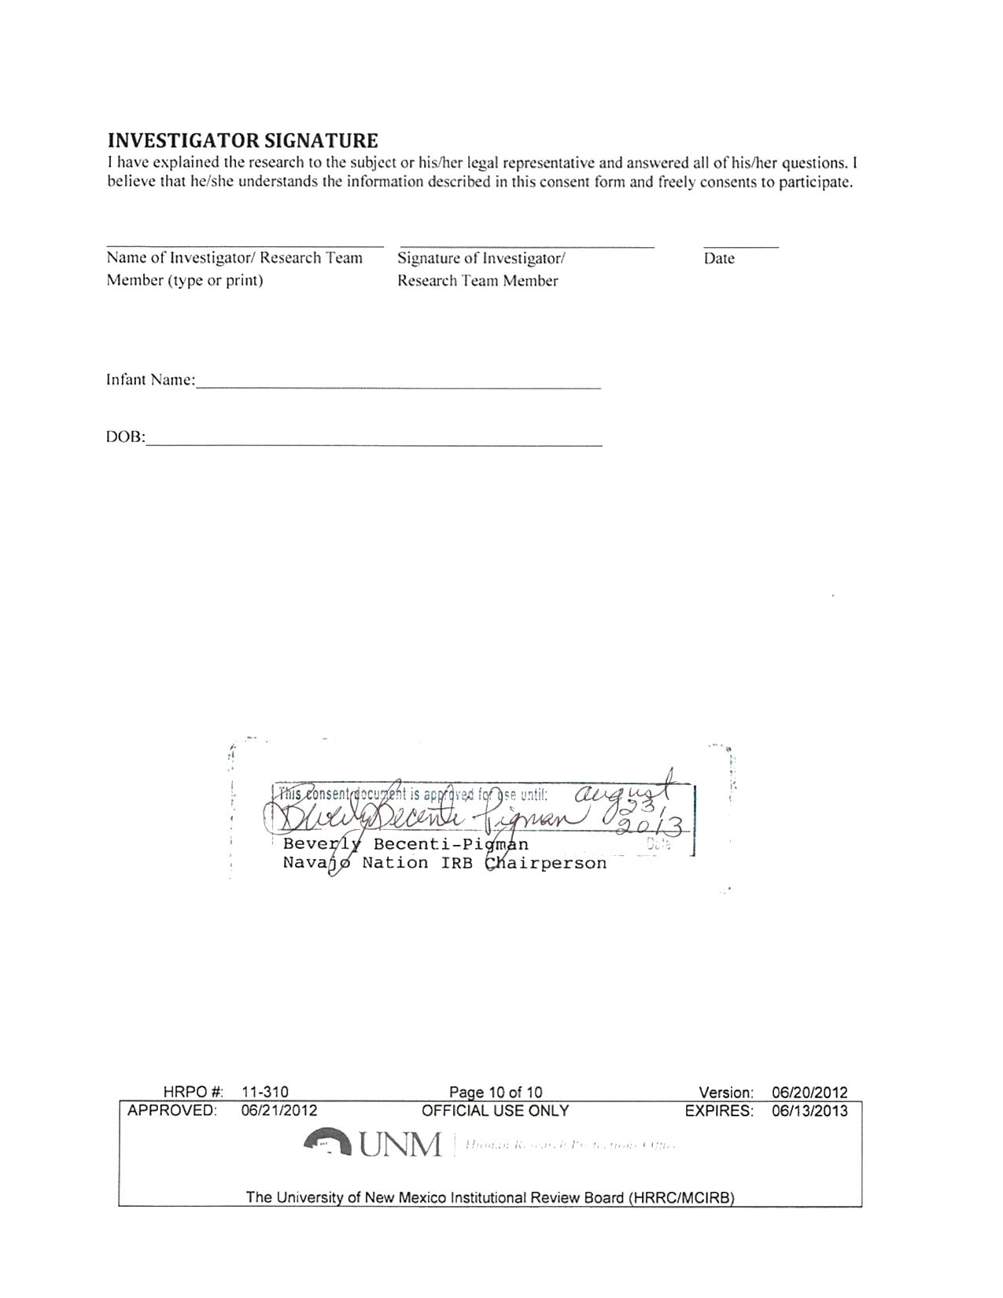
The University of New Mexico Health Sciences Center Father’s Consent/Assent to Participate in Research

The Navajo Birth Cohort Study
06/20/2012
Introduction
Based on community input, and input from Navajo Nation officials and researchers conducting studies on uranium health impacts on the Navajo Nation, Center for Disease Control and Prevention/Agency for Toxic Substances and Disease Registry (CDC/ATSDR) determined that the greatest need was research on the effects of uranium exposures on reproductive and developmental outcomes on the Navajo Nation. In September 2010, CDC/ATSDR selected the University of New Mexico to develop, coordinate and conduct, in partnership with the Navajo Area Indian Health Service (NAIHS) and Navajo Nation Division of Health (NNDOH), and Navajo Nation
Environmental Protection Agency (NNEPA), a prospective birth cohort study ― called the Navajo Birth Cohort Study (NBCS) ― to investigate the effects of environmental exposures to uranium and other toxicants on pregnancies and child development on the Navajo Nation over a three-year period. Direct funding has been provided to UNM, NAIHS and the NNDOH. NAIHS in turn will fund the key medical facilities identified as necessary to answer the communities’ questions, based on the number of deliveries and the potential for exposure to uranium wastes: Northern Navajo Medical Center, Chinle Comprehensive Health Care Facility, Gallup Indian Medical Center, Tuba City Regional Health Care Corporation and Tséhootsooí Medical Center. Kayenta Health Center is also funded to participate in the pre- and post-natal care phases of the study.
The principal investigator for the Navajo Birth Cohort Study is Johnnye Lewis, Ph.D., D.A.B.T., who is the director of the Community Environmental Health Program (CEHP) at the University of New Mexico Health Sciences Center (UNMHSC) in Albuquerque. Dr. Lewis is assisted by David Begay, Ph.D., co-investigator, who is also with UNM-CEHP; co-investigator Adrienne Ettinger, ScD., MPH, from Yale University; and Christopher Shuey, MPH, with Southwest Research and Information Center (SRIC). You (or your child) are being asked to participate in this study because you (or your child) have been identified as a father of a study participant’s child. An estimated 1600 mothers and fathers, and their children living on the Navajo Nation will take part in this study.
This form will explain the research study, and will also explain the possible risks as well as the possible benefits to you. You will be asked to consent for yourself (or your child if he is under 18) if you are 18 years of age or older. . If you are under 18, you will be asked to assent to your interest in participating in the study and we will need the consent of your parent or guardian to include you in the study..
What will happen if I decide to participate?
If you agree to participate, the following things will happen:
- We will interview you in a culturally appropriate and sensitive manner to identify any possible exposure to environmental chemicals through work or other activities, health and reproductive histories, demographic information (age, income, education, residence history), land and water use, medication, smoking and drug use history;
- • We will determine exposure risks in and around the home by:
-  Asking questions in the survey regarding the home construction, when available we will use existing data, and collect additional samples and scans if necessary;
- We will conduct a health and exposure assessment

- We will collect blood and urine to look for uranium and other contaminants that you may have come in contact with in your environment, as well as other contaminants related to oil and gas production, household chemicals, and burning of coal or wood in your home. (Some of the blood and urine may be stored for later testing as additional funding becomes available.);
- We will collect about 1 tablespoon of blood and 3 tablespoons of urine from you at enrollment. (Note: all blood will be drawn by licensed health care professionals, whether in the home or the clinic.);
- We will collect information from your medical records for your general health history;
- We will place a note in your medical record to identify you as a research participant for the duration of this study.

We will use samples of blood and urine from you for evidence of environmental exposures as well as biological changes in the immune system, circulation system; kidney and DNA repair mechanisms that may be related to exposures. To ensure compliance with the Navajo Nation Human Research Review Board moratorium on genetic analyses, no genetic analyses will be done in this research.
Your records at your healthcare facility will note your participation in the study and your willingness to be contacted for continuation of this study and any future follow-up research.
Please initial here if you ARE willing to be contacted for continuation of this study or future studies.
Please initial here if you NOT are willing to be contacted for continuation of this study or future studies.
How long will I be in this study?
Participation in this study will take a total of 3 to 4 hours. Participation will occur at a time determined by you and the research staff.
What are the risks or side effects of being in this study?
There are risks of stress, emotional distress, and inconvenience and possible loss of privacy and confidentiality associated with participating in a research study.
All precautions will be taken when your blood is drawn. Blood samples will be drawn using the same procedures used in most standard hospital testing procedures. The most common risks of having a blood sample taken are temporary discomfort or pain from the needle stick site, occasional bruising, sweating, light-headiness, and in rare cases, faintness or infection.
There are no risks or discomfort associated with giving a clean-catch urine sample.
For more information about risks and side effects, call Beverly Becenti-Pigman, chairperson at the Navajo Nation Human Research Review Board at 928-871-6650 and the principal investigator, Dr. Johnnye Lewis, at 877-5456775 .
What are the benefits to being in this study?
You may benefit directly by the information gained from the results of tests performed on the blood and urine samples you provide.
Tests of blood and urine samples collected from you will give us two sets of results. One set comes from the usual examinations that take place in a doctor’s office, clinic or hospital. These results will automatically be reported to your clinicians and your results will go into your medical record.
The second set of results (1) measures your exposures to heavy metals and other contaminants (called “biomonitoring”) and (2) indicates any biological changes related to exposure (called “biomarkers”). You will be informed of any biomonitoring or biomarker levels that indicate health risks, if that information is known. While there may not be particular interventions suggested by the biomonitoring results, the information may help you in identifying exposure sources and reducing them to prevent potential health effects. The biomarker results are experimental and their interpretation is the focus of this research. The results of the study should help us interpret how biomarker results are related to exposure and can serve as early indicators of diseases.
With your permission, the biomonitoring and biomarker results will be placed in your medical record, so they are available to be discussed with your doctor in the context of your health care. Please indicate your permission below:
□ Yes, include my biomonitoring and biomarker results in my medical record.
□ No, do not include my biomonitoring and biomarker results in my medical record.

What other choices do I have if I do not want to be in this study?
You do not have to participate in this study. Participation is voluntary and can be ended at any point.
How will my information be kept confidential?
We will take measures to protect the security of all your personal information, but we cannot guarantee confidentiality of all study data.
Information and /or specimens collected, as part of the study will be labeled with an assigned study number. Collected information (without your name) will be entered into a secure computer database maintained at CDC. The list that links your name to the study number, as well as any paper copies of data will be stored in a locked file in the office of Dr. Johnnye Lewis (Principal Investigator) at the University of New Mexico (UNM). Dr. Lewis and her research associates will maintain access to participants’ study information by participant number, with Dr. Lewis having the only access to information linking participant’s names to their study numbers. At certain times during the study, other members of the research team will need identified information either to clarify discrepancies in the data or to schedule appointments. This information will be provided in a limited manner sufficient to accomplish the task, and destroyed once the task is complete. Data will be stored for 3 years following conclusion of the study, and then de-identified data (without names) will be turned over to the Navajo Nation per the Navajo Nation Human Research Code (1996). A copy of this consent form will be kept in your medical record.
All biological specimens will be stored in secure, temperature regulated facilities at CDC until analysis. Samples will be kept for 3 years beyond the end of the study to allow for any reanalysis to clarify results. Any remaining biological samples after the analyses will be destroyed by standard procedures. If you would like, the remaining samples can be returned to you as choose below.
Please return any remaining portion of my specimen once the project is completed.
Do not return any remaining portion of my specimen once the project is completed.
What are the costs of taking part in this study?
There will be no costs to you associated with your participation in this study. All clinical visits will be performed under your existing healthcare coverage.
What will happen if I am injured or become sick because I took part in this study?
Taking part in this research is your choice. You may refuse to take part. You can withdraw from the research study at any time, for any reason, even after you have started the study. The Investigator may take you out of the project at any time without regard to your consent, if you do not follow the project schedule, if you have a study-related injury or if doctors involved in the study feel it would be unsafe for you to continue in the study or for administrative reasons. Even if you do not want to join the study, or if you withdraw from the study for any reason, you will still receive the same quality of medical care to which you are entitled.
You should ask the principal investigator listed below any questions you may have about this research study. You may ask him/her questions in the future if you do not understand something that is being done. The study staff will share with you any new findings that may develop while you are participating in this study. If you have any questions about these issues, or believe that you have been treated carelessly in the study, please contact Ms. Becenti-Pigman at the Navajo Nation Human Research Review Board at (928) 871-6650 or toll free at (877) 8734356 and the Human Research Review Committee (HRRC) at the University of New Mexico Health Sciences Center, Albuquerque, New Mexico 87131, (505) 272-1129 for more information. It is important for you to tell the Principal Investigator immediately at 877-545-6775 if you have been injured or become sick because of taking part in this study
Will I be paid for taking part in this study?
You will receive a gift as a token of our appreciation for your participation in the study.
How will I know if you learn something new that may change my mind about participating?
You will be informed of any significant new findings that become available during the course of the study, such as changes in the risks or benefits resulting from participating in the research or new alternatives to participation that might change your mind about participating.
Can I stop being in the study once I begin?
Your participation in this study is completely voluntary. You have the right to choose not to participate or to withdraw your participation at any point in this study without affecting your future health care or other services to which you are entitled.
You may choose to withdraw at any time by contacting Ms. Becenti-Pigman at the Navajo Nation Research Review Board office at (928) 871-6650 or toll free at (877) 873-4356 and by contacting Dr. Lewis’s office at (877) 545-6775. A member of the research staff will contact you for a signature confirming your withdrawal and no future contact will be made. Information collected at that point will be used confidentially in the overall analysis of study data. .
Whom can I call with questions or complaints about this study?
If you would like to speak with someone other than the research team, you may call Ms. Becenti-Pigman at the Navajo Nation Human Research Review Board office at (928) 871-6650 or toll free at (877) 873-4356 and you may also call the UNMHSC HRRC at (505) 272-1129.
If you have any questions, concerns or complaints at any time about the research study, Dr. Lewis, or her research associates will be glad to answer them at 505-272-4853 or (877) 545-6775.
If you need to contact someone after business hours or on weekends, please call one of the numbers listed above, leave a message and your call will be returned as soon as possible.
Whom can I call with questions about my rights as a research subject?
If you have questions regarding your rights as a research subject, you may call Ms. Becenti-Pigman at the Navajo Nation Human Research Review Board (NNHRRB) office at (928) 871-6650 or toll free at (877) 873-4356 and the UNMHSC HRRC at (505) 272-1129. The Navajo Nation Human Research Review Board and UNMHSC Human Research Review Committee are groups of people from the Navajo Nation, UNM, and their respective communities who provide independent oversight of safety and ethical issues related to research involving human subjects. For more information, you may also access their websites at http://www.nnhrrb.navajonsn.gov/index.htm (NNHRRB) and http://hsc.unm.edu/som/research/hrrc/ (UNM HSC HRRC).
CONSENT/ASSENT
You are making a decision to participate (or to have your child participate) in this study. Your signature below indicates that you/your child read the information (or the information was read to you/your child) and the information was explained to you. By signing this consent form, you are not waiving any of your (your child's) legal rights as a research subject.
If Participant is 18 and OVER, complete this section:
Consent of Adult Participant:
I have had an opportunity to ask questions and all questions have been answered to my satisfaction. By signing this consent form, I agree to participate (or let my child participate) in this study. I acknowledge that a copy of this consent form has been provided to me.
Name of Adult Participant (print) Signature of Adult Participant Date
If Participant is UNDER 18, complete this section:
Consent of Parent/Guardian for Minor Participant:
I have had an opportunity to ask questions and all questions have been answered to my satisfaction. By signing this consent form, I agree to let my child participate in this study. I acknowledge that a copy of this consent form has been provided to me.
____________________________ | ____________________________ | _______
Name of Parent/Guardian (print) | Signature of Parent/Guardian of | Date
 | Minor Participant
Assent of Minor Subject:

I have had an opportunity to ask questions and all questions have been answered to my satisfaction. By signing this form, I agree that I am interested in and willing to participate in this study. I acknowledge that a copy of this consent has been provided to me.
Minor Child’s Name (print) Minor’s Signature Date
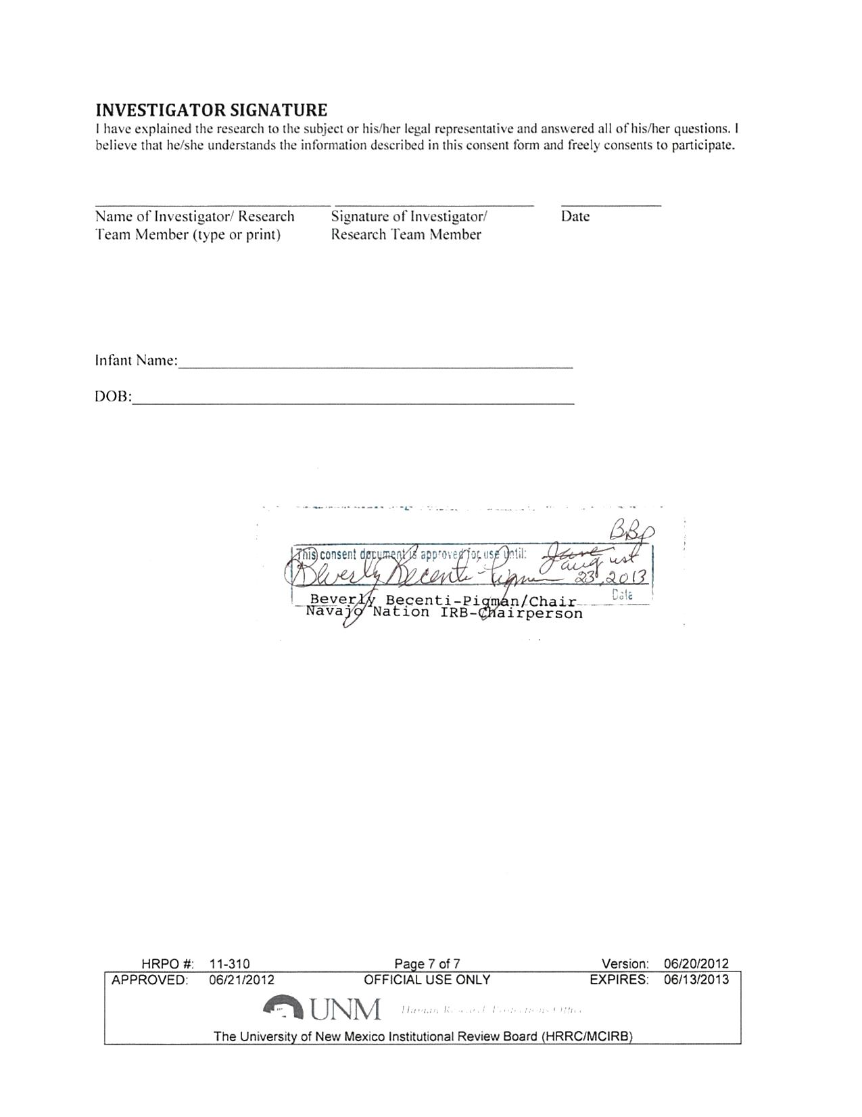
UNIVERSITY OF NEW MEXICO HEALTH SCIENCES CENTER HIPAA¹ AUTHORIZATION TO USE AND DISCLOSE PROTECTED HEALTH INFORMATION FOR RESEARCH PURPOSES
Title of Study: The Navajo Birth Cohort Study
Principal Investigator: Johnnye L. Lewis Ph.D., D.A.B.T.
UNMHSC Department: College of Pharmacy/ Pharmaceutical Sciences
Mailing Address: University of New Mexico / 1 University of New Mexico / MSC 09 5360 / Albuquerque, NM 87131-0001
Co-Investigators: David Begay, Ph.D., Adrienne Ettinger, ScD., MPH, and Christopher Shuey, MPH
Sponsor: Centers for Disease Control and Prevention / Agency for Toxic Substance and Disease Registry
- What is the purpose of this form? You have been asked to take part in a research study. The consent form for this study describes your participation, and that information still applies. This extra form is required by the federal Health Insurance Portability and Accountability Act (HIPAA). The purpose of this form is to get your permission (authorization) to use health information about you that is created by or used in connection with this research.
- What if I don’t want my personal health information (PHI) to be used in this research study? You do not have to give this permission. Your decision not to sign this form will not change your ability to get health care outside of this research study. However, if you do not sign, then you will not be allowed to participate in the study.
- What PHI am I allowing to be used for this research? The information that may be used includes: Current and past medical problems for yourself; for female participants all pregnancy related care, treatment, and outcome; medications you are taking; your height and weight; diet and exercise level; and if you have a chronic disease and medications prescribed.
- Where will researchers go to find my PHI? We may ask to see your personal information in records at hospitals, clinics or doctor’s offices where you may have received care in the past, including but not limited to facilities in the UNM health care system.
- Who will be allowed to use my information for this research and why? The researchers named above and their staff will be allowed to see and use your health information for this research study. It may be used to check on your progress during the study, or analyze it along with information from other study participants. Sometimes research information is shared with collaborators or other institutions. Your records may also be reviewed by representatives of the research sponsor or funding agency, the Food and Drug Administration (FDA) to check for quality, safety or effectiveness, or the Human Research Review Committee (HRRC) for the purposes of oversight and subject safety and compliance with human research regulations.
- Will my information be used in any other way? Your information used under this permission may be subject to re-disclosure outside of the research study and be no longer protected under certain circumstances such as required reporting of abuse or neglect, required reporting for law enforcement purposes, and for health oversight activities and public health purposes.

¹ HIPAA is the Health Insurance Portability and Accountability Act of 1996, a federal law related to privacy of health information.
Version: 06/16/11 HRPO # 11-310

- What if I change my mind after I give this permission? You can change your mind and withdraw this permission at any time by sending a written notice to the Principal Investigator at the mailing address listed at the top of this form to inform the researcher of your decision. If you withdraw this permission, the researcher may only use and share your information that has already been collected for this study. No additional health information about you will be collected by or given to the researcher for the purposes of this study.
- What are the privacy protections for my PHI used in this research study? HIPAA regulations apply to personal health information in the records of health care providers and other groups that share such information. There are some differences in how these regulations apply to research, as opposed to regular health care. One difference is that you may not be able to look at your own records that relate to this research study. These records may include your medical record, which you may not be able to look at until the study is over. The HIPAA privacy protections may no longer apply once your PHI has been shared with others who may be involved in this research.
- How long does this permission allow my PHI to be used? If you decide to be in this research study, your permission to access and use your health information in this study may not expire, unless you revoke or cancel it. Otherwise, we will use your information as long as it is needed for the duration of the study.

I am the research participant or the personal representative authorized to act on behalf of the participant. By signing this form, I am giving permission for my personal health information to be used in research as described above. I will be given a copy of this authorization form after I have signed it.
Name of Research Subject Signature of Subject/Legal Representative Date
Describe authority of legal representative
Name of Person Obtaining Authorization Signature Date
Version: 06/16/11 HRPO # 11-310

