Attachment 18

Site Visit Interview Consent Form

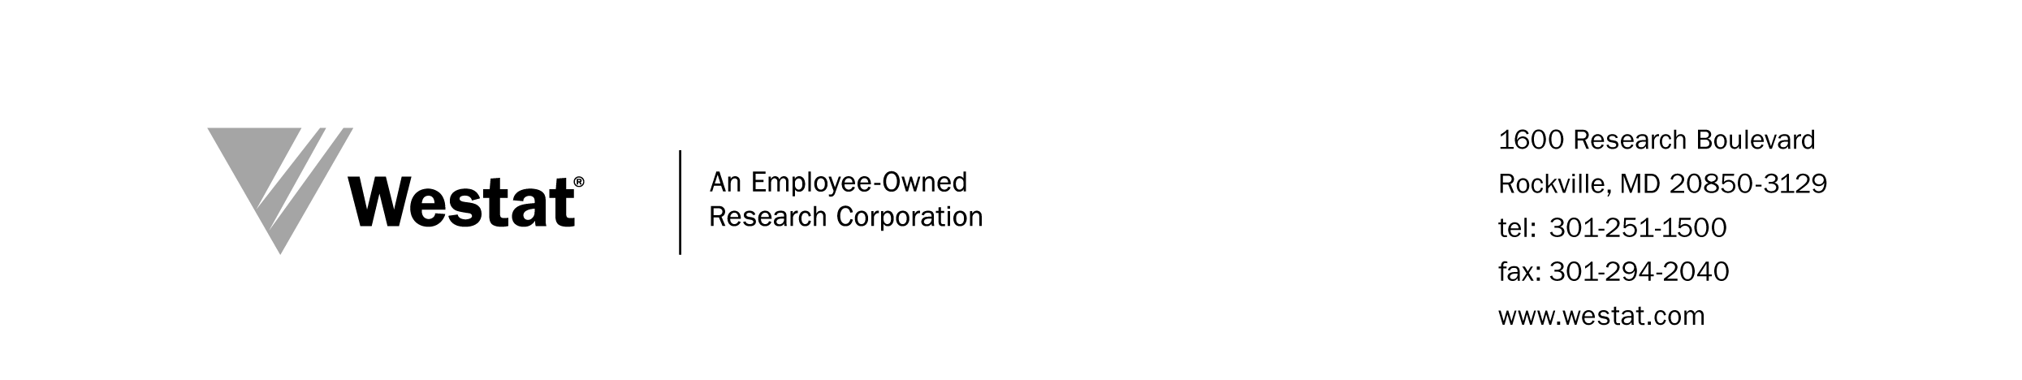

OMB No: XXXX-XXXX
Expiration Date: XX/XX/20XX

Rights of study participants are protected by The Privacy Act of 1974. Participation is voluntary, and there are no penalties for not participating or withdrawing from the study at any time. Refusal to participate will not affect your benefits in any way. The information collected in this study will be kept private to the extent provided by law. Names and other identifiers will not appear in any report of the study. Information provided will be combined for all study participants and reported as summaries. You are being contacted to participate in this data collection so that we can evaluate the Science Education Partnership Award Program.

SITE VISIT INTERVIEW INFORMED CONSENT

EVALUATION OF THE SCIENCE EDUCATION PARTNERSHIP AWARD PROGRAM

August 2016

Westat, an independent social science research company in Rockville, Maryland is working with the Science Education Partnership Award (SEPA) Program of the National Institutes of Health (NIH) to conduct an evaluation of the SEPA Program. Westat is conducting interviews at a number of SEPA project sites to learn about the extent to which projects are aligned with the goals of the SEPA program, the outcomes associated with SEPA projects, the types of contributions made by partners, issues impinging on the rigor of the evaluation, and the extent to which projects and their partnerships are being sustained.

Participation in the interview is voluntary, but through your involvement you can contribute to this important effort and help ensure that SEPA is successful. Information shared in the expert panel will be kept private to the extent provided by law; no reports will identify you by name or affiliation. Additionally, the information obtained during the interview will be shared only with the sponsoring agency personnel and staff authorized to work on this study. The session will be audio-taped to assist with analysis but only the Westat staff present will have access to this recording. The tape will be destroyed immediately after analysis.

Please print your name in the following paragraph and sign at the bottom of this form. Return this form to the Westat staff member who is conducting the interview.

I, _____________________________________, have agreed to participate in the interview component of the SEPA Evaluation. I understand that my participation is voluntary; that a temporary audio-recording will be made of the session; and that the resulting report will not identify me by name.

I have read this informed consent form and understand the proposed study.

______________________________
Participant’s Signature

____/____/____
Date

