DATE: March 16, 2015
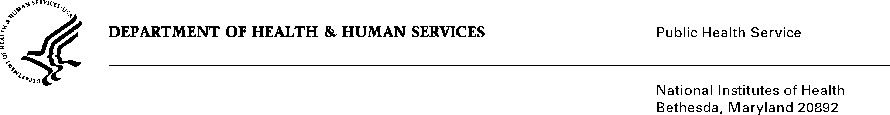

TO: Carla L. Easter, Ph.D.
Chief, Education and Community Involvement Branch
National Human Genome Research Institute

FROM: NIH Privacy Act Officer

SUBJECT: Applicability of the Privacy Act: Surveys to Support an Evaluation of the National Human Genome Research Institute Summer Workshop in Genomics (Short Course)

I have reviewed the NHGRI submission to OMB referenced above. The project involves the use of web-based surveys to evaluate the long-term outcomes of the Short Course, identify resources and barriers associated with curriculum integration, and explore the program’s influence on student participant career paths. Results from the survey will be used to inform extramural budget allocations and future program design.

I have determined that the Privacy Act will apply to this data collection, which includes the collection of personally identifiable information (PII) such as the respondent’s first and last name, email, gender, and other identifiers stored in a system designed to be retrieved by a personal identifier.

This evaluation will survey all faculty and students who attended the Short Course between 2004-2012. NHGRI will provide an evaluation team with the participants’ most current e-mail address to facilitate the survey administration. The evaluation team will send an invitation letter with the survey link to the faculty and students. The survey protocols will focus on collecting information on the integration of Short Course knowledge into teaching materials; dissemination of genomics beyond the classroom; pursuit of careers related to genomics; and continued participation in NIH-related activities. NHGRI will also develop a database that contains the names of the respondents, their contact information, and the dates of all email and telephone contact. The NHGRI Contracting Officer's Technical Representative and approved members of the evaluation project team will have access to the collected PII.

The data collection is covered by NIH Privacy Act Systems of Record 09-25-0156, “Records of Participants in Programs and Respondents in Surveys Used to Evaluate Programs of the Public Health Service, HHS/PHS/NIH/OD.” If you have questions, please contact me at (301) 402-6201.

Karen M. Plá

Enclosure

cc: Gloria Butler, NHGRI PRA Liaison (w/o enclosure)

