***Mark J. Warshawsky***

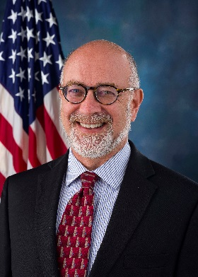

***Deputy Commissioner for Retirement and Disability Policy***

***Social Security Administration***

Mark Warshawsky is Deputy Commissioner for Retirement and Disability Policy at the Social Security Administration (SSA). His interests include social security, employer-sponsored pension and retirement programs, financial planning, health and long-term care financing, public finance, and macroeconomics. He has testified before Congress and administrative agencies many times, and was recently a Senior Research Fellow at the Mercatus Center of George Mason University, as well as a visiting scholar at the MIT Golub Center for Finance and Policy.

Mark is the author of over 150 published articles and four books. From 2006 to 2013, he was Director of Retirement Research at Towers Watson, a global human capital consulting firm.

Mark was a member of the Social Security Advisory Board from 2006 through 2012 and was Vice Chairman of the Federal Commission on Long-Term Care in 2013. From 2004 to 2006, Mark served as Assistant Secretary for Economic Policy at the U.S. Department of the Treasury, playing a key role in the development of the Pension Protection Act of 2006.

He is the inventor of the life care annuity, a product integrating the immediate life annuity and long-term care insurance benefits, and a developer of planning software. Mark has held senior-level positions at the Federal Reserve Board, the Internal Revenue Service, and the Teachers Insurance and Annuity Association - College Retirement Equities Fund. He received a Ph.D. in economics from Harvard University and a B.A. with highest distinction from Northwestern University.

***Beatrice Disman***

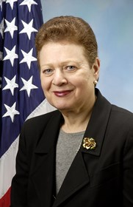

***Acting Chief of Staff***

***Social Security Administration***

Beatrice Disman is the Acting Chief of Staff for SSA. Most recently, Bea served as an advisor to the agency’s Commissioner on significant management challenges including the disability program and anti-fraud initiatives. From 1995 to 2014, Bea was the Regional Commissioner for the agency’s New York Region. As Regional Commissioner, Bea had direct authority over SSA’s operations in New York, New Jersey, Puerto Rico, and the U.S. Virgin Islands including 3,900 employees in 123 locations serving more than 7 million beneficiaries who received more than $88 billion in Social Security and Supplemental Security Income (SSI) benefits annually. She also planned and implemented the agency’s responsibilities in the Medicare Prescription Drug Act of 2003, the Medicare Improvements for Patients and Providers Act of 2008, and the Affordable Care Act of 2010.

Chairman Emeritus of the New York Federal Executive Board, Bea served as its Chair from 1997 to 2003, leading the collaborative effort among 150 Federal agencies throughout the City of New York, most notably during the aftermath of September 11. She is a member of the National Academy of Social Insurance and a tireless advocate for many social issues through her leadership roles on her local Community Board.

Bea holds a B.A. in History and Political Science from Brooklyn College, an M.A. in American Diplomatic History from Ohio State University Graduate School, and an M.B.A. from New York University’s Graduate School of Business. She also completed the Harvard University Senior Executive Fellows Program and is an alumna of the Federal Executive Institute in Charlottesville, VA.

Winthrop S. Cashdollar

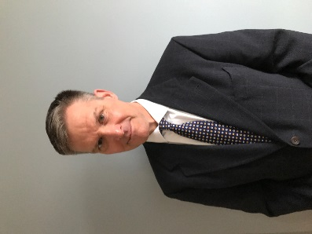

***Executive Director, Product Policy***

***America’s Health Insurance Plans***

Winthrop Cashdollar oversees America’s Health Insurance Plans’ (AHIP) advocacy on behalf of disability insurance products. He promotes private disability income protection nationwide through efforts to educate policymakers, the media, and the public on the role and value of disability coverage in helping families maintain financial security against the risk of serious illness or injury. Winthrop oversees AHIP’s research on disability income protection issues; leads AHIP’s efforts to develop and advocate for policy that will expand disability income protection; and leads efforts to build stronger partnerships between private insurers and SSA for the benefit of both the private and public programs.

Prior to joining AHIP, Winthrop served as Executive Director of the Nevada Health Care Association and as Director of Legislative Policy and Analysis for the American Health Care Association (AHCA), where he was instrumental in AHCA’s work on long-term care financing reform and long-term care insurance. Winthrop began his career in Washington, D.C., as an advisor on health and other issues to then Senator William Cohen (R-ME). A native of Pennsylvania, Winthrop received a Bachelor of Science degree from Penn State University and a Master of Public Policy Studies degree from the University of Michigan.

**Catherine Liston**

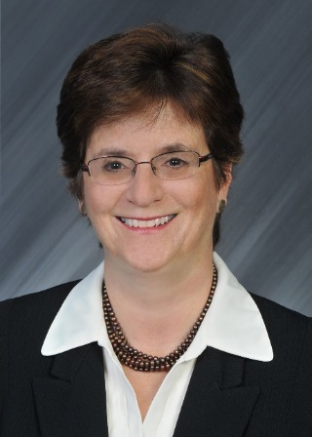

***Vice President, Group and Voluntary Claims***

***Sun Life Financial Services***

Catherine Liston joined Sun Life Financial Services in July 2016. Cathy is a highly regarded leader in the employee benefits industry with decades of experience leading large-scale claims operations. Before joining Sun Life, she served as Vice President of Group Disability and Life Claims at Prudential Financial (2013-2016), Head of Disability and Absence Management at Aetna (2003-2012), and Vice President of Disability Benefits at Unum (1983-2000).

Cathy is a graduate of Colby College in Waterville, ME with a degree in mathematics. She currently serves on the Board of Directors for Spurwink Services, a nationally accredited non-profit organization that assists children and families with a wide variety of health and educational needs. Cathy is based in Scarborough, ME in Sun Life’s Center for Healthy Work, an industry-leading facility that promotes Sun Life’s “Work is Healthy” philosophy.

Kristin Tugman, Ph.D., CRC, LPC

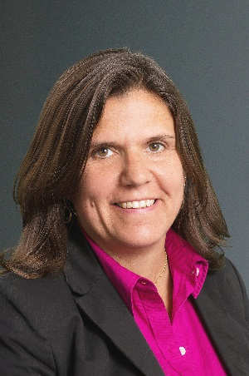

***Vice President, Health & Productivity Analytics and Consulting Practice***

***Prudential***

Kristin Tugman has over 15-years’ experience in the health and productivity consulting field and currently heads the Health and Productivity Analytics and Consulting Practice for Prudential group insurance products. The team is responsible for analyzing lost time for large employers and designing and implementing solutions to help them minimize absence and maximize productivity.

She is a certified rehabilitation counselor and a licensed professional counselor. She has authored several publications pertaining to the psychological aspects of disability. Her work details a specific cognitive behavioral model to assist individuals in overcoming psychological barriers that prevent a return to productivity.

Kristin continues to actively research and develop techniques to assist individuals with psychiatric and other disabilities in maintaining appropriate function in the competitive work force.

She graduated from Georgia State University with a Master’s Degree in Rehabilitation Counseling and earned a Ph.D. in Industrial and Organizational Psychology from Capella University.

Margarita Devlin, MA, CRC



***Executive Director, Benefits Assistance Service***

***Veterans Benefits Administration, U.S. Department of Veterans Affairs***

Margarita Devlin serves as the Executive Director of Benefits Assistance Service (BAS) in the Veterans Benefits Administration (VBA). BAS coordinates, supports, and facilitates client-centered outreach and direct services to ensure active duty personnel, veterans, family members, and members of the Reserve and National Guard understand and have access to benefits gained as a result of service to our Nation. Margarita is responsible for providing executive-level oversight in the development of policy, planning, and integration of VBA's Direct Services, Client Outreach, and the Transition Assistance Program.

Margarita has a long history with the Department of Veterans Affairs (VA), having served for over 20 years in various positions of increasing responsibility. She is a certified rehabilitation counselor who provided counseling and evaluation services to veterans in the Vocational Rehabilitation and Employment (VR&E) division of the St. Petersburg, FL VA Regional Office, where she later progressed to positions as Assistant VR&E Officer and VR&E Officer. She subsequently served in Washington, D.C. as the Deputy VR&E Service Director; Acting VR&E Service Director; Executive Director for Interagency Care and Benefits Coordination; and most recently, as the Executive Director for Navigation, Advocacy, and Community Engagement in the VA’s Veterans Experience Office.

Margarita earned her Bachelor and Master of Arts from the University of South Florida in Tampa, FL.

**Stacy Braverman Cloyd**



***Deputy Director of Government Affairs***

***National Organization of Social Security Claimants’ Representatives***

The National Organization of Social Security Claimants’ Representatives (NOSSCR) encourages the highest quality representation and advocacy on behalf of persons seeking Social Security Disability Insurance and SSI benefits. Prior to her work in the policy sector, Stacy Braverman Cloyd worked as a public benefits attorney, representing low-income individuals primarily in pre-and post-eligibility Social Security matters, Medicaid, Temporary Assistance for Needy Families, Supplemental Nutrition Assistance Program, rent control, and landlord-tenant disputes.

Stacy was a panelist at the Social Security Advisory Board’s SSI Policy Forum in 2016, discussing the challenges and options for in-kind support and maintenance policy. She has also spoken at conferences for people with specific impairments, such as the 2015 Scleroderma Foundation conference and the 2016 Myotonic Dystrophy Foundation conference. Stacy became a member of the National Academy of Social Insurance in 2017. She holds a bachelor’s degree from Smith College and a Juris Doctor and Master of Urban Planning degrees from the University of Michigan.

**Hilery Z. Simpson**

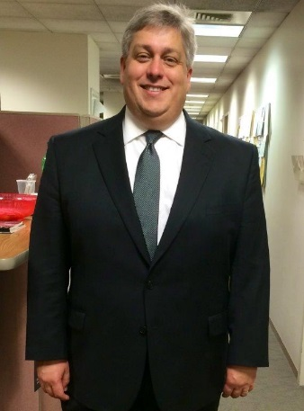

***Assistant Commissioner for Compensation Levels and Trends***

***Bureau of Labor Statistics, U.S. Department of Labor***

Hilery Simpson is Assistant Commissioner for Compensation Levels and Trends at the Bureau of Labor Statistics (Bureau). Hilery’s office produces such products as the Employment Cost Index, a Principal Federal Economic Indicator that measures the cost of wages and benefit to employers, and the Occupational Requirements Survey, which the SSA will use to replace the Dictionary of Occupational Titles (DOT) in its Disability Determination process.

Previously, Hilery served as Assistant Commissioner for Safety, Health, and Working Conditions. In that capacity, he oversaw new approaches to measuring employer under-reporting in the Survey of Occupational Injuries and Illnesses, including development and testing of a household survey of injuries and illnesses. He also led Bureau efforts in the computer assisted coding of survey data. Hilery continues as the co-sponsor of a National Academy of Sciences’ panel on measuring occupational injuries and illnesses.

Hilery’s new position represents his return to compensation statistics. As a Division Chief in this office, he developed the partnership between SSA and the Bureau that resulted in the new Occupational Requirements Survey. He has also authored several papers on the compensation practices of U.S. employers. Hilery has worked on wage and benefit programs since joining the Bureau in 1992. He holds a B.A. and M.S. in Economics from DePaul University.