|  |  |
| --- | --- |
|  | Westat's Logo Signature, blue on white |
|  |

RISE Research Participant's Bill of Rights

You have been asked to participate in a research study. Any participant in a research study has the right to:

1. Be told the nature and purpose of the study.
2. Be given an explanation of what will happen during the study and of how the research participant is expected to participate.
3. Be given an explanation of any risks or discomforts that may be experienced as a result of participating in the study.
4. Be given an explanation of any benefits that may be expected from participation in the study.
5. Be told of other appropriate choices that may be better or worse than being in the study, and be told of the risks and benefits of those other choices.
6. Have the opportunity to ask questions about the study or about your participation in it, both before agreeing to participate in the study and during the course of the study.
7. Be told that you may withdraw your consent and participation in the study at any time, and that your withdrawal will not affect your services.
8. Be told that you may refuse to answer any question.
9. Be given a copy of the signed and dated consent form.
10. Be free of pressure when considering whether to consent to, and participate in, the study.
11. Be informed, upon request, about the results of the study.

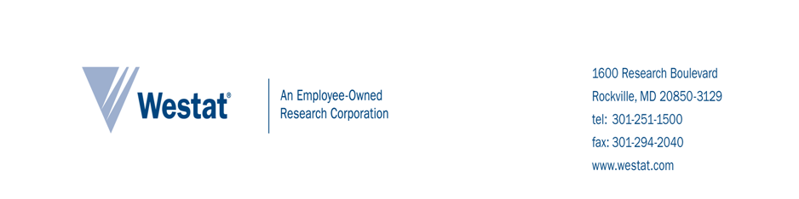

**Introduction and PURPOSE OF STUDY**

The U. S. Department of Health and Human Services has hired Westat, a research company, to study the RISE program, a new local program working with the Los Angeles County Department of Children and Family Services (DCFS). The program is housed at the Los Angeles Gay and Lesbian Center. The goal of the RISE program is to reduce the number of lesbian, gay, bisexual, transgender, and questioning (LGBTQ) children and youth in long-term foster care in Los Angeles County. RISE is supported by the Permanency Innovations Initiative (PII), a federal initiative that seeks to build the evidence base for innovative intervention to enhance well-being and improve permanency outcomes for children who are in or at risk for long-term foster care.

One part of the study involves examining ways organizations can better support and serve LBGTQ children through a staff survey. We would like your help in assisting us with this part of the study.

**Procedures**

We invite you to participate in a voluntary, anonymous survey. The survey asks about your views and experiences with LGBTQ clients and the availability of agency resources to help you work with this population. Reading the Bill of Rights and consent sheet and completing the survey will take no more than 15 minutes.

This is the first of two surveys that we will ask you to complete. Later you will be asked to participate in another similar survey.

**DIFFERENT WAYS TO PARTICIPATE**

There are no alternative ways to participate in the study.

**Participant and Data Privacy**

Your survey responses will be anonymous and identifiable only by a unique study identification number. We will keep your information private to the extent permitted by law. We will use your information for research purposes only. We will not include information that identifies you in any reports we write.

To help us protect your information, we received a Certificate of Confidentiality from the U. S. Department of Health and Human Services. With this Certificate, no one can force us to share information that could identify you, even in any court or legal proceeding, under a court order or subpoena.

**VOLUNTARY PARTICIPATION**

You are not required to participate in the RISE study. If you consent to participate, you can choose to end participation at any time. Your decision to participate will not affect your ability to participate the RISE staff trainings.

**BENEFITS**

There are no direct benefits to you in participating in the survey. However, you will help your organization and others come up with better ways to serve families and children. You will receive a token of appreciation for participating in the study valued at approximately $10.

**RISKS**

We do not expect any risks to you in participating in the survey. You can skip questions that you do not want to answer.

**treatment for injury related to this study**

We do not expect that you will experience any injuries as a result of participating in the study. Therefore, no treatment will be available to address any injuries.

**CONFLICT OF INTEREST**

Westat has no financial or other relationships with your agency that will affect our role in conducting this study, including interpreting and reporting the study results.

**participation decision**

To ensure your responses remain anonymous, you will not sign a consent form to indicate your decision to complete the survey. You agree to participate by just completing the survey. Please keep one copy of the consent information sheet for your records.

If you *agree* to participate, you can proceed with completing the survey. When you are done, please place the other copy of this sheet and the survey in the envelope provided.

If you *do not agree* to participate, please check the box below and place this copy of the sheet and the survey in the envelope provided.

🞎 I do not want to participate in this survey.

**QUESTIONS**

If you have questions about the survey, you may ask the Westat researcher facilitating the survey data collection**.** You may also contact the individuals below.

|  |
| --- |
|  |

|  |  |
| --- | --- |
| For questions about the RISE study, please  contact:  Jaymie Lorthridge, *Westat Study Contact*  1-800-WESTAT1 (937-8281), x5871  [JaymieLorthridge@westat.com](mailto:LizQuinn@westat.com) | You can learn more about your rights as a part of the study from the *Research Participant’s Bill of Rights* document. For additional questions about your rights as a participant in this study, contact:  *The* *State of California* *Committee for the Protection of Human Subjects,* (916) 326-3660 |