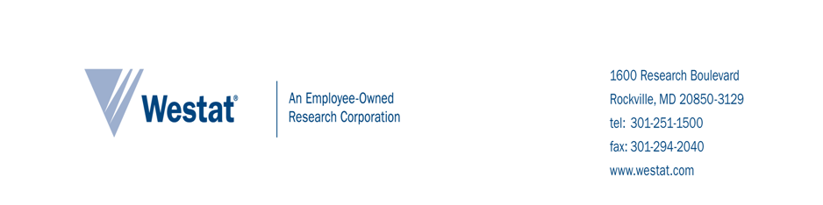
Introduction and PURPOSE OF STUDY
The U. S. Department of Health and Human Services has hired Westat, a research company, to study the RISE program, a new local program working with the Los Angeles County Department of Children and Family Services (DCFS). The program is housed at the Los Angeles Gay and Lesbian Center. The goal of the RISE program is to reduce the number of lesbian, gay, bisexual, transgender, and questioning (LGBTQ) children and youth in long-term foster care in Los Angeles County. RISE is supported by the Permanency Innovations Initiative (PII), a federal initiative that seeks to build the evidence base for innovative intervention to enhance well-being and improve permanency outcomes for children who are in or at risk for long-term foster care.

One part of the study involves examining ways organizations can better support and serve LBGTQ children through a staff survey. We would like your help in assisting us with this part of the study.

Procedures
At the first Outreach and Relationship Building (ORB) training, we invited staff from your organization to complete a voluntary, anonymous survey. We are now inviting you to participate in a second round of surveys. You are eligible to complete the survey regardless of whether you participated in the first round of surveys. All staff receiving (or who have previously received) ORB training are invited to participate.

The survey asks about your views and experiences with LGBTQ clients and the availability of agency resources to facilitate your work with this population. Reading this consent sheet and completing the survey will take no more than 10 minutes.

DIFFERENT WAYS TO PARTICIPATE
There are no alternative ways to participate in the study.

Participant and Data Privacy
Your survey responses will be anonymous and identifiable only by a unique study identification number. We will keep your information private to the extent permitted by law. We will use your information for research purposes only. We will not include information that identifies you in any reports we write.

To help us protect your information, we received a Certificate of Confidentiality from the U. S. Department of Health and Human Services. With this Certificate, no one can force us to share information that could identify you, even in any court or legal proceeding, under a court order or subpoena.

BENEFITS
There are no direct benefits to you in participating in the survey. However, you will help your organization and others come up with better ways to serve families and children. You will receive a token of appreciation for participating in the study valued at approximately $10.

VOLUNTARY PARTICIPATION
You are not required to participate in the RISE study. If you consent to participate, you can choose to end participation at any time. Your decision to participate will not affect your ability to participate the RISE staff trainings.

RISKS
We do not expect any risks to you in participating in the surveys. You can skip questions that you do not want to answer.

treatment for injury related to this study
We do not expect that you will experience any injuries as a result of participating in the study. Therefore, no treatment will be available to address any injuries.

CONFLICT OF INTEREST
Westat has no financial or other relationships with your agency that will affect our role in conducting this study, including interpreting and reporting the study results.

participation decision
To ensure your responses remain anonymous, you will not sign a consent form to indicate your decision to complete the survey. You agree to participate by just completing the survey. Please keep one copy of the consent information sheet for your records.

If you agree to participate, you can proceed with completing the survey. When you are done, please mail the other copy of the consent sheet and the survey in the envelope provided.

If you do not agree to participate, please check the box below and place this copy of the consent sheet and the survey in the envelope provided.

I do not want to participate in this survey.

QUESTIONS
If you have questions about the survey, you may ask the Westat researcher facilitating the survey data collection. You may also contact the individuals below.

For questions about the RISE study, please  contact:  Jaymie Lorthridge, Westat Study Contact  1-800-WESTAT1 (937-8281), x5871  JaymieLorthridge@westat.com | You can learn more about your rights as a part of the study from the Research Participant’s Bill of Rights document that was distributed at the pretest. For additional questions about your rights as a participant in this study, contact:  The State of California Committee for the Protection of Human Subjects, (916) 326-3660

