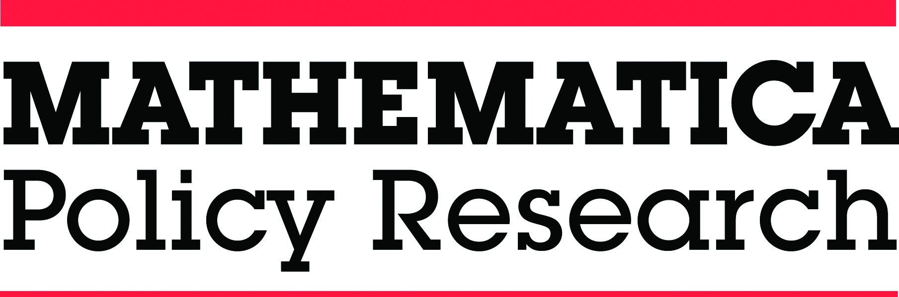

CONFIDENTIALITY AGREEMENT

I understand that the names, and any other identifying facts or information, of individuals, businesses, organizations, and families participating in the American Indian/Alaska Native Head Start Family and Child Experiences Survey (AI/AN FACES) 2014-2018 being conducted by Mathematica Policy Research (“Mathematica”), under contract to the Office of Planning, Research and Evaluation (“OPRE”), within the Administration for Children and Families (“ACF”) of the U.S. Department of Health and Human Services (“HHS”) (Contract No. HHSP23320095642WC/HHSP2337052T) are confidential information.

I agree that I may only use such confidential information for purposes of the AI/AN FACES study and further agree that I will not disclose or reveal any such confidential information, regardless of how or where I acquired it, to any person unless such person has been authorized by ACF, OPRE, or Mathematica to have access to the information for purposes of the AI/AN FACES study.

I understand that Mathematica and the contracting organizations have the exclusive right to all confidential information acquired or developed under the AI/AN FACES contract. I acknowledge that I acquire no right, title, or interest in and to any such confidential information to which I have access by reason of my employment or position.

I agree to promptly notify Mathematica or ACF of any unauthorized disclosure or use of confidential information covered under this agreement that I observe or of which I become aware.

Name:

Title:

Signature:

Date:

