1. AESDirect Record Formats

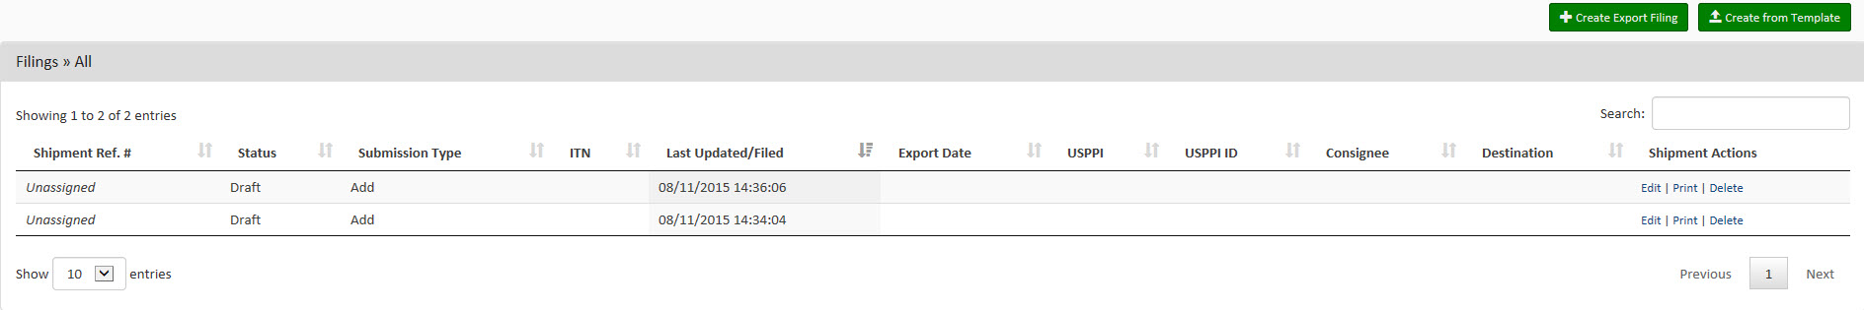Launch Page

Shipment Page

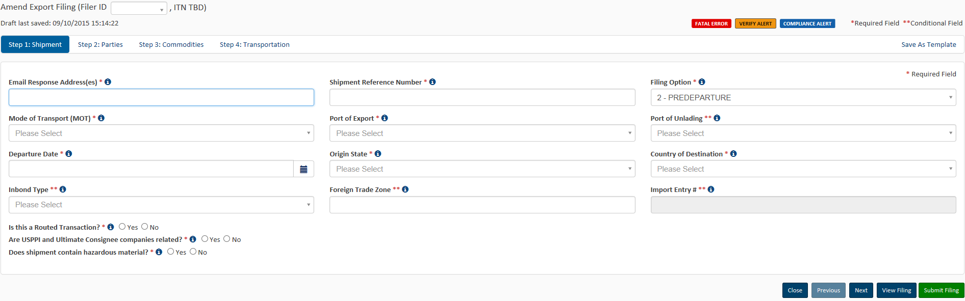

Parties Page 1: First half of screen

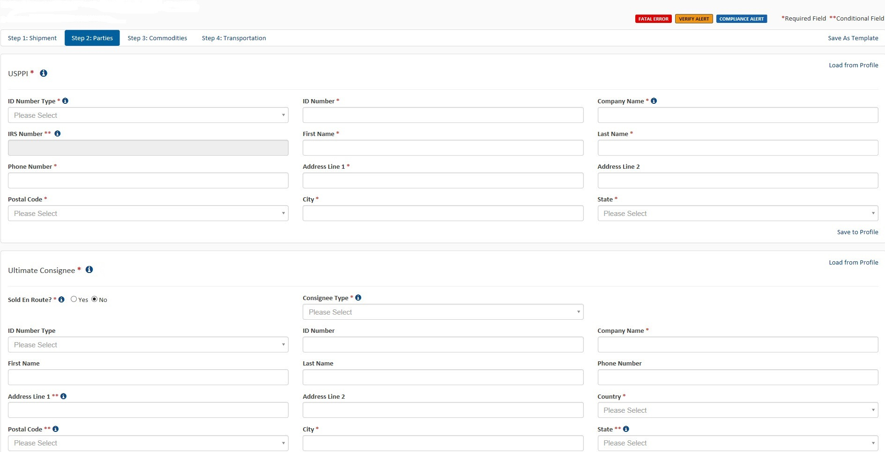

Parties Page 2: Second half of screen

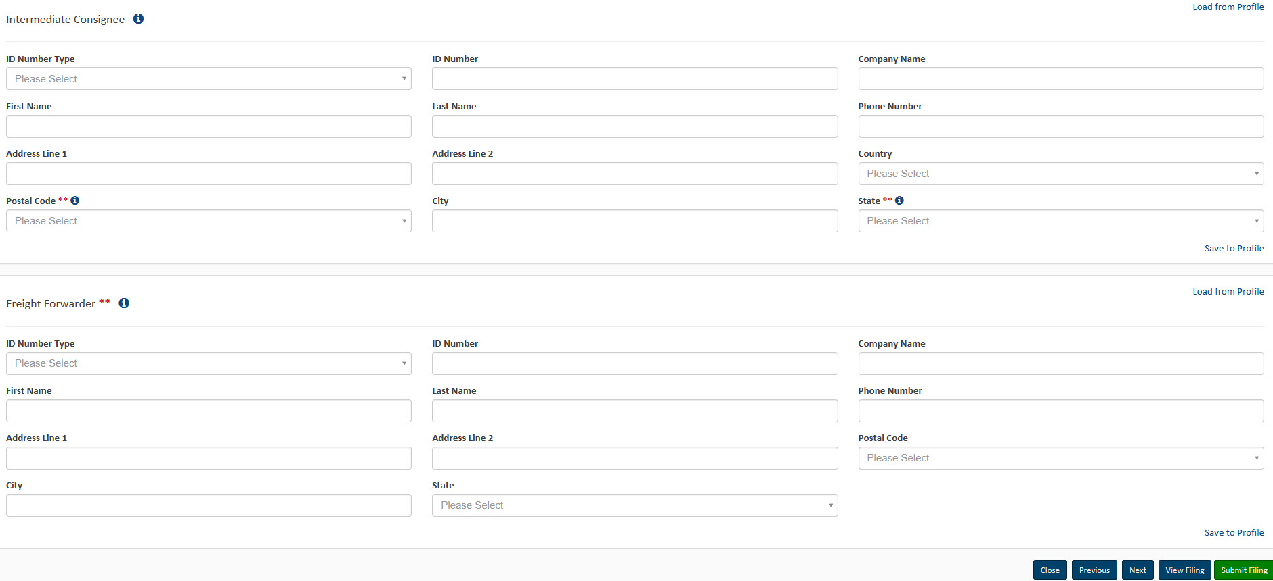

Commodities Page 1

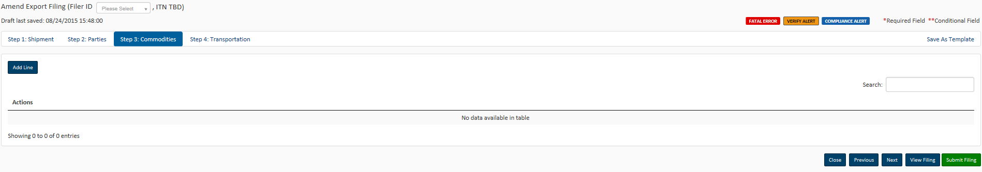

Commodities Page 2

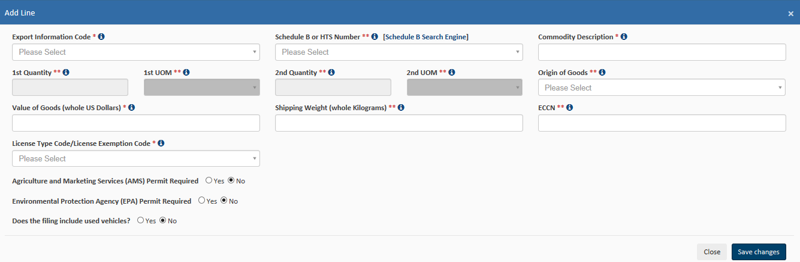

Transportation Page

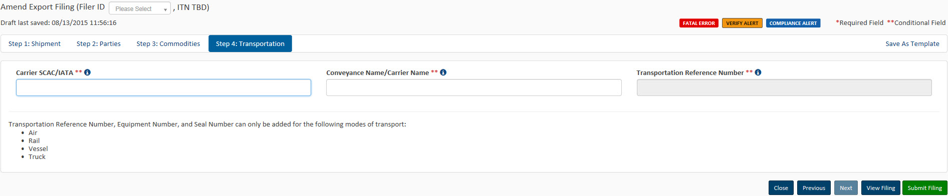

Proposed Data Fields Page 1

Original ITN Field

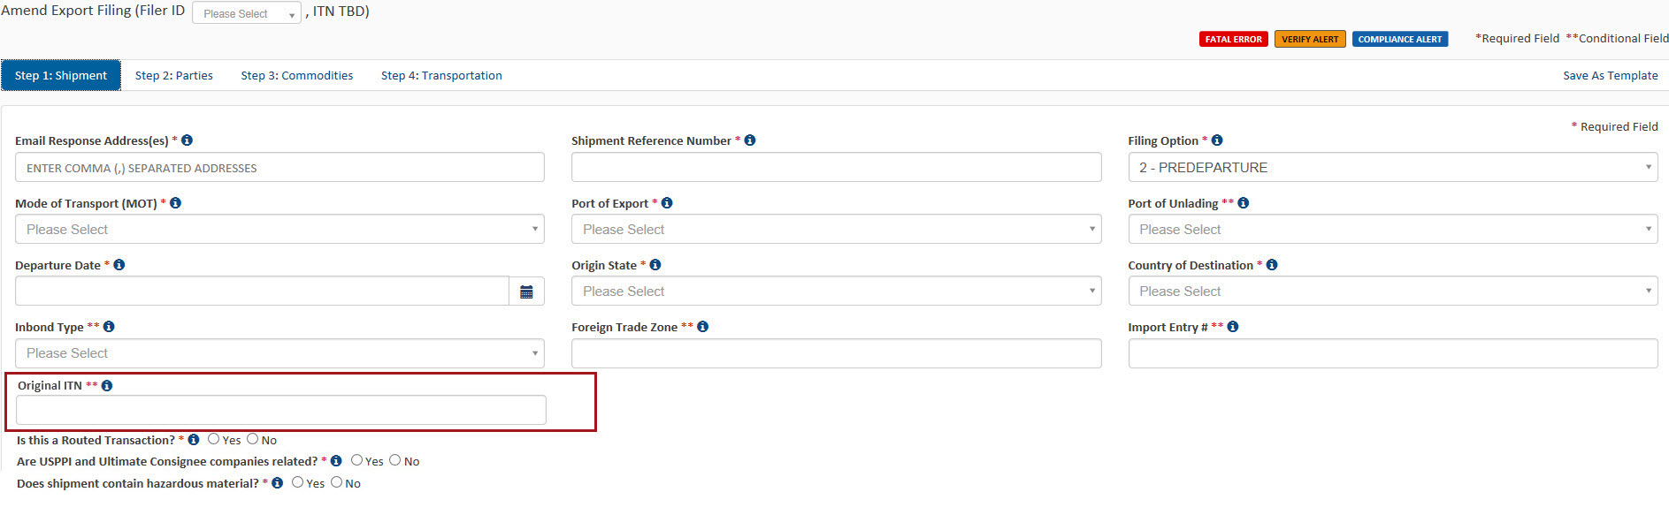

Proposed Data Fields Page 2

Used Electronics Indicator Field

