- AESDirect Record Formats
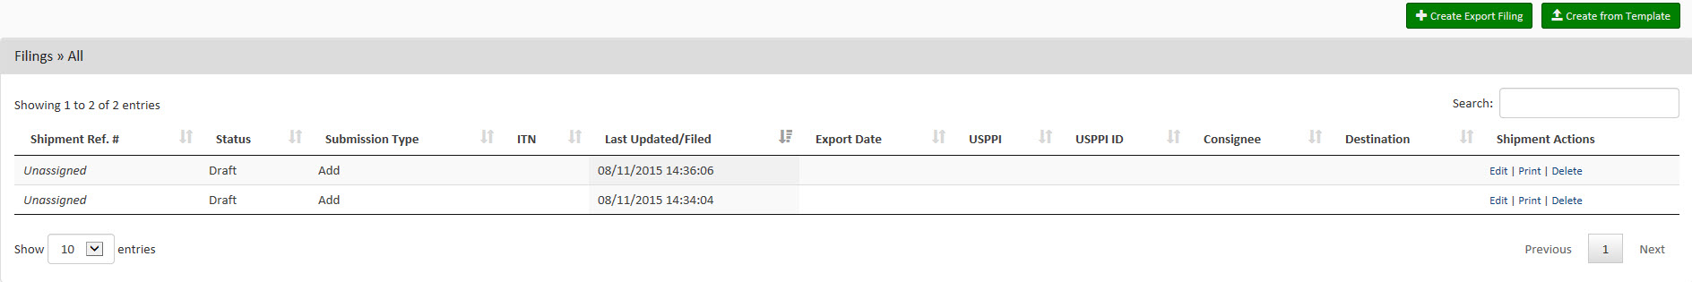
Launch Page

Shipment Page
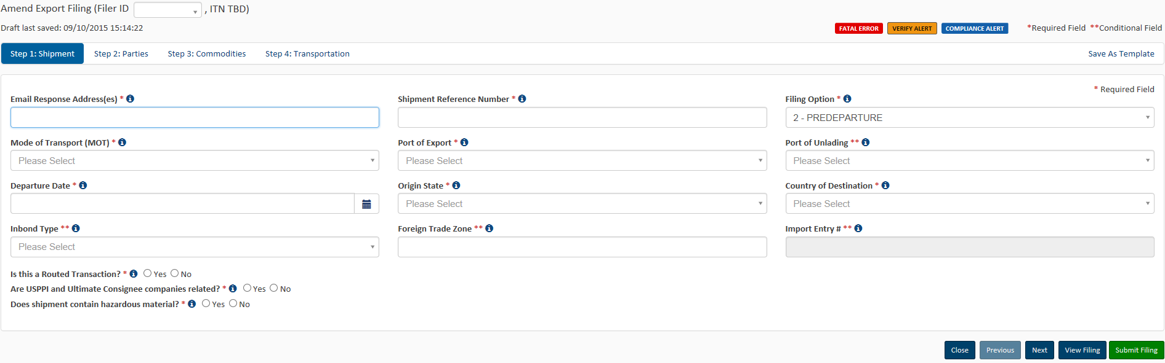
Parties Page 1: First half of screen
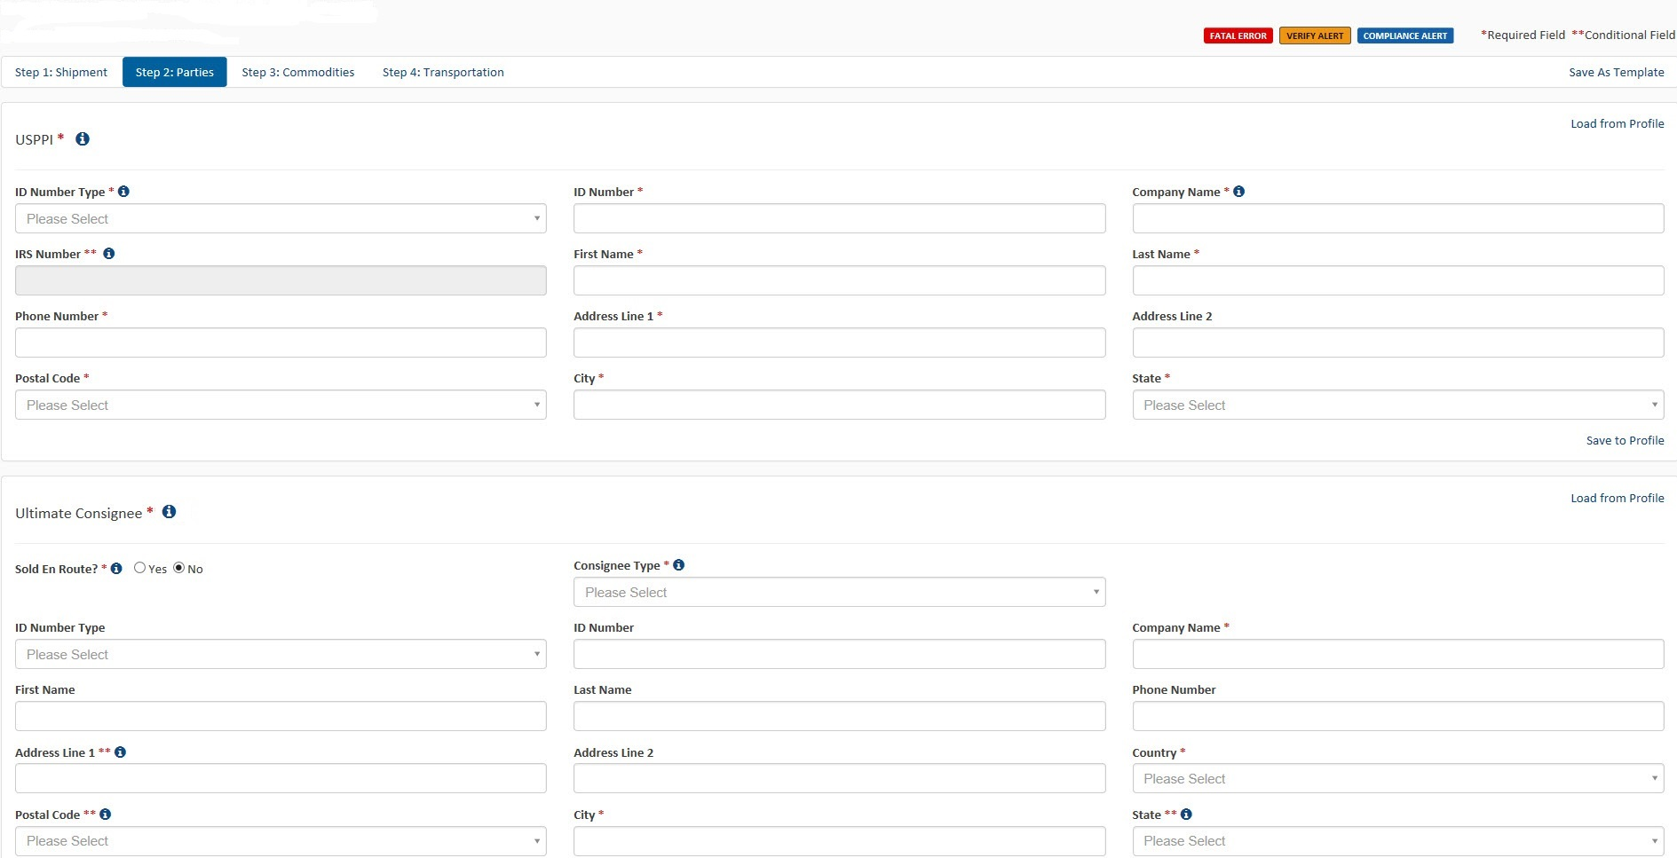

Parties Page 2: Second half of screen
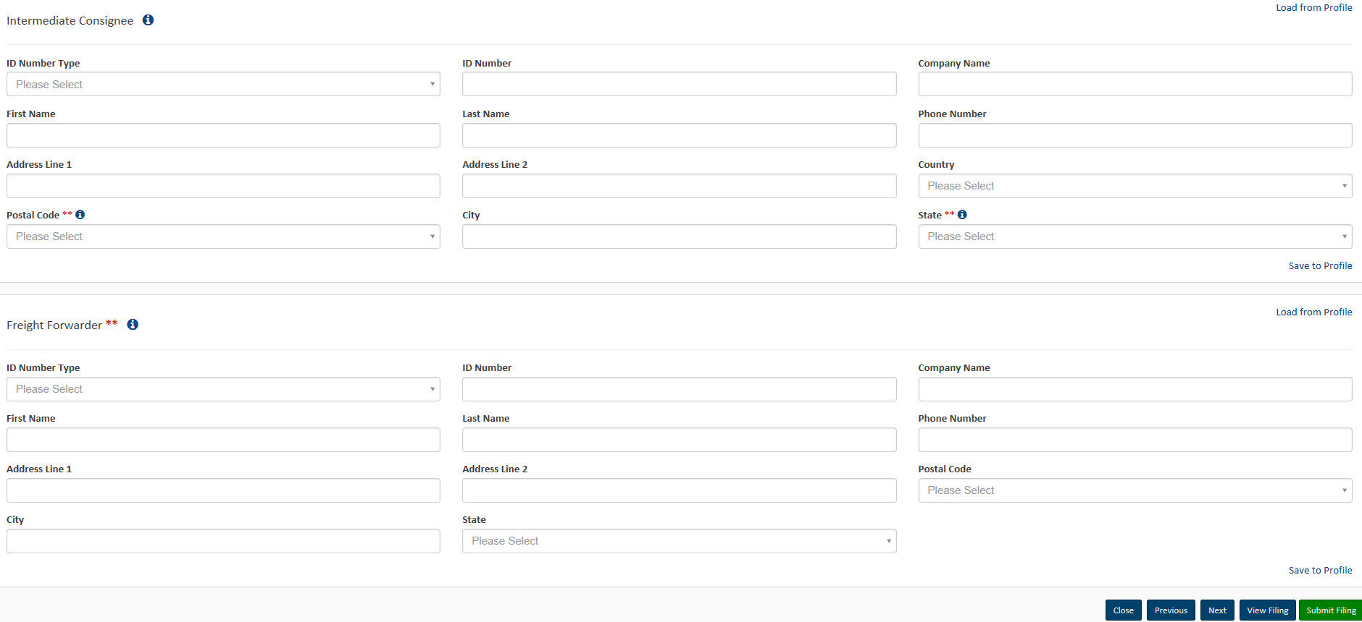

Commodities Page 1
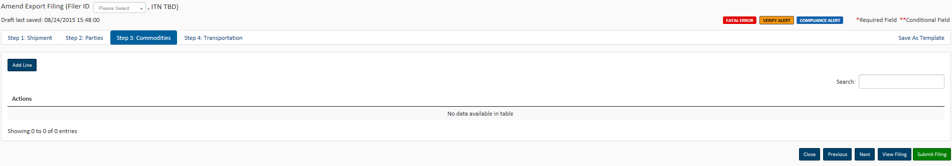
Commodities Page 2
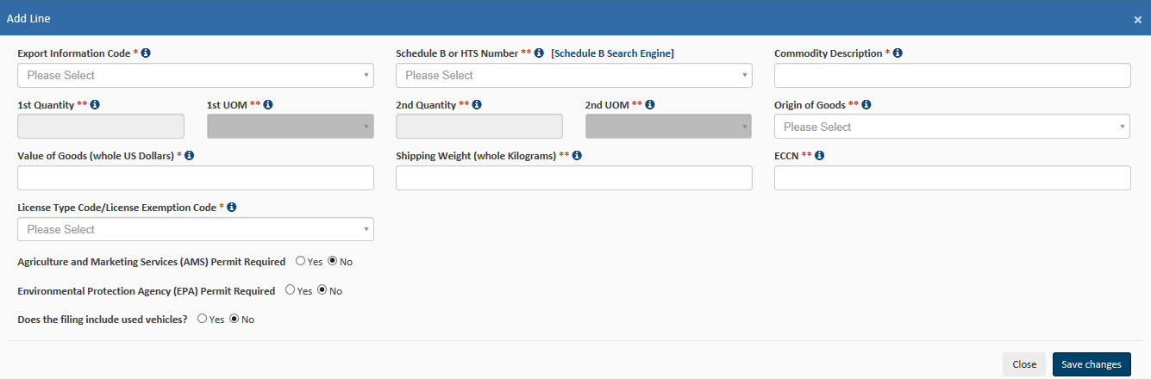

Transportation Page
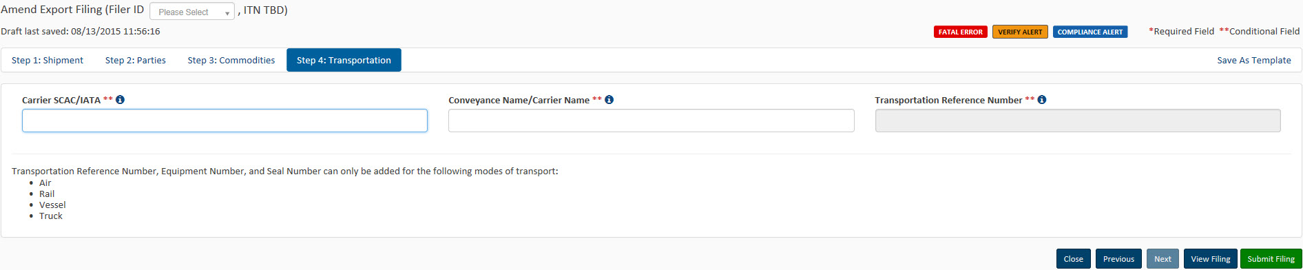

Proposed Data Fields Page 1
Original ITN Field
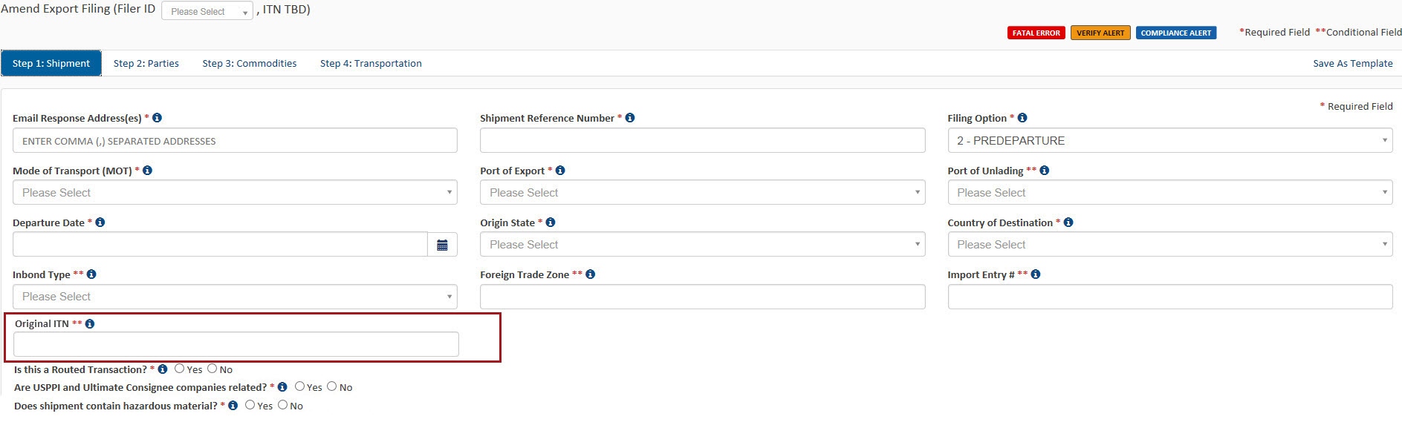

Proposed Data Fields Page 2
Used Electronics Indicator Field
