The Census Bureau wishes to make nonsubstantive changes to the Management and Organizational Practices Survey (MOPS) form MA-10002. After having conducted a second round of cognitive testing, as planned for and documented in our recent request for clearance of the MOPS, we request the following changes. A report of findings and recommendations from the second round of cognitive testing and the revised MA-10002 form are submitted with this request:
2015 MOPS changes as a result of second round of cognitive testing:
- Question 17: Removed “In 2010 and 2015,” clause from the question text so that the question reads “Was the headquarters for this company at the same location as this establishment?”
- Question 26: Change “Managers at other establishments including headquarters” to “Managers at headquarters and/or other establishments”.
- Question 28: Change “often” in the question text for both parts (a) and (b) to “frequently”
- Question 36: Change question text to, “For calendar years 2015 and 2016, what are the approximate dollar expenditures for this establishment on materials, parts, containers, and packaging?”
- Question 37: Change question text to, “Looking ahead to the 2017 calendar year, what are the approximate dollar expenditures on materials, parts, containers, and packaging you would anticipate for this establishment in the following scenarios, and what likelihood do you assign to each scenario?”
- Question 43: Change question to,
  - “In 2010 and 2015, what percent of all employees at this establishment could be classified in the following ways?”
  - Add telework option in order to distinguish from other flexible hours
 | 2010 |  | 2015
Employees who were part-time . . . . . . . . . . . . . . . . . . . . . . . . . . . . . . . . . . . . . . |  | % |  | %
Employees who were working flexible hours . . . . . . . . . . . . . . . . . . . . . . . . . . . |  | % |  | %
Employees who worked from home one day or more per week . . . . . . . . . . . |  | % |  | %
Employees who were cross-trained . . . . . . . . . . . . . . . . . . . . . . . . . . . . . . . . . . . |  | % |  | %

- Question 44:
  - Move line for “Cellular manufacturing” to between “Batch production” and “Continuous flow”.
  - Change “Continuous flow” to “Continuous flow (other than cellular manufacturing).”
- Question 45: Change question text to,
  - “Is this establishment owned 50% or more by its founder(s) or member(s) of a founder’s family?”
  - Change first response to “Yes, founder(s) owns it.”
  - Change the second response to “Yes, member(s) of a founder’s family owns it (e.g., daughter, son, sister, brother).”
  - Change third response to “No.”
  - Change conditional question to “If yes to either of the above, is the CEO of the firm also a founder or a member of a founder’s family?”
- Question 46: Change question text to, “Is this establishment part of a firm which has production establishments in other countries?”
- Add Instructions (between questions 29 and 30) to help respondents complete questions 30-37): 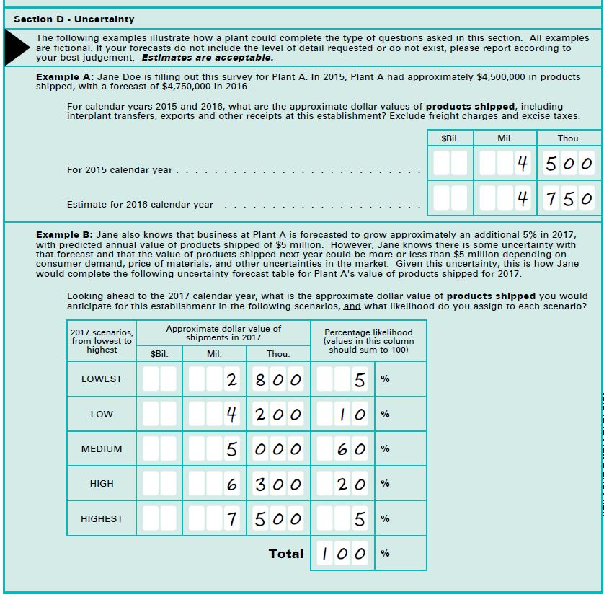

Additionally, we have made revisions to the L1 respondent letter to remove the user name and password. This information already appears directly on the MA-10002, MOPS form.

