date

John Smith
123 Average Avenue
Ft Lauderdale, FL 55555

Dear Permit Owner:

The NOAA Fisheries Service is working to improve its ability to determine the economic effects of regulations and other factors that impact South Atlantic fisheries. Therefore, we are conducting an Economic Expenditure Survey of Golden Crab Fishermen in the U.S. South Atlantic Region. In the interest of fairness and data quality, and in accordance with federal regulations, all selected individuals are required to complete and submit this survey.

Enclosed is a form asking about expenditures you made in 2015 for your vessel “ANON” with the registration number 555555. Please look at the enclosed materials for more details on this survey effort and why we need to collect this data.

Please complete the enclosed survey form and return it to us by August 30, 2016. A pre-addressed, postage-paid envelope is enclosed. All information you supply is confidential and will be combined with information from other fishermen to present an overall view of the economic status of the fishery.

By accurately completing this survey, you will ensure that management decisions are based on the best possible information about the economic effects of regulations on fishermen. Please print all requested information clearly. A form with incomplete or unclear information cannot be entered into the database and will be returned for clarification. If you have any questions or require help filling out the survey, please contact me at (305) 361-4468.

Thank you very much for your cooperation with this data collection and good luck this crabbing season.

Sincerely yours,
Scott Crosson
Economist

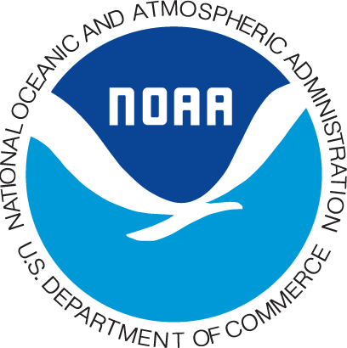
Golden Crab
Economic
Survey

Sponsored by
NOAA Fisheries

Last week a questionnaire seeking information on your business expenditures was mailed to you. If you have already completed and returned the questionnaire to us, please accept our sincere thanks. If not, please do so today. The number of golden crab fishermen is very small so it is extremely important that we hear from you. Your response ensures that the study accurately results reflect the economics of the fishery and will aid NOAA and the South Atlantic Fishery Management Council in the policy-making process.
REMINDER

If by some chance you did not receive the questionnaire,
or it got misplaced, please call
1-866-xxx-xxx

date

«Primary_Mailing_Recipient»
«Street_Address»
«City», «State» «Zipcode»

Dear <recipient>:

We want to thank you for your participation in the Economic Expenditure Survey of Golden Crab Fishermen in the U.S. South Atlantic Region. The information will help our researchers conduct economic and statistical analyses on the golden crab fishery.

If you have any further questions, please contact me at (305) 361-4468.

Thank you very much.

Sincerely yours,
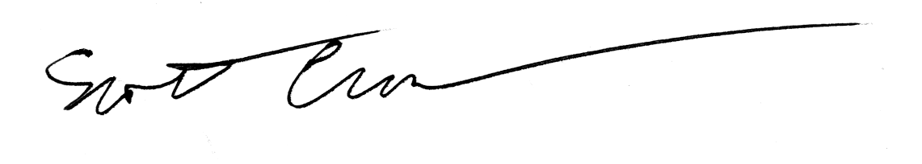
Scott Crosson
Resource Economist

