OFFICE OF THE aSSISTANT SECRETARY OF DEFENSE

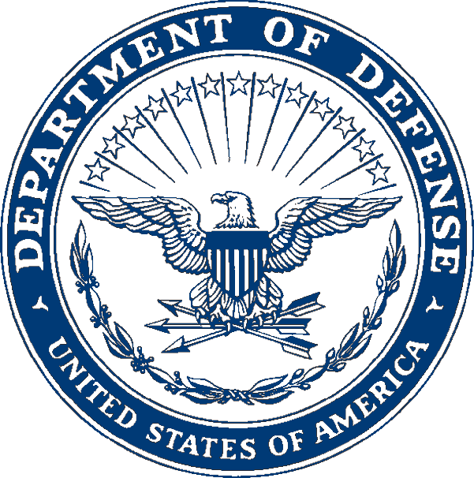
4000 DEFENSE PENTAGON
WASHINGTON, D.C. 20301-4000

manpower AND
reserve affairs

<Address>

Dear Sir/Madam:

The January 15, 2014 Joint Explanatory Statement of the Consolidated Appropriations Act of 2014 (Enclosure 1) requests the Department of Defense (DoD) to submit a report assessing the oversight, evaluation, and enforcement of the DoD Voluntary Education Partnership Memorandum of Understanding (MOU) related to advertising and marketing. The relevant excerpt may be found at Enclosure 1, entitled “Voluntary Military Education Programs Advertising and Marketing.” Specifically, Congress requested a voluntary accounting of the ten participating institutions that received the most Tuition Assistance (TA) program funds in fiscal year 2013 (FY13).

On June 30, 2014, DoD supported a working group meeting, facilitated by the Service members Opportunity Colleges, to identify and define common advertising, publicity, and marketing expenditures and resources employed to recruit Service members into Voluntary Education programs. Attendees included experienced institutional representatives from nine of the ten educational institutions receiving the most TA program funds in FY13. Since the meeting, DoD has been working to further develop common definitions and parameters for the data collection effort required in support of this reporting requirement.

Due to the delay experienced in meeting this reporting requirement, DoD will provide Congress with data for fiscal year, FY14. Your educational institution was one of the top ten recipients of TA program funds during FY14. As such, the Department is requesting your educational institution’s participation in this report. Specifically, please provide the total dollar value of your institution’s marketing, advertising, and recruitment budget and the percentage of that budget targeting Service members. Common definitions and parameters for the data collection effort are provided in Enclosure 2, entitled “Collection of Institution Advertising and Marketing Data Instructions,” to assist in more uniform reporting.

The Department is committed to reporting to Congress in a timely and responsive manner. However, numerous challenges were encountered in meeting the requested June 1, 2014, deadline.

Given your institution’s is a long-standing recipient of TA program funds and a signatory of the DoD Voluntary Education Partnership MOU, your institution’s participation is critical to accomplishing this important objective. Your input for this report is of great value to ensure the Department provides a comprehensive report on all the criteria established by Congress.

Please submit your response on official letterhead within 45 days from the date of this memorandum (transmission via email is acceptable). My point of contact for this matter is, Mr. Anthony Clarke, who can be reached at 571-372-5355 or anthony.b.clarke.civ@mail.mil.

Sincerely,

Dawn Bilodeau
Chief, DoD Voluntary Education
Military Community and Family Policy
Enclosures:
As stated

Sent via Certified Mail/Return Receipt

