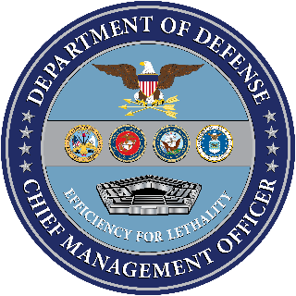

OMB Control NO: 0704-0553

Expiration Date: 4/30/2019

[Subject: REMINDER: There is still time to respond to the WHS Customer Experience Survey]

Good afternoon,

I am writing to remind you of an important initiative: Washington Headquarters Services (WHS) is surveying its customers to understand better how it provides services. We want to ensure future priorities at WHS are informed by our customers’ perspectives. I’m asking for your help in **completing the linked survey** **by Friday, November 16th** to ensure WHS provides you with the best possible service across its portfolio.

The survey will take about 10 minutes to complete. This survey is optional to take and is confidential. All results will be analyzed in aggregate and not individually.

If you have already completed the WHS survey, we thank you for your participation.

INSERT LINK (Either actual link or statement “Click here to begin the survey” with embedded link)

Thank you, in advance, for your time.

Sincerely,

Ms. Lisa Hershman