*OMB CONTROL NUMBER: 0710-0018*

*OMB EXPIRATION DATE: 11/30/2019*

**2017 Agricultural Shipper Needs Survey:**

**Upper Mississippi River System**

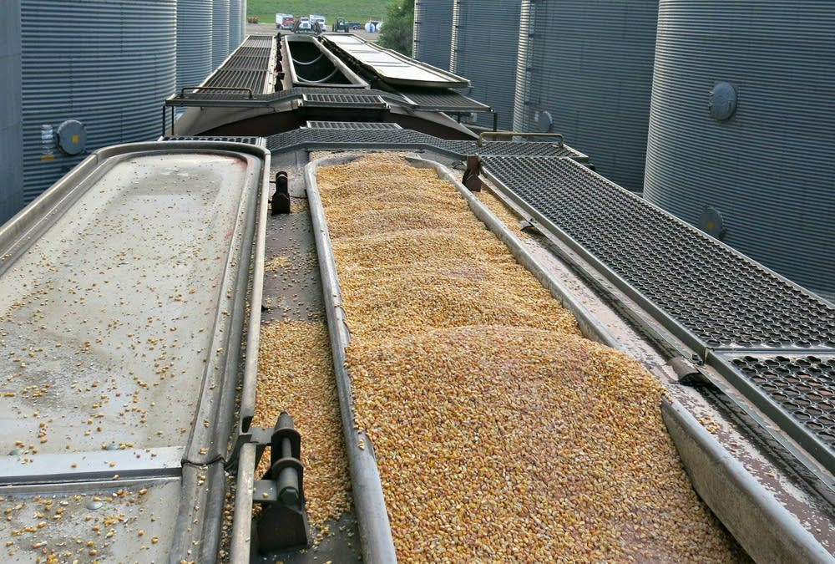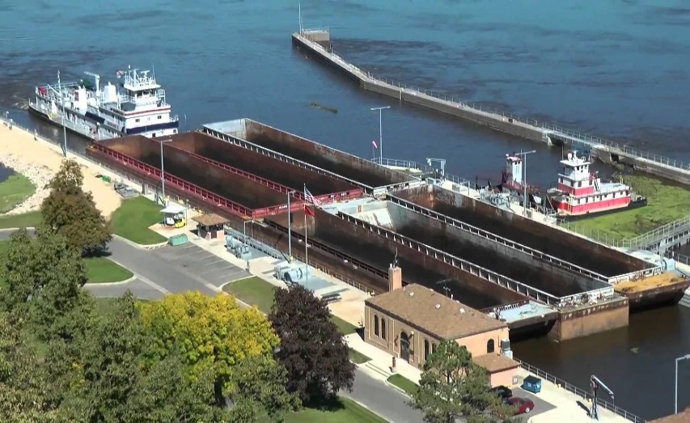

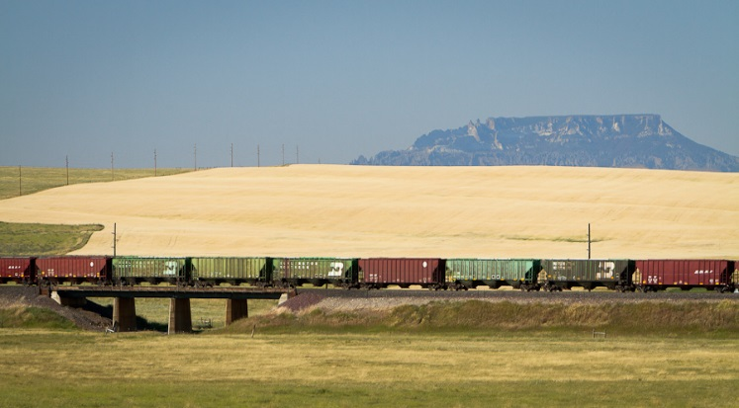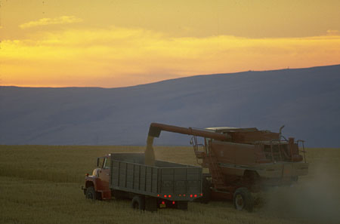

Sponsored by:

United States Army Corps of Engineers and Washington State University

Your responses to this survey will help us determine the need for transportation investments in your region. This information will be used by Federal and State Transportation agencies to evaluate and support public provision of transportation infrastructure improvements. The survey should take only about 15 minutes.

The public reporting burden for this collection of information, 0710-0018, is estimated to average 15 minutes per response, including the time for reviewing instructions, searching existing data sources, gathering and maintaining the data needed, and completing and reviewing the collection of information. Send comments regarding the burden estimate or burden reduction suggestions to the Department of Defense, Washington Headquarters Services, at whs.mc-alex.esd.mbx.dd-dod-information-collections@mail.mil. Respondents should be aware that notwithstanding any other provision of law, no person shall be subject to any penalty for failing to comply with a collection of information if it does not display a currently valid OMB control number.

**RETURN YOUR COMPLETED QUESTIONNAIRE TO:**

**Social & Economic Sciences Research Center**

**Washington State University**

**PO Box 641801**

**Pullman, WA 99164-1801**

**Shipment Information**

***«NAME»***

**Choice:** Consider your last shipment from this elevator: ***«ADDRESS1»***

***«CITY», «STATE» «ZIP»***

**Q1. What is the primary commodity you ship from this elevator?**  _____________ commodity

**Q2. At this location, do you have loading capabilities for…**

**Yes No**

**▼ ▼**

1. Trucks 🞏1 🞏2
2. Rail Cars 🞏1 🞏2

c. Barges 🞏1 🞏2

**Q2b. If YES to Rail loading capability, what is your rail car loading capacity?**

______ # of cars

**Q2c. If NO to Rail loading capability, how close is the nearest rail loading facility to this elevator?**

_______ miles

**Q2d. If NO to Barge loading capability, how close is the nearest barge loading facility to this elevator?**

_______ miles

**Your last Freight Shipment**

**Q3. What commodity was shipped in your last shipment?**  _____________ commodity

**Q4. Where was this commodity shipped to?** ____________________________ city ___________ state

**Q4b. What type of destination is this?**

🞏1 River terminal 🞏2 Another Elevator 🞏3 Railroad terminal 🞏4 Processing Plant

🞏5 Other (specify): ________________________

**Q5. How large was this shipment (payload weight)?**

_____________________________ payload weight, in

🞏1 Tons 🞏2 Hundred Weight (Cwt)* 🞏3 Gallons

🞏4 Bushels 🞏5 Shipment 🞏6 Other (specify): _________________

* *Cwt used throughout*

**Q6. What type of transportation was used for this shipment, approximately what**

**distance did each travel (in miles), and what was the transportation rate?**

**Mode** **Distance** **Transportation** **Per Unit type for commodity**

(check if used) **Traveled** Rate **Tons Cwt Gallons Bushels Shipment Othe**r (specify)

▼ ▼ ▼ ▼ ▼ ▼ ▼ ▼ ▼

🞏Truck __________ miles $_________ rate 🞏1 🞏2 🞏3 🞏4 🞏5 🞏6 _________

🞏Rail __________ miles $_________ rate 🞏1 🞏2 🞏3 🞏4 🞏5 🞏6 _________

🞏Barge __________ miles $_________ rate 🞏1 🞏2 🞏3 🞏4 🞏5 🞏6 _________

**Total Distance**

**Traveled** **Total Cost** **Tons Cwt Gallons Bushels Shipment Other** (specify)

▼ ▼ ▼ ▼ ▼ ▼ ▼

**Total Shipment** _________ miles $_________rate🞏1 🞏2 🞏3 🞏4 🞏5 🞏6 _________

**Q7. What do you estimate was the shipment time (include scheduling time, wait for equipment and transit time)?**

_________ days + _________ hours.

**Q8. How reliable is the service? That is, for shipments like this one, what percent of the time do you expect them to arrive on time?**

__________ percent on-time arrivals

**Q9. What price did you receive for your commodity at the destination terminal?**

__________ dollars per unit

🞏1 Tons 🞏2 Cwt 🞏3 Gallons 🞏4 Bushels 🞏5 Shipment 🞏6 Other (specify): _________________

**Shipping Alternatives**

***We want to know what options you could take if the mode and destination you used for your last shipment had not been available and would never be available. For example, if the rail system were shut down, shippers who used rail could use truck instead of rail, or could use barge with truck access to a barge loading facility, or could have sent the shipment to a different destination. We need to know what these alternatives are for you. Nearly everyone has some kind of shipping alternatives. If not, then the only alternative is to shut down and go out of business. Please provide us with information on these alternatives for you.***

**Q10. If the mode and destination you used for your last shipment had not been available and would never be available, what would you do?**

🞏1 Shut down and go out of business **🡪 skip to Q25**

🞏2 Continue your operations but in a different, perhaps costlier way

**First Shipping Alternative**

**Q11. Where would this commodity be shipped to?**  ____________________ city _______ state

**Q11b. What type of destination is this?**

🞏1 River terminal 🞏2 Another Elevator 🞏3 Railroad terminal 🞏4 Processing Plant

🞏5 Other (please specify): ________________________

**Q12. What transportation would be used for this shipment, approximately what distance would each travel (in miles) and what would be the transportation rate?**

Mode Distance Transportation **Per Unit type for commodity**

(check if used) traveled rate Tons Cwt Gallons Bushels Shipment Other (specify)

▼ ▼ ▼ ▼ ▼ ▼ ▼ ▼ ▼

🞏Truck __________ miles $________ rate 🞏1 🞏2 🞏3 🞏4 🞏5 🞏6 _________

🞏Rail __________ miles $________ rate 🞏1 🞏2 🞏3 🞏4 🞏5 🞏6 _________

🞏Barge __________ miles $________ rate 🞏1 🞏2 🞏3 🞏4 🞏5 🞏6 _________

**Estimate of**

**Total Distance Estimate of Per Unit type for commodity**

**Traveled** **Total Cost** Tons Cwt Gallons Bushels Shipment Other (specify)

▼ ▼ ▼ ▼ ▼ ▼ ▼ ▼

**Total Shipment ________ miles $________rate** 🞏1 🞏2 🞏3 🞏4 🞏5 🞏6 _________

**Q13. What do you estimate would be the shipment time (include scheduling time,**

**wait for equipment and transit time)?**

_________ days + _________ hours.

**Q14. How reliable would the service be? That is, for shipments like this one, what percent**

**of the time would you expect them to arrive on time?**

__________ percent on-time arrivals

**Q15. How large would your shipment be (payload weight)?**

_____________________________ payload weight, in

🞏1 Tons 🞏2 Cwt 🞏3 Gallons 🞏4 Bushels 🞏5 Other (specify): ____________________

**Q16. What price would you receive for your commodity at the destination terminal?**

__________ dollars per unit

🞏1 Tons 🞏2 Cwt 🞏3 Gallons 🞏4 Bushels 🞏5 Shipment 🞏6 Other (specify): __________________

**Other Shipping Alternatives**

**Please complete the table below for your other shipping alternatives. If you have no other alternatives, skip to Q24**

|  |  |  |
| --- | --- | --- |
|  | **Second Alternative** | **Third Alternative** |
| **Q17. Where would it be shipped to?** | ______________ city _______ state | ______________ city _______ state |
| **Q18. What type of destination is this?** | 🞏1 River terminal🞏2 Another Elevator  🞏3 Rail terminal🞏4 Processing Plant  🞏5 Other (specify): _______________ | 🞏1 River terminal🞏2 Another Elevator  🞏3 Rail terminal🞏4 Processing Plant  🞏5 Other (specify): _______________ |
| **Q19a. What type of transportation modes would be used for this shipment?** | Mode Distance Transportation  (Check if used) traveled rate  ▼ ▼ ▼  🞏Truck _____miles ____rate  🞏Rail _____miles ____rate  🞏Barge _____miles ____rate  🞏1 Tons 🞏2 Cwt 🞏3 Gallons  🞏4 Bushels 🞏5 Shipment  🞏6 Other (specify):__________________ | Mode Distance Transportation  (Check if used) traveled rate  ▼ ▼ ▼  🞏Truck _____miles ____rate  🞏Rail _____miles ____rate  🞏Barge _____miles ____rate  🞏1 Tons 🞏2 Cwt 🞏3 Gallons  🞏4 Bushels 🞏5 Shipment  🞏6 Other (specify):__________________ |
| **Q19b. What is the total distance and total cost for this shipment?** | **Total Total**  **Distance Cost**  Total  Shipment ________Miles $ _______rate  🞏1 Tons 🞏2 Cwt 🞏3 Gallons  🞏4 Bushels 🞏5 Shipment  🞏6 Other (specify):__________________ | **Total Total**  **Distance Cost**  Total  Shipment ________Miles $ ______  🞏1 Tons 🞏2 Cwt 🞏3 Gallons  🞏4 Bushels 🞏5 Shipment  🞏6 Other (specify):_________________ |
| **Q20. What do you estimate would be the shipment time?** | _____ days + _____ hours | _____ days + _____ hours |
| **Q21. How reliable would the service be?** | _____% on-time arrivals | _____% on-time arrivals |
| **Q22. How large would the shipment be?** | __________ payload weight  🞏1 Tons 🞏2 Cwt 🞏3 Gallons  🞏4 Bushels 🞏5 Other (specify):  _____________________ | __________ payload weight  🞏1 Tons 🞏2 Cwt 🞏3 Gallons  🞏4 Bushels 🞏5 Other (specify):  ______________________ |
| **Q23. What estimated price would you receive for your commodity at the destination terminal?** | __________ dollars  🞏1 Tons 🞏2 Cwt 🞏3 Gallons  🞏4 Bushels 🞏5 Shipment  🞏6 Other (specify): | __________ dollars  🞏1 Tons 🞏2 Cwt 🞏3 Gallons  🞏4 Bushels 🞏5 Shipment  🞏6 Other (specify): |

**Best Alternative Choice**

**Q24. Of the alternative shipments, if any, what is your “preferred alternative”? That is, if you could not make the shipment you made what shipment would you have made?**

🞏1 First Alternative

🞏2 Second Alternative

🞏3 Third Alternative

🞏4 Other Alternative (specify): _____________________

Transportation Rates

In each of the next three questions relating to rate and service changes, please regard the changes as **permanent** changes. Also, **if you marked you have no alternatives in Q10, page 3, please consider “out-of-business” as your alternative.**

**Q25. For your last shipment, if the transportation rate increased «Percent_change1»*%*, would you continue with the original mode and destination or switch to your best alternative choice?**

🞏1 Continue to use Original mode

🞏2 Switch to Best Alternative Choice **🡪** **Skip to Q26**

🞏3 Go out-of-business **🡪** **Skip to Q26**

**Q25b. If you would continue to use your Original mode, what percentage increase in the transportation rate would be necessary to cause you to switch to the Alternative transportation mode?**

______ % increase

Transit Time

**Q26. For your last shipment, if the transit time (including scheduling and wait for equipment) for the original option increased «Percent_change2»*%*, would you continue with the original mode and destination or switch to the alternative at this location?**

🞏1 Continue to use Original mode

🞏2 Switch to Best Alternative Choice **🡪** **Skip to Q27**

🞏3 Go out-of-business **🡪** **Skip to Q27**

**Q26b. If you would continue to use your Original mode, what percentage increase in the transit time would be necessary to cause you to switch to the Alternative transportation mode?**

______ % increase

Reliability

**Q27. For your last shipment, if the reliability (percentage of time shipments arrived on-time) of the original option decreased «Percent_change3»*%*, would you continue with the original mode and destination or switch to the alternative at this location?**

🞏1 Continue to use Original mode

🞏2 Switch to Best Alternative Choice **🡪** **Skip to Q28**

🞏3 Go out-of-business **🡪** **Skip to Q28**

**Q27b. If continue to use Original mode, what percentage decrease in the reliability would be necessary to cause you to switch to the Alternative transportation mode?**

______ % decrease

Volume

**Q28. If the average transportation rate you pay increased by «Percent_change4»*%*, would your annual volume shipped decrease** (assume the rate increase applies to *BOTH* you and to your competitors)**?**

🞏1 Yes

🞏2 No **🡪 Skip to Q29**

**Q28b. If yes, by how much would the volume decrease** (assuming the rate increase applies to both you and to your competitors)**?**

__________ volume decrease

**Q29. If the average transportation rate you pay increased by «Percent_change5»*%*, would your annual volume decrease** (assume that the rate increase applies *ONLY* to your firm and *NOT* to your competitors)**?**

🞏1 Yes

🞏2 No **🡪 Skip to Q30**

**Q29b. If yes, by how much would the volume decrease** (assuming that the rate increase applies ONLY to your firm and NOT to your competitors)**?**

__________ volume decrease

**Q30. If the average time in transit increased by «Percent_change6»*%*, would your annual volume decrease?**

🞏1 Yes

🞏2 No **🡪 skip to Q31**

**Q30b. If yes, by how much would the volume decrease?**

__________ volume decrease

**Q31. If the average time that shipments arrive on-time decreased by «Percent_change7»*%*, would your annual volume decrease?**

🞏1 Yes

🞏2 No **🡪 skip to Q32**

**Q31b. If yes, by how much would the volume decrease?**

__________ volume decrease

Shipper Characteristics

**Q32. How long has this elevator been at its current location?**

_____ years

**Q33. How large is your elevator?**

__________________ **Total Amount of Annual Units Shipped**

*please check the type of unit for this elevator*

🞏1 Tons 🞏2 Cwt 🞏3 Gallons 🞏4 Bushels 🞏5 Other (specify): __________________

__________________ **Total Amount of Storage Capacity**

🞏1 Tons 🞏2 Cwt 🞏3 Gallons 🞏4 Bushels 🞏5 Other (specify): __________________

**Q34. Does your firm (or parent firm) own export or import facilities?**

🞏1 Yes

🞏2 No

**Q35. How many facilities such as this one does your firm own and/or operate?**

_______________ number of elevators.

**Q36. Thank you for your help with this study. We would welcome any additional comments you would like to provide about shipping.**

**Please return your completed questionnaire to:**

**Social & Economic Sciences Research Center**

**Washington State University**

**PO Box 641801**

**Pullman, WA 99164-1801**

*(Form: ELVA-17 20170718*)

«ID» - 1