Screenshot of GISP web application Main Menu:
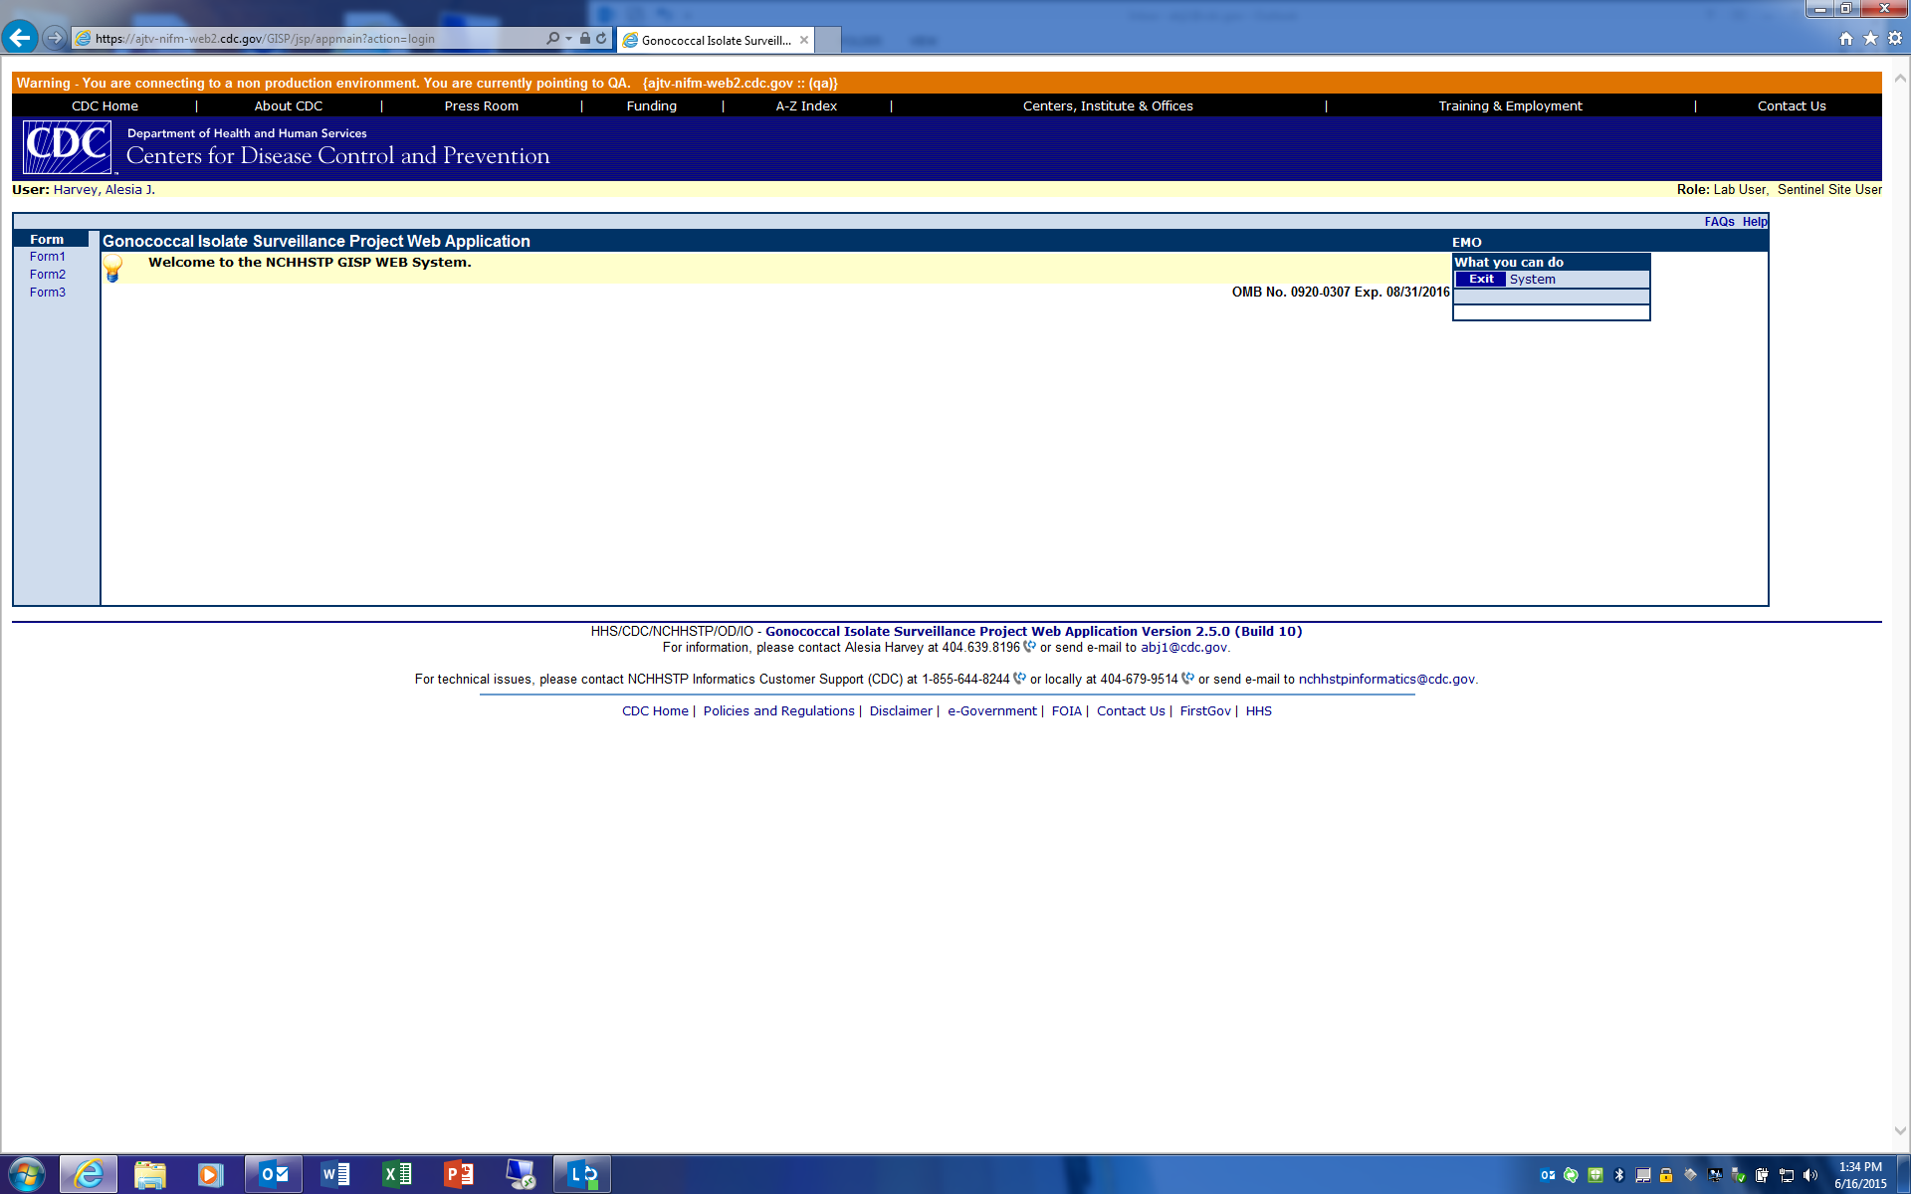

Screenshot of Form 1 data entry:
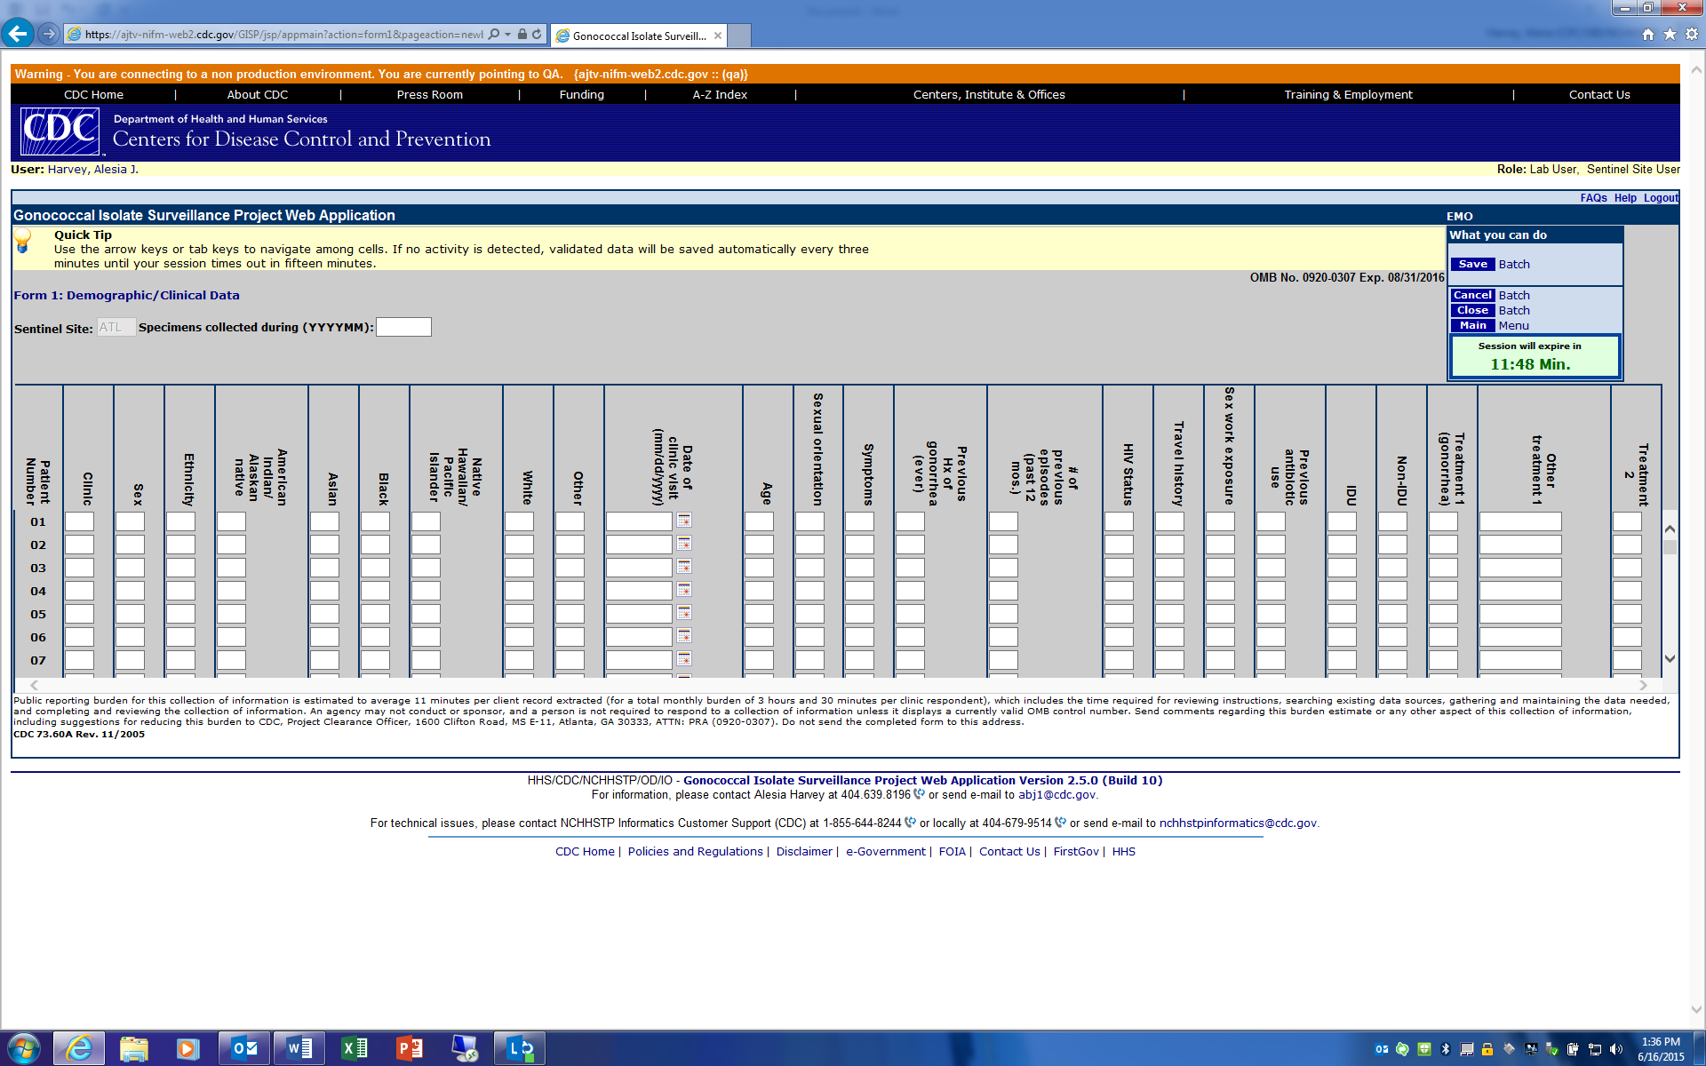

Screenshot of Form 2 Main Menu:
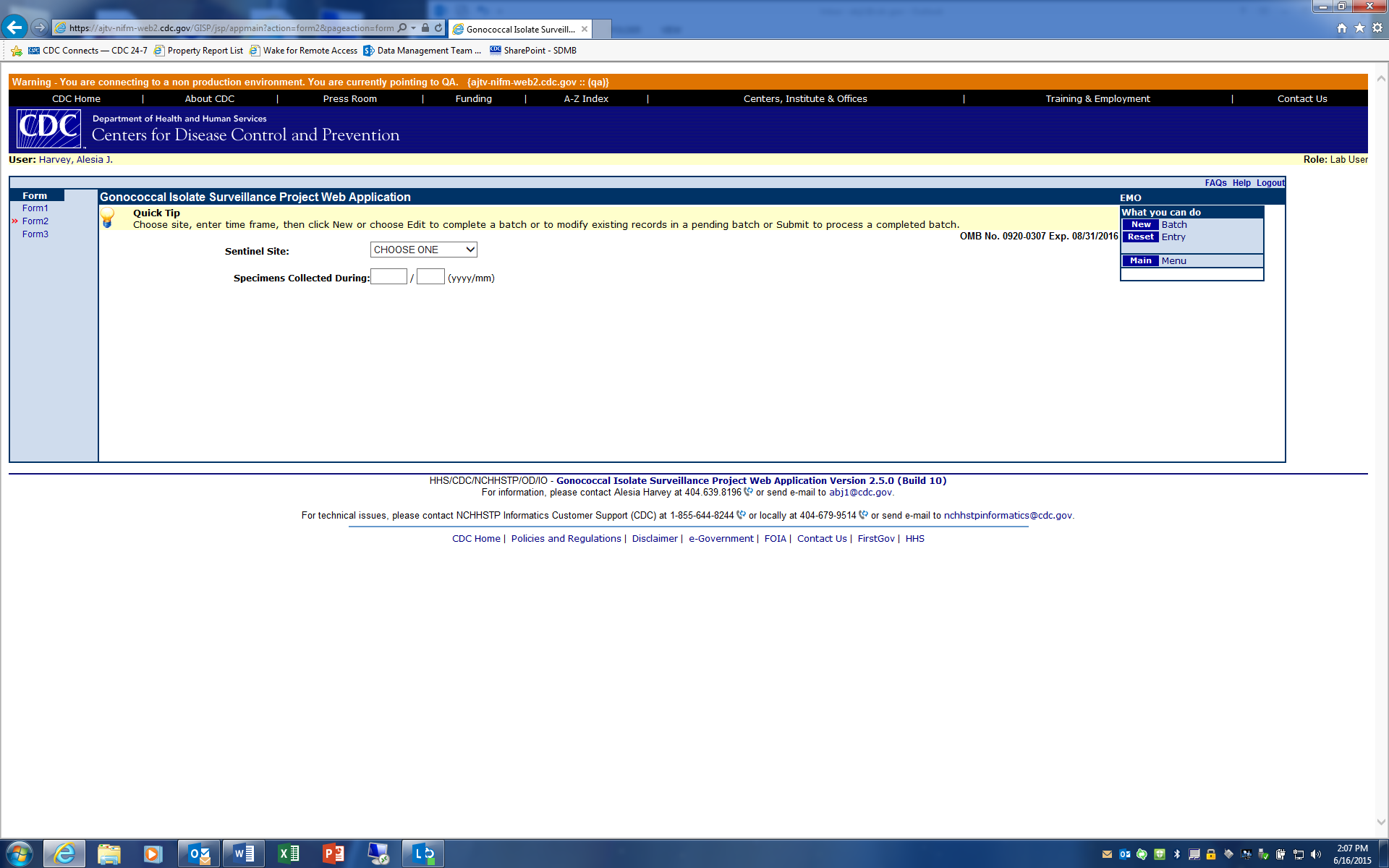

Screenshot of Form 2 data entry:
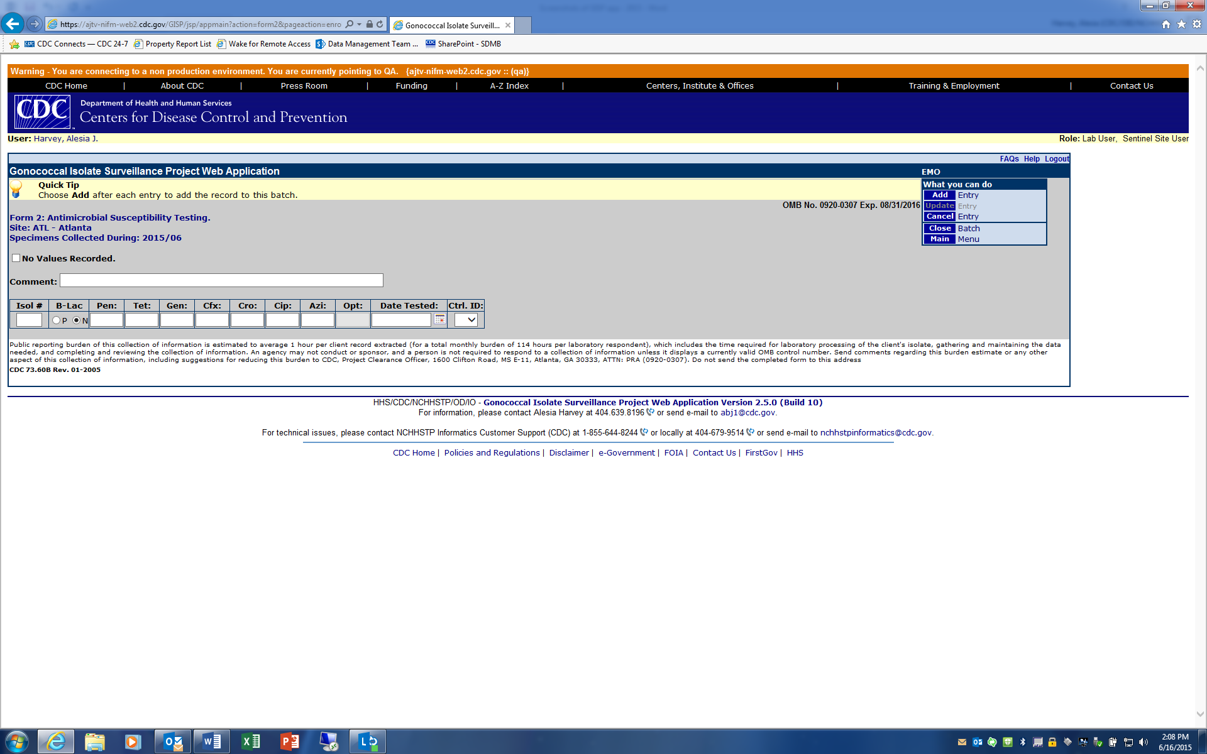

Screenshot of Form 3 data entry:
