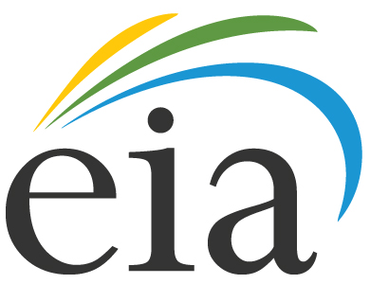

**U.S. Energy Information Administration**

**Office of Energy Analysis**

**Office of Electricity, Coal, Nuclear and Renewables Analysis**

**Supporting Statement for Survey Clearance**

**Standard Remittance Advice for Payment of Fees (NWPA-830G)**

**OMB No. 1901-0260**

|  |
| --- |
| **Collection of Information Employing Statistical Methods**  **Part B** |

Original Date: May 2015

**B. STATISTICAL METHODS**

1. Respondent Universe

All domestic owners and operators of operating commercial nuclear reactors will be providing data. The survey is a census of the target population and, therefore, no statistical sample methods will be employed. Changes to the respondent population are only made when a reactor permanently shuts down and is no longer required to pay fees into the Nuclear Waste Fund. The number of operable units in the United States, which remained at 104 for several years, has dropped to 99.

1. Procedures for Collecting the Information

Per contractual requirements, the Form NWPA-830G, “Appendix G - Standard Remittance Advice for Payment of Fees,” including Annex A to Appendix G, are required quarterly to ensure the accuracy of the quarterly fees, and to minimize interest payments when errors are made. There are no statistical procedures involved. However, since respondents are required to report only the adjustment factors used to calculate the “and sold” portion of their net electricity generated and sold amount, mathematical procedures must be used by the U.S. Energy Information Administration (EIA) to recalculate these factors using other data sources, from both EIA and the Federal Energy Regulatory Commission (FERC).

1. Methods to Maximize Response Rates

Response rates have always been 100 percent. The forms are transmittal documents and serve as a regulatory mechanism to insure timely response, since late response and fee payment will result in interest charged on the past due amount.

1. Tests of Procedures

These data collections have been ongoing since July 31, 1983; therefore, no additional tests of procedures are necessary.

1. Name and Telephone Number of Individuals

Marta Gospodarczyk of the Office of Electricity, Coal, Nuclear, and Renewables Analysis is the contact person regarding this information collection. Ms. Gospodarczyk may be contacted by e-mail (Marta.Gospodarczyk@eia.gov) which is recommended, or telephone at 202-586-0527, or fax via (202-287-1946). The mailing address is Office of Electricity, Coal, Nuclear, and Renewables Analysis, EI-34, U.S. Department of Energy, Washington, DC 20585.