Paperwork Reduction Act Submission
Please read the instruction before completing this form. For additional forms or assistance in completing this forms, contact your agency’s Paperwork Reduction Officer. Send two copies of this form, the collection instrument to be reviewed, the Supporting Statement, and any additional documentation to: Office of Information and Regulatory Affairs, Office of Management and Budget, Docket Library, Room 10102, 725 Seventeenth St. NW, Washington, DC 20503.
1. Agency/Subagency Originating Request:  U.S. Department of Housing and Urban Development  Office of Public and Indian Housing | 2. OMB Control Number:  a. 2577-0232 | b. None
3. Type of information collection: (check one)  - New Collection  - Revision of a currently approved collection  - Extension of a currently approved collection  - Reinstatement, without change, of previously approved  collection for which approval has expired  - Reinstatement, with change, of previously approved collection  for which approval has expired  - Existing collection in use without an OMB control number | 4. Type of review requested: (check one)  - Regular  - Emergency - Approval requested by  - Delegated  5. Small entities: Will this information collection have a significant economic impact on a substantial number of small entities?  Yes No  6. Requested expiration date:  a. Three years from approval date b. Other (specify)
3a. Public Comments
Has the agency received public comments on this information collection?
Yes No
7. Title:
Screening for Drug Abuse and Criminal Activity in Public Housing/Section 8 Admissions and Terminations

8. Agency form number(s): (if applicable)

N/A
9. Keywords:
Housing, screening, eviction, termination, drug abuse, criminal activity, criminal records

10. Abstract:
The information and collection requirements consist of PHA screening requirements to obtain criminal conviction records from law enforcement agencies to prevent admission of criminals into the public housing and Section 8 programs and to assist in lease/program enforcement and eviction/termination of those individuals in the public housing and Section 8 programs who engage in criminal activity.

11. Affected public: (mark primary with “P” and all others that apply with “X”)  a. X Individuals or households e. Farms  b. Business or other for-profit f. Federal Government  c. Not-for-profit institutions g. X State, Local or Tribal Government |  | 12. Obligation to respond: (mark primary with “P” and all others that apply with “X”)  a. Voluntary  b. P Required to obtain or retain benefits  c. Mandatory
13. Annual reporting and recordkeeping hour burden:  a. Number of respondents 3,946  b. Total annual responses 5,497,832  1. Percentage of these responses collected electronically 95%  c. Total annual hours requested 2,118,814  d. Current OMB inventory 2,118,814  e. Difference (+,-)  f. Explanation of difference:  1.  2. Adjustment: |  | 14. Annual reporting and recordkeeping cost burden: (in thousands of dollars)  Do not include costs based on the hours in item 13.  a. Total annualized capital/startup costs 0  b. Total annual costs (O&M)  c. Total annualized cost requested  d. Current OMB inventory  e. Difference  f. Explanation of difference:  1. Program change:  2. Adjustment:
15. Purpose of Information collection: (mark primary with “P” and all others that apply with “X”)  a. P Application for benefits e. Program planning or management  b. Program evaluation f. Research  c. General purpose statistics g. X Regulatory or compliance  d. X Audit |  | 16. Frequency of recordkeeping or reporting: (check all that apply)  a. Recordkeeping b. Third party disclosure  c. Reporting:  1. On occasion 2. Weekly 3. Monthly  4. Quarterly 5. Semi-annually 6. Annually  7. Biennially 8. Other - admissions/retention
17. Statistical methods:  Does this information collection employ statistical methods?  Yes No | 18. Agency contact: (person who can best answer questions regarding the content of this submission)  Name: Sheba Cousins  Phone: (202) 402-2986

19. Certification for Paperwork Reduction Act Submissions
On behalf of this Federal Agency, I certify that the collection of information encompassed by this request complies with 5 CFR 1320.9.
Note: The text of 5 CFR 1320.9, and the related provisions of 5 CFR 1320/8(b)(3). Appear at the end of the instructions. The certification is to be made with reference to those regulatory provisions as set forth in the instructions.

The following is a summary of the topics, regarding the proposed collections of information that the certification covers:
- It is necessary for the proper performance of agency functions;
- It avoids unnecessary duplication;
- It reduces burden on small entities;
- It uses plain, coherent, and unambiguous terminology that is understandable to respondents;
- Its implementation will be consistent and compatible with current reporting and recordkeeping practices;
- It indicates the retention periods for recordkeeping requirements;
- It informs respondents of the information called for under 5 CFR 1320.8(b)(3):
- Why the information is being collected;
- Use of the information;
- burden estimate;
- Nature of response (voluntary, required for a benefit, or mandatory);
- Nature and extent of confidentiality; and
- Need to display currently valid OMB control number;
- It was developed by an office that has planned and allocated resources for the efficient and effective management and use of the information to collected (see note in item 19 of the instructions);
- It uses effective and efficient statistical survey methodology; and
- It makes appropriate use of information technology.

If you are unable to certify compliance with any of these provisions, identify the item below and explain the reason in item 18 of the Supporting Statement.

Signature of Program Official:  X Milan Ozdinec, Deputy Assistant Secretary | Date:
Signature of Senior Officer or Designee:  Colette Pollard, Departmental Reports Management Officer  X Office of Chief Information Officer | Date:
Supporting Statement for Paperwork Reduction Act Submissions

A. Justification

1. Explain the circumstances that make the collection of information necessary. Identify any legal or administrative requirements that necessitate the collection. Attach a copy of the appropriate section of each statute and regulation mandating or authorizing the collection of information.

PHAs that administer the public housing and Section 8 programs are authorized under 42 USC 1437d(q) to obtain criminal conviction records from law enforcement agencies to prevent admission of criminals to public housing and Section 8 and to assist in lease/program enforcement and eviction/termination of those individuals in the public housing and Section 8 programs who engage in criminal activity. The aforementioned statutory authority is codified at 24 CFR 960.204 and 24 CFR 982.553, for the public housing and Section 8 programs, respectively.

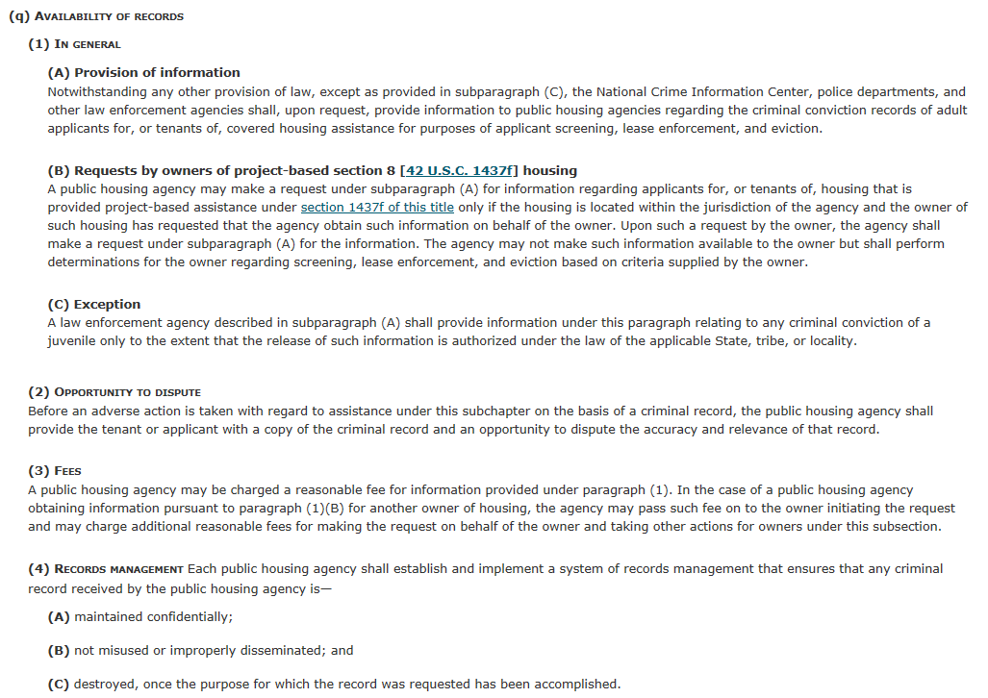
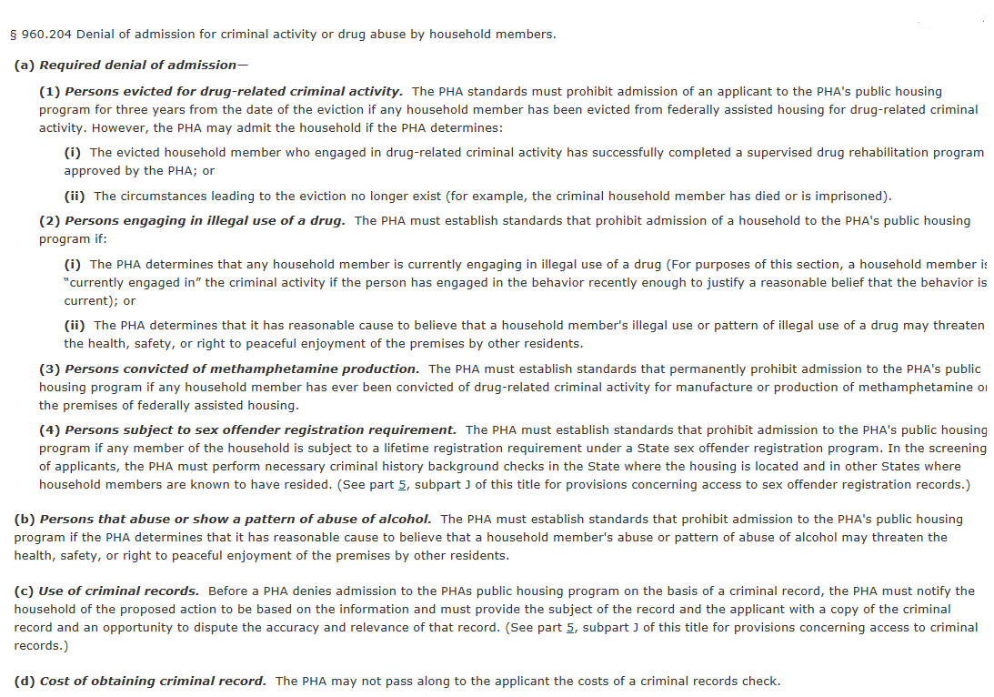
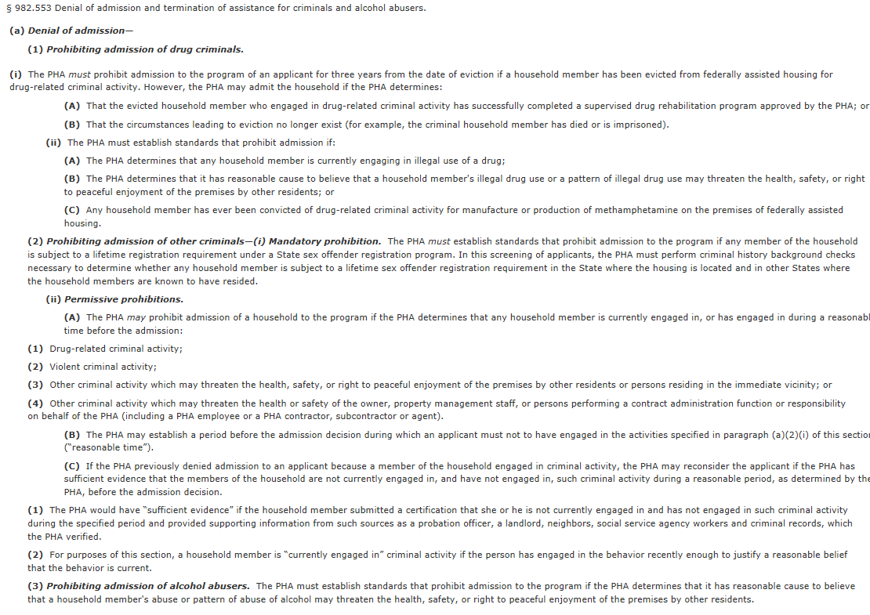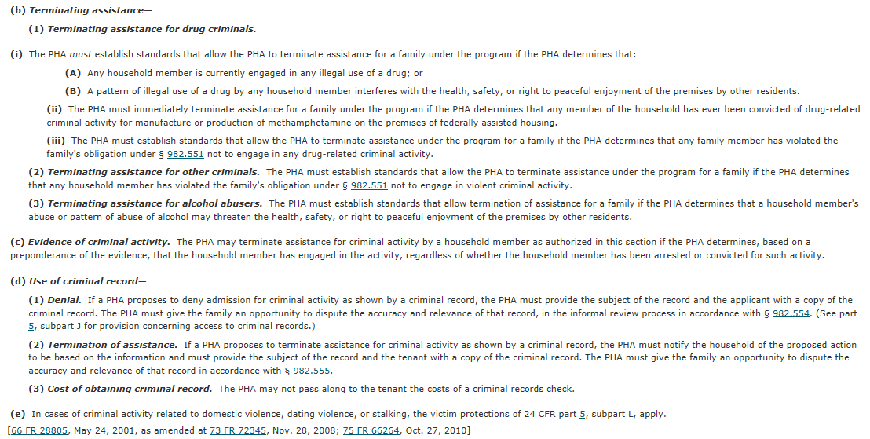

Public Housing Agencies (PHAs) must establish standards to prohibit the admission of Public Housing program applicants under the following circumstances:

- if the PHA determines that any household member is currently engaging in illegal use of a drug;
- if the housing agency believes there is illegal use or pattern of illegal drug use may threaten the health, safety, or right to peaceful enjoyment of the premises by other residents;
- if any member of the household is subject to a lifetime registration requirement under a State sex offender registration program; and
- if any household member has ever been convicted of drug-related criminal activity for manufacture or production of methamphetamine on the premises of federally assisted housing.

The collection of criminal conviction records of applicant and participant families of the public housing and Section 8 programs is also necessary to assist in the lease/program enforcement and evictions/terminations. Utilizing this information as part of program/lease enforcement emphasizes the importance of promoting safe and decent communities, as well improving program integrity by ensuring that limited affordable rental housing is provided to families who will comply with lease/program requirements.

2. Indicate how, by whom, and for what purpose the information is to be used. Except for a new collection, indicate the actual use the agency has made of the information received from the current collection.

To ensure eligibility, PHAs obtain criminal record information either manually or electronically through web-based applications (where available) prior to admission of an applicant family (only adult household members age 18 and over) to the Public Housing or Section 8 program. (This will be done all at once for members of applicant families). PHAs may also obtain criminal record information at any time during the participant family's tenancy, especially when there is an allegation of a lease/program violation related to criminal activity. Criminal record information is a tool that PHAs may use if there is a question regarding whether a household member committed an act that would result in eviction/termination under Department regulations.

3. Describe whether, and to what extent, the collection of information involves the use of automated, electronic, mechanical, or other technological collection techniques or other forms of information technology, e.g., permitting electronic submission of responses, and the basis for the decision for adopting this means of collection. Also describe any consideration of using information technology to reduce burden.
The information to be collected by PHAs is available via the National Criminal Information Center (NCIC) system, an automated and electronic database owned and managed by the Federal Bureau of Investigation (FBI). NCIC is a computerized index of criminal justice information; it is available to Federal, state, and local law enforcement and other criminal justice agencies and is operational 24 hours a day, 365 days a year. Data contained in NCIC is provided by the FBI, federal, state, local and foreign criminal justice agencies, and authorized courts. Many PHAs work through their local law enforcement agencies to obtain criminal records electronically from the NCIC system of applicant and participants in the public housing and Section 8 programs.

4. Describe efforts to identify duplication. Show specifically why any similar information already available cannot be used or modified for use for the purposes described in Item 2 above.

The criminal record information collection is applicant/participant-specific. The collection of criminal records only occurs once during the application process. The collection is performed again if a PHA needs to determine whether a participant is complying with the lease or program requirements, and may occur multiple times as needed as this information is subject to change. It should be noted that once the purpose of the criminal record use has been obtained, the record must be destroyed as prescribed by HUD requirements. As such, criminal records cannot be maintained for extended periods of time. Thus there is no duplication of information collection related to criminal records.

5. If the collection of information impacts small businesses or other small entities (Item 5 of OMB Form 83-I), describe any methods used to minimize burden.

This collection of information does not impact small businesses or other small entities. However, it should be noted that the PHA's burden in collecting criminal records is minimized through electronic and automated collection of the information as described in item 3 above.

6. Describe the consequence to Federal program or policy activities if the collection is not conducted or is conducted less frequently, as well as any technical or legal obstacles to reducing burden.

If criminal records are not collected by the PHA, it is possible that the PHA may admit a non-permissible criminal into the Public Housing or Section 8 program; it may also continue to allow a criminal to illegally occupy a unit subsidized by the Federal government. This will result in program non-compliance, decreased program integrity; decrease the availability of rental assistance to a needy and eligible low-income family, and misuse of Federal funds.

7. Explain any special circumstances that would cause an information collection to be conducted in a manner:

* Requiring respondents to report information to the agency more often than quarterly;

Information is collected at the PHA level on an individual, as-needed basis. Once the purpose for the criminal record has been fulfilled, the housing agency must destroy it. Respondents do not report information to the agency more often than quarterly.

* Requiring respondents to prepare a written response to a collection of information in fewer than 30 days after receipt of it;

Respondents are not required to prepare a written response related to the collection of criminal records. The PHA uses this information only for admission screening and eviction/termination purposes.

* Requiring respondents to submit more than an original and two copies of any document;

Respondents are not required to submit original or copies of the information collected. The PHA uses this information only for admission screening and eviction/termination purposes.

* Requiring respondents to retain records, other than health, medical, government contract, grant-in-aid, or tax records, for more than three years;

Respondents are not required to maintain the criminal records for more than three years.

* In connection with a statistical survey, that is not designed to produce valid and reliable results that can be generalized to the universe of study;

This collection of information is not in connection with a statistical survey.

* Requiring the use of a statistical data classification that has not been reviewed and approved by OMB;

This collection of information does not require the use of a statistical data classification that has not been reviewed and approved by OMB.

*That includes a pledge of confidentiality that is not supported by authority established in statute or regulation, that is not supported by disclosure and data security policies that are consistent with the pledge, or which unnecessarily impedes sharing of data with other agencies for compatible confidential use; or

A pledge of confidentiality is supported by the statutory authority established at 42 USC 1437d(q)(5) .

* Requiring respondents to submit proprietary trade secrets, or other confidential information unless the agency can demonstrate that it has instituted procedures to protect the information's confidentiality to the extent permitted by law.

PHAs are not required to submit proprietary trade secrets or other confidential information.

8. If applicable, provide a copy and identify the date and page number of publication in the Federal Register of the agency's notice, required by 5 CFR 1320.8(d), soliciting comments on the information collection prior to submission to OMB. Summarize public comments received in response to that notice and describe actions taken by the agency in response to these comments.

Describe efforts to consult with persons outside the agency to obtain their views on the availability of data, frequency of collection, the clarity of instructions and recordkeeping, disclosure, or reporting format (if any), and on the data elements to be recorded, disclosed, or reported. Consultation with representatives of those from whom information is to be obtained or those who must compile records should occur at least once every 3 years - even if the collection of information activity is the same as in prior periods. There may be circumstances that may preclude consultation in a specific situation. These circumstances should be explained.

HUD published a Notice of Proposed Information Collection for Public Comments in the Federal Register, Volume 81; No. 25; Page 6535 on February 8, 2016. The public was given until April 8, 2016 to submit comments on the proposed information collection.

9. Explain any decision to provide any payment or gift to respondents, other than re-enumeration of contractors or grantees.

No payment or gift will be provided to respondents.

10. Describe any assurance of confidentiality provided to respondents and the basis for the assurance in statute, regulation, or agency policy.

Respondents are not required to provide HUD with the collected information. The requested information is destroyed after the screening process is complete.

11. Provide additional justification for any questions of a sensitive nature, such as sexual behavior and attitudes, religious beliefs, and other matters that are commonly considered private. This justification should include the reasons why the agency considers the questions necessary, the specific uses to be made of the information, the explanation to be given to persons from whom the information is requested, and any steps to be taken to obtain their consent.

HUD does not require the asking of private or sensitive questions of the respondents or third parties.

12. Provide estimates of the hour burden of the collection of information. The statement should:

* Indicate the number of respondents, frequency of response, annual hour burden, and an explanation of how the burden was estimated. Unless directed to do so, agencies should not conduct special surveys to obtain information on which to base hour burden estimates. Consultation with a sample (fewer than 10) of potential respondents is desirable. If the hour burden on respondents is expected to vary widely because of differences in activity, size, or complexity, show the range of estimated hour burden, and explain the reasons for the variance. Generally, estimates should not include burden hours for customary and usual business practices.

Burden Hours for Admission Screening and Eviction/Termination of Public Housing and Section 8 Participants:

Burden Hours for Public housing New Admissions | Burden Hours for Public Housing evictions | Burden Hours for Section 8 New Admissions | Burden Hours for Section 8  terminations | Total Admission Screening and evictions/ terminations Burden hours
93,289 | 616,296 | 124,821 | 1,284,408 | 2,118,814

Number of Respondents | Number of Public Housing Responses | Number of Voucher Responses | Total  Responses
3946 | 1,805,222 | 3,692,210 | 5,497,832

Methodology for Calculations:
The burden hours were determined by adding together the following totals”

Screening of New Admissions, Public Housing (PH) Program = 93,289 (new admits) x 1 = 93,289 (burden hours)
Evictions of Public Housing participants = 1,711,933 (adults +50% children evicted) x .04 (per cent evicted) = 68,477 (annual evictions) x 9 (hrs. per response) = 616,296 burden hours
Screening of New Admissions, Voucher (PH) Program = 124,821 (new admits) x 1 = 124,821 (burden hours)

Terminations of Voucher participants = 3,567,789 (adults +50% children evicted) x .04 (per cent evicted) = 142,712 (annual terminations) x 9 (hrs. per response) = 1,284,408

The calculation for the total burden hours is below:

Total Public Housing Burden Hours for admission & eviction screening (709,585 hours) + Total Voucher Burden Hours for admission & termination screening of Voucher participants (1,409,229 hours) = 2,118,814

Calculation of Annualized Costs to Respondents for Cost of Burden Hours: 2,118,814 total hours x $17.11 per hour = $36,252,908. The hourly rate represents an average rate of pay earned by a housing specialist in a PHA responsible for collecting criminal information records as part of applicant screenings, activities associated with tenant evictions/terminations, etc.

13. Provide an estimate for the total annual cost burden to respondents or recordkeepers resulting from the collection of information. (Do not include the cost of any hour burden shown in Items 12 and 14).

There are no other costs associated with this collection of information other that what is reported in Item 12 above.

14. Provide estimates of annualized costs to the Federal government. Also, provide a description of the method used to estimate cost, which should include quantification of hours, operational expenses (such as equipment, overhead, printing, and support staff), and any other expense that would not have been incurred without this collection of information. Agencies may also aggregate cost estimates from Items 12, 13, and 14 in a single table.

There is no additional cost to HUD for the collection of this information.

15. Explain the reasons for any program changes or adjustments reported in Items 13 or 14 of the OMB Form 83-I.

The Number of Public Housing Authorities has decreased since the 2012 submission.

16. For collections of information whose results will be published, outline plans for tabulation and publication. Address any complex analytical techniques that will be used. Provide the time schedule for the entire project, including beginning and ending dates of the collection of information, completion of report, publication dates, and other actions.

The information collected by PHAs will not be published.

17. If seeking approval to not display the expiration date for OMB approval of the information collection, explain the reasons that display would be inappropriate.

PHAs will obtain criminal records from the National Criminal Information Center (NCIC). The collection of information will not be recorded on any HUD form. As such, it is not necessary to display the assigned OMB number and expiration date.

18. Explain each exception to the certification statement identified in Item 19, "Certification for Paperwork Reduction Act Submissions," of OMB Form 83-I.

There are no exceptions to the certification statement.

B. Collections of Information Employing Statistical Methods - [NOT APPLICABLE]

The agency should be prepared to justify its decision not to use statistical methods in any case where such methods might reduce burden or improve accuracy of results. When Item 17 on the Form OMB 83-I is checked, "Yes," the following documentation should be included in the Supporting Statement to the extent that it applies to the methods proposed:

1. Describe (including a numerical estimate) the potential respondent universe and any sampling or other respondent selection methods to be used. Data on the number of entities (e.g., establishments, State and local government units, households, or persons) in the universe covered by the collection and in the corresponding sample are to be provided in tabular form for the universe as a whole and for each of the strata in the proposed sample. Indicate expected response rates for the collection as a whole. If the collection had been conducted previously, include the actual response rate achieved during the last collection.

2. Describe the procedures for the collection of information including:

* Statistical methodology for stratification and sample selection,
* Estimation procedure,
* Degree of accuracy needed for the purpose described in the justification,
* Unusual problems requiring specialized sampling procedures, and
* Any use of periodic (less frequent than annual) data collection cycles to reduce burden.

3. Describe methods to maximize response rates and to deal with issues of non-response. The accuracy and reliability of information collected must be shown to be adequate for intended uses. For collections based on sampling, a special justification must be provided for any collection that will not yield "reliable" data that can be generalized to the universe studied.

4. Describe any tests of procedures or methods to be undertaken. Testing is encouraged as an effective means of refining collections of information to minimize burden and improve utility. Tests must be approved if they call for answers to identical questions from 10 or more respondents. A proposed test or set of test may be submitted for approval separately or in combination with the main collection of information.

5. Provide the name and telephone number of individuals consulted on statistical aspects of the design and the name of the agency unit, contractor(s), grantee(s), or other person(s) who will actually collect and/or analyze the information for the agency.

