PANELIST REVIEW OF ARS RESEARCH PROJECT PLAN
The purpose of this review is to judge the technical merit of the planned research and to make constructive comments for improvement. The focus of research has been determined by ARS to be essential to its mission, and, if approved, funding is available. It is important to state briefly the rationale for suggestions or questions posed. Recommendations can include specific questions you believe should be addressed by the lead scientist.

________________________________________________________________________________
- Adequacy of Approach and Procedures:
Are the hypotheses and/or plan of work well conceived? Are the experiments, analytical methods, and approaches and procedures appropriate and sufficient to accomplish the objectives? How could the approach or research procedures be improved?

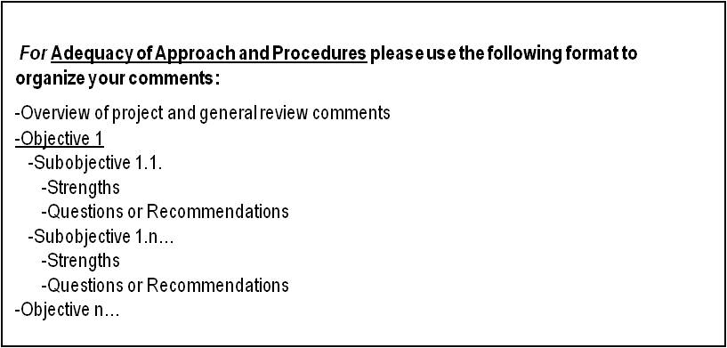

_______________________________________________________________________________
- Probability of Successfully Accomplishing the Project’s Objectives:
What is the probability of success in light of the investigator or project team’s training, research experience, preliminary data, if available, and past accomplishments? Are the objectives both feasible and realistic within the stated timeframe and with the resources proposed? Do the investigators have an adequate knowledge of the literature as it relates to the proposed research?

________________________________________________________________________________
- Merit and Significance:
Will the successful completion of the project enhance knowledge of a scientifically important problem? Will the project lead to the development of new knowledge and technology? Are you aware of any other data/studies relevant to this research effort? If applied research, comment on the value of the research to its customers.

________________________________________________________________________________
Additional Comments or Suggestions:

Public Burden Statement: According to the Paperwork Reduction Act of 1995, an Agency may not conduct or sponsor, and a person is not required to respond to a collection of information unless it displays a valid OMB number. The valid OMB control number for this information collection is 0518-0028. The time required to complete this information collection is estimated to average 6 hours per response, including the time for reviewing instructions, searching existing data sources, gathering and maintaining the data needed, and completing and reviewing the collection of information.

