Project Code 171 QID 050127 Dealers |  | OMB No. 0535-0003 Approval Expires 5/31/2016
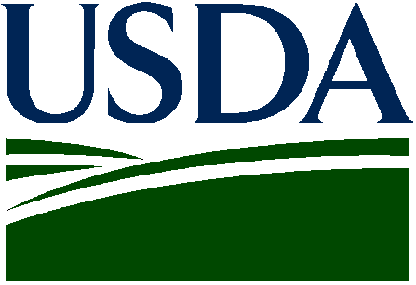 | RETAIL SUNFLOWER SEED  PRICE INQUIRY  March 2015 |  |  |  | 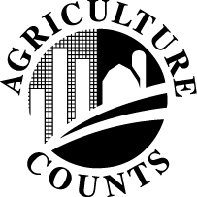 | NATIONAL  AGRICULTURAL  STATISTICS  SERVICE
USDA/NASS
Northern Plains Region
Room 298, Federal Bldg
100 Centennial Mall North
Lincoln, NE 68508
Phone: 1-800-582-6443
Fax: 1-855-270-2720
E-mail: NASSRFONPR@nass.usda.gov
This inquiry is to obtain information on prices farmers are paying for sunflower seed. Data from this survey is used to compute the Index of Prices Paid by Farmers, which is used in measuring price trends and the purchasing power of farm commodities.

The information you provide will be used for statistical purposes only. In accordance with the Confidential Information Protection provisions of Title V, Subtitle A, Public Law 107–347 and other applicable Federal laws, your responses will be kept confidential and will not be disclosed in identifiable form to anyone other than employees or agents. By law, every employee and agent has taken an oath and is subject to a jail term, a fine, or both if he or she willfully discloses ANY identifiable information about you or your operation. Response is voluntary.

Please make corrections in name, address and zip code, if necessary

- INSTRUCTIONS –

Please report quantity sold and to be sold to farmers this spring for planting and prices currently in effect (include transportation and handling costs). Enter price for the type MOST COMMONLY SOLD to farmers. Exclude state sales tax.

PLEASE RETURN BY APRIL 3, 2015

SUNFLOWER SEED PURCHASED BY GROWERS FOR PLANTING IN 2015
Item | Quantity (sold/to be sold)  Pounds | Price (paid/to be paid)  Dollars/Pound
Oil Type
Non-Oil Type

Reported by: ______________________________________________________ Date: _______________________________________

According to the Paperwork Reduction Act of 1995, an agency may not conduct or sponsor, and a person is not required to respond to, a collection of information unless it displays a valid OMB control number. The valid OMB number is 535-0003. The time required to complete this information collection is estimated to average 10 minutes per response, including the time for reviewing instructions, searching existing data sources, gathering and maintaining the data needed, and completing and reviewing the collection of information.

