United States Department of Agriculture

Farm and Foreign
Agricultural
Services

Farm Service Agency

1400 Independence Avenue, SW
Stop 0540
Washington, DC
20250-0540

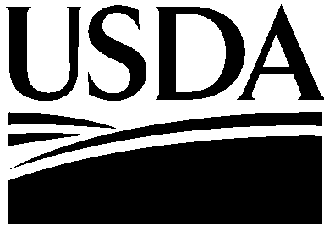


USDA is an Equal Opportunity Provider and Employer

DATE: February 9, 2016

TO: Cortney Higgins
OMB Desk Officer

THROUGH: Ruth Brown
USDA Information Collection Officer

FROM: Val Dolcini
FSA Administrator

SUBJECT: Request for Emergency Approval for a New Information Collection Request (ICR)—EZ Guarantee Program and Micro Lender Program (MLP) Status

This request is for OMB review and emergency approval of a new collection of information for the EZ Guarantee Program and MLP Status. The Farm Service Agency (FSA) is implementing a EZ Guarantee Program to provide guarantees for the Farm Loan Programs Operating Loans (OLs) and Farm Ownership Loans (FOs) and implementing a new micro lender status. FSA is establishing the EZ Guarantee Program to provide a guarantee for OLs and FOs up to $50,000. The reporting and record keeping requirements imposed on the public by regulations set out in 7 CFR part 761and 7 CFR part 762 are necessary to administer the EZ Guarantee Program and MLP in accordance with the statutory requirements and are consistent with commonly performed lending practices. Periodic collection of information after loans are made is necessary to protect the Government's financial interest. FSA is implementing the MLP Status to allow nontraditional lenders to participate in the Guaranteed ML Program.

FSA will merge the information collection with the ICR 0560-0155 upon OMB approval. FSA is doing an emergency request processing instead of the regular processing because OMB’s ROCIS system requires this request be submitted as an emergency request because. FSA was not required to do a proposed rule for the programs.

FSA will incorporate new provisions that include:

- Making the program available in credit deserts, tribal communities, and rural areas that are underserved.
- Extend eligibility to include non-traditional lenders.
- Establish new program requirements under new CFR part 761 and 762.
- Incorporate new instructions into internal handbooks used by State and county offices.
- Further, as required by the Departmental guidance and Freedom to E-File Act, FSA handbooks and forms are available in electronic format.

The collected information is needed to evaluate an applicant’s eligibility, determine the feasibility of the proposed operation, and the adequacy of the security being offered. In addition, a new lender status for nontraditional lenders is being added. The collection of information is need to evaluate those lenders that are non-traditional lenders who typically underwrite smaller size loans. The new status would allow for lenders who are not regulated by the typical federal regulatory agencies that oversee FSA’s current eligible lenders to underwrite guaranteed microloans.

We are requesting emergency approval of the new information collection package by April 29, 2016, in order to start the program effective immediately upon publication of the final rule.

If there are any questions or concerns, please call Deirdre Holder at 202-205-5851 or Mary Ann Ball at 202-720-4283.

