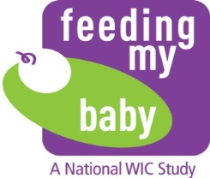

OMB Approval No.: 0584-0580

Approval Expires: XX/XX/20XX

**APPENDIX G9a**

**Reminders for consent – English**

**(Delivered by postal service)**

DATE

Dear [PARTICIPANT FIRST NAME]:

Thank you so much for continuing in the WIC ***Feeding My Baby*** study! You are in a select group of people who will help inform America about the choices families make in feeding their children, while receiving WIC or once they leave WIC.

While we know that you gave your consent over the telephone to be in the study extension, we are also seeking your written permission.

Please take a few minutes to read and sign the study **Consent** form. Return a signed copy in the enclosed prepaid envelope. Keep the other copy for your records.

If you have any questions, please contact <Study Liaison> at <toll-free number> or <email address> or by text at <test number>.

Thank you and we are looking forward to talking to you again.

The Feeding My Baby Study

According to the Paperwork Reduction Act of 1995, an agency may not conduct or sponsor, and a person is not required to respond to, a collection of information unless it displays a valid OMB control number. The valid OMB control number for this information collection is 0584-0580.  The time required to complete this information collection is estimated to average 1 minute (0.0167 hours) per response, including the time for reviewing instructions, searching existing data sources, gathering and maintaining the data needed, and completing and reviewing the collection of information.