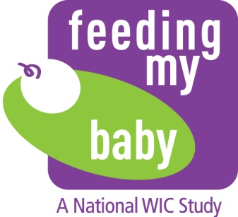

Dear [insert name]:

Thank you for your participation in the *Feeding My Baby Study*. With assistance from State and local agencies and the 80 WIC study sites, a total of 4,367 infants were enrolled in the study and the majority of them are still participating in it. In 2015, *Feeding My Baby* was extended for one additional year to follow the infants enrolled in the study through their third birthday. We are pleased to announce that the study is being extended for two additional years. The USDA Food and Nutrition Service (FNS) has continued to contract with Westat and its partners to follow the infants enrolled in the study through their fifth birthday, with four additional phone interviews conducted at ages 42, 48, 54 and 60 months and weight and length measurements collected at ages 48 and 60 months (fourth and fifth birthdays). This will further contribute to the study’s goals of documenting feeding practices of WIC infants, toddlers and pre-school age children and assessing the impact of WIC on those practices. It will also provide important information about parent/caregiver decisions regarding whether or not to continue participating in WIC as their child grows older.

For the two additional years, State and local agencies and WIC sites will be asked to provide a minimal amount of assistance. Westat will communicate about the extension of the study with the parents/caregivers of the children, obtain their consent to continue on the study, and stay in contact with them to encourage their ongoing participation in the study. Westat’s Institutional Review Board (IRB) has reviewed and approved the study extension. For States or local agencies that require IRB approval, Westat will submit an amendment for the study extension to the IRB that has previously approved the study.

During the additional two years, the WIC State Agencies and sites in the study will be asked to:

* Conduct weight and height measurements for children in the study around the time of the fourth and fifth birthdays, and record the measurements on a *Feeding My Baby Study Measurement Card*. Westat will ask parents/caregivers to go to a WIC site or healthcare provider to obtain the measurements and will provide them with the measurement card to take to WIC or the healthcare provider and mail back to Westat.
* Respond to one additional WIC administrative data request for height and weight measurements for four year old children on the study who are still participating in WIC at the time of the 48-month interview. The request will be made during October 2018 - January 2019, and it will include only children whose parents/caregivers have not returned a *Feeding My Baby Study Measurement Card* with the measurements.
* Occasionally assist with contacting parents/caregivers of children in the study when they cannot be located through other means. Requests for assistance will occur only when the child is believed to be enrolled in WIC.

As we explained when the study was extended to age three years, the collection of height and weight measurements for study participants who are no longer on WIC is an authorized use of Nutrition Services and Administration funds under Federal regulations at 7 CFR 246.26(k), which require State and local agencies to cooperate in studies and evaluations conducted by or on behalf of FNS. However, with State agency agreement, Westat will offer small grants to the 80 study sites for their assistance in weighing and measuring the children who are no longer on WIC.

Altarum and Westat will host a *Feeding My Baby Study* webinar to provide study updates and describe future data collection activities planned for the study extension period. We are pleased to invite you to join the webinar on:

[Date and time]

[Webinar link and telephone conference information]

The Study Contact(s) at each of the WIC sites will also receive an announcement regarding the extension of the study with an invitation to the webinar.

Following the webinar, we will schedule a short phone call with you to discuss details about the activities associated with the study extension and answer your questions regarding the study. We will also request your assistance in scheduling a conference call to discuss the study extension with the WIC sites in your State. A member of the study team from Altarum will contact you to schedule a convenient time for a call. In the meantime, please feel free to contact Linnea Sallack at [linnea.sallack@altarum.org](mailto:linnea.sallack@altarum.org) or by phone at 405-310-4775 if you have questions or concerns about the study or if there has been a change in your State Agency point-of-contact for the study.

We appreciate your ongoing support for the *Feeding My Baby Study* and look forward to talking to you about the extension of the study.

Sincerely,

cid:image002.jpg@01CD5F73.396A54C0

Linnea Sallack, MPH, RD

Altarum Institute Study Coordinator

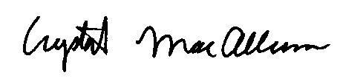

Crystal MacAllum, PhD

Operations Director, Westat