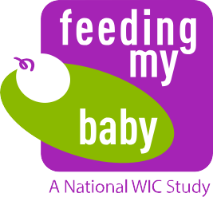
We want to interview you twice a year (every 6 months) and get height and weight measurements for your child once a year until your child is age 5. After each interview
and measurement, we will add cash to your prepaid MasterCard (see back for details).
You can receive up to $500 during this 3 year extension. Each interview will take about
30 minutes.

We ask you to let us know you will continue in the study by signing one copy of the
consent form. Please return the form in the self-addressed postage-paid envelope.
Your continued participation is key to the success of the study.
The USDA Food & Nutrition Service is finding the Feeding My Baby Study
so important that they want to continue to collect information about
your child through his or her 5th birthday.

This unique national study is providing information on what children eat and how they
grow. 4,367 parents from 27 states enrolled in the study. YOU are one of them and a
critical part of the study! No one can take your place.
We have good news to share!
As a token of our appreciation, we will add cash to your prepaid MasterCard
in these amounts:

$30 ($40*) | after you complete the age 2½ interview.
$40 ($50*) | after you complete the age 3 interview. If you are no longer receiving  WIC, you will receive another $30 after taking your child to WIC  or your doctor’s office to be weighed and measured and return the measurement card to us.
$45 ($55*) | after you complete the age 3½ interview.
$50 ($60*) | after you complete the age 4 interview. You will receive another $60  after you take your child to WIC or your doctor’s office to be weighed  and measured and return the measurement card to us.
$55 ($65*) | after you complete the age 4½ interview.
$60 ($70*) | after you complete the age 5 interview. You will receive another $70  after you take your child to WIC or your doctor’s office to be weighed  and measured and return the measurement card to us.
 | * if you are using your own cell phone.
In total, you could receive up to $500 after completing 6 interviews and getting your child’s height and weight measurements from WIC (or your doctor’s office) 3 times between ages 2½ and 5. All incentives will be loaded onto your prepaid MasterCard, so please hold onto the card between interviews!
Study Extension Incentive

