**Appendix**

**Example of the use of the Generic Field Clearance Package**

Objective: To test changes to the Census Bureau’s mailing material messages we used the Generic Field Clearance Package to implement a small test with modifications to our mailing materials in October 2015. The October 2015 Small-Scale Mailout Test determined whether modifying the “community benefits” message would increase online response to a Census Bureau survey. Research conducted by Reingold, Inc. (a communications and marketing firm under contract with the Census Bureau) suggested benefits to local communities (such as new schools) would motivate people to answer Census Bureau surveys. It would be impossible to print particular examples of census data uses for the mailings in each community. A feasible alternative was to specify the “community.” The modifications to the messages in our mailing materials included making the “community benefits” message more geographic specific, referring to the city, state or the state alone. We used a small-nationally representative sample under the field clearance to test it.

Panel Design and Schedule

|  |  |  |  |
| --- | --- | --- | --- |
| Panels | October 9, 2015  Mailout of Initial Letter | October 16, 2015  Mailout of Reminder Postcard | October 23, 2015  Mailout of Final Letter |
| 2,000 Housing units with the traditional “community benefits message” | Figure 1 | Figure 4 | Figure 5 |
| 2,000 Housing units with a fill of City and State in the “community benefits message” | Figure 2 | Figure 4 | Figure 6 |
| 2,000 Housing units with a State fill in the “community benefits message” | Figure 3 | Figure 4 | Figure 7 |

Results: With a three week response period (October 9-October 31, 2016), results showed there was no significant difference in the response rate between treatments (Chi-sq=2.83, p=0.24). Therefore, adding a specific geography to the benefits message did not improve response over the production “community” message.

|  |  |  |
| --- | --- | --- |
| Traditional – No fill (Value=1) | 34.2% | 683/2000 |
| City /State fill (Value=2) | 31.7% | 633/2000 |
| State fill (Value=3) | 33.0% | 659/2000 |

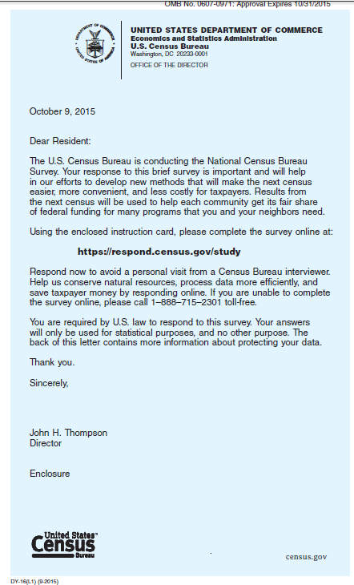

Figure : Traditional use of "each community" in the initial letter

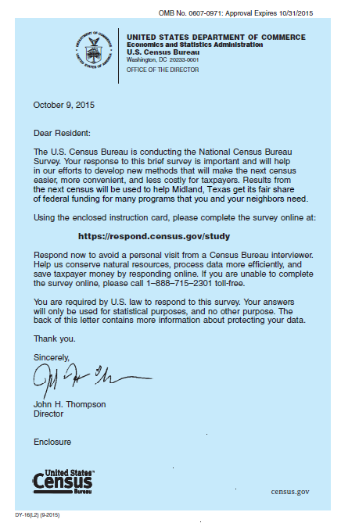

Figure : Replacing “each community” with a city and state (Midland, Texas is an example.)

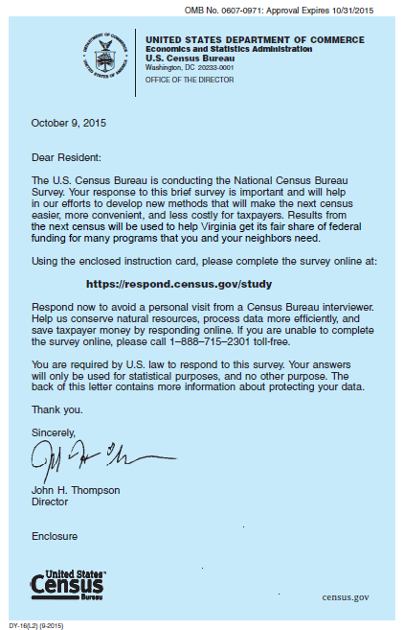

Figure : Replacing “each community” with a state (Viginia is an example)

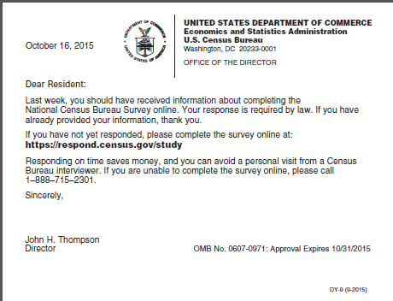

Figure : Reminder postcard

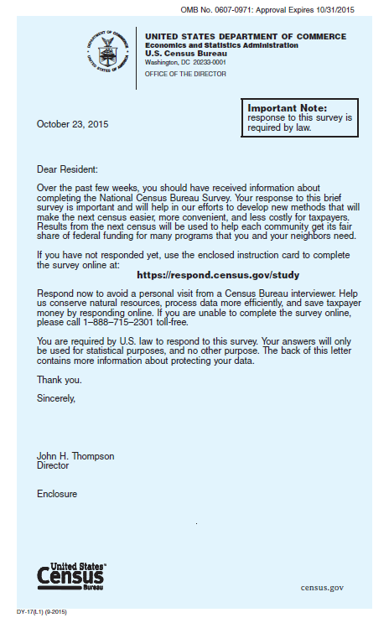

Figure : Traditional reminder letter with "each community"

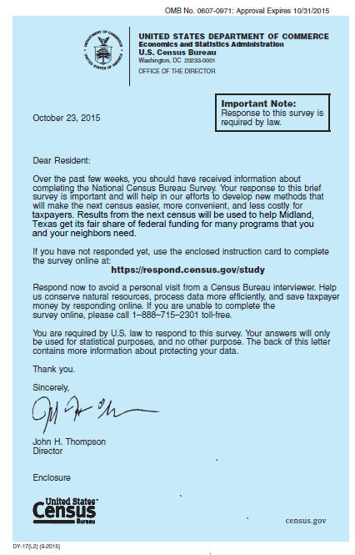

Figure : Reminder letter replacing "each community" with city and state (Midland, Texas is an example)

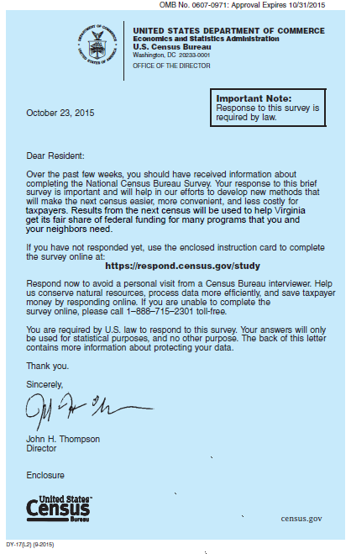

Figure : Reminder letter replacing "each community" with state (Virginia is an example)