A Census Operations Mobile Platform for Adaptive Services and Solutions (COMPASS) mobile device will support the 2016 SBE Census Test. Below are samples of COMPASS screenshots that were developed to meet the needs of the 2016 SBE Census Test.

Active and Inactive Caselist Screen | Case Details Screen
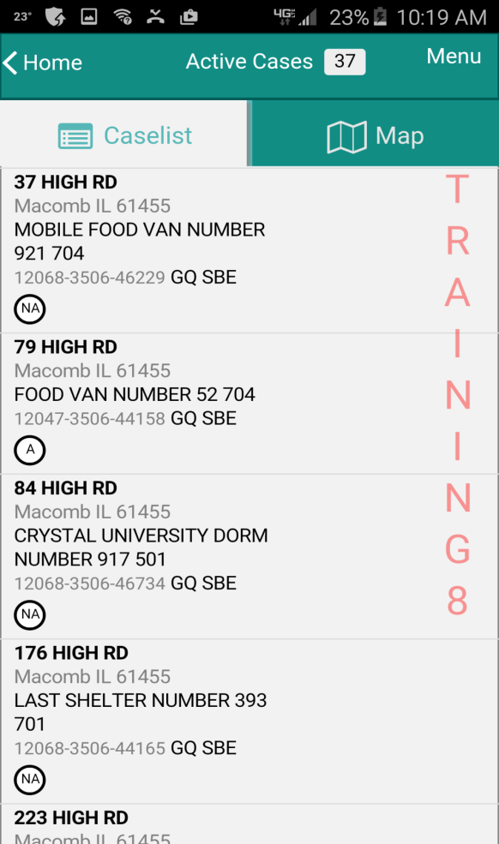 | 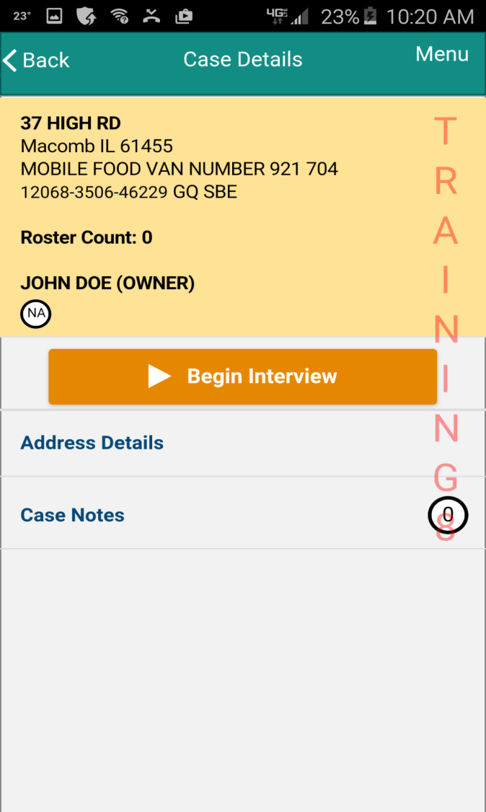

Attempt Type Screen | No Complete Screen
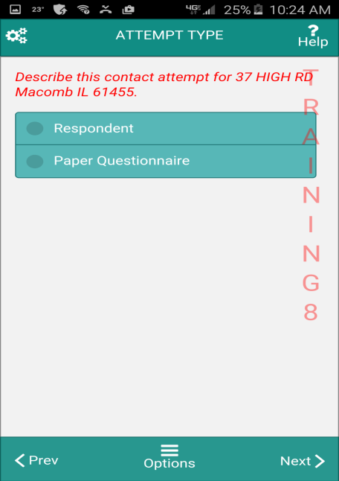 | 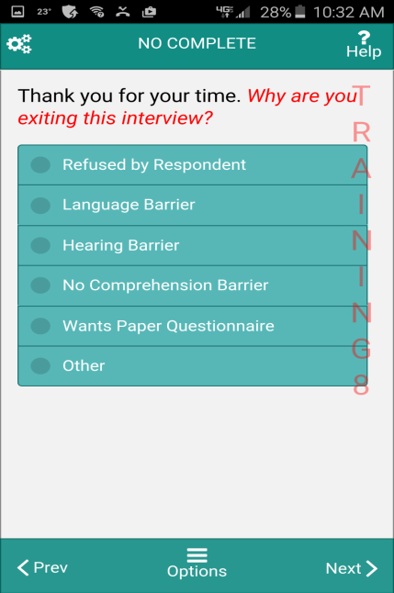

Paper ID Screen | Attempt Type Screen
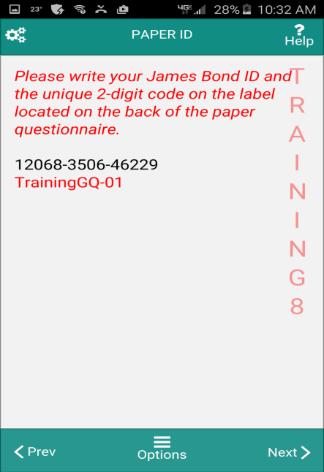 | 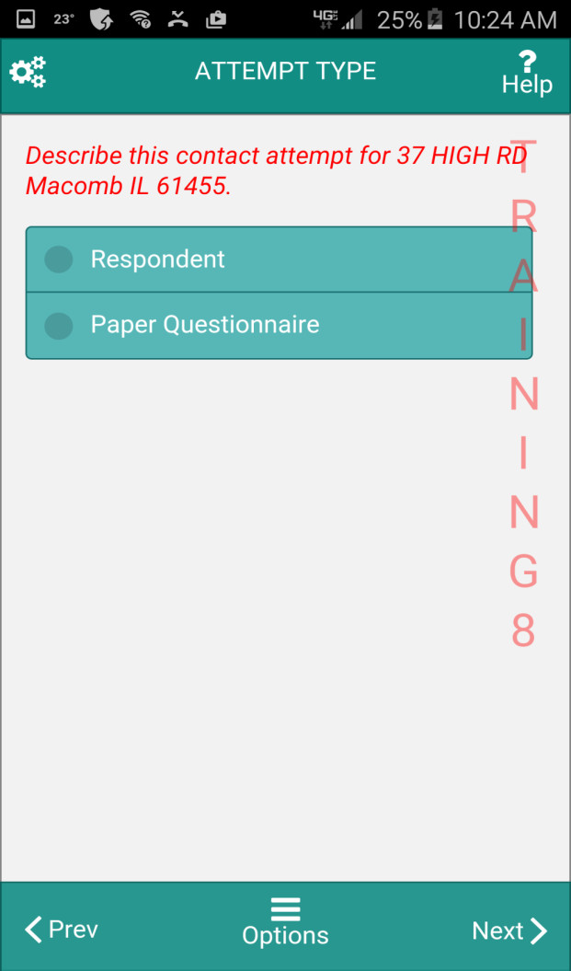

Enter Paper ID Screen | GQ Most Screen
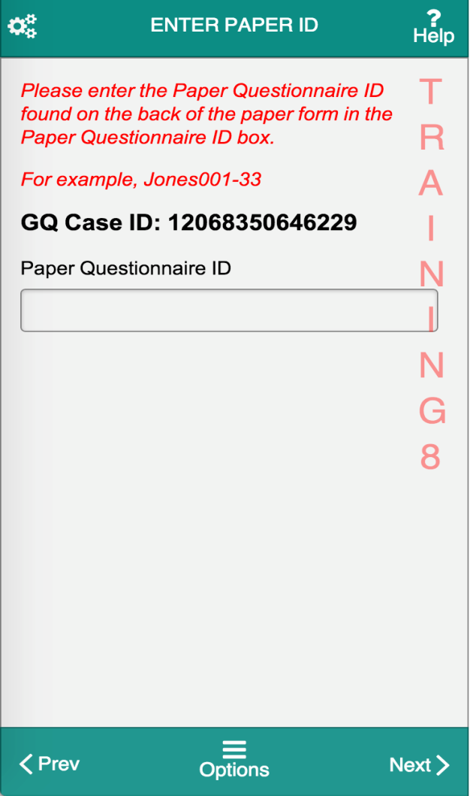 | 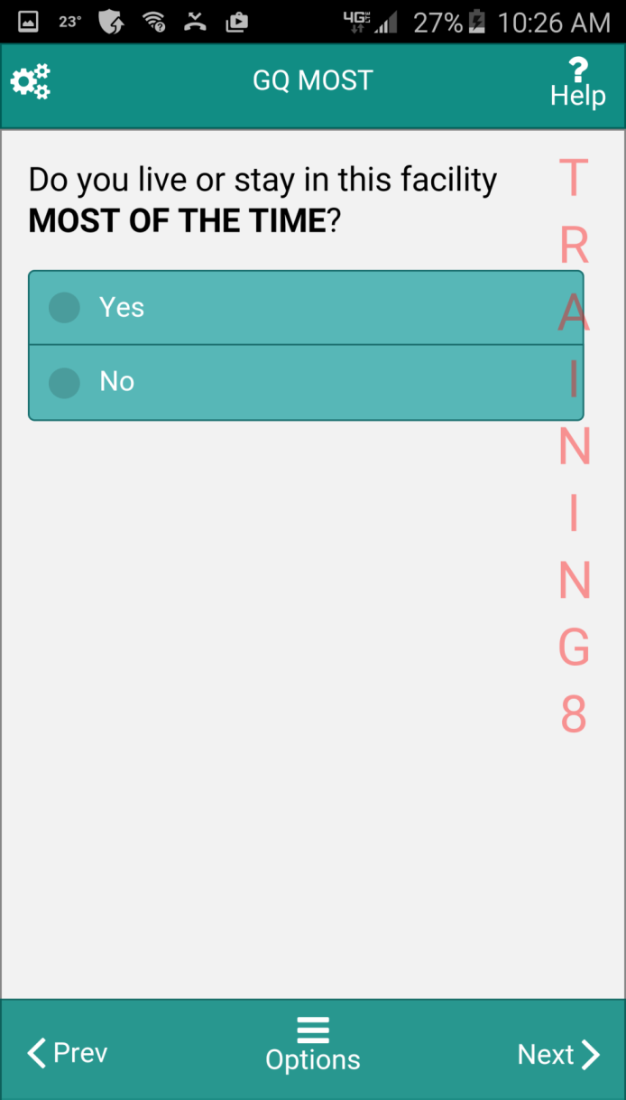

GQ Fullstay Screen | Another Interview Screen
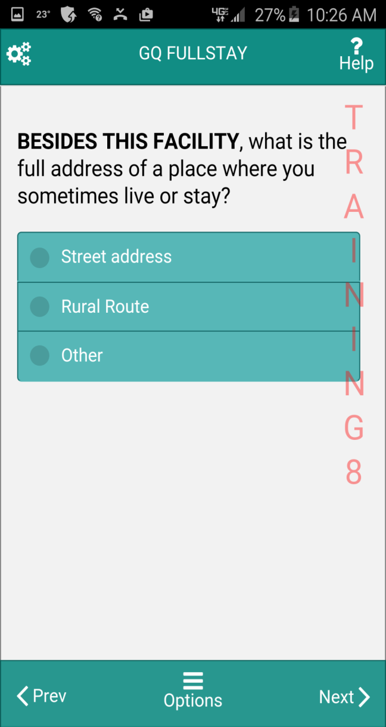 | 