**Overview**

These are screenshots and help text for the last iteration of the National Census Bureau Survey (NCSB). For the January 2017 iteration of this survey, we will employ a split-panel design. Respondents will receive Version 1 or Version 2 of the survey. All respondents will go to the same website, but then half will be redirected to a different URL with the second version of the survey. Most of the screens and their functionality will remain the same for the second version of the survey (including a mobile web responsive design). The only changes are to the text. Changes appear in red throughout this document. The base design for both surveys is the existing NCBS survey.

In addition to the text changes provided in red in this document, the following changes will also be made:

Census Day: February 1, 2017

Survey Open Period: ~6 weeks

Survey Open Day: January 23, 2017

Survey Close Day: March 15, 2017

After March 15, 2017, display:

National Census Bureau Survey is now closed.

The National Census Bureau Survey provides information to study a variety of new methods and advanced technologies that are under consideration for the 2020 Census. This is an ongoing survey conducted approximately four times a year. We appreciate your interest in this survey, but we will no longer be processing responses to this survey for the current data collection period. Thank you.

**Welcome**

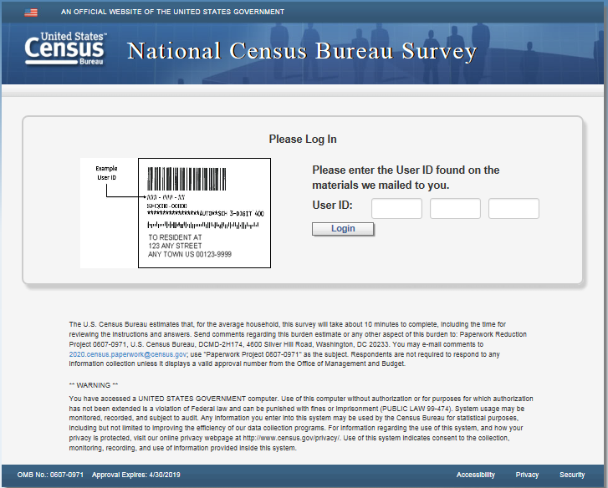

Version 1 and Version 2: Use 12-digit user-id for login. Update example image to XXXX-XXXX-XXXX

**Confirm**

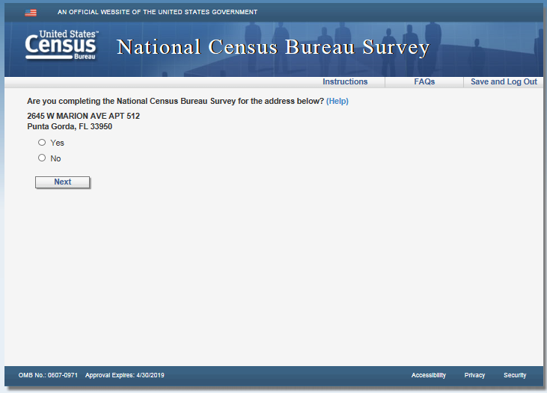

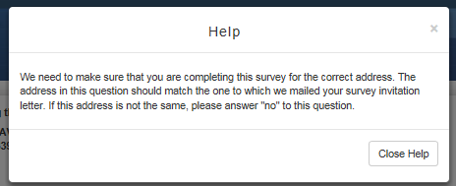

**Pin**

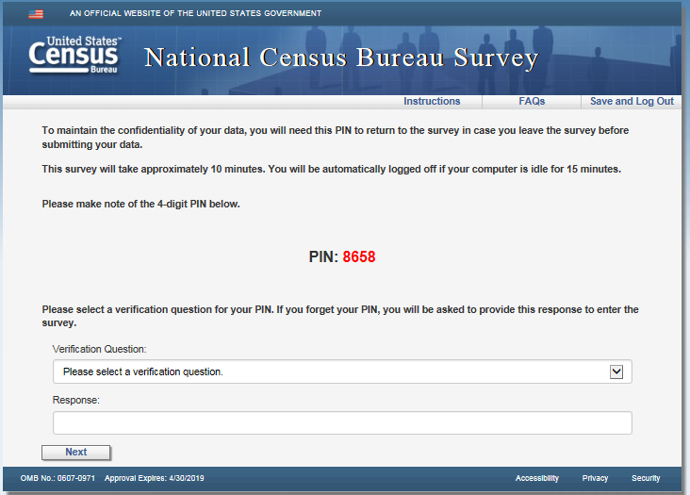

**Address**

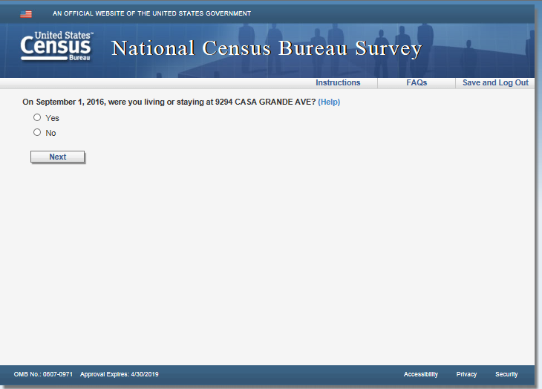

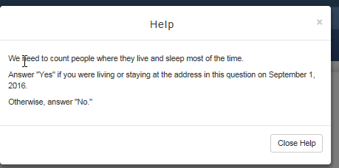

**Anyone**

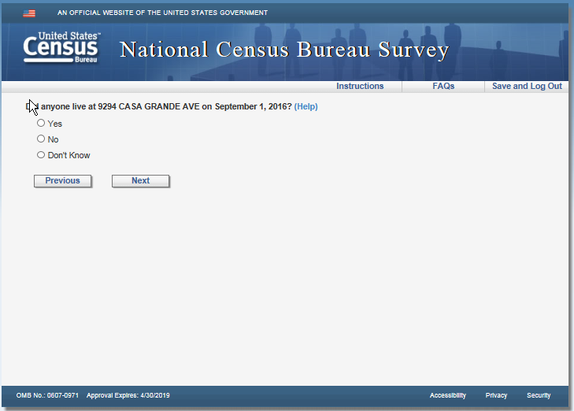

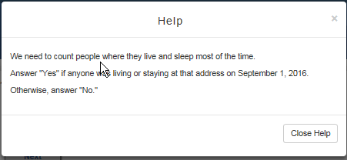

**Vacancy**

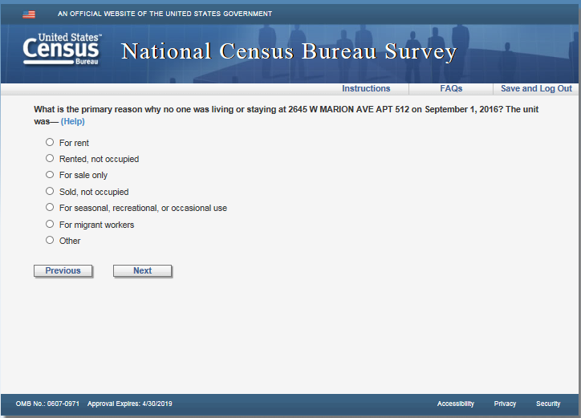

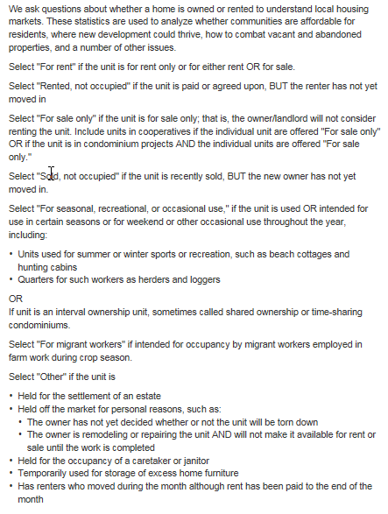

**Respondent**

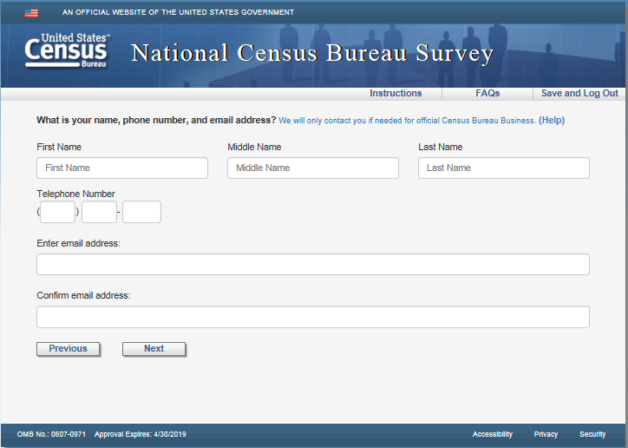

Version 2 - Remove blue instruction: “We will only contact you if needed for official Census Bureau Business”

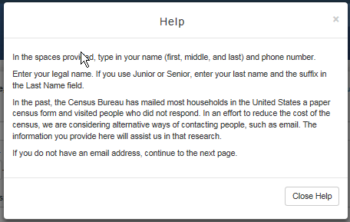

Version 2 – Add “We will only contact you if needed for official Census Bureau Business” as a new paragraph after the second paragraph.

**Others**

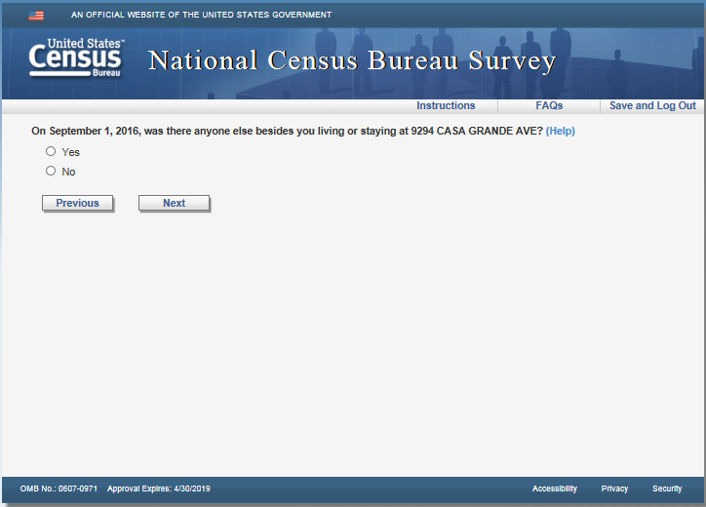

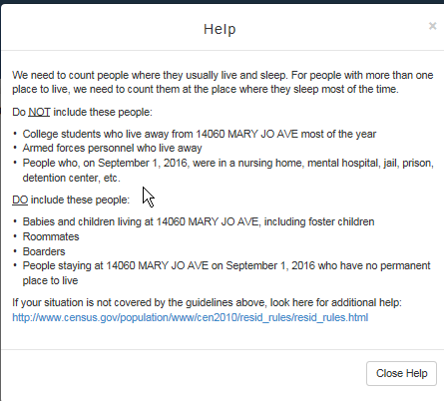

**People**

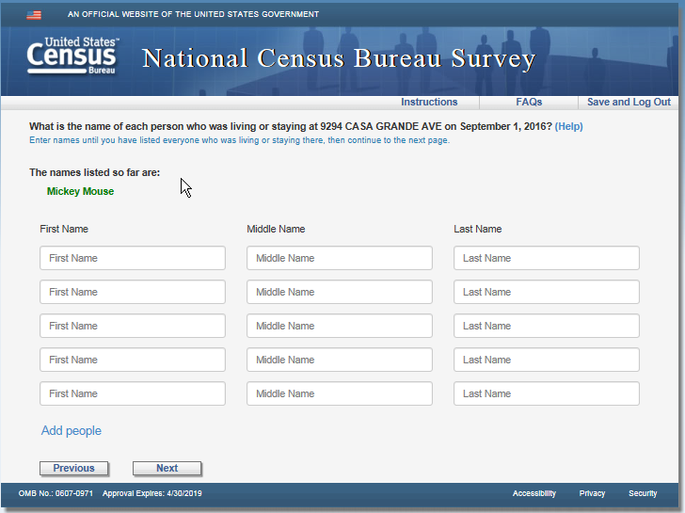

Version 2: Remove text “Enter names until you have listed everyone who was living or staying there, then continue to the next page.”

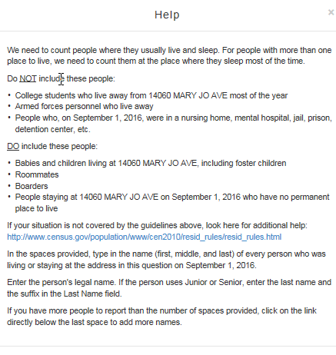

**Add_ppl**

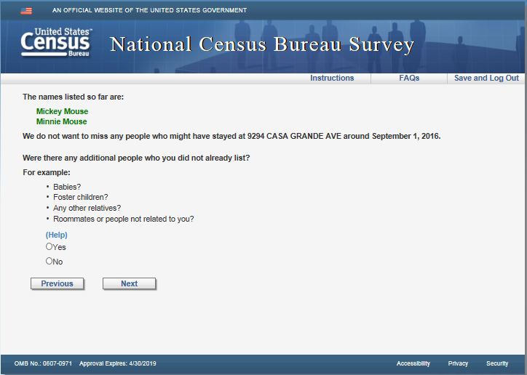

Version 2: Remove “For example: Babies? Foster children? Any other relatives? Roommates or people not related to you?”

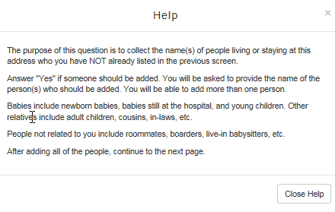

Version 2: Add “Consider babies, foster children, other relatives, roommates, and people not related to you.” at the end of the second paragraph.

**Add_noperm**

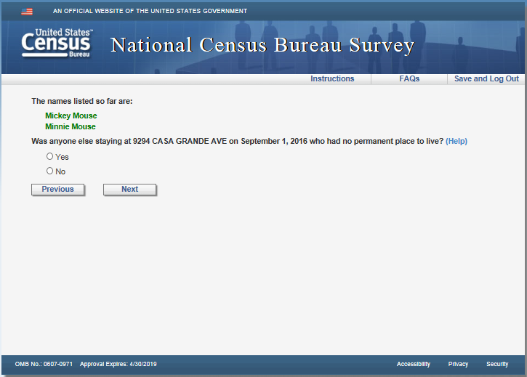

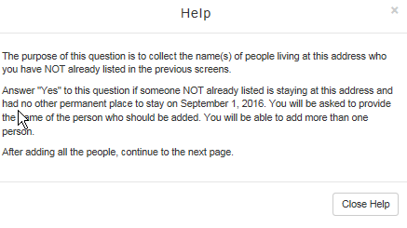

**Roster_review**

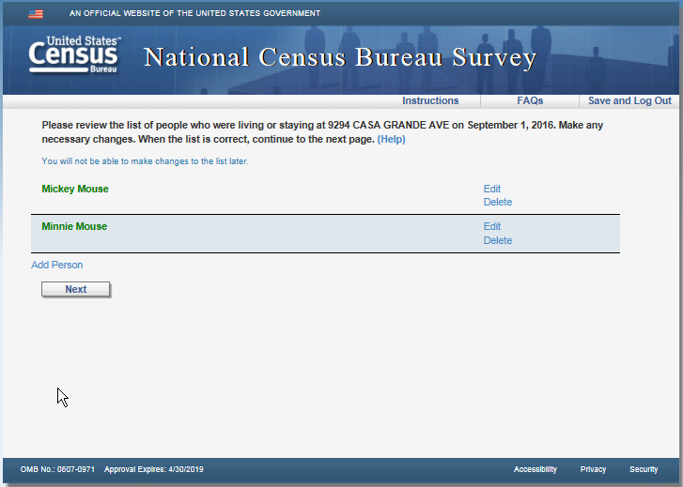

Version 2: Remove blue instruction text: “You will not be able to make changes to the list later.”

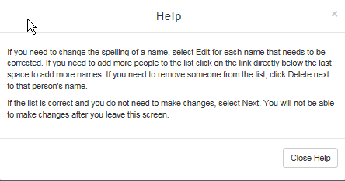

**Home**

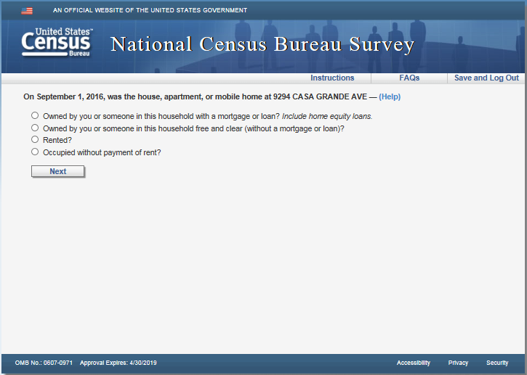

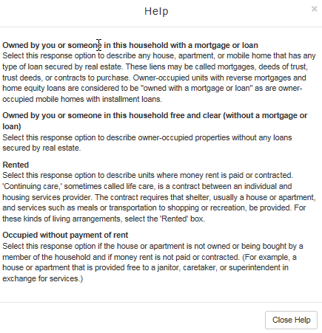

**Renter**

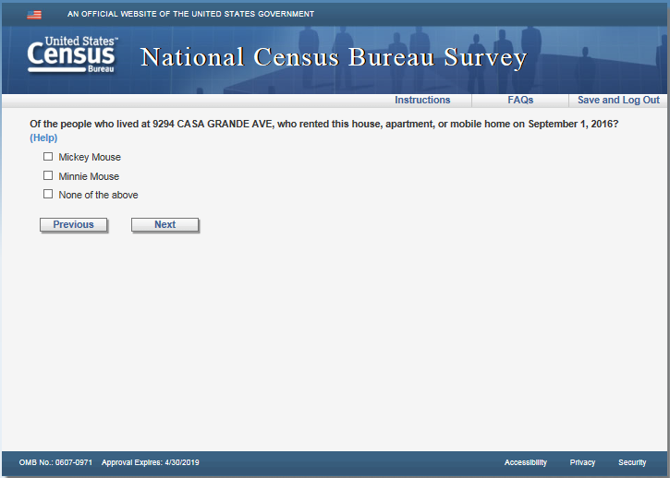

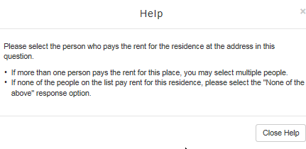

**Owner**

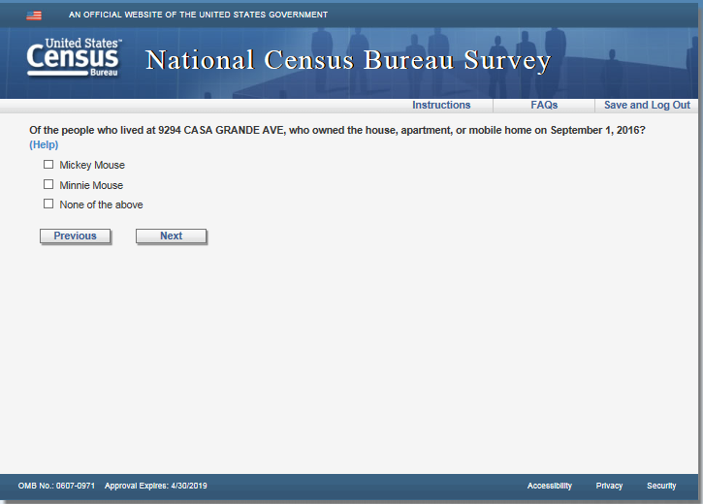

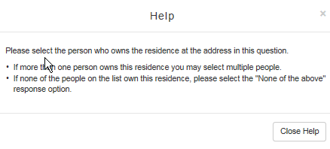

**Relation2**

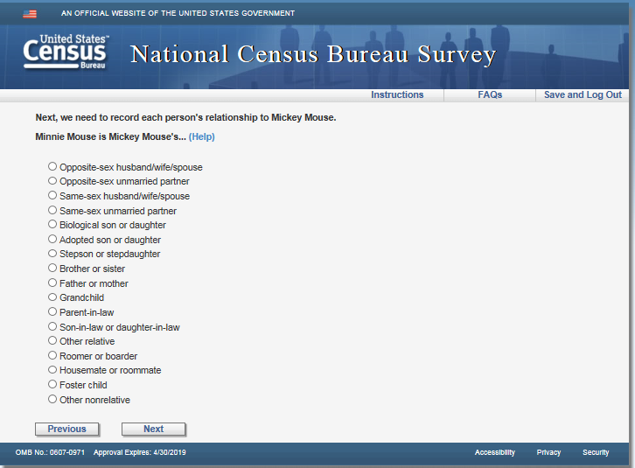

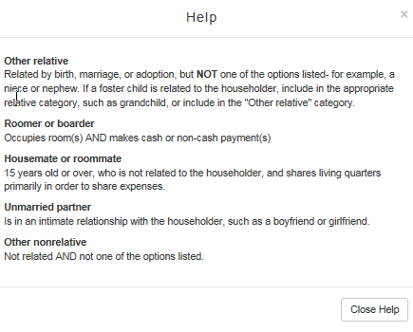

**Sex**

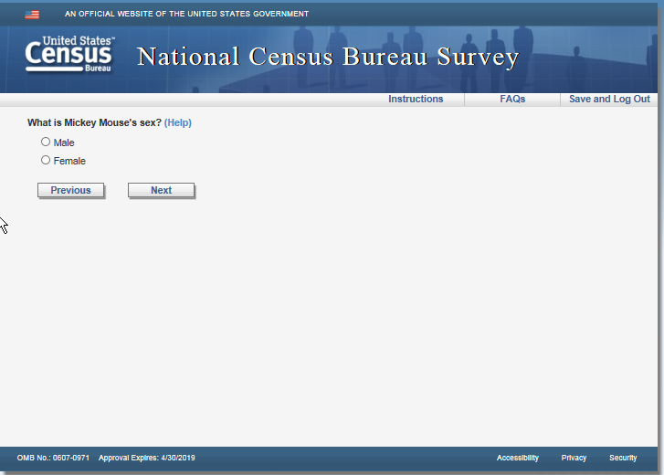

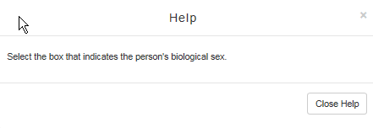

**Relconfirm**

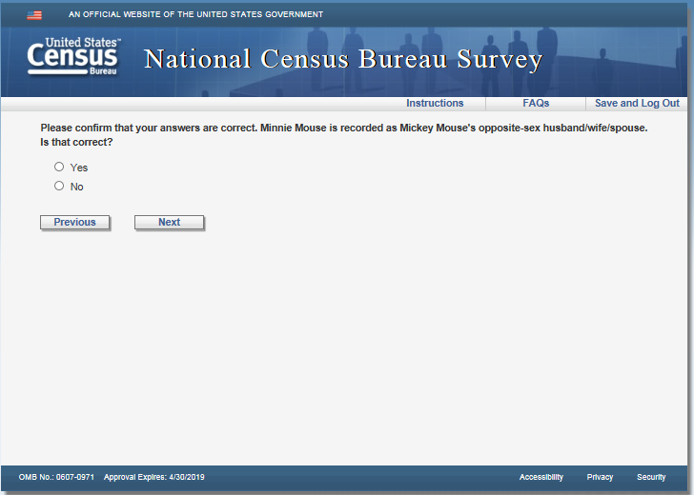

**Sexconfirm**

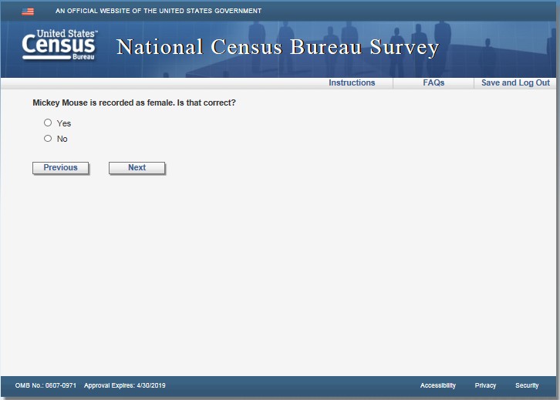

**Age**

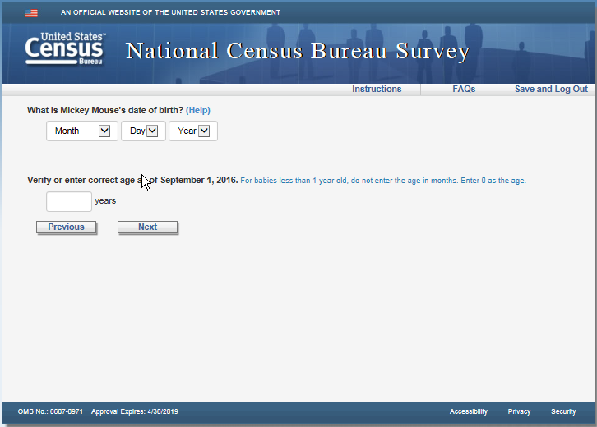

Version 2: Remove blue instruction text “For babies less than 1 year old, do not enter the age in months. Enter 0 as the age.”

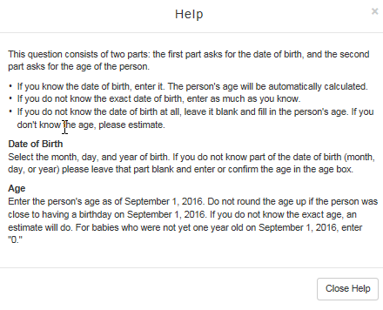

**Race2**

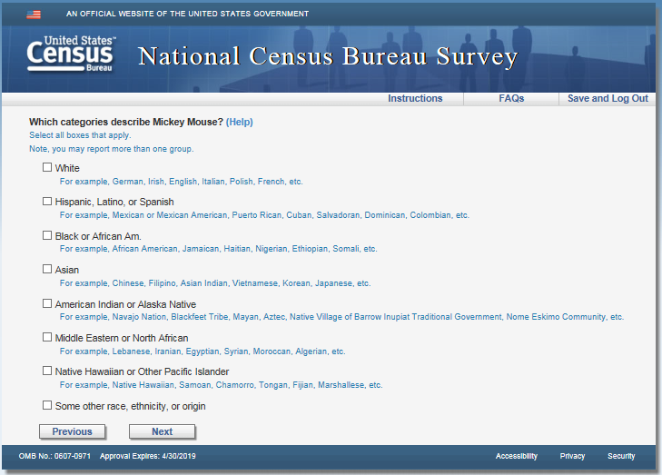

Version 2: Remove all instruction text…“Select all boxes that apply.” “Note, you may report more than one group.” And all the examples under the race categories.

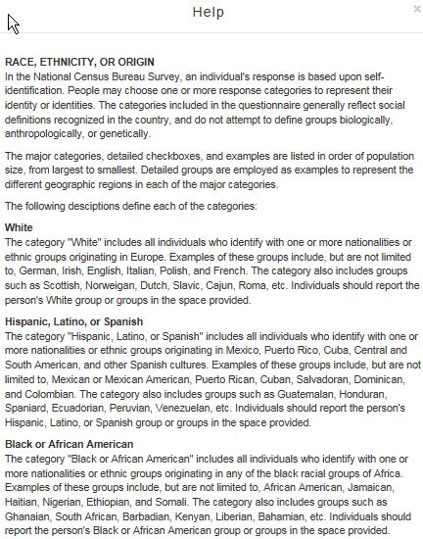

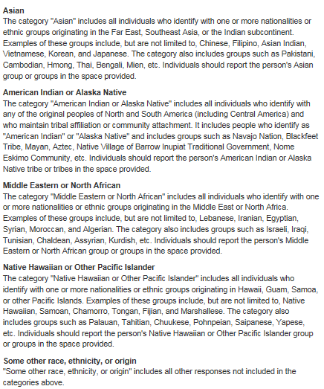

**Race2_origin**

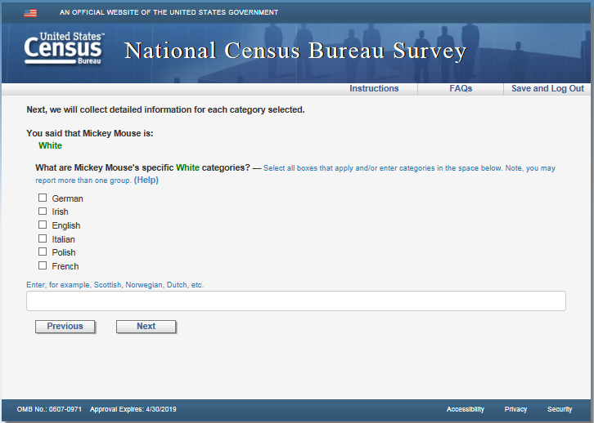

Version 2: Remove blue instruction text “Select all boxes that apply and/or enter categories in the space below. Note, you may report more than one group.” and “Enter, for example, Scottish, Norwegian, Dutch, etc.”

Version 2: Add an “Other” checkbox under the last category

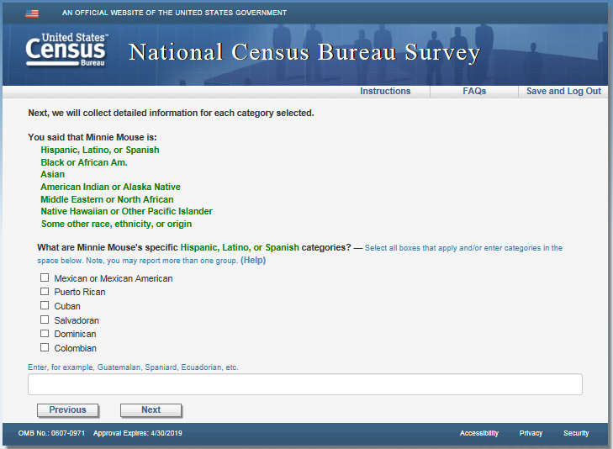

Version 2: Remove blue instruction text “Select all boxes that apply and/or enter categories in the space below. Note, you may report more than one group.” and “Enter, for example, Guatemalan, Spaniard, Ecuadorian, etc.”

Version 2: Add an “Other” checkbox under the last category

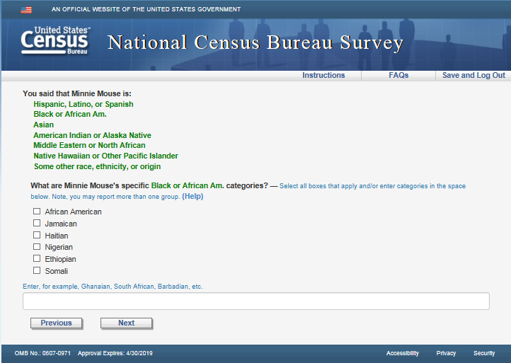

Version 2: Remove blue instruction text “Select all boxes that apply and/or enter categories in the space below. Note, you may report more than one group.” and “Enter, for example, Ghanaian, South African, Barbadian, etc.”

Version 2: Add an “Other” checkbox under the last category

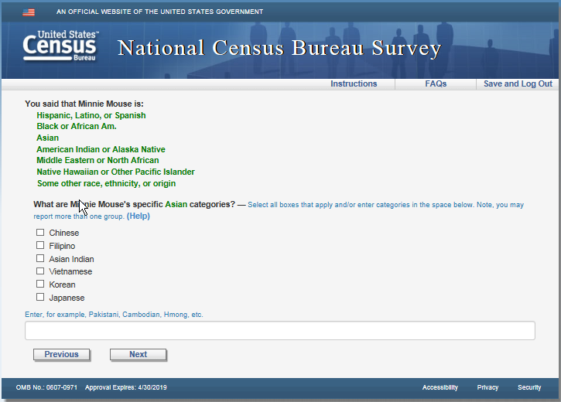

Version 2: Remove blue instruction text “Select all boxes that apply and/or enter categories in the space below. Note, you may report more than one group.” and “Enter, for example, Pakistani, Cambodian, Hmong, etc.”

Version 2: Add an “Other” checkbox under the last category

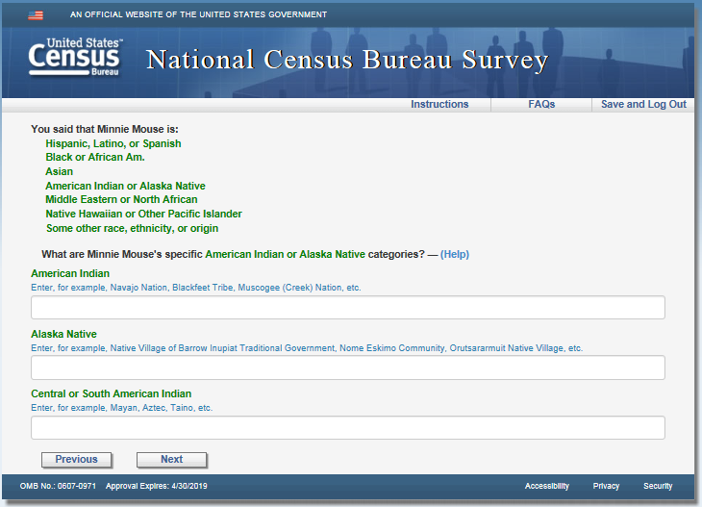

Version 2: Remove blue instruction text “Enter, for example, Navajo Nation, Blackfeet Trive, Muscogee (Creek) Nation, etc.”, “Enter, for example, Native Village of Barrow Inupiat Traditional Government, Nome Eskimo Community, Orutsararmuit Native Village, etc.”, and “Enter, for example, Mayan, Aztect, Taino, etc.”

Version 2: Add an “Other” checkbox under the last category

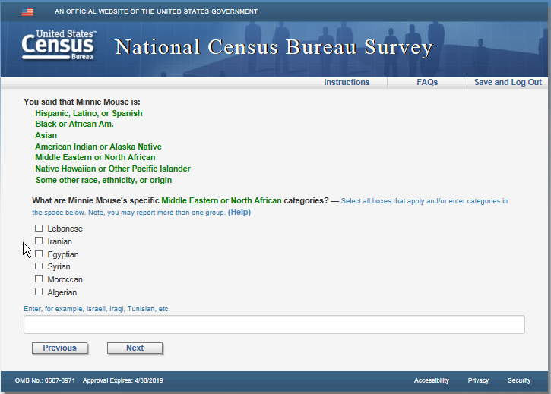

Version 2: Remove blue instruction text “Select all boxes that apply and/or enter categories in the space below. Note, you may report more than one group.” and “Enter, for example, Israeli, Iraqi, Tunisian, etc.”

Version 2: Add an “Other” checkbox under the last category

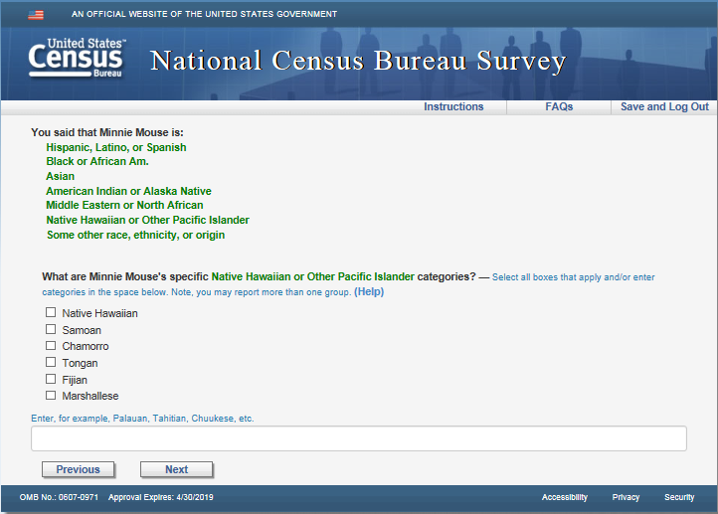

Version 2: Remove blue instruction text “Select all boxes that apply and/or enter categories in the space below. Note, you may report more than one group.” and “Enter, for example, Palauan, Tahitian, Chuukese, etc.”

Version 2: Add an “Other” checkbox under the last category

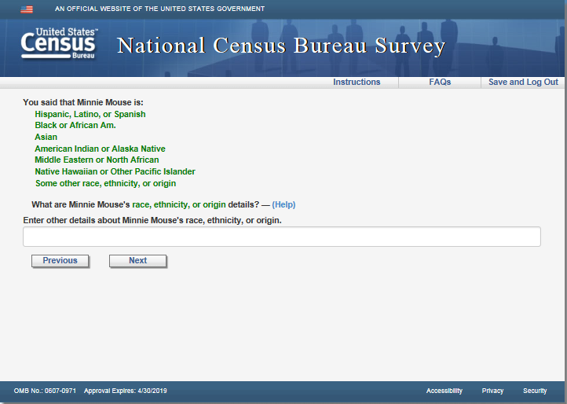

Version 2: Remove text “Enter other details about [Persons fill]’s race, ethnicity, or origin.”

**Del_rel_1**

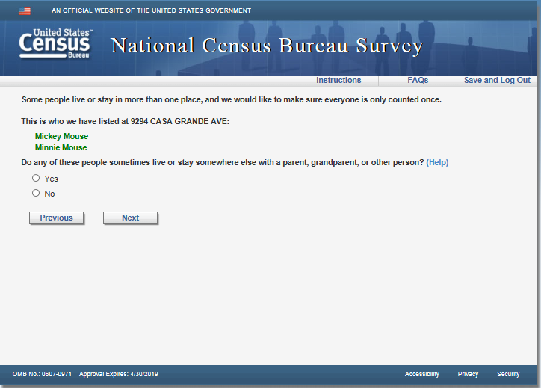

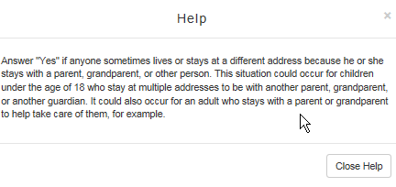

**Del_rel_2**

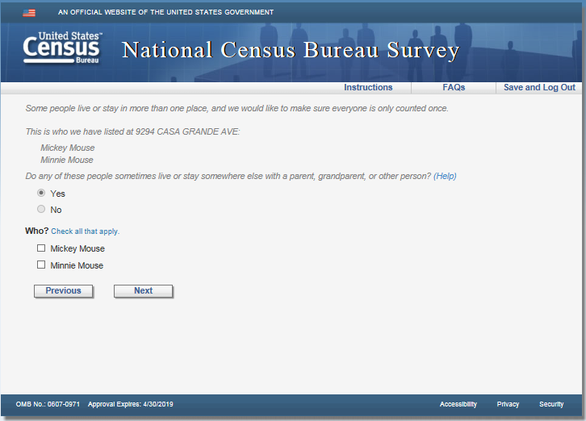

Version 2: Remove blue instruction text “Check all that apply.” Applies to del_rel_2, del_college_2, del_military_2, del_nurse_2, del_jail_2, del_season_2, and del_other_2.

**Del_college**

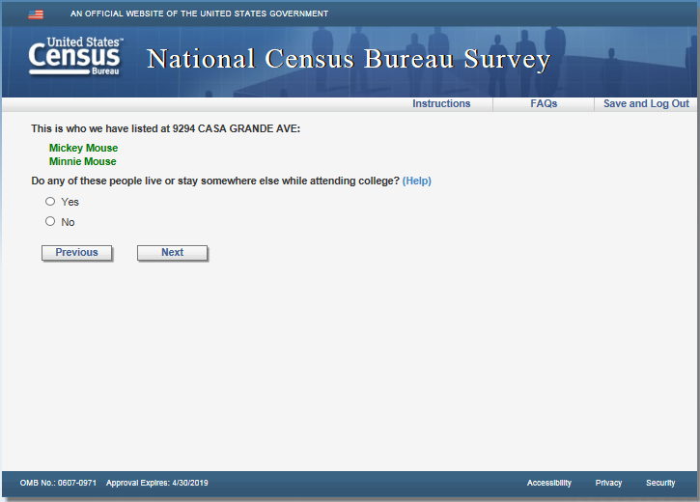

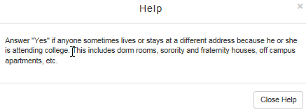

**Del_military**

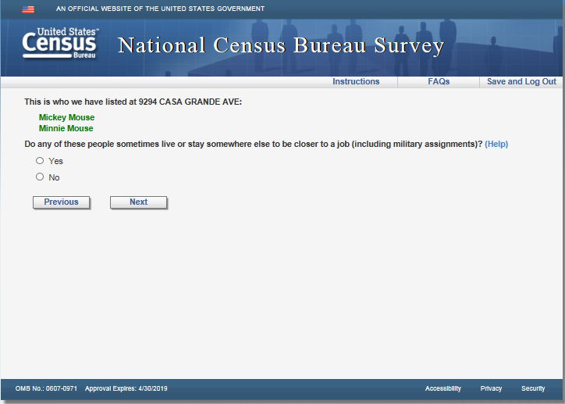

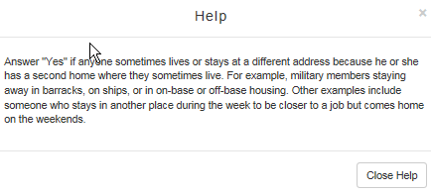

**Del_nurse**

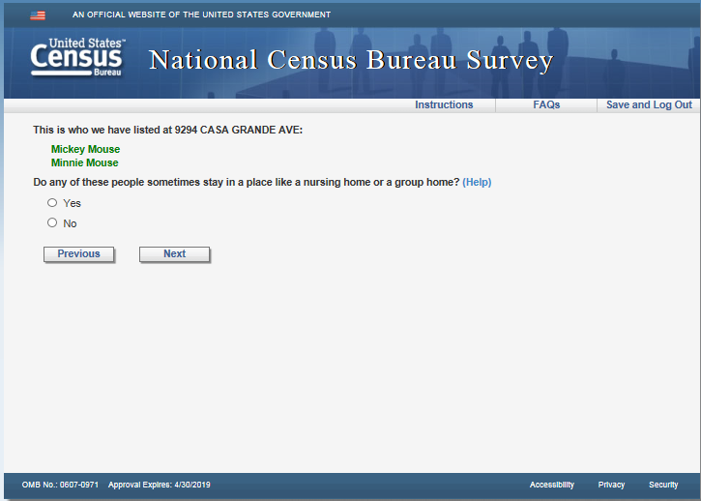

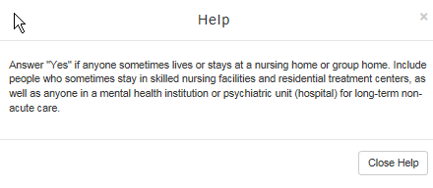

**Del_jail**

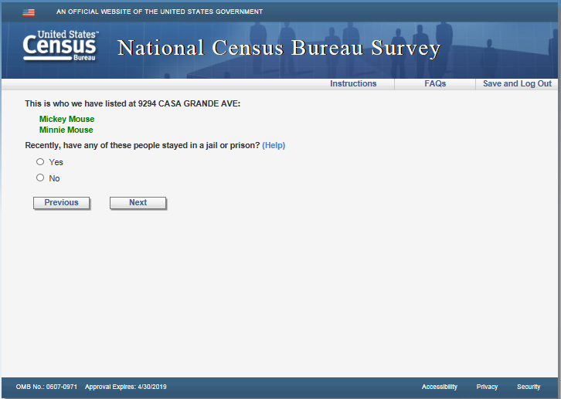

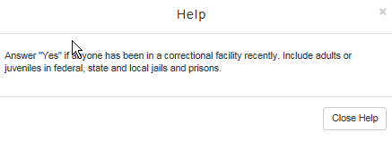

**Del_season**

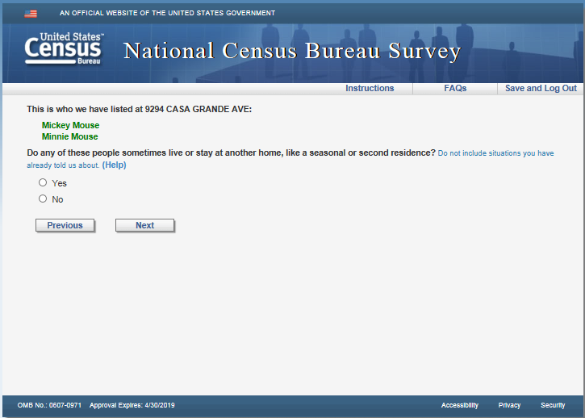

Version 2: Remove blue instruction text “Do not include situations you have already told us about.”

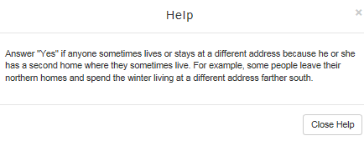

Version 2: Add “Do not include situations you have already told us about.” to Help after the last sentence.

**Del_other**

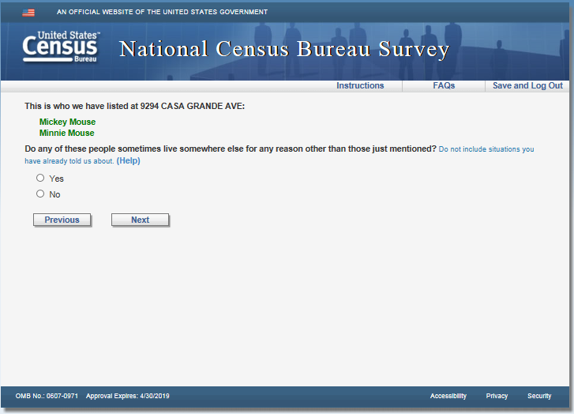

Version 2: Remove blue instruction text “Do not include situations you have already told us about.”

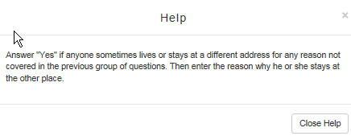

Version 2: Add “Do not include situations you have already told us about.” to Help after the last sentence.

**Fullstay**

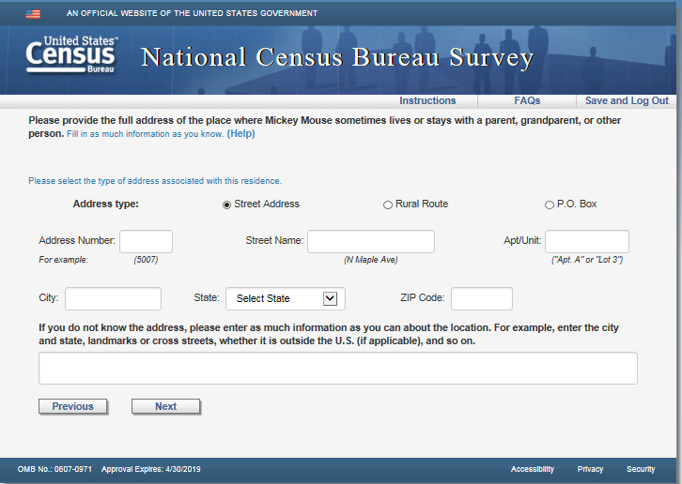

Version 2: Remove blue instruction text “Fill in as much information as you know.” and “Please select the type of address associated with this residence.”

Version 2: Remove text “For example, enter the city and state, landmarks or cross streets, whether it is outside the U.S. (if applicable), and so on.” above the write-in box.

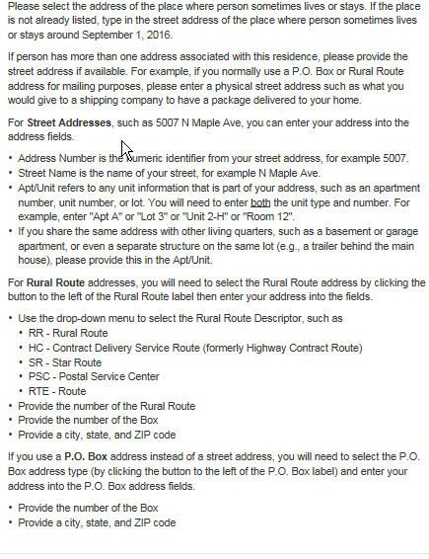

Version 2: Add “If you do not know the address, please enter as much information as you can about the location. For example, enter the city and state, landmarks or cross streets, whether it is outside the U.S. (if applicable), and so on.” to the end of the first paragraph.

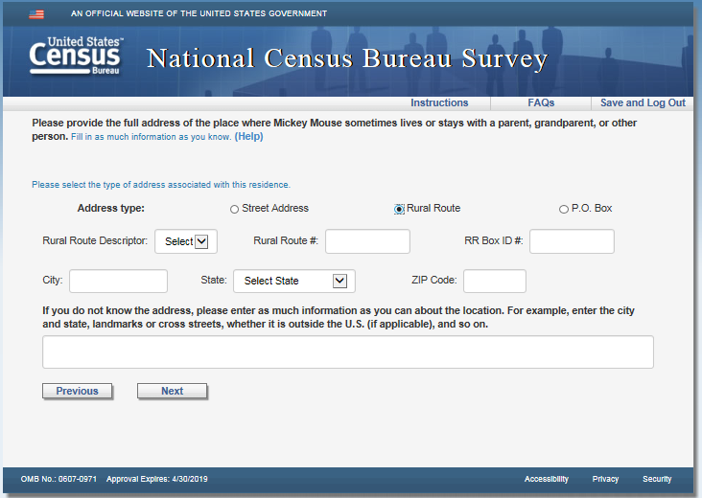

Version 2: Remove blue instruction text “Fill in as much information as you know.” and “Please select the type of address associated with this residence.”

Version 2: Remove text “For example, enter the city and state, landmarks or cross streets, whether it is outside the U.S. (if applicable), and so on.” above the write-in box.

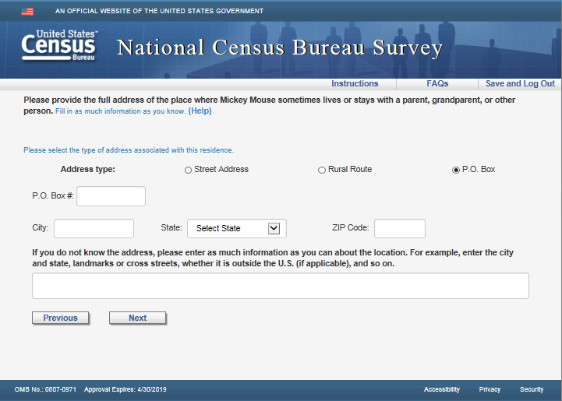

Version 2: Remove blue instruction text “Fill in as much information as you know.” and “Please select the type of address associated with this residence.”

Version 2: Remove text “For example, enter the city and state, landmarks or cross streets, whether it is outside the U.S. (if applicable), and so on.” above the write-in box.

**Fullstay_phys**

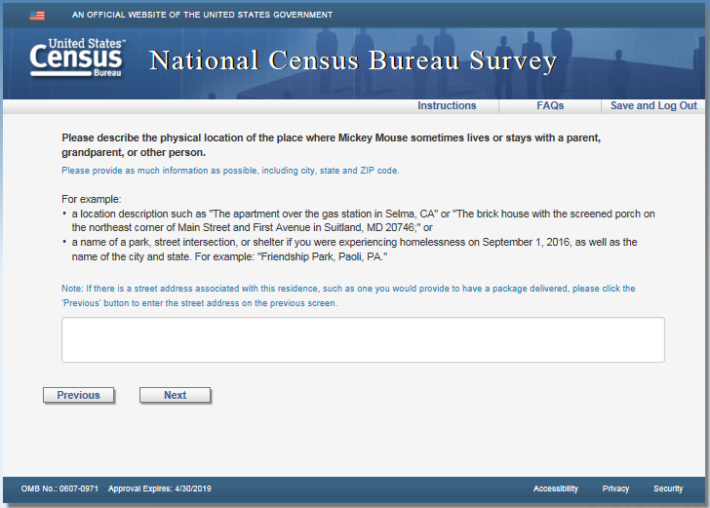

Version 2: Remove all blue instruction text “Please provide as much information as possible, including city, state and ZIP code.”, “Note: If there is a street address associated with this residence, such as one you would provide to have a package delivered, please click the ‘Previous’ button to enter the street address on the previous screen.”, and the “For example:” along with both bullets.

**Most**

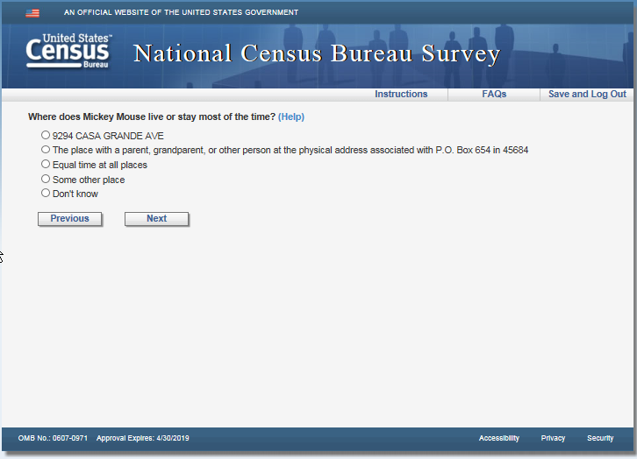

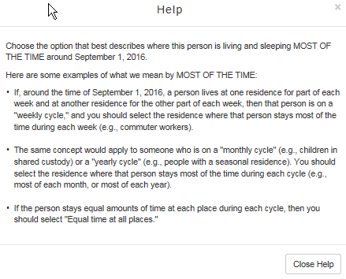

**Where**

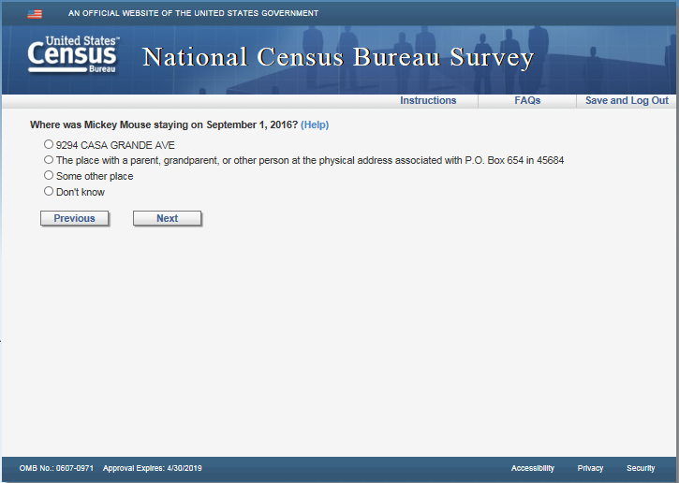

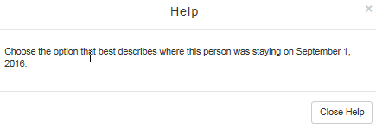

**Submit**

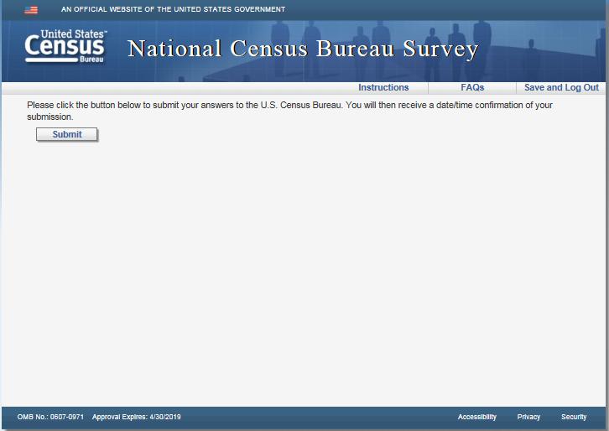

**Confirmation**

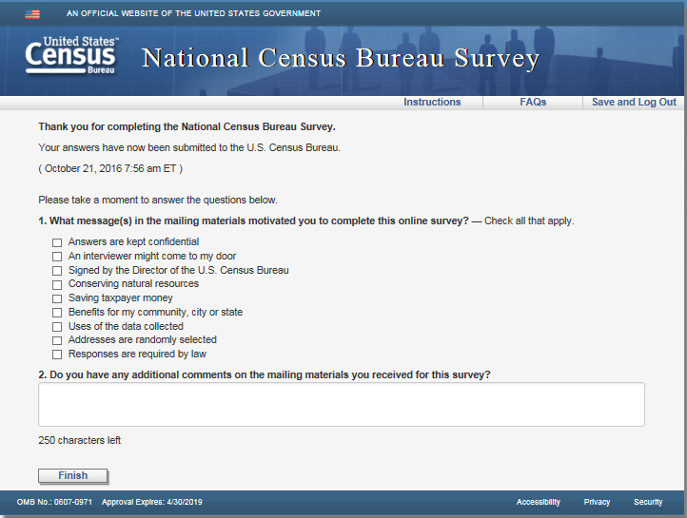

Both versions: Remove current question 1 “What message(s) in the mailing materials motivated you to complete this online survey?” and in its place add 2 new questions.

Question 1 text: When did you receive the Census Bureau mailing you are using to access the survey?

Input fields: Day, Month, and Year dropdown menus formatted like DOB

Year: Fill with 2017, do not provide other options

Month: Only display January, February and March in the list

Day: Use the same edits as the Age/DOB (correct number of days per month displaying)

Below these fields have a check box with Don't know next to it)

Question 2: Overall, completing this survey was

Very easy o o o o o Very difficult

Question 3: (the question 2 on the screen shot ) opened ended response field.

**Thank you**

