Mail Materials, SMarT January/February 2017 Test

|  |  |  |  |  |  |  |
| --- | --- | --- | --- | --- | --- | --- |
|  |  | Changes to the materials | | | |  |
| Form Number | Description | Mailout Date | Date in box | Census Day in letter | Telephone number | Notes |
| CSM-16(4L-1) | Initial letter, version 1 | January 23, 2017 |  | February 1, 2017 | 1-888-715-2301* | Use CSM-16(L)(1) with changes specified |
| CSM-16(4L-2) | Initial letter, version 2 | January 26, 2017 |  | February 1, 2017 | 1-844-251-3784 | Use CSM-16(L)(1) with changes specified |
| CSM-33 | Internet instruction card |  |  |  |  | Use CSM-33 |
| CSM-9(4P-1) | First reminder postcard, version 1 | January 26, 2017 |  |  | 1-888-715-2301* | Use CSM-9(P1) with changes specified |
| CSM-9(4P-2) | First reminder postcard, version 2 | January 30, 2017 |  |  | 1-844-251-3784 | Use CSM-9(P1) with changes specified |
| CSM-10(4P-1) | Second reminder postcard, version 1 | February 6, 2017 |  |  | 1-888-715-2301* | Use CSM-10(P) with changes specified |
| CSM-10(4P-2) | Second reminder postcard, version 2 | February 9, 2017 |  |  | 1-844-251-3784 | Use CSM-10(P) with changes specified |
| CSM-17(4L-1) | Final letter, version 1 | February 13, 2017 | January 31, 2017 |  | 1-888-715-2301* | Use CSM-17(L1) with changes specified |
| CSM-17(4L-2) | Final letter, version 2 | February 16, 2017 | February 3, 2017 |  | 1-844-251-3784 | Use CSM-17(L1) with changes specified |

* **\*this is actually the same telephone number on the original material**

**Initial Mail Letter, Version 1 / CSM-16 (4L-1)**

**Send date: Monday, January 23, 2017**

January 23, 2017

Dear Resident:

Your address has been randomly selected by the U.S. Census Bureau to participate in the National Census Bureau Survey. The Census Bureau conducts this important, 10-minute survey to help make the 2020 Census easier, more convenient, and less costly.

Results from the 2020 Census will be used to:

* Allocate resources for schools, health services, and new business development
* Prepare your community to meet transportation and emergency readiness needs
* Help ensure the political representation of your community

|  |
| --- |
| Respond by February 1 at:  **https://respond.census.gov/ncbs** |

The Census Bureau is using the Internet instead of paper forms mailed to you to securely collect this information, to conserve natural resources, save taxpayer money, and process data more efficiently. If you are unable to complete the survey online, please call 1-888-715-2301 toll-free.

The census is so important that your response is required by U.S. law, and your answers are kept completely confidential. If you don’t respond, we will need to send a Census Bureau interviewer to your home to collect your answers in person.

Thank you in advance for your prompt response.

Sincerely,

John H. Thompson

Director

**Your Answers are Confidential**

The U.S. Census Bureau is required by U.S. law to keep your answers confidential. This means that the Census Bureau cannot give out information that identifies your or your household to anyone, including other government agencies. The Census Bureau chose your address, not you personally, as part of a randomly selected sample.

We are conducting this survey under the authority of Title 13, United States Code, Sections 141 and 193. Federal law protects your privacy and keeps your answers confidential (Title 13, United States Code, Sections 9 and 214).

For more information about this survey, visit [www.census.gov](http://www.census.gov).

For more information about how we protect your information, please visit our website at [www.census.gov](http://www.census.gov) and click on “Data Protection & Privacy Policy” at the bottom of the homepage.

|  |
| --- |
| The U.S. Census Bureau estimates that, for the average household, this survey will take about 10 minutes to complete, including the time for reviewing the instructions and answers. Send comments regarding this burden estimate or any other aspect of this burden to: Paperwork Reduction Project 0607-0971, U.S. Census Bureau, DCMD-2H174, 4600 Silver Hill Road, Washington, DC 20233. You may e-mail comments to <2020.census.paperwork@census.gov>: use “Paperwork Project 0607-0971” as the subject.  You are not required to respond to this collection of information if it does not display a valid approval number from the Office of Management and Budget (OMB). The eight-digit OMB number is 0607-0971. |

**Initial Mail Letter, Version 2 / CSM-16 (4L-2)**

**Send date: Thursday, January 26, 2017**

January 26, 2017

Dear Resident:

Your address has been randomly selected by the U.S. Census Bureau to participate in the National Census Bureau Survey. The Census Bureau conducts this important, 10-minute survey to help make the 2020 Census easier, more convenient, and less costly.

Results from the 2020 Census will be used to:

* Allocate resources for schools, health services, and new business development
* Prepare your community to meet transportation and emergency readiness needs
* Help ensure the political representation of your community

|  |
| --- |
| Respond by February 1 at:  **https://respond.census.gov/ncbs** |

The Census Bureau is using the Internet instead of paper forms mailed to you to securely collect this information, to conserve natural resources, save taxpayer money, and process data more efficiently. If you are unable to complete the survey online, please call 1-844-251-3784 toll-free.

The census is so important that your response is required by U.S. law, and your answers are kept completely confidential. If you don’t respond, we will need to send a Census Bureau interviewer to your home to collect your answers in person.

Thank you in advance for your prompt response.

Sincerely,

John H. Thompson

Director

**Your Answers are Confidential**

The U.S. Census Bureau is required by U.S. law to keep your answers confidential. This means that the Census Bureau cannot give out information that identifies your or your household to anyone, including other government agencies. The Census Bureau chose your address, not you personally, as part of a randomly selected sample.

We are conducting this survey under the authority of Title 13, United States Code, Sections 141 and 193. Federal law protects your privacy and keeps your answers confidential (Title 13, United States Code, Sections 9 and 214).

For more information about this survey, visit [www.census.gov](http://www.census.gov).

For more information about how we protect your information, please visit our website at [www.census.gov](http://www.census.gov) and click on “Data Protection & Privacy Policy” at the bottom of the homepage.

|  |
| --- |
| The U.S. Census Bureau estimates that, for the average household, this survey will take about 10 minutes to complete, including the time for reviewing the instructions and answers. Send comments regarding this burden estimate or any other aspect of this burden to: Paperwork Reduction Project 0607-0971, U.S. Census Bureau, DCMD-2H174, 4600 Silver Hill Road, Washington, DC 20233. You may e-mail comments to <2020.census.paperwork@census.gov>: use “Paperwork Project 0607-0971” as the subject.  You are not required to respond to this collection of information if it does not display a valid approval number from the Office of Management and Budget (OMB). The eight-digit OMB number is 0607-0971. |

**Internet Instruction Card / CSM-33**

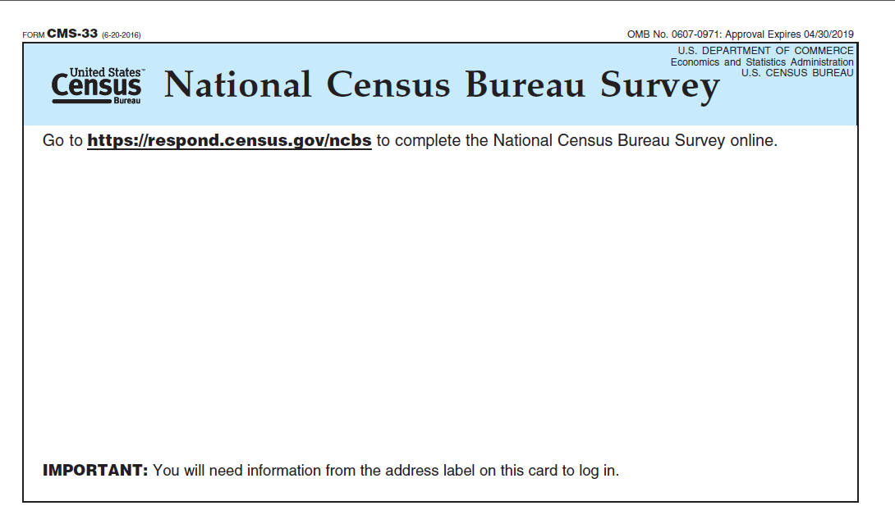

**First Reminder Mail Postcard, Version 1 / CSM-9(4P-1)**

**Send date: Thursday, January 26, 2017**

January 26, 2017

Dear Resident:

Earlier, you should have received instructions for completing the **National Census Bureau Survey** online. Local communities depend on information from the census to fund programs that promote the well-being of families and children as well as equal employment opportunities for you and your neighbors. If you have not already responded, please complete this short 10-minute survey now.

|  |
| --- |
| Respond now at **https://respond.census.gov/ncbs** |

Your response is critically important to your local community and your country and is required by law. Responding promptly will prevent you from receiving phone calls or personal visits from U.S. Census Bureau interviewers.

By law, your answers are confidential. The Census Bureau cannot give out information that identifies you or your household to anyone, including other government agencies.

If you are unable to complete the survey online, please call 1-888-715-2301 toll-free.

Sincerely,

John H. Thompson

Director

**First Reminder Mail Postcard, Version 2 / CSM-9(4P-2)**

**Send date: Monday, January 30, 2017**

January 30, 2017

Dear Resident:

Earlier, you should have received instructions for completing the **National Census Bureau Survey** online. Local communities depend on information from the census to fund programs that promote the well-being of families and children as well as equal employment opportunities for you and your neighbors. If you have not already responded, please complete this short 10-minute survey now.

|  |
| --- |
| Respond now at **https://respond.census.gov/ncbs** |

Your response is critically important to your local community and your country and is required by law. Responding promptly will prevent you from receiving phone calls or personal visits from U.S. Census Bureau interviewers.

By law, your answers are confidential. The Census Bureau cannot give out information that identifies you or your household to anyone, including other government agencies.

If you are unable to complete the survey online, please call 1-844-251-3784 toll-free.

Sincerely,

John H. Thompson

Director

**Second Reminder Mail Postcard, Version 1 / CSM-10 (4P-1)**

**Send date: Monday, February 6, 2017**

February 6, 2017

**Now is the time to respond.**

The U.S. Census Bureau has sent you several requests to complete the **National Census Bureau Survey**. If you have not already responded, it is imperative that you complete this 10-minute survey now. Information from the census is used to help your community get the affordable housing, services for the elderly, and education programs it needs.

|  |
| --- |
| Respond now at **https://respond.census.gov/ncbs** |

Help us conserve natural resources, process data more efficiently, and save taxpayer money by responding online. You are required by U.S. law to respond to this survey.

The Census Bureau is required by U.S. law to keep your answers are confidential. Your information will not be shared with anyone, including other government agencies.

If you are unable to complete the survey online, please call 1-888-715-2301 toll-free.

Sincerely,

John H. Thompson

Director

**Second Reminder Mail Postcard, Version 2 / CSM-10 (4P-2)**

**Send date: Thursday, February 9, 2017**

February 9, 2017

**Now is the time to respond.**

The U.S. Census Bureau has sent you several requests to complete the **National Census Bureau Survey**. If you have not already responded, it is imperative that you complete this 10-minute survey now. Information from the census is used to help your community get the affordable housing, services for the elderly, and education programs it needs.

|  |
| --- |
| Respond now at **https://respond.census.gov/ncbs** |

Help us conserve natural resources, process data more efficiently, and save taxpayer money by responding online. You are required by U.S. law to respond to this survey.

The Census Bureau is required by U.S. law to keep your answers are confidential. Your information will not be shared with anyone, including other government agencies.

If you are unable to complete the survey online, please call 1-844-251-3784 toll-free.

Sincerely,

John H. Thompson

Director

**Final Mail Letter, Version 1 / CSM-17 (4L-1)**

**Important Note:**

You are receiving this notice because we did not receive your response by January 31, 2017.

**Send date: Monday, February 13, 2017**

February 13, 2017

Dear Resident:

A few weeks ago, the U.S. Census Bureau sent instructions for completing the **National Census Bureau Survey** online. If you have already completed the survey, you do not need to take any further action. If you have not already responded to this important 10-minute survey, please do so now.

|  |
| --- |
| Use the enclosed instruction card to complete the survey online at:  **https://respond.census.gov/ncbs** |

**Your response is important to your community.** You are required by U.S. law to respond to this survey. It is vital that you complete this survey to help meet critical needs in your area – including helping to put roads, parks, and hospitals where they are needed most.

If you do not respond promptly, a Census Bureau interviewer may contact you to complete the survey.

**Your answers are completely confidential**. By law, the Census Bureau cannot publish or release information that would identify you or your household to anyone, including other government agencies. If you are unable to complete the survey online, please call 1-888-715-2301 toll-free.

Thank you for your prompt response.

Sincerely,

John H. Thompson

Director

**Your Answers are Confidential**

The U.S. Census Bureau is required by U.S. law to keep your answers confidential. This means that the Census Bureau cannot give out information that identifies your or your household to anyone, including other government agencies. The Census Bureau chose your address, not you personally, as part of a randomly selected sample.

We are conducting this survey under the authority of Title 13, United States Code, Sections 141 and 193. Federal law protects your privacy and keeps your answers confidential (Title 13, United States Code, Sections 9 and 214).

For more information about this survey, visit [www.census.gov](http://www.census.gov).

For more information about how we protect your information, please visit our website at [www.census.gov](http://www.census.gov) and click on “Data Protection & Privacy Policy” at the bottom of the homepage.

|  |
| --- |
| The U.S. Census Bureau estimates that, for the average household, this survey will take about 10 minutes to complete, including the time for reviewing the instructions and answers. Send comments regarding this burden estimate or any other aspect of this burden to: Paperwork Reduction Project 0607-0971, U.S. Census Bureau, DCMD-2H174, 4600 Silver Hill Road, Washington, DC 20233. You may e-mail comments to <2020.census.paperwork@census.gov>: use “Paperwork Project 0607-0971” as the subject.  You are not required to respond to this collection of information if it does not display a valid approval number from the Office of Management and Budget (OMB). The eight-digit OMB number is 0607-0971. |

**Final Mail Letter, Version 2 / CSM-17 (4L-2)**

**Important Note:**

You are receiving this notice because we did not receive your response by February 3, 2017.

**Send date: Thursday, February 16, 2017**

February 16, 2017

Dear Resident:

A few weeks ago, the U.S. Census Bureau sent instructions for completing the **National Census Bureau Survey** online. If you have already completed the survey, you do not need to take any further action. If you have not already responded to this important 10-minute survey, please do so now.

|  |
| --- |
| Use the enclosed instruction card to complete the survey online at:  **https://respond.census.gov/ncbs** |

**Your response is important to your community.** You are required by U.S. law to respond to this survey. It is vital that you complete this survey to help meet critical needs in your area – including helping to put roads, parks, and hospitals where they are needed most.

If you do not respond promptly, a Census Bureau interviewer may contact you to complete the survey.

**Your answers are completely confidential**. By law, the Census Bureau cannot publish or release information that would identify you or your household to anyone, including other government agencies. If you are unable to complete the survey online, please call 1-844-251-3784 toll-free.

Thank you for your prompt response.

Sincerely,

John H. Thompson

Director

**Your Answers are Confidential**

The U.S. Census Bureau is required by U.S. law to keep your answers confidential. This means that the Census Bureau cannot give out information that identifies your or your household to anyone, including other government agencies. The Census Bureau chose your address, not you personally, as part of a randomly selected sample.

We are conducting this survey under the authority of Title 13, United States Code, Sections 141 and 193. Federal law protects your privacy and keeps your answers confidential (Title 13, United States Code, Sections 9 and 214).

For more information about this survey, visit [www.census.gov](http://www.census.gov).

For more information about how we protect your information, please visit our website at [www.census.gov](http://www.census.gov) and click on “Data Protection & Privacy Policy” at the bottom of the homepage.

|  |
| --- |
| The U.S. Census Bureau estimates that, for the average household, this survey will take about 10 minutes to complete, including the time for reviewing the instructions and answers. Send comments regarding this burden estimate or any other aspect of this burden to: Paperwork Reduction Project 0607-0971, U.S. Census Bureau, DCMD-2H174, 4600 Silver Hill Road, Washington, DC 20233. You may e-mail comments to <2020.census.paperwork@census.gov>: use “Paperwork Project 0607-0971” as the subject.  You are not required to respond to this collection of information if it does not display a valid approval number from the Office of Management and Budget (OMB). The eight-digit OMB number is 0607-0971. |