ATTACHMENT 12: SOCIAL MEDIA RECRUITMENT ADVERTISEMENTS
Female-oriented campaign ads:
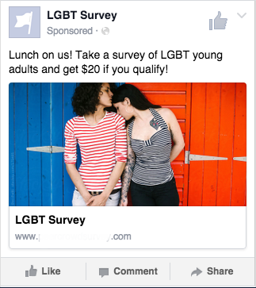

Male-oriented campaign ads:
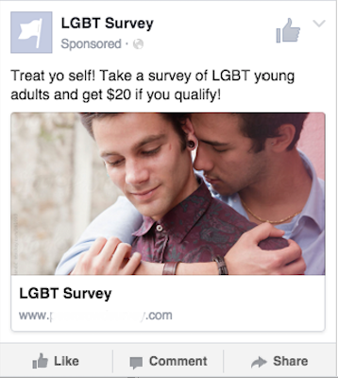

Ad to be used in both male and female-oriented ads:
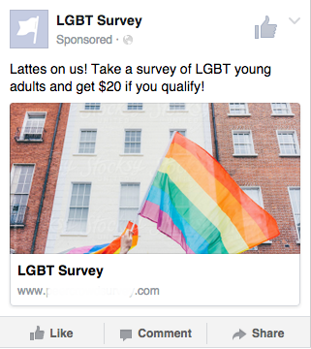

Additional ad text (both male and female oriented campaigns)*:
Treat yo self! Take a survey of LGBT young adults and get $20 if you qualify!
Lunch on us! Take a survey of LGBT young adults and get $20 if you qualify!
Lattes on us! Take a survey of LGBT young adults and get $20 if you qualify!
Late night snacks on us! Take a survey of LGBT young adults and get $20 if you qualify!
Book club on us! Take a survey of LGBT young adults and get $20 if you qualify!
Breakfast on us! Take a survey of LGBT young adults and get $20 if you qualify!
Hot cocoa on us! Take a survey of LGBT young adults and get $20 if you qualify!
Burgers on us! Take a survey of LGBT young adults and get $20 if you qualify!
Cupcakes on us! Take a survey of LGBT young adults and get $20 if you qualify!
Tacos on us! Take a survey of LGBT young adults and get $20 if you qualify!

* We will choose additional similar images for the male and female-oriented campaigns, which will be approved by RTI’s IRB. Various combinations of images and text will be used in both male and female-oriented ad campaigns for social media ads.

