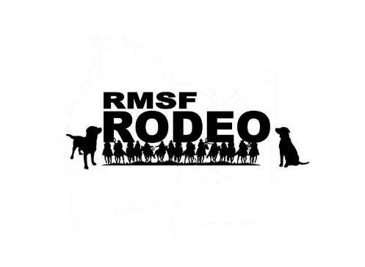
The Rocky Mountain spotted fever (RMSF) Rodeo Project is a trial pet health project happening in Poblado Miguel Aleman (PMA) in 2016, with approval from the PMA Council. PMA is teaming up with the University of Sonora Medical School, the Centers for Disease Control and Prevention (CDC), other partners for the project.
The RMSF Rodeo Project’s goal is to have less people get RMSF by improving pet health. This project will focus on three main areas, #1 - tick control on dogs #2 - tick control around the home, and #3 – community education
Participating households in the project area will receive:
- Free tick collars & other tick treatments for your dogs for the summer (timed and checked by RMSF Rodeo team members)
- Free pest management treatments for your yard (timed and checked by RMSF Rodeo team members)
- Educational materials provided by the RMSF Rodeo team during home visits
Registered participants must agree to:
- Ensure tick products or collars, provided by the RMSF Rodeo team, are placed on dogs and remain in place for the duration of the project.
- Allow RMSF Rodeo teams to apply pest management treatments around the home and in the yard.
- Allow RMSF Rodeo teams to check tick levels on dogs during routine visits.
- Consider participation in knowledge attitudes and practices surveys before and following the program activities.
Timeline for 2016

For more information, please contact:

Owner’s information (Consenting Household Member, must be > 18 years old or head of household):

________________________________/______________________________/_________________________
First Name Last Name How many people live at this residence?
Address: ________________________________/______________/______________________/___________________
Street Number and Name PO Box # Neighborhood (PROJECT HOUSE #

Phone Number: ( ) ____-_______________ ( ) _____-_____________ ( ) ____-_________
Home Work Cell
Email address: __________________________________________________________________________

What is the best method to reach you? (circle) Phone call / Home visit / Email

What is the best time to reach you? __________________________________________________________________

1) Do you require a local dialect interpreter? Yes / No 2) Are the dog(s) currently restrained? Yes / No / Mixed

3) Do you have a working outside water faucet? Yes / No 4) Have you seen ticks inside your home? Yes / No

Identify Dogs the Owner wishes to register in the RMSF Rodeo: (All owned dogs receive a tick collar and a nylon collar. If more than 5 dogs, continue with a separate sheet and attach to this record)

Dog Name | Breed/  Color | Age (indicate  years or months if < 1 yr) | Sex  (M/F) | Dog’s Behavior  A: nice  B: fearful  C: mean | Tick Count:  A: None  B: 1-10  C: 11-100  D: >100

I declare that to the best of my knowledge all of the information provided above is true and correct. I acknowledge the requirements to participate in the RMSF Rodeo Project and would like to register and participate in the program.

Signature_________________________________________________Date___________________________

Additional Comments:
______________________________________________________________________________________________________________________________________________________________________________________________________________________________________________________

Environmental Assessment (Draw home, to include location of outdoor water faucet, dog areas and areas of potential tick harborage. Include brief house description, identifying characteristics.)

