From: Klimek - CDHS, Augusta [mailto:augusta.klimek@state.co.us]
Sent: Thursday, January 28, 2016 2:04 PM
To: OIRA_submission@omb.eop.gov
Cc: DOL_PRA_PUBLIC
Subject: Unified and Combined State Plan ICR - Comment

To Whom it May Concern:
The following comments are related to the final draft of the proposed "Required Elements for Submission of the Unified or Combine State Plan and Plan Modifications under the Workforce Innovation and Opportunity Act", in particular the requirements for the Vocational Rehabilitation services portion and Appendix 1.

The Vocational Rehabilitation Assurances include duplication of the "Administration of the VR services portion of the Unified or Combined State Plan" assurance, which is identified as both number 3 and number 5. Colorado DVR recommends removing this duplication to ensure each of the assurance is documented only one.

Colorado DVR appreciates the identification of "Effectiveness in Serving Employers" as a baseline indicator for the first two years of the plan. The ability to gather and review data during the first two years of the plan will allow agencies to identify meaningful targets for future years. However, DVR also believes each of the performance measures will require vocational rehabilitation agencies to gather and report information in a manner which significantly differs from prior reporting on historic standards and indicators. These differences will make it difficult to identify meaningful targets in the first two years of the plan and are further complicated by lingering ambiguity about exactly how data will be defined while regulations and reporting instructions are finalized. For these reasons, DVR would welcome consideration of additional performance measures as baseline indicators. Because DVR has not historically considered employment or earnings data after exit, targets will be extrapolated from data currently available and may carry limited relevance. Of particular concern, "Credential Attainment Rate" and "Measurable Skills Gain" reflect data elements that have not been defined or collected by vocational rehabilitation programs in the manner anticipated to be required through the Workforce Innovation and Opportunity Act. The data currently available does not provide agencies the level of specificity needed to identify meaningful targets. At a minimum, including the "Credential Attainment Rate" and "Measurable Skills Gain" as baseline measures will provide agencies with an adequate opportunity to ensure systems and processes are in place to accurately evaluate these measures, development meaningful targets and demonstrate reasonable levels of performance. Without this opportunity, initial targets and data are likely to provide limited value in evaluating the effectiveness of programs to provide and improve upon services leading to the attainment of the credentials and skills needed to achieve competitive integrated employment and increase self-sufficiency of individuals with disabilities.

Thank you for your consideration of these comments.

Augusta Klimek, M.A., CRC
HR Development Specialist
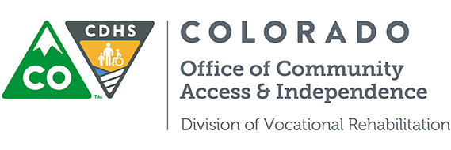

P 303.866.4763 | F 303.866.4905 | C 303.815.7218
1575 Sherman St., Fourth Floor, Denver CO 80203
augusta.klimek@state.co.us | www.dvrcolorado.com

CONFIDENTIALITY STATEMENT
This email message and any included attachments, from the Colorado Department of Human Services, are confidential and intended solely for the use of the individual or entity to which it is addressed. The information contained herein may include protected health information or otherwise privileged information. Unauthorized review, forwarding, printing, copying, distributing, or using such information is strictly prohibited and may be unlawful. If you received this message in error, please notify the sender by replying to this message and delete the email without disclosure.

