**Email Introduction:**

I am writing to invite you to participate in a customer survey being conducted on behalf of the Job Accommodation Network (JAN). JAN is funded by a contract to West Virginia University (WVU) from the Office of Disability Employment Policy, U.S. Department of Labor. As part of this contract, JAN staff work collaboratively with the WVU School of Social Work to conduct an ongoing customer survey.

On ___________________ (date), you contacted JAN, either by phone or electronically, to request information about ___________________. I am conducting the follow-up survey that will evaluate the services you received from JAN. Your feedback will be extremely beneficial in JAN’s ability to serve you and other customers in the future.

As you may be aware, JAN is a free consulting service that provides information about job accommodations, the Americans with Disabilities Act, and the employability of people with disabilities. The purpose of this follow-up is to evaluate JAN’s service and to identify ways that it could improve services to its customers.

This follow-up survey will take about 15 minutes of your time. The information that you provide to us will be kept confidential to the extent permitted by law. Any reports or articles about these follow-ups will describe results in a summarized manner so that you cannot be identified.

Your participation in this interview is voluntary. Your decision whether or not to participate will not affect the services you may receive from JAN. You may choose to skip any question you wish and you may choose to stop participating at any time.

There are no foreseeable risks to participating in this research study. There will be no personal benefit to participating in this study.

I appreciate your time and hope that you will consider completing the survey by following the link below. Should you have any questions or concerns, please feel free to contact me.

Regards-

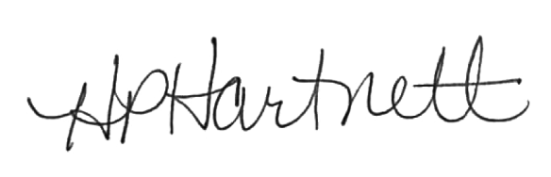

**Helen P. Hartnett, MA, MSW, PhD**

**Professor of Social work**

**Administrative Leadership Fellow**

**Office of the Dean**

**Eberly College of Arts and Sciences**

**West Virginia University**

[**Helen.hartnett@mail.wvu.edu**](mailto:Helen.hartnett@mail.wvu.edu)

**304-293-2505**