**Welcome to the Commercial Buildings Energy Consumption Survey (CBECS) Pretest.** 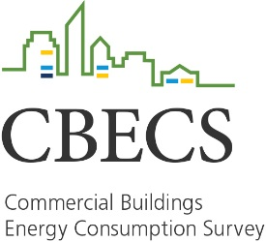

The U.S. Energy Information Administration (the statistical agency of the Department of Energy) has selected this building to be part of a pretest study for the Commercial Buildings Energy Consumption Survey (CBECS). CBECS has been conducted many times since 1979 and provides important energy-related information about commercial buildings throughout the United States. Westat, a research company in Maryland, is conducting this study on behalf of EIA.

We are currently developing new study procedures and testing them to determine if we need to make any changes before conducting the study. To do this, we are asking you to help us by completing a short survey online, which will take no more than 10 minutes.

Please complete the survey online at **[URL]**.

**Your participation is very important.**

We look forward to working with you, and we thank you for participating in this important national energy study.