«Date»

Dear «Name»,

The U.S. Energy Information Administration (EIA) is considering changes to Forms EIA-860 and EIA-923 and is looking to assess our respondents’ abilities to report information related to battery storage, microgrid systems, and the capacity of these storage systems. EIA would also like to understand if respondents are part of a Microgrid system and determine respondent’s abilities to report information related their Microgrids. In addition, EIA is interested in receiving feedback on the amount of time and effort it takes you to complete these surveys.

As part of this research project, we are conducting in-person interviews with Forms EIA-860 and EIA-923 respondents. We will be in your area the week of XX/XX- XX/XX and want to visit with you to discuss these research topics. The interview will take approximately 1 hour. Participation in this research is voluntary. Your responses will be protected as confidential information and results from this study will not include information that can be used to identify you or anyone in your organization.

Your opinions are important to us and we look forward to your participation. If you would like to participate in an interview please follow the following link below to set up
a date and time that works best with your schedule https://calendly.com/eia-survey-development-team/XXXX. Please reach out to Anna Hamelin on my staff if you have any questions at (202) 586-0858, email anna.hamelin@eia.gov.

Sincerely yours,

Nanda Srinivasan, Director
Office of Survey Development and Statistical Integration
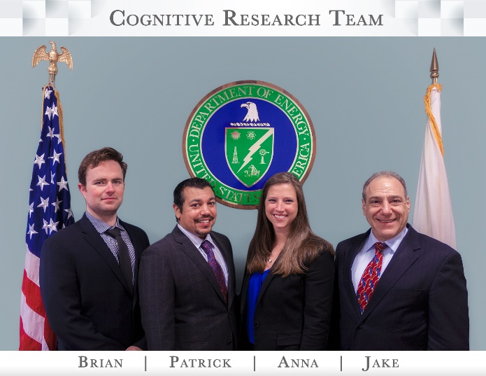
U.S. Energy Information Administration
1000 Independence Avenue SW
Washington DC 20585

