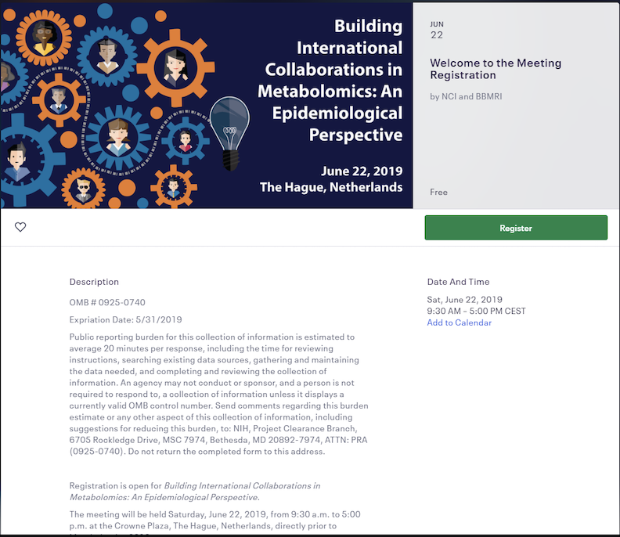
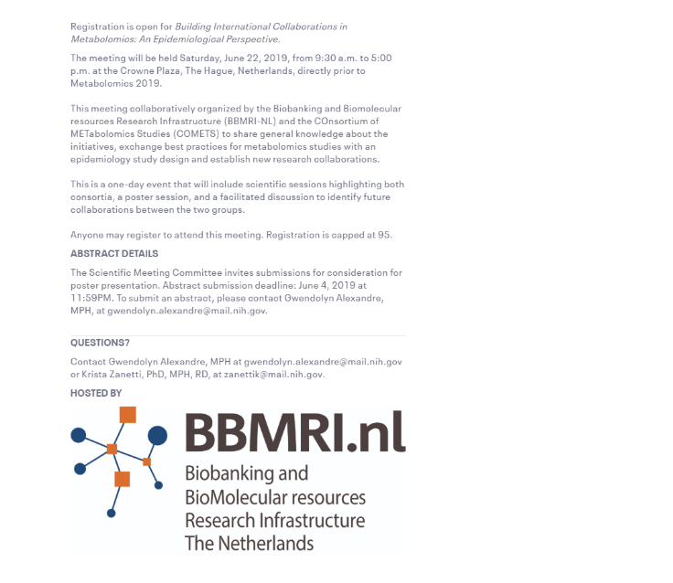

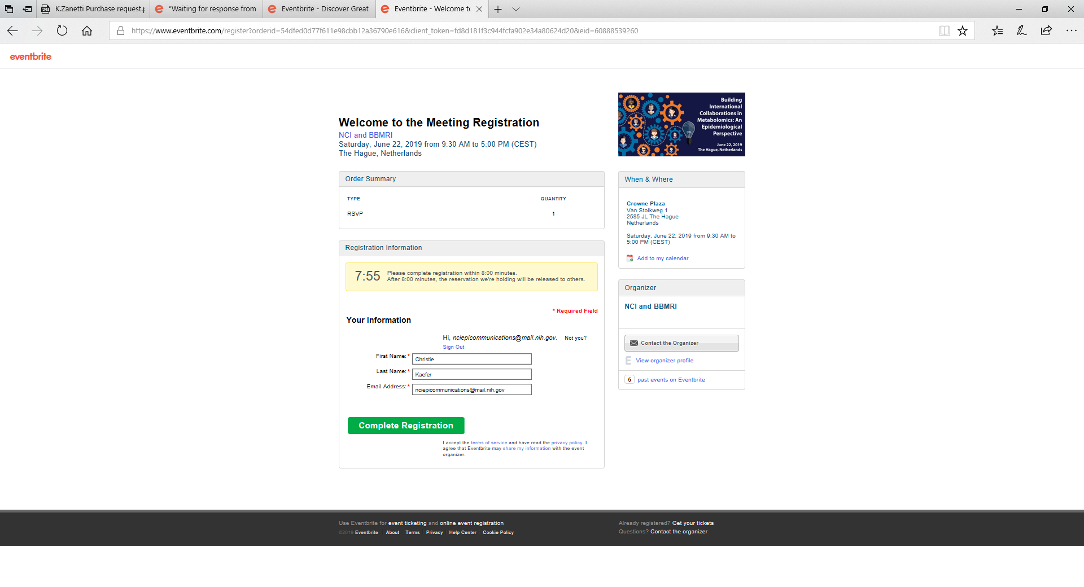

OMB # 0925-0740
Expiration Date: May 31, 2019
Public reporting burden for this collection of information is estimated to average 20 minutes per response, including the time for reviewing instructions, searching existing data sources, gathering and maintaining the data needed, and completing and reviewing the collection of information. An agency may not conduct or sponsor, and a person is not required to respond to, a collection of information unless it displays a currently valid OMB control number. Send comments regarding this burden estimate or any other aspect of this collection of information, including suggestions for reducing this burden, to: NIH, Project Clearance Branch, 6705 Rockledge Drive, MSC 7974, Bethesda, MD 20892-7974, ATTN: PRA (0925-0740). Do not return the completed form to this address.

Welcome to the abstract submission form for
Building International Collaborations in Metabolomics: An Epidemiological Perspective
The Crowne Plaza, The Hague, Netherlands
June 22, 2019

The Scientific Meeting Committee invites submissions for consideration for poster presentation.

Abstract Submission Deadline: June 4th, 2019 at 11:59PM ET.

Welcome to the abstract submission page for Building International Collaborations in Metabolomics: An Epidemiological Perspective.

Abstract Submission Deadline: June 4th, 2019 at 11:59PM ET.

The Scientific Meeting Committee invites submissions for consideration for poster presentation.

*Please select the single topic area that best fits your abstract:

Presenting Abstract Author Information:
*First Name

*Last Name

*Affiliation

*Email

Corresponding Abstract Author Information:

*First Name

*Last Name

*Affiliation

*Email

*City

*State

*Country

*Phone

Enter a valid U.S. or International number format

Co-Author Information

*Abstract Title:

*Body of Abstract:

Please organize your abstract with the following headings: Background, Methods, Results and Conclusion.
Abstracts should be 2,200 characters, including spaces. Paste abstract text in the box provided below.

Potential conflicts with commercial interests for the first author and all co-authors must be disclosed at the time of submission (A commercial interest is defined as any entity developing, producing, marketing, re-selling or distributing goods or services relevant to geospatial research on Cancer Control and Population Sciences).
*Do any of the authors have a conflict of interest?

If yes, please briefly describe the conflict below:

Email your completed abstract to Gwendolyn Alexandre at gwendolyn.alexandre@mail.nih.gov by
11:59 PM ET on May 31st, 2019.

