9-15-2012 | Department of Veterans Affairs  VA Health Administration Center  3773 Cherry Creek North drive, STE 450  Denver, Colorado 80209-3812  William Bechtel 303-398-5135 william.bechtel@va.gov
White Paper | Proposed  Correction | CHAMPVA  Claim Form -  VA Form  10-7959a  Collection  2900-0219 | 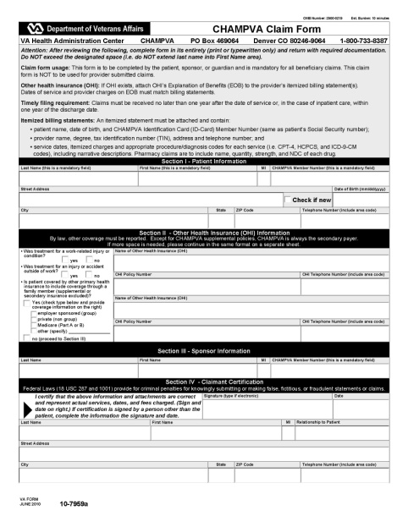
Error found in recent OMB approved form  (approved 8-16-2010) | REASON FOR CHANGE:  We have discovered a text error and wish to make a correction to this recently OMB approved form. The change is necessary because the form is asking for incorrect information that may confuse the beneficiary.  DESCRIPTION:  Within Section III – Sponsor Information, we have a box asking the Sponsor for “CHAMPVA Member Number (this is a mandatory field)”  This was changed on the last OMB collection review from a box asking for the Social Security Number (SSN). A similar change was made, at the same time, within Section I – Patient Information. Because the VA has an initiative to reduce the use of SSN’s it was decided to remove the two requests for SSN’s and replace them with this statement: “CHAMPVA Member Number (this is a mandatory field)”  www.privacy.va.gov/ssn.asp  Stomp out SSN    (live link to Web Page - Social Security Number (SSN) Reduction Effort)  Asking for “CHAMPVA Member Number” information of the Patient is OK, but asking this information of the Sponsor is not. A sponsor is a Veteran, not a beneficiary or a member.  The ERROR:  THE FIX:  We concluded that since the claim form is sent in by a CHAMPVA beneficiary and the Sponsor’s information (SSN) is already in our data base, there is no reason to ask for this information (SSN) again. It is prudent to decrease the use of Veteran’s SSNs for privacy protection (Stomp Out Initiative).  We fixed the form by eliminating the text and box asking for the Sponsor SSN (On the current form – eliminating the incorrect box asking for “CHAMPVA Member Number”). This should not affect the burden hours of this form as it is a minimal change.  The FIX - action:  We did leave the boxes requesting the Sponsor’s name because it was determined this may be useful information in discerning the correct beneficiary if a claim was submitted by a similar named individual (e.g. John Johnson, Mary Ford, etc.).  ___________________________________________________________
Blow-up views showing the existing form and the proposed correction:

CURRENT FORM – showing error:
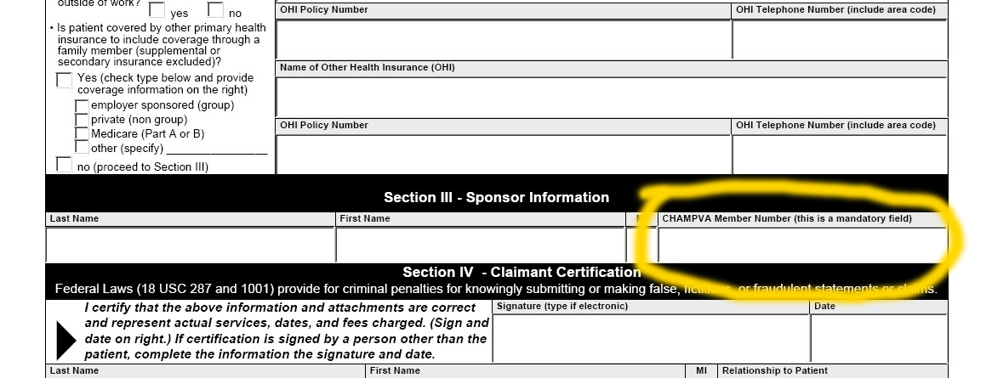

CORRECTED FORM - Proposed:
