Attachment A2

AISL Monitoring System Screenshots: OPMS Baseline Survey

Baseline Survey Screenshots for
The NSF Advancing Informal STEM Learning (AISL) Program’s
Online Project Monitoring System (OPMS)
NOTE: The OPMS Baseline Survey collects anticipated data over the course of the AISL grant.

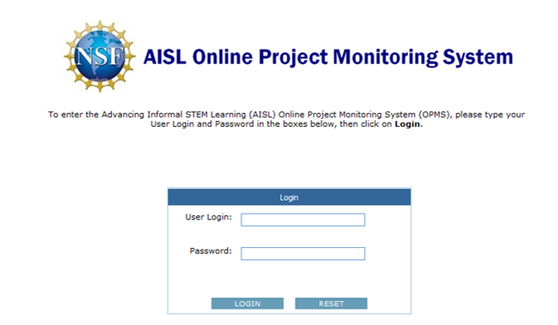

OMB # 3145-0226, Expiration Date: 2/29/2016
Advancing Informal STEM Learning (AISL)
Online Project Monitoring System (OPMS)
Sponsored by the
National Science Foundation
Conducted by
Westat
1650 Research Boulevard
Rockville, Maryland 20850

Privacy Notice
Information from this monitoring system will be retained by the National Science Foundation, a federal agency, and will be an integral part of its Privacy Act System of Records in accordance with the Privacy Act of 1974 and maintained in the Education and Training System of Records, 63 Fed. Reg. 264, 272 (January 5, 1998). These are confidential files accessible only to appropriate National Science Foundation (NSF) officials, their staffs, and their contractors responsible for monitoring, assessing, and evaluating NSF programs. Only data in highly aggregated form, or data explicitly requested as “for general use,” will be made available to anyone outside of the National Science Foundation for research purposes. Data submitted will be used in accordance with criteria established by NSF for monitoring research and education grants, and in response to Public Law 99-383 and 42 U.S.C. 1885c.
Public Burden
Submission of the requested information is voluntary. Failure to provide full and complete information, however, may reduce the possibility for continued support thorough the award/project subject to this survey. The public reporting burden for this collection of information is estimated to average 24.0 person hours for the Baseline submission, 8.0 person hours for each Annual Report, and 16.0 person hours for the Closeout Report, including the time for reviewing instructions. Send comments regarding this burden estimate or any other aspect of this collection of information, including suggestions for reducing this burden, to Suzanne Plimpton, Reports Clearance Officer for OMB Collection 3145-0226, National Science Foundation, 4201 Wilson Blvd., Suite 1265, Arlington, VA 22230.
If you have any questions, contact isehelp@westat.com
Contact Us

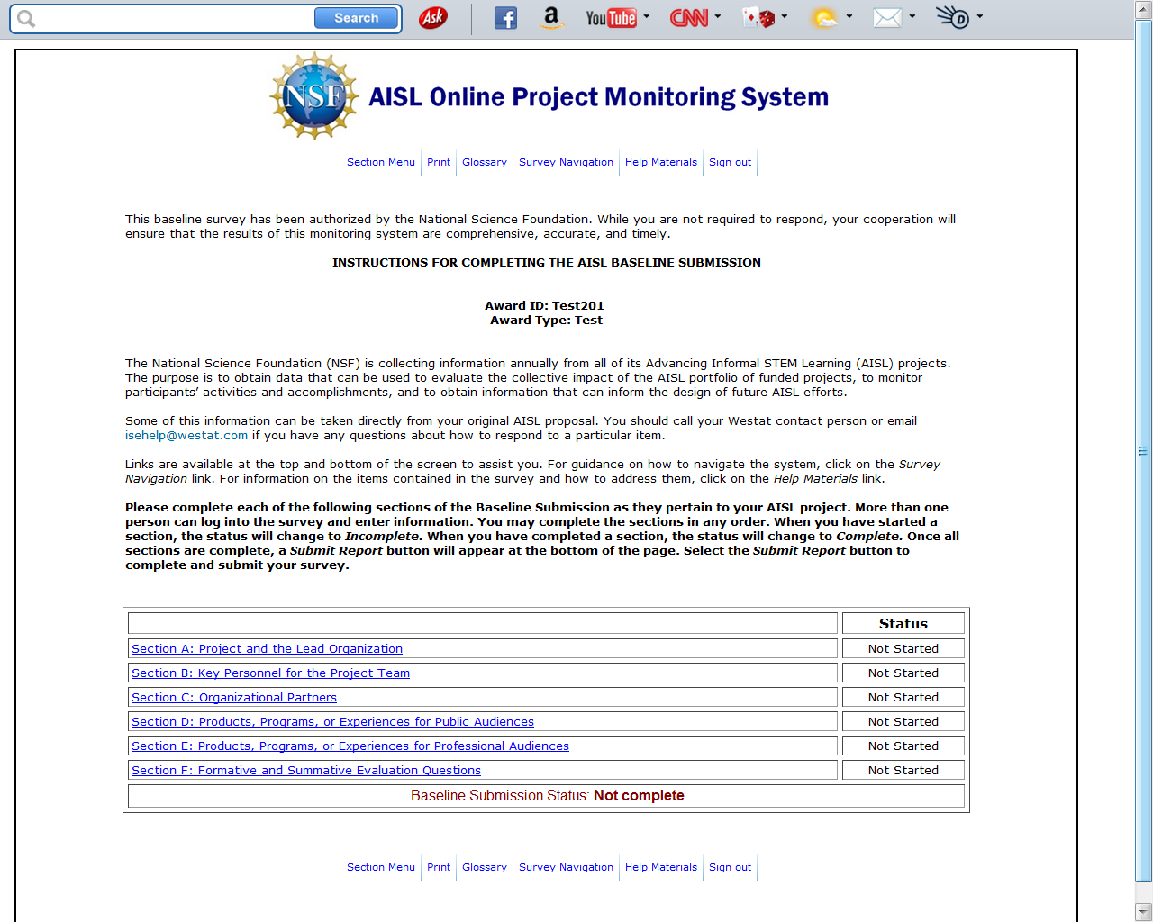

Section A: Project and the Lead Organization

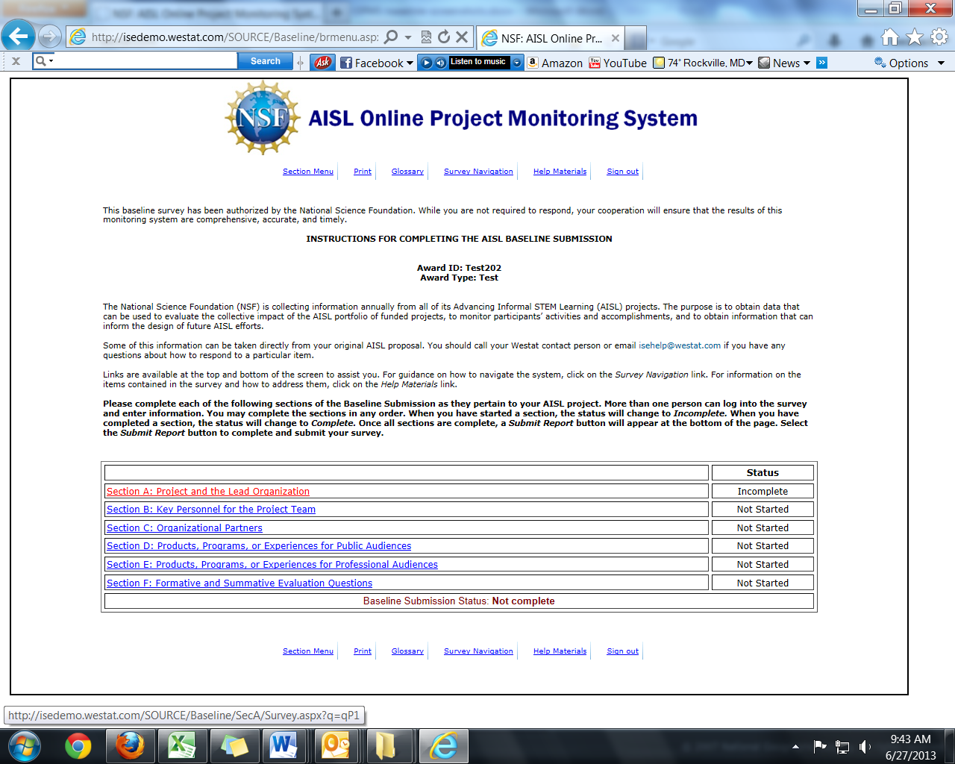

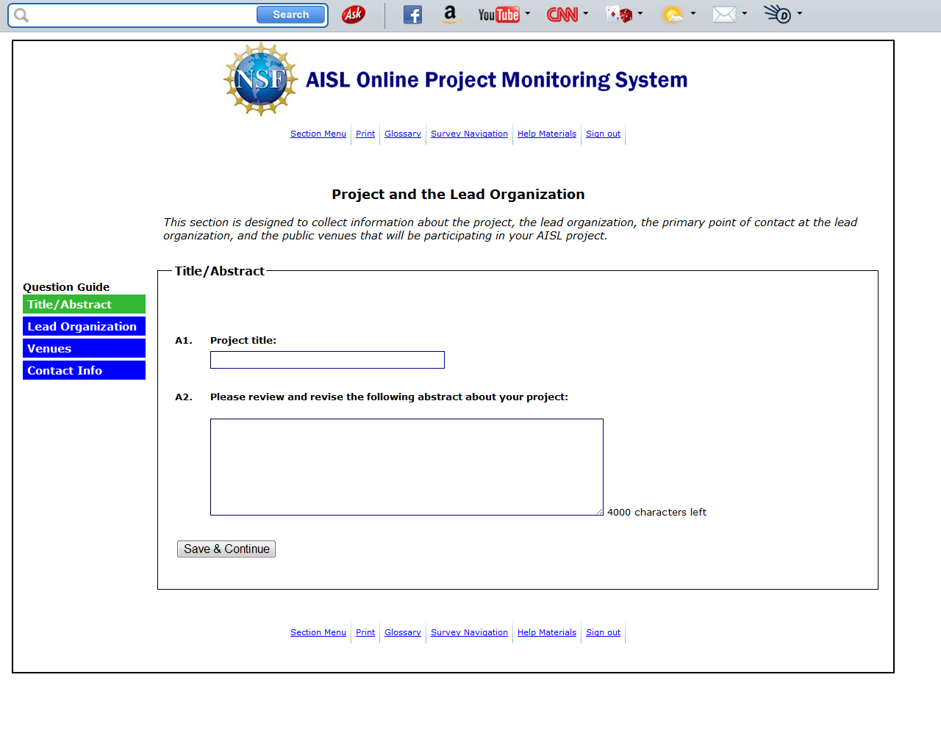
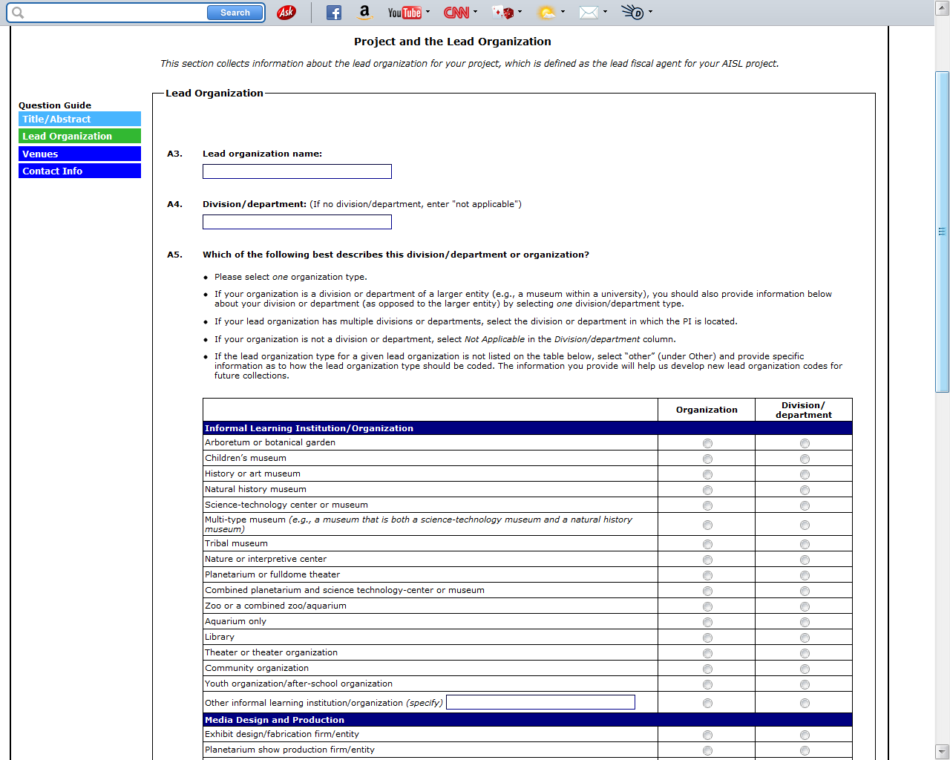
(CONTINUED ON NEXT PAGE)

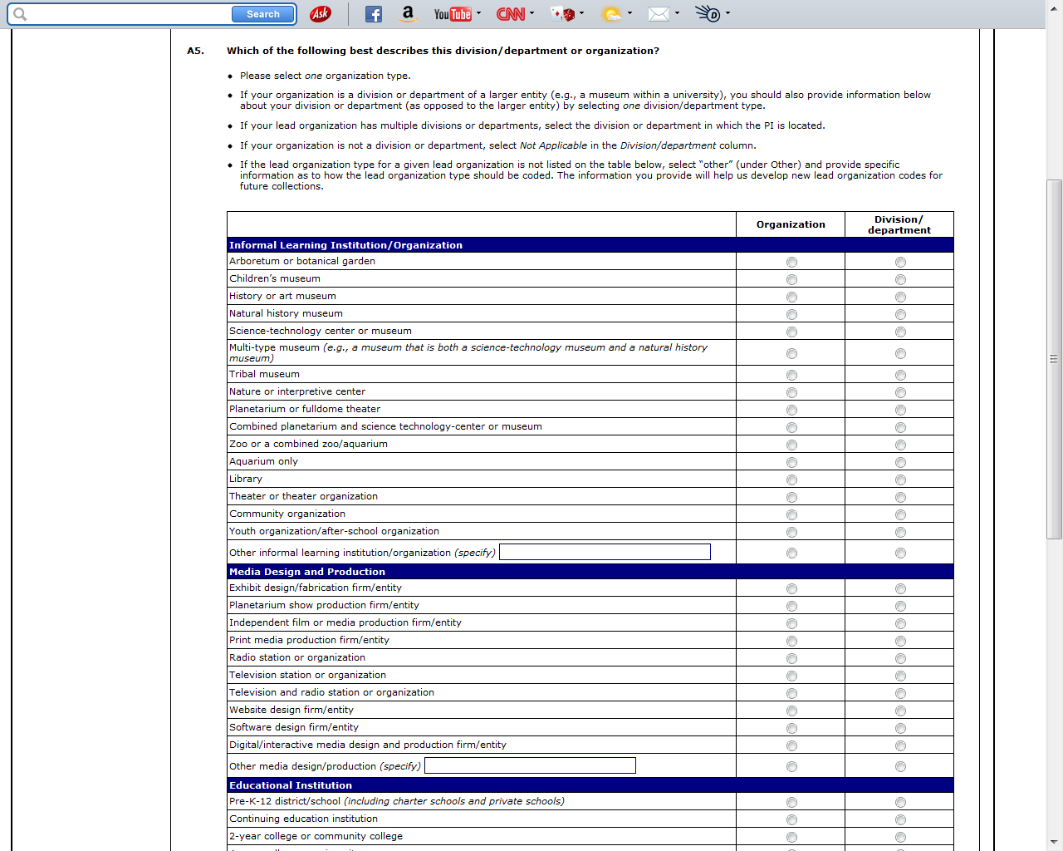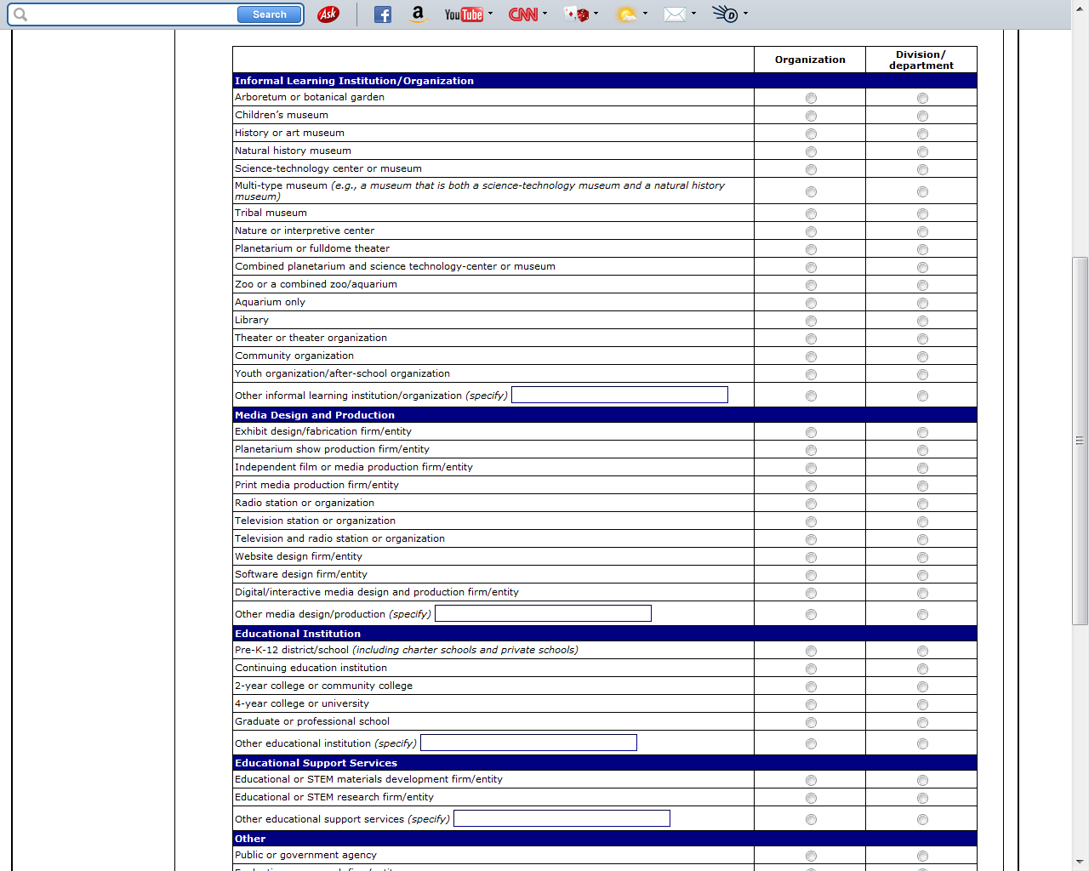
(CONTINUED ON NEXT PAGE)
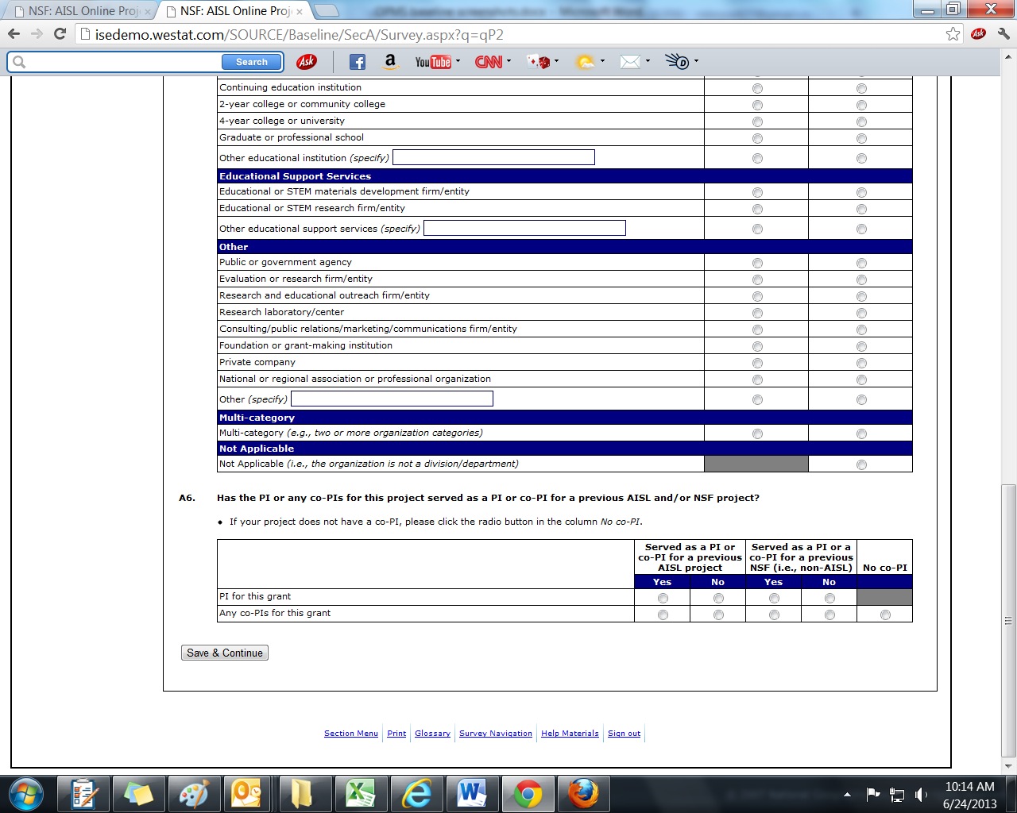

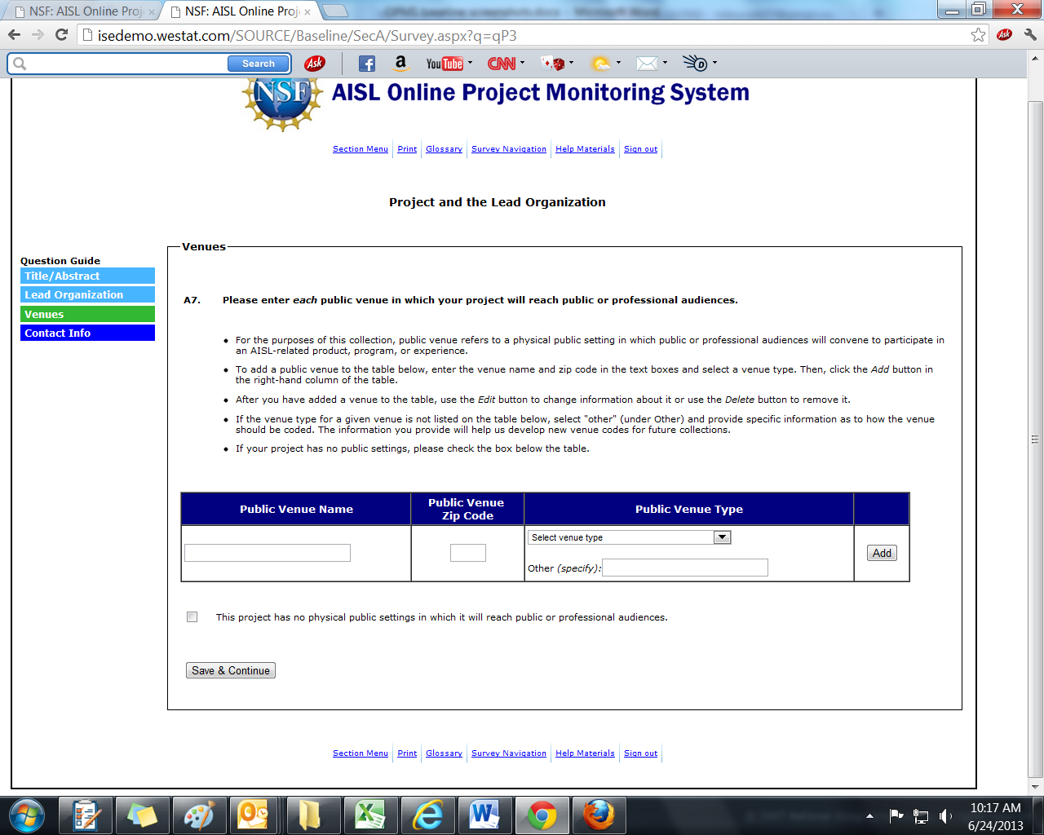
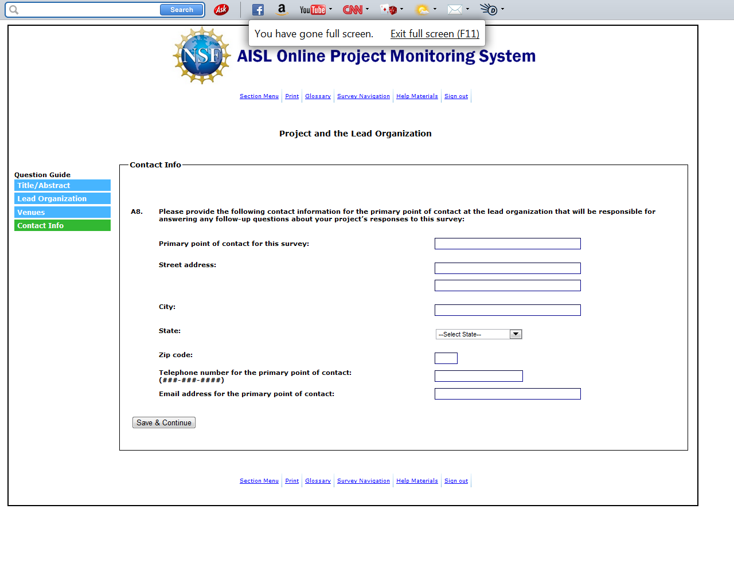

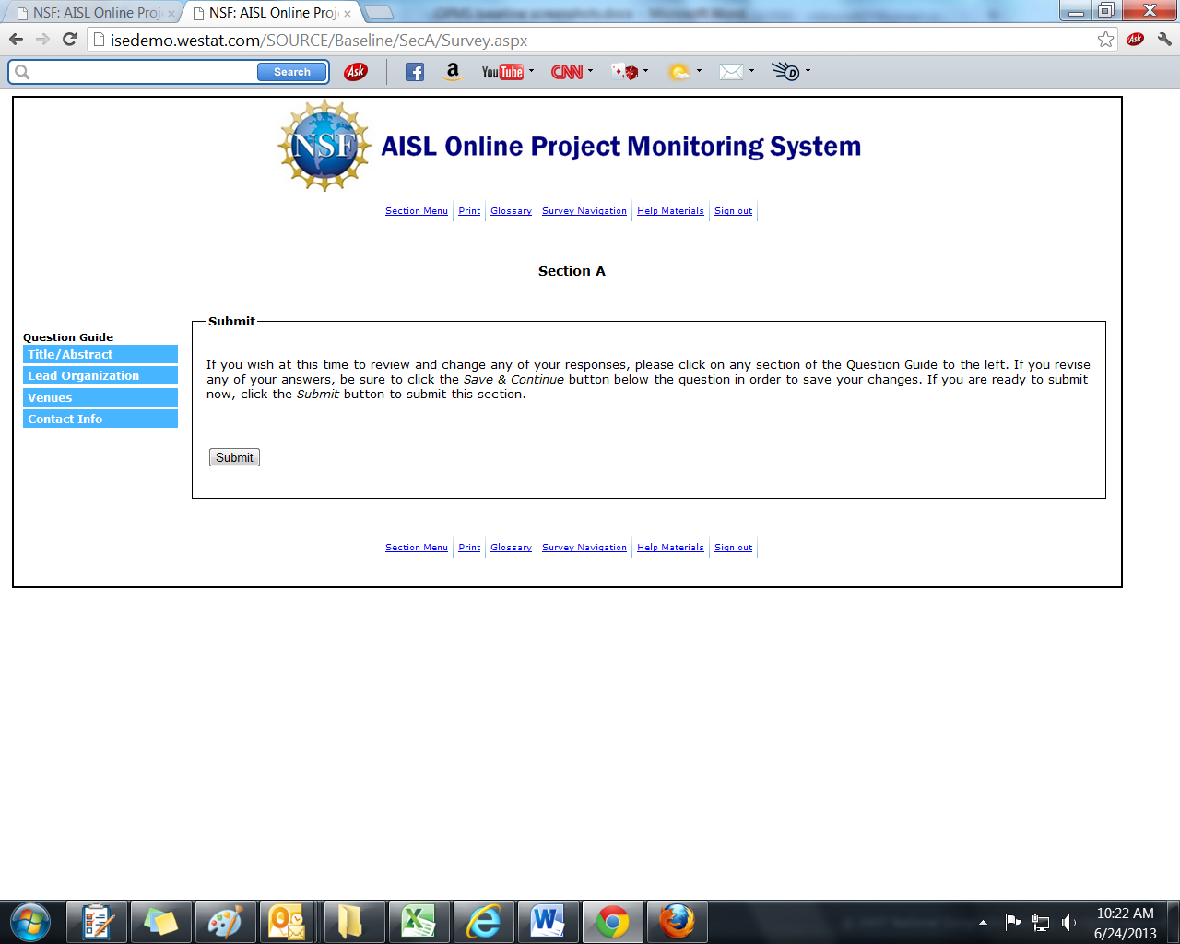
Section B: Key Personnel for the Project Team

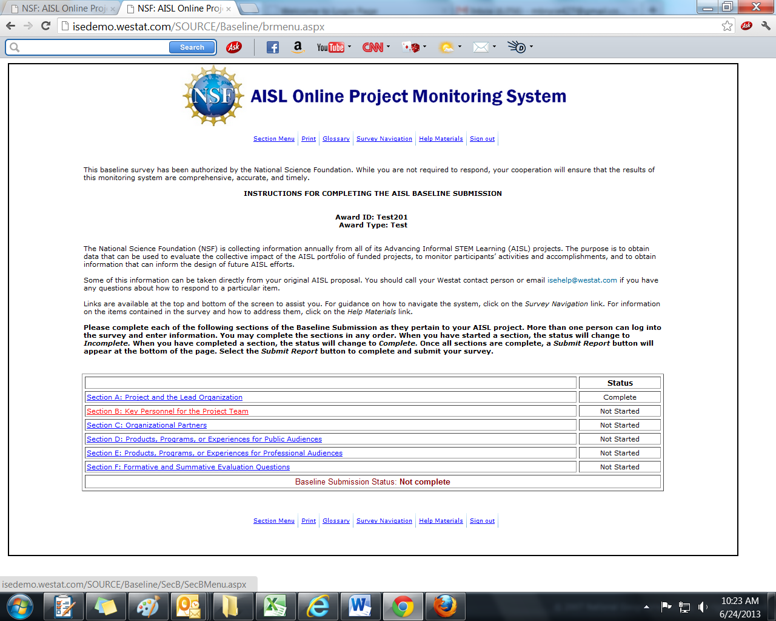

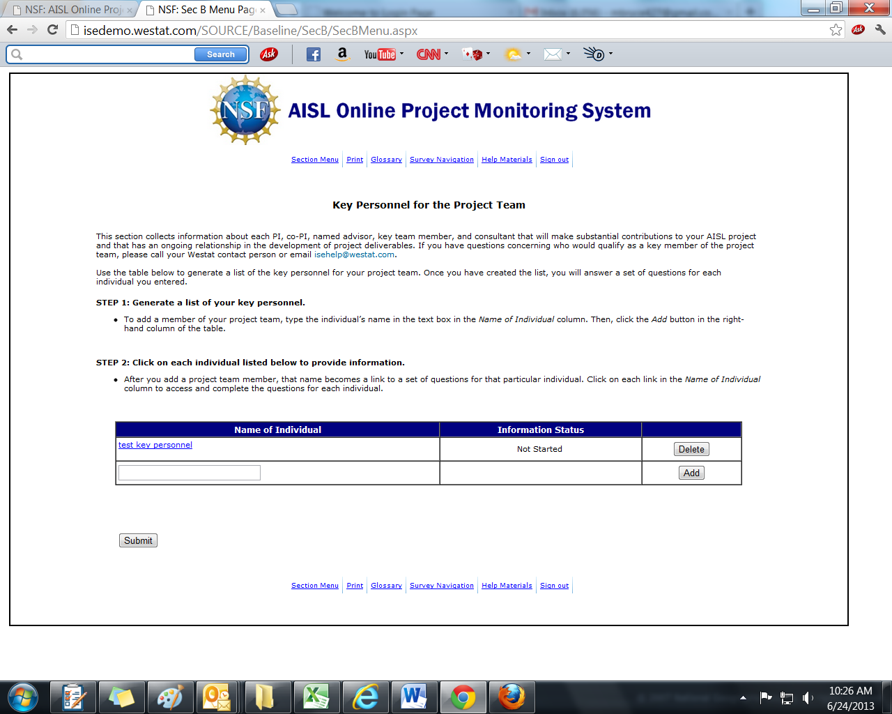

(B1-B4 ARE COMPLETED FOR EACH PERSON ENTERED INTO THE KEY PERSONNEL TABLE)
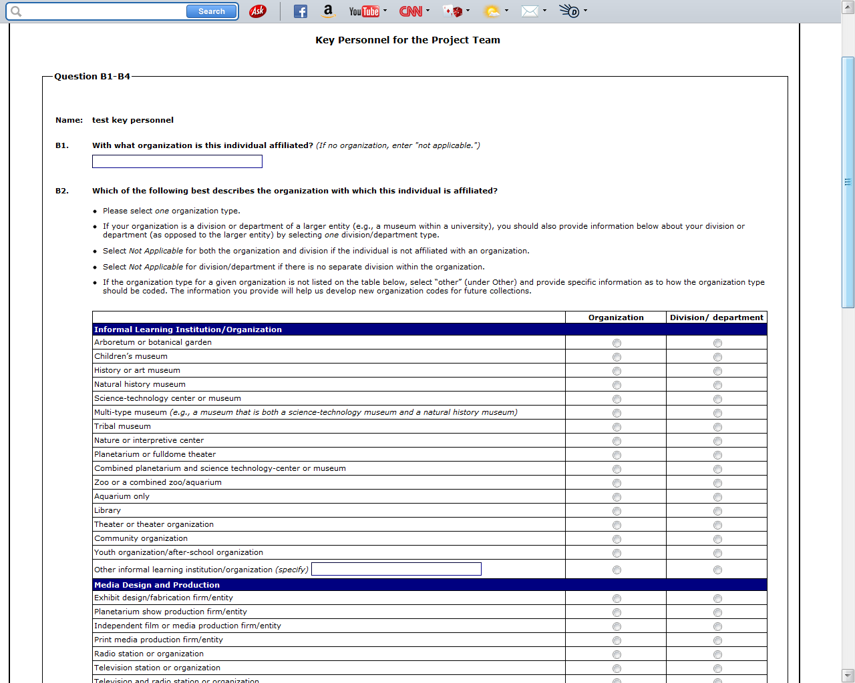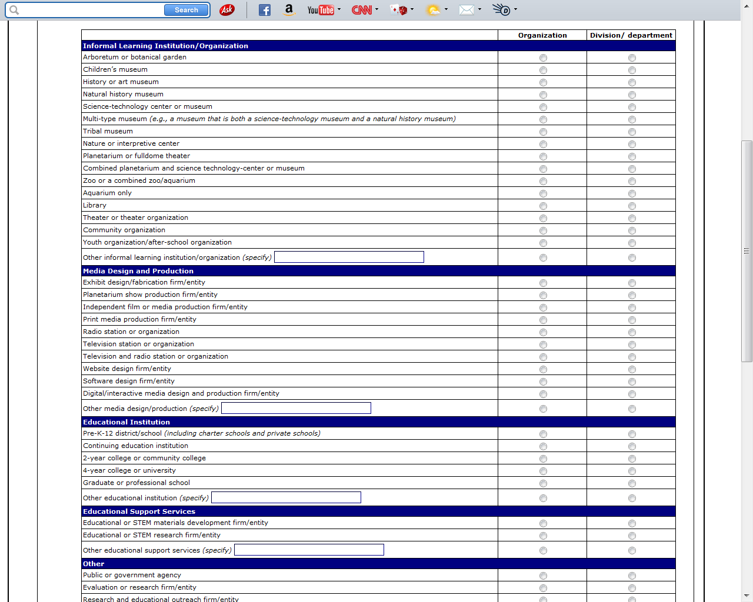
(CONTINUED ON NEXT PAGE)
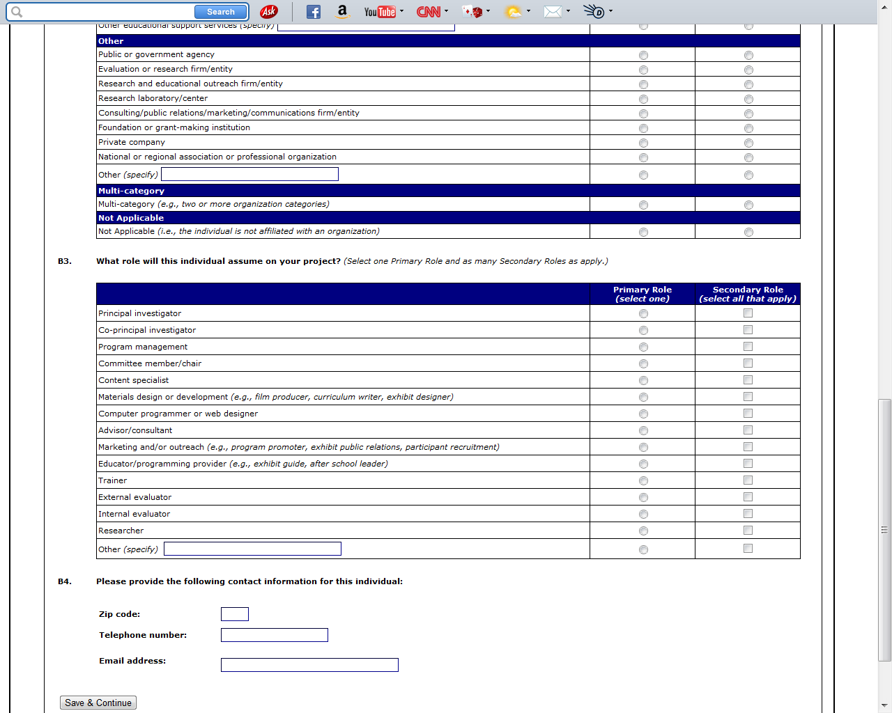

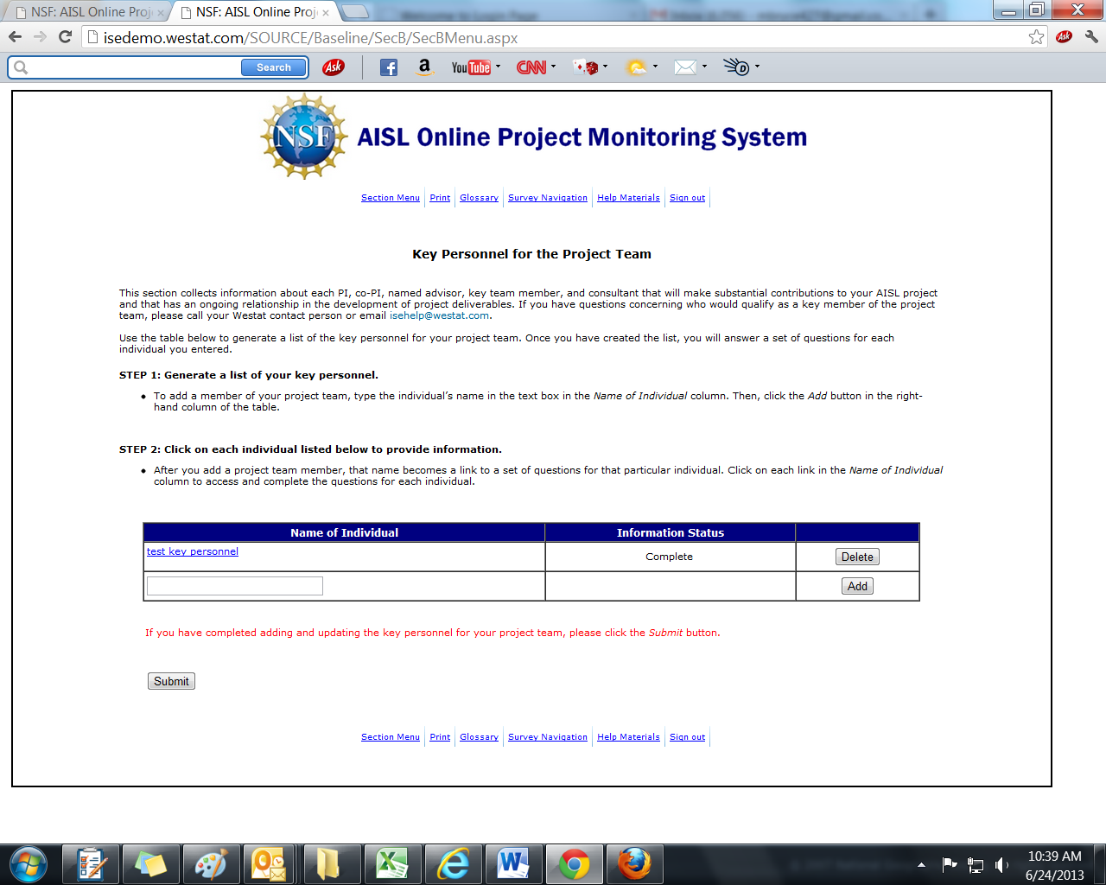

Section C: Organizational Partners

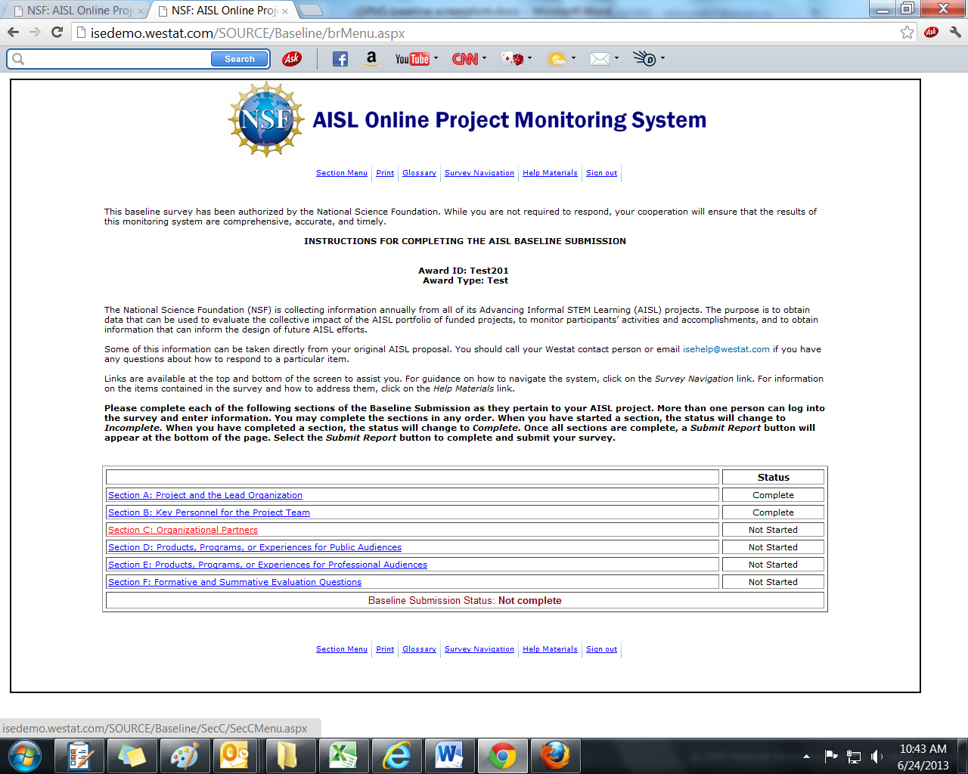

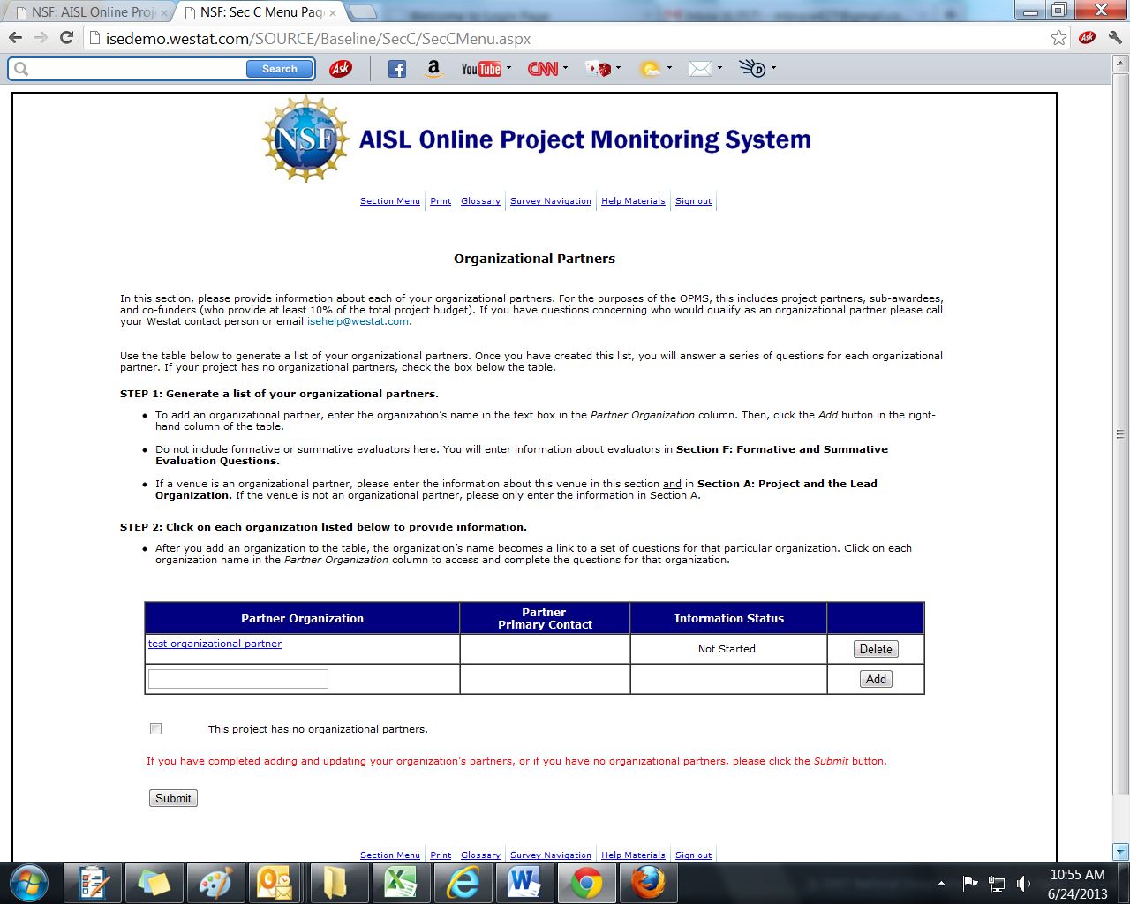

(C1-C5 ARE COMPLETED FOR EACH ORGANIZATION ENTERED IN THE PARTNER ORGANIZATION TABLE)
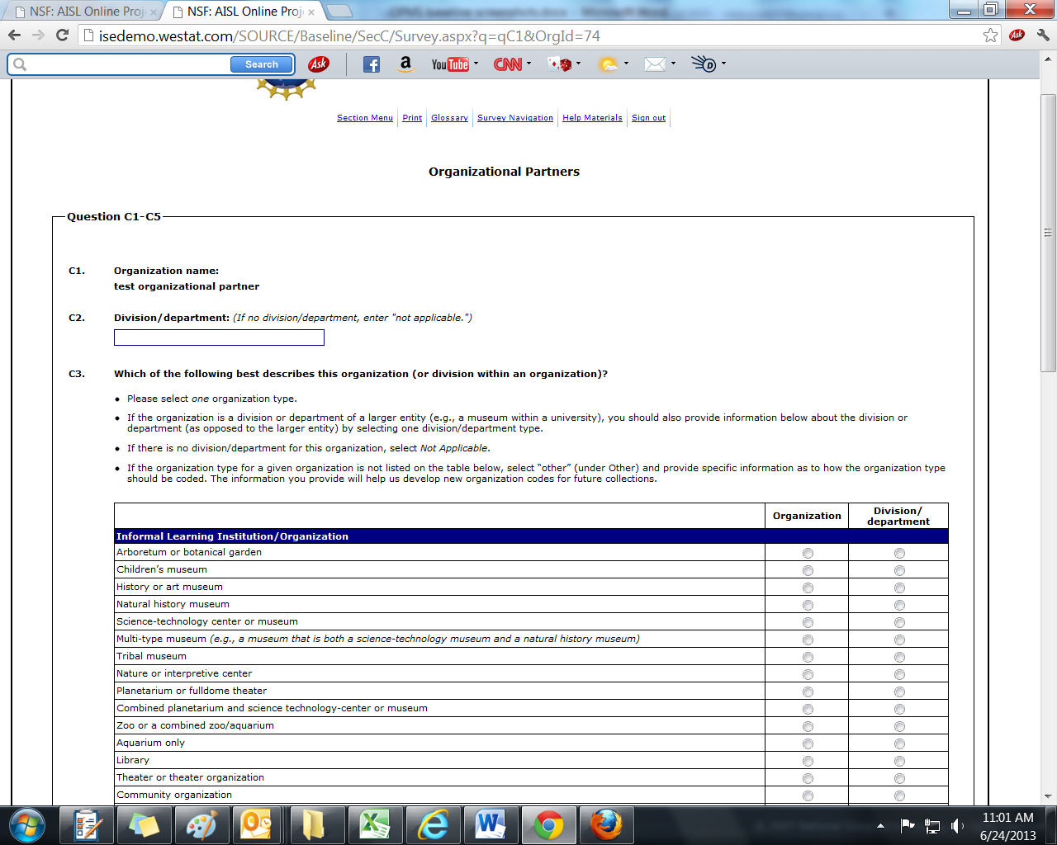
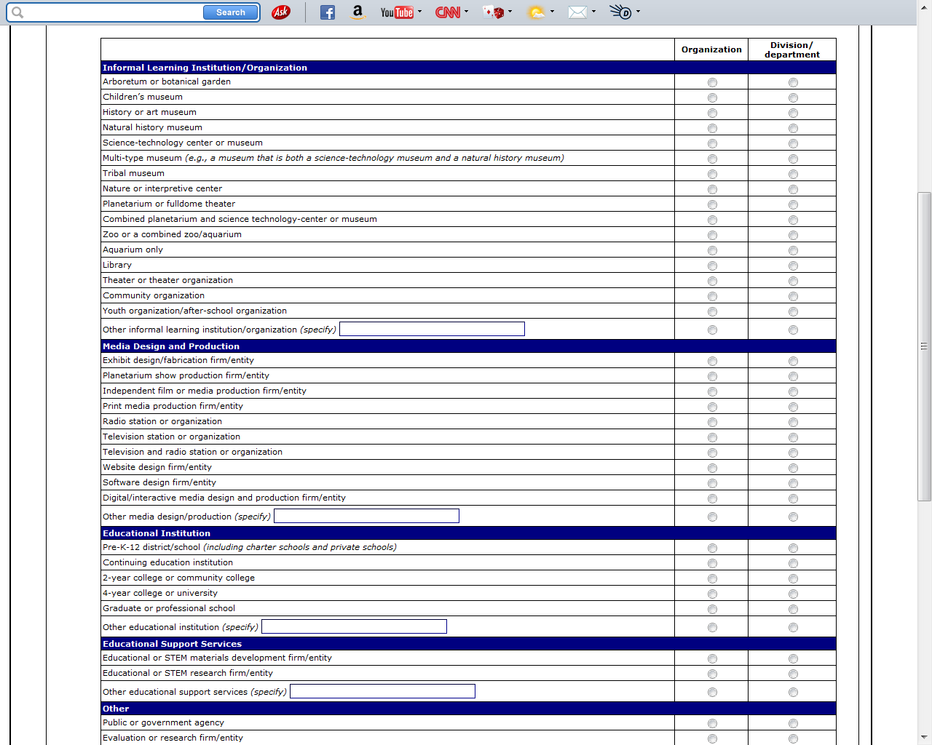
(CONTINUED ON NEXT PAGE)
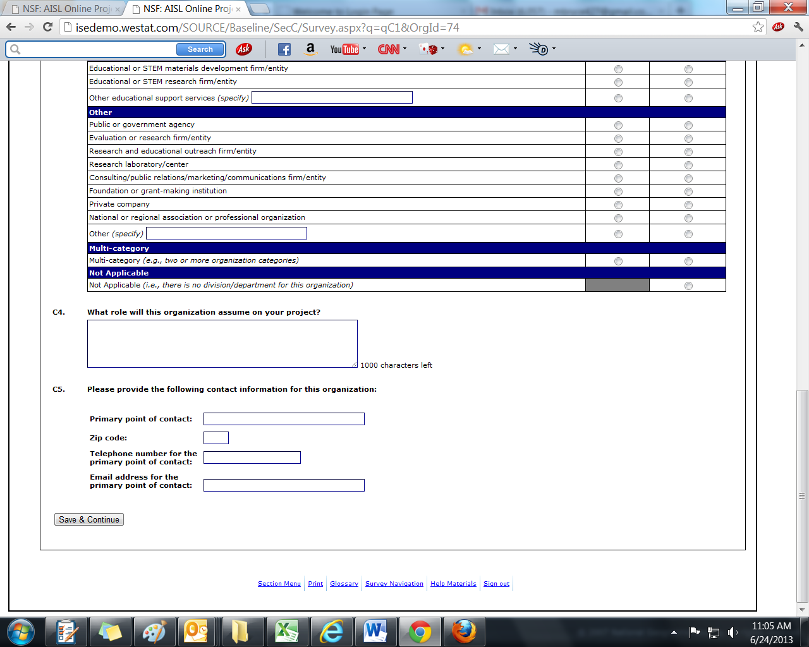

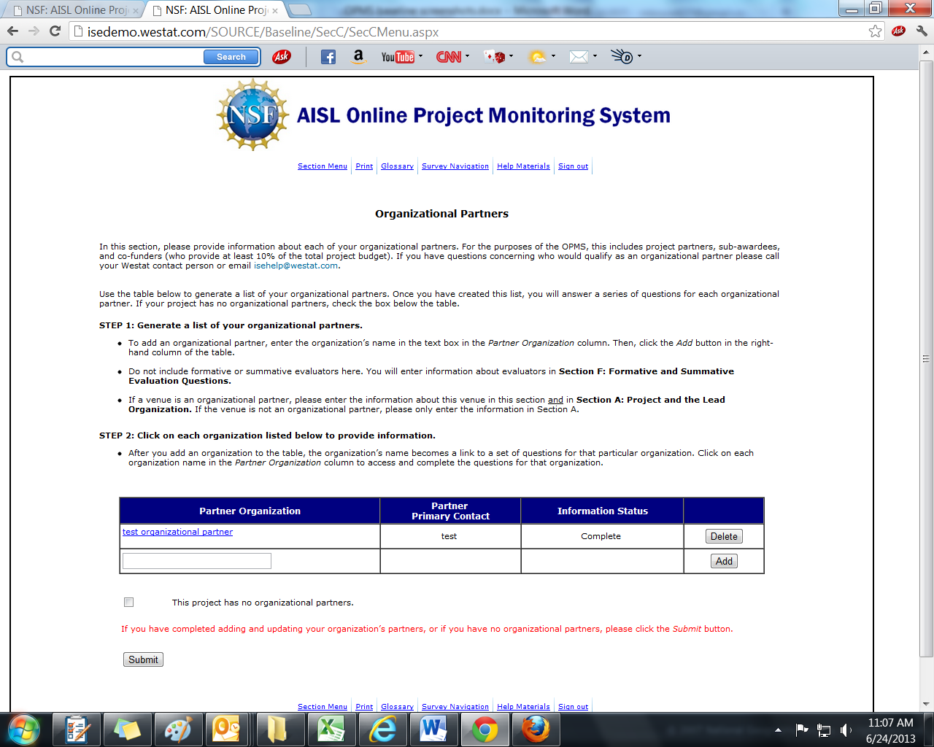

Section D: Products, Programs, or Experiences for Public Audiences

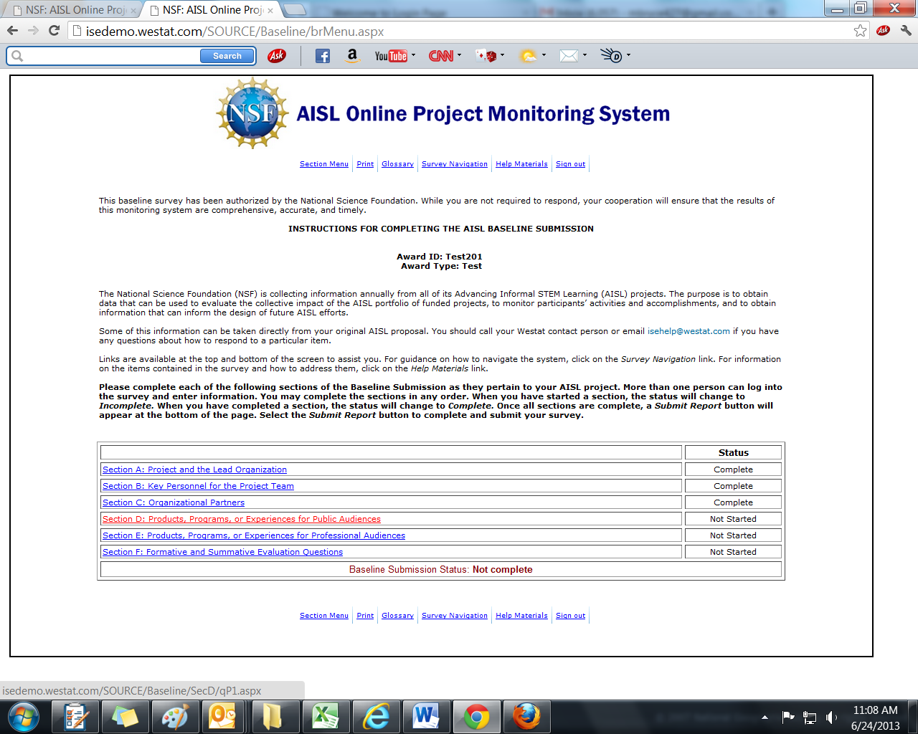

(SECTION D IS ONLY COMPLETED IF A PROJECT HAS AT LEAST ONE PUBLIC AUDIENCE DELIVERABLE. IN D1, A SELECTION OF “YES” CONTINUES TO THE DELIVERABLE LIST SCREEN. A SELECTION OF “NO” RETURNS TO THE SECTION MENU.)
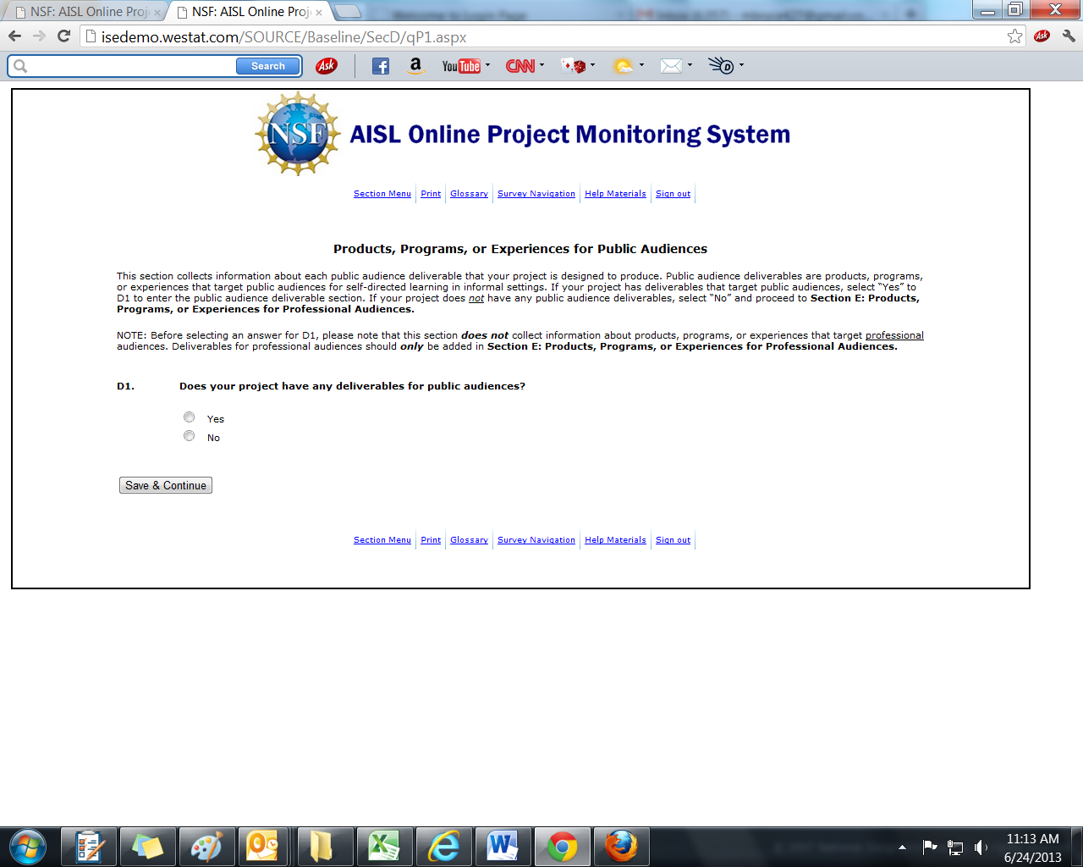

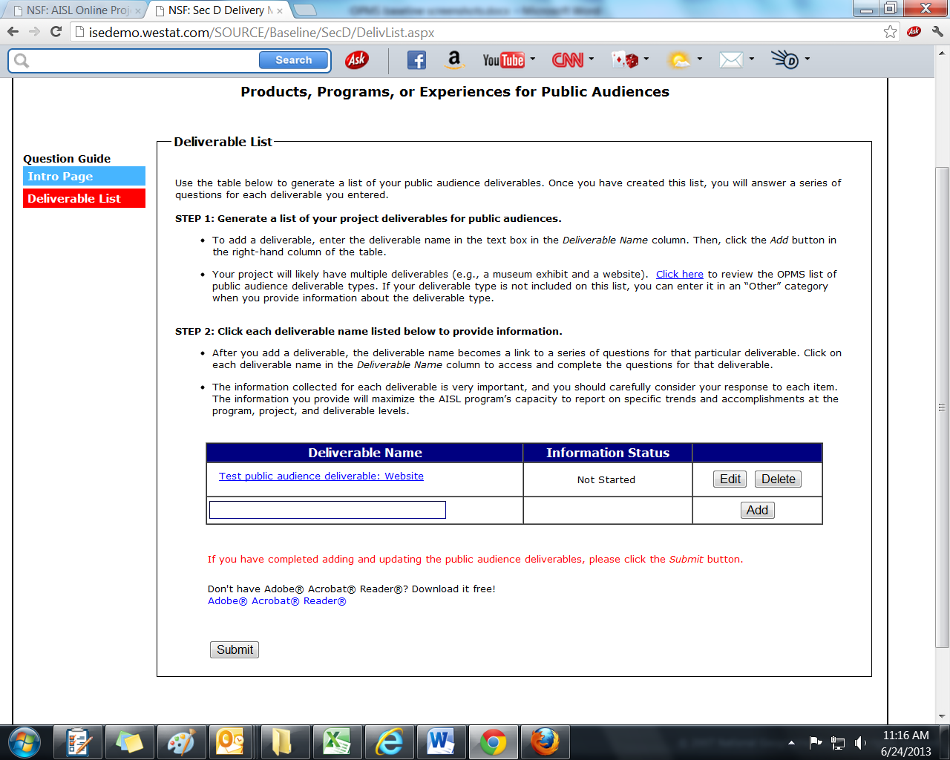

(SECTION D QUESTIONS ARE ANSWERED FOR EACH DELIVERABLE ENTERED IN THE DELIVERABLE TABLE)
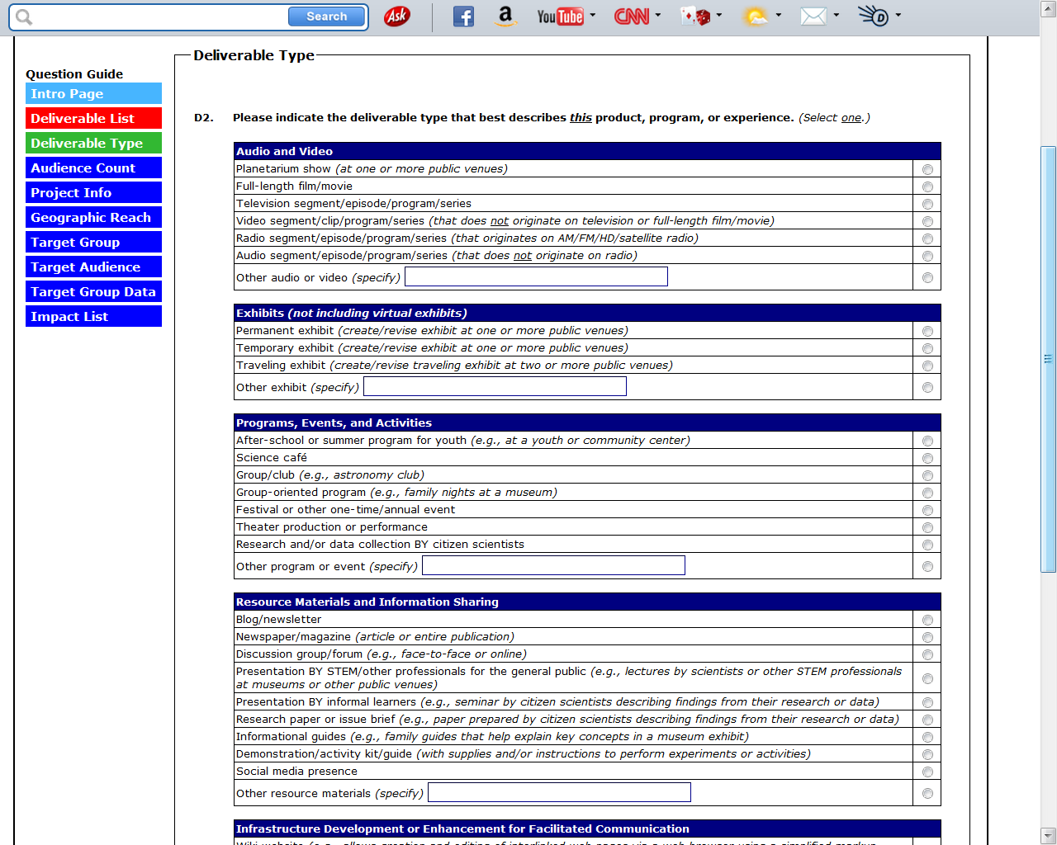
(CONTINUED ON NEXT PAGE)

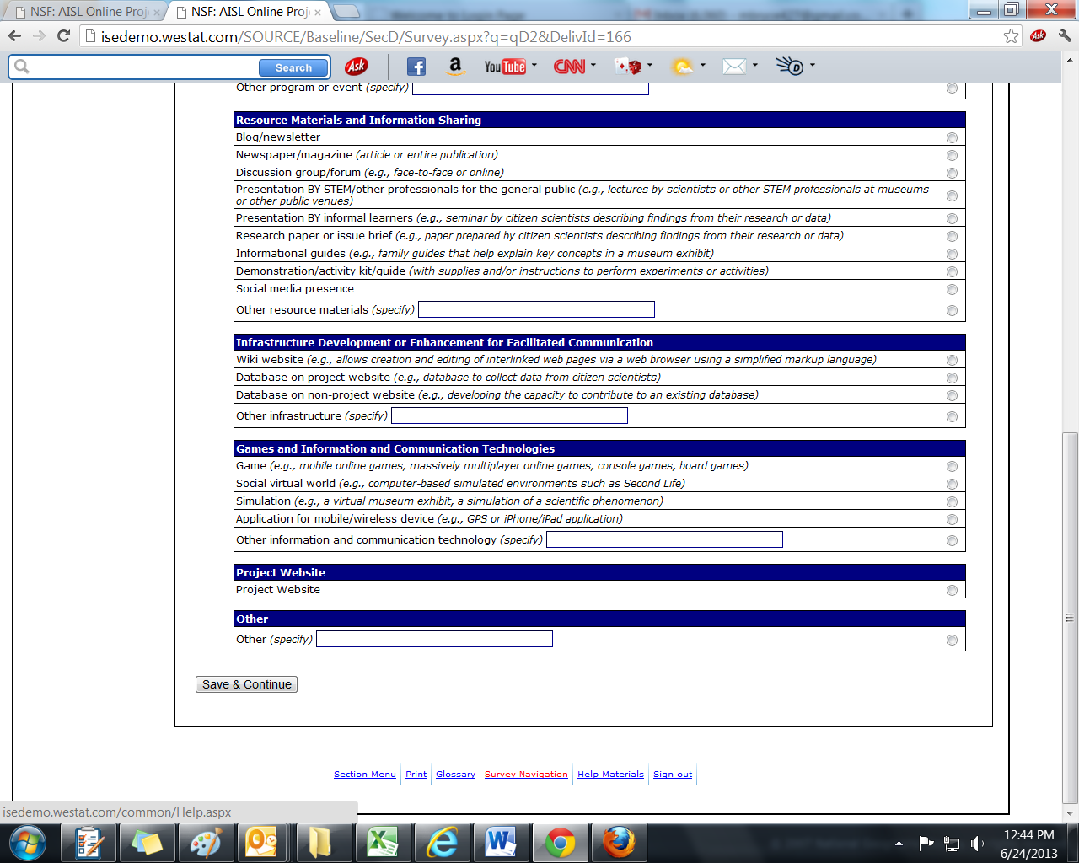

(D2A IS ONLY ANSWERED IF THE DELIVERABLE TYPE SELECTED IN THE PREVIOUS QUESTION, D2, IS “PROJECT WEBSITE”)
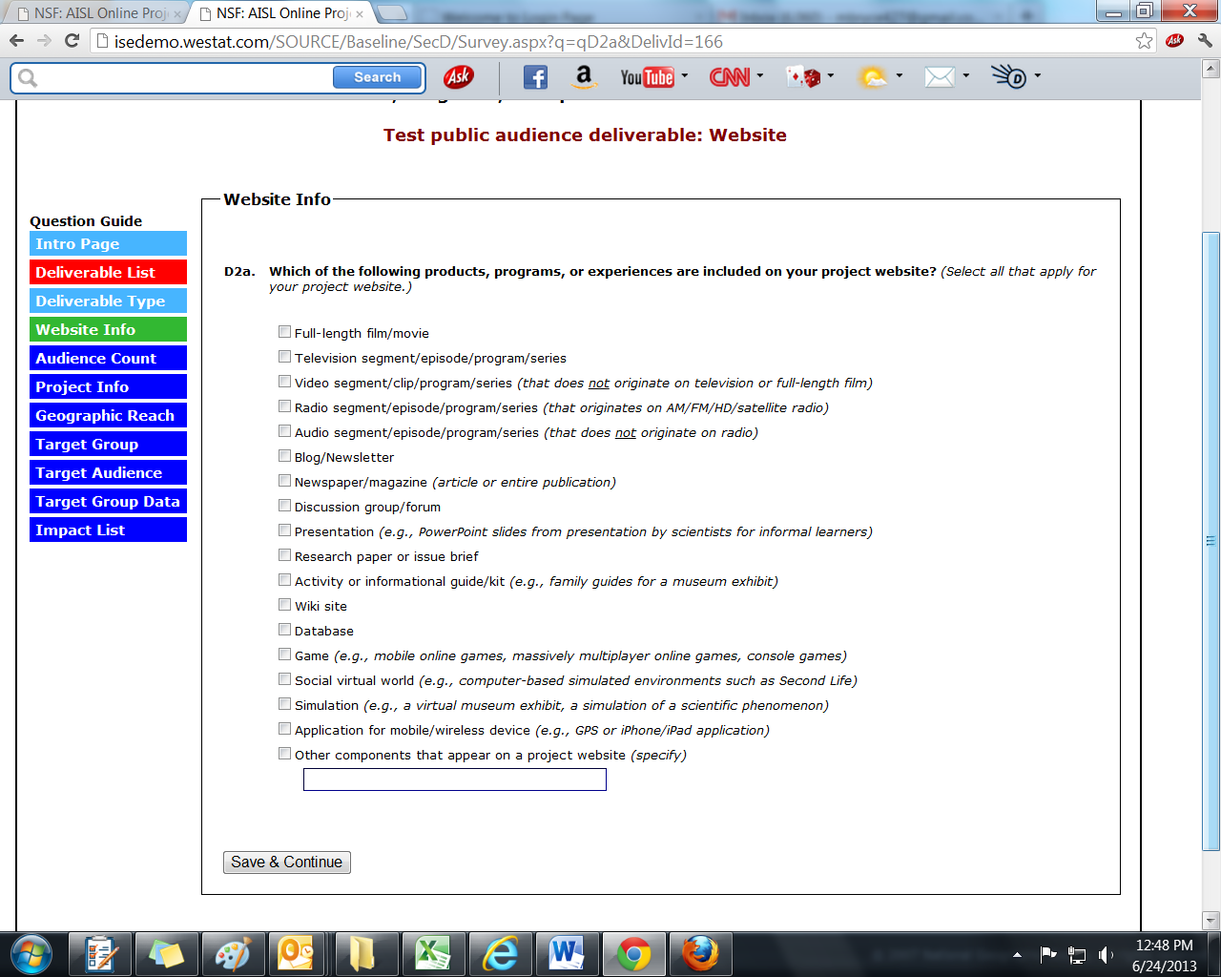

(EACH OF THE EIGHT DELIVERABLE CATEGORIES IN D2 (E.G., AUDIO AND VIDEO) SKIPS TO A UNIQUE D3 (AUDIENCE COUNT) QUESTION. ALTHOUGH ALL EIGHT D3 ITEMS ARE DISPLAYED BELOW, ONLY ONE OF THE D3 QUESTIONS IS ANSWERED FOR EACH DELIVERABLE.)
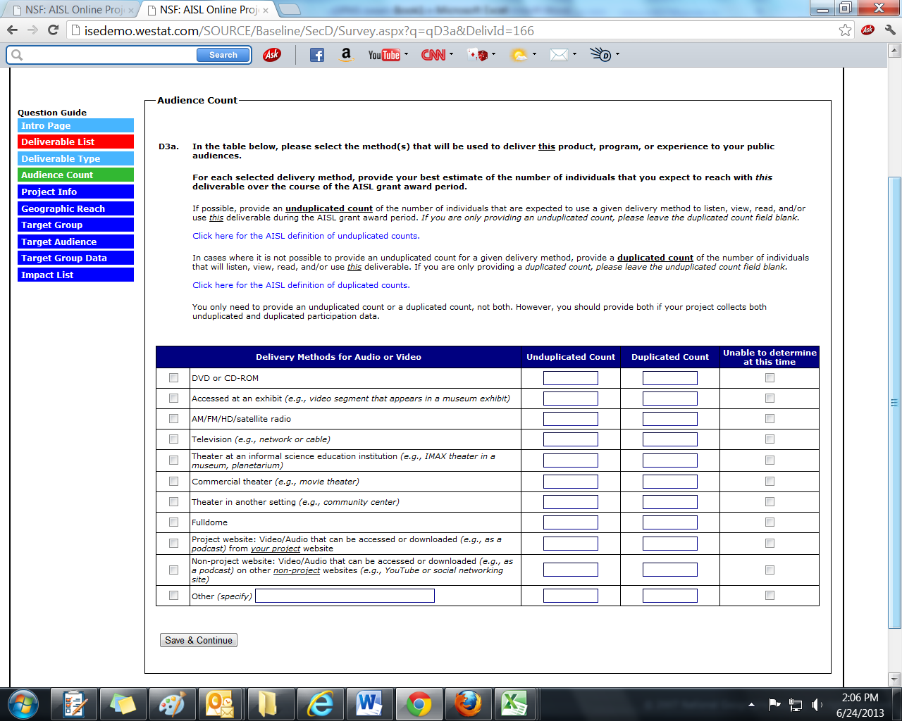

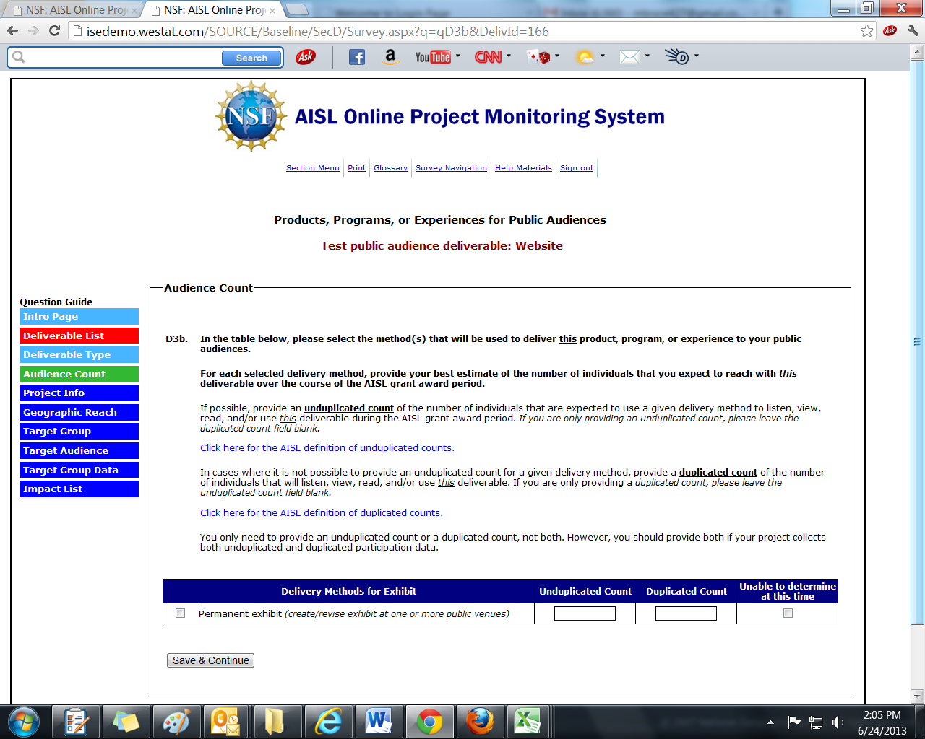
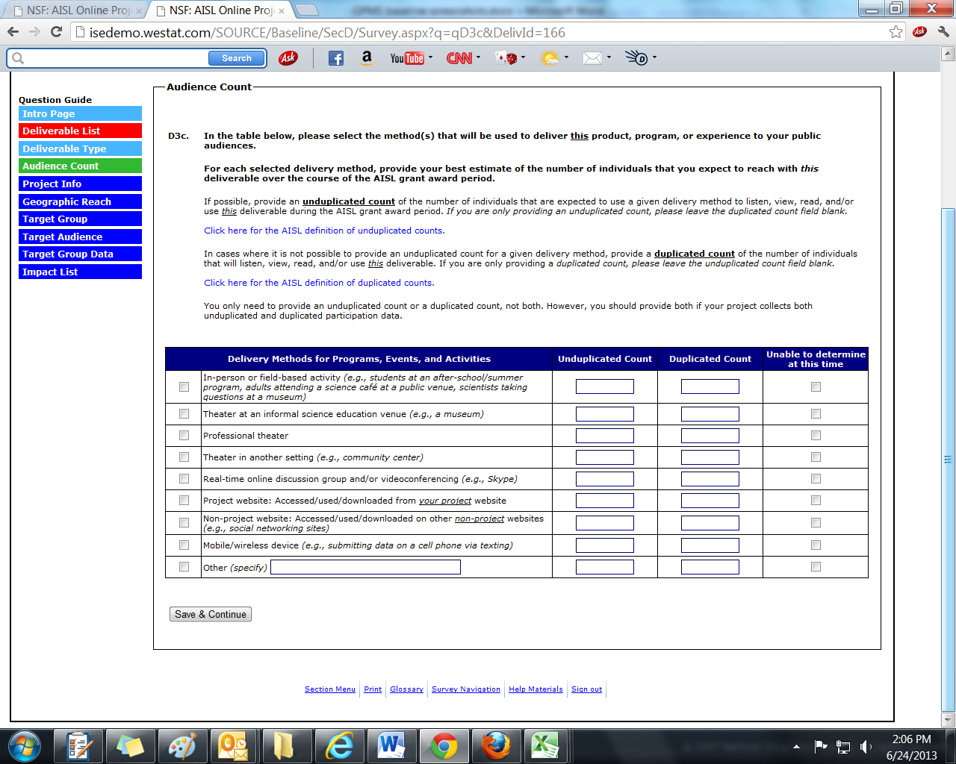

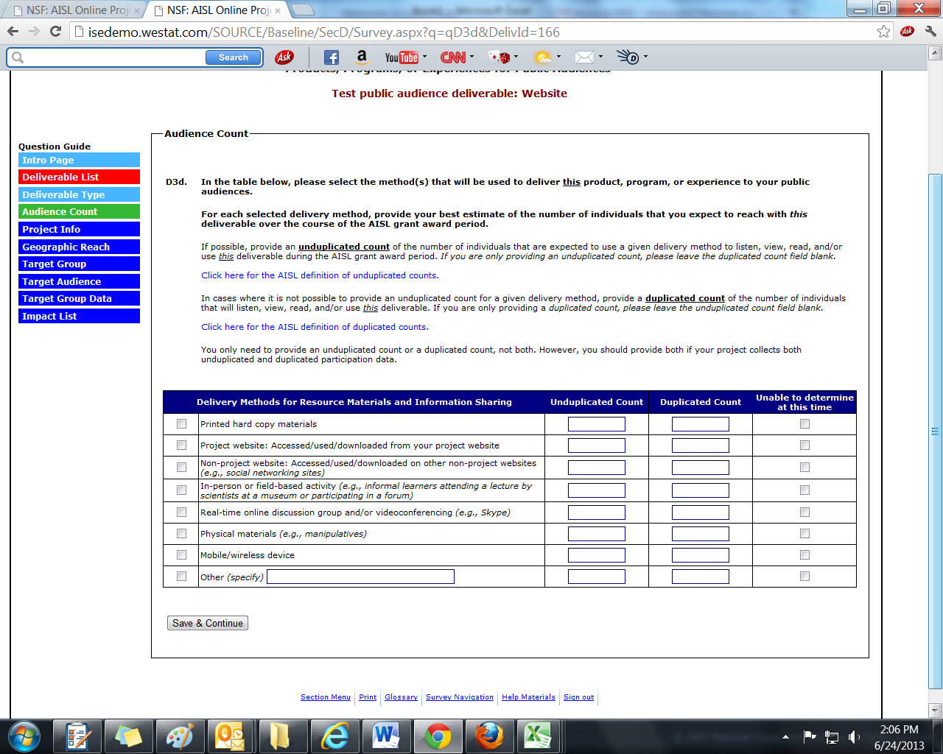
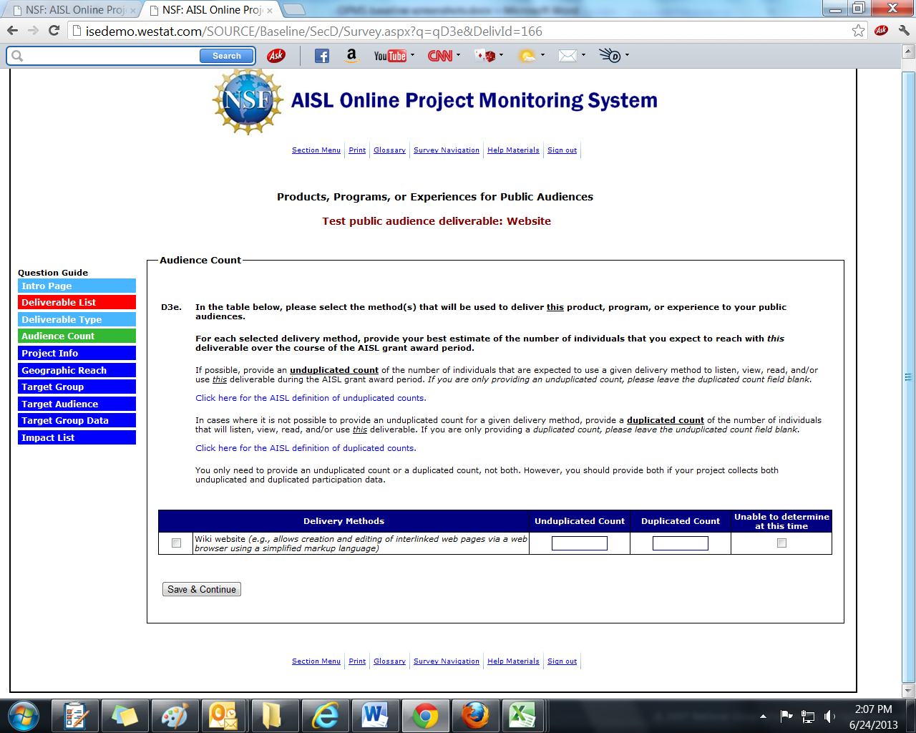

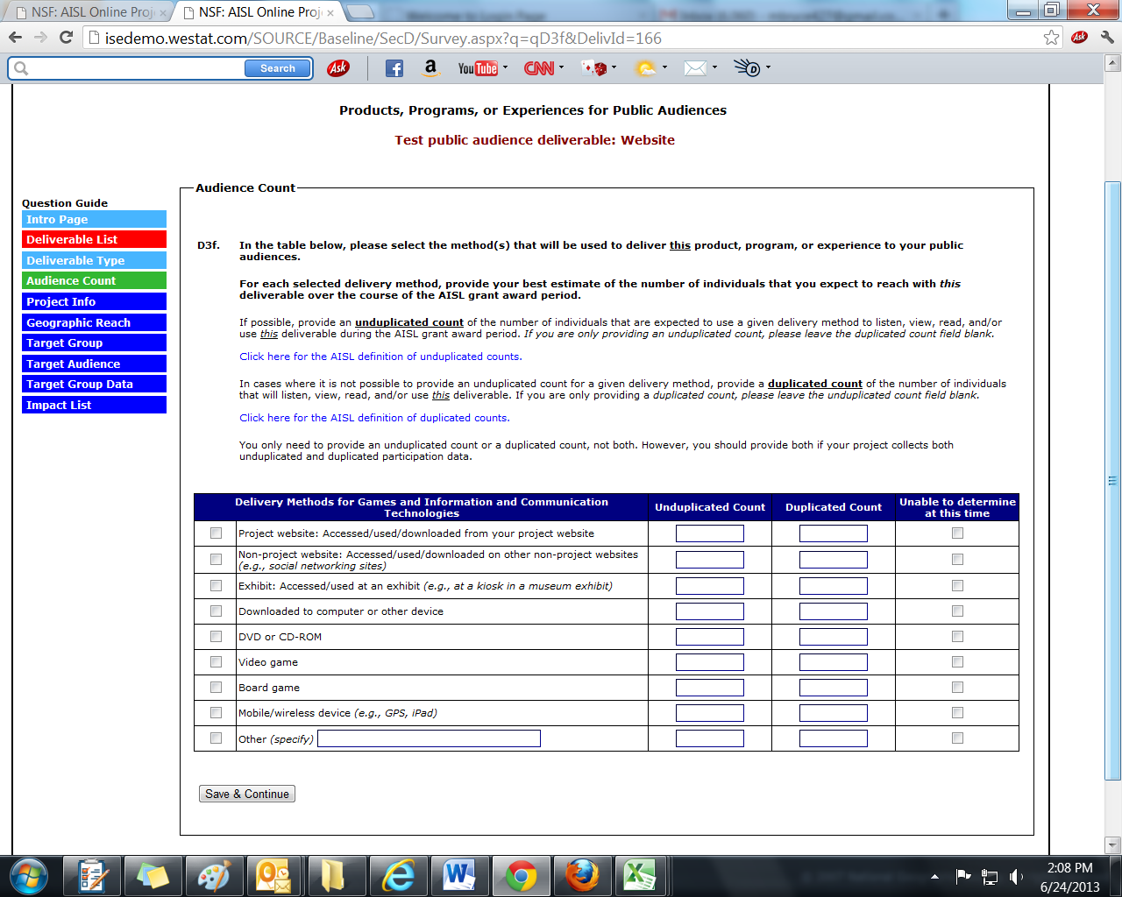
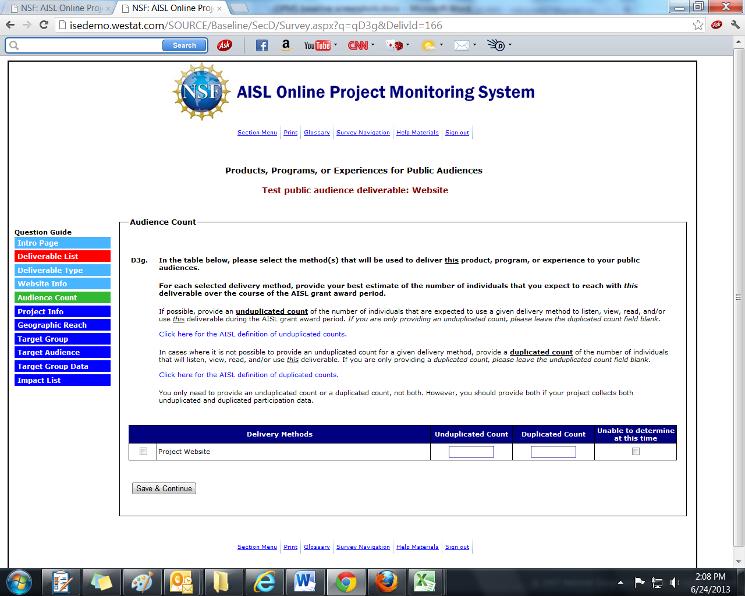
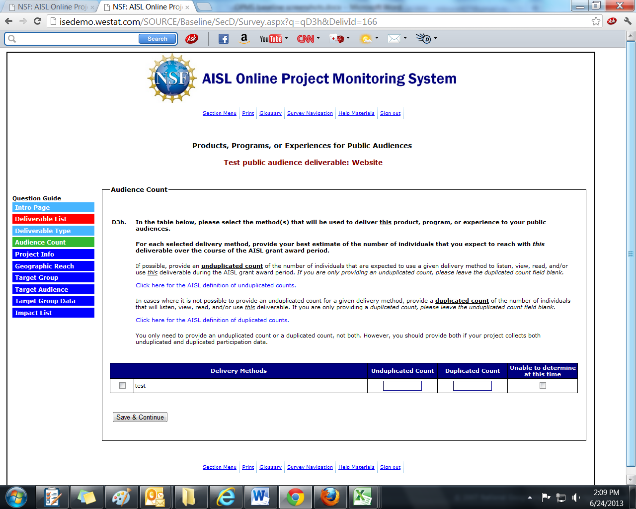

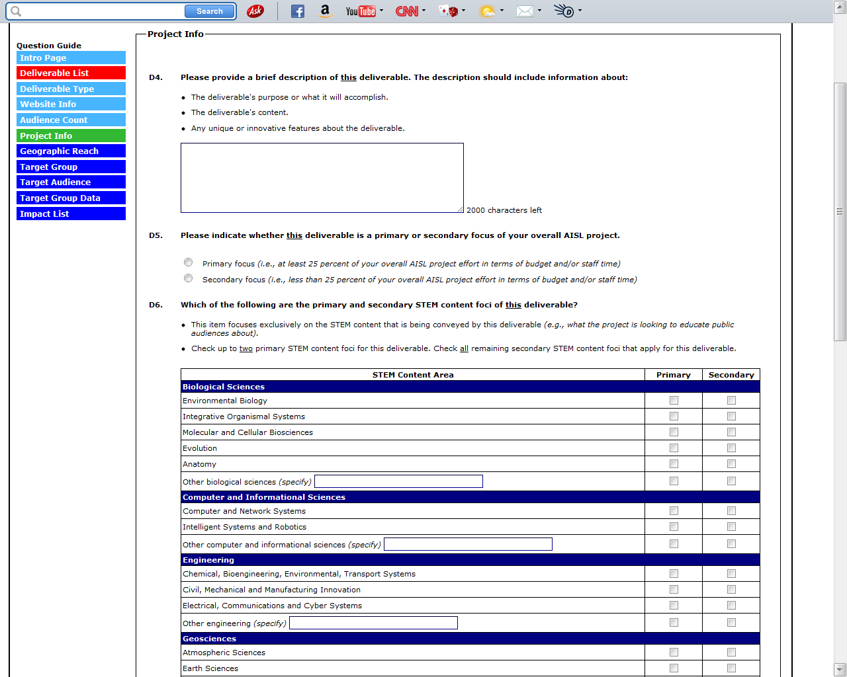
(CONTINUED ON NEXT PAGE)
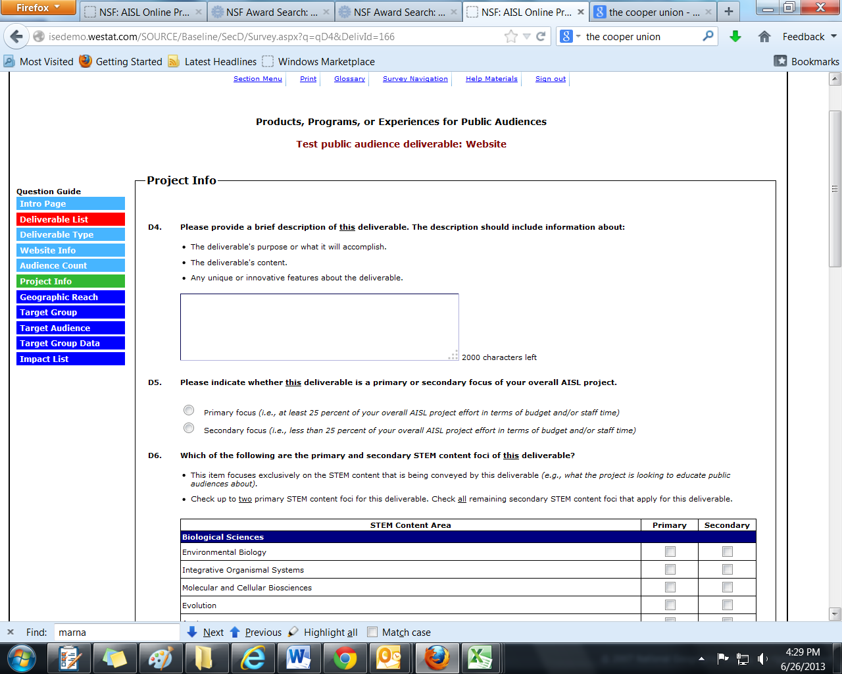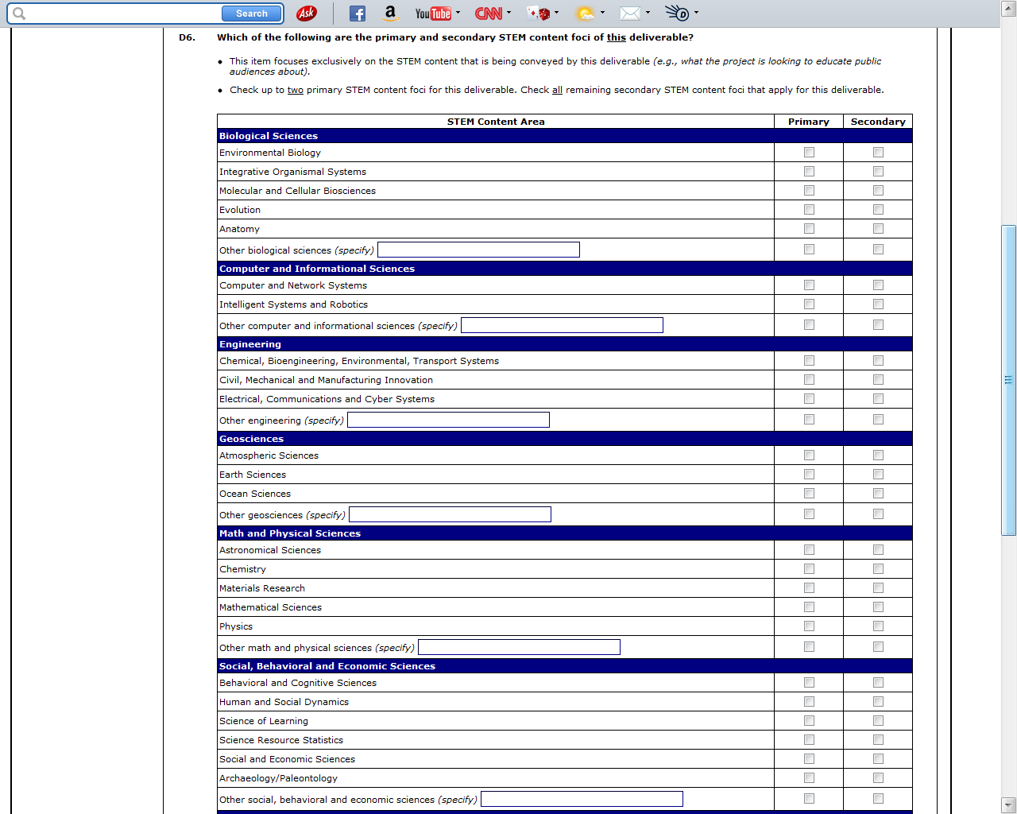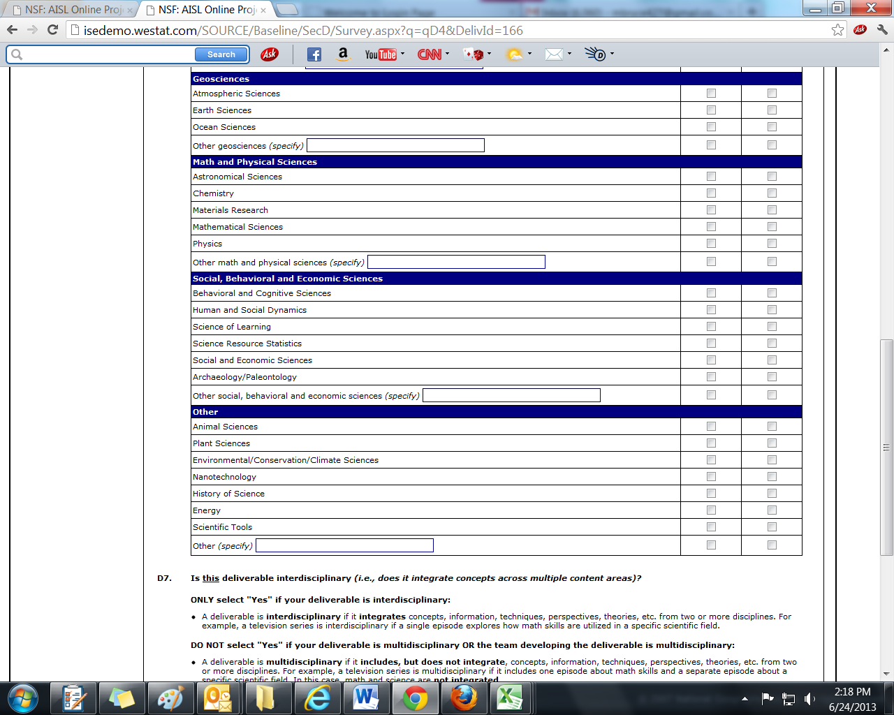
(CONTINUED ON NEXT PAGE)

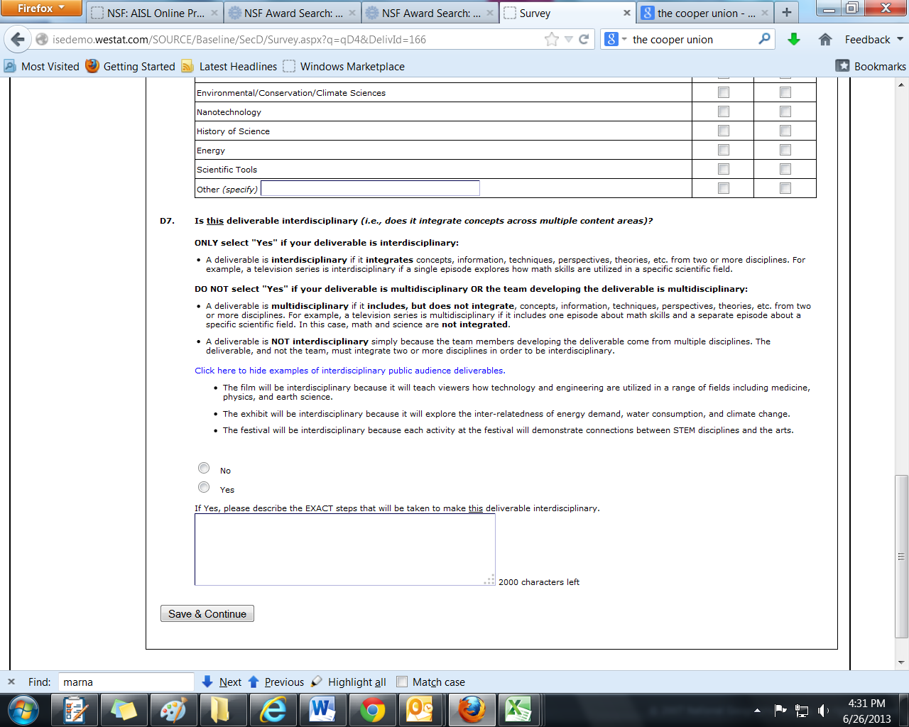
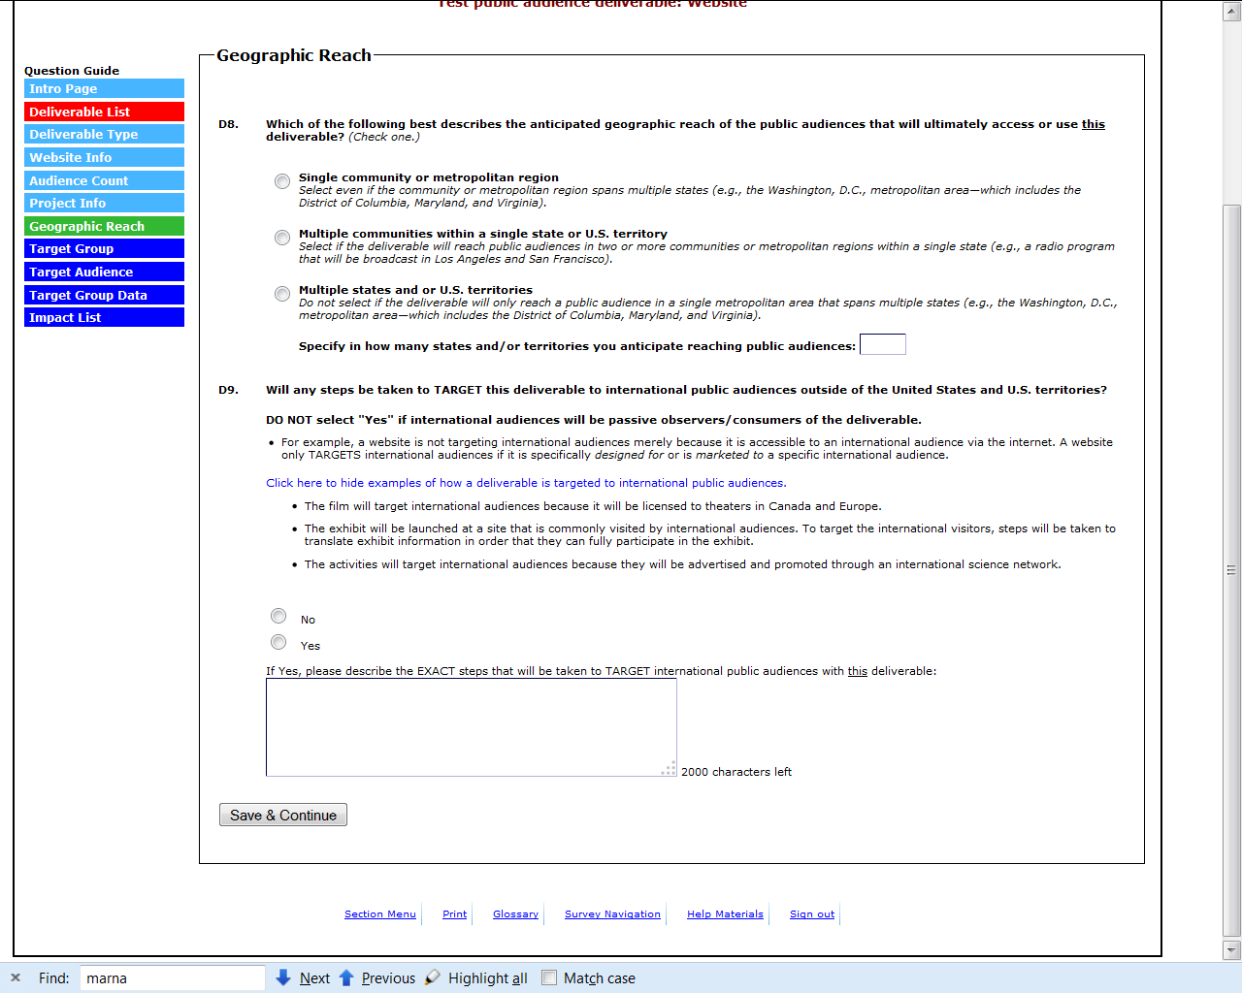
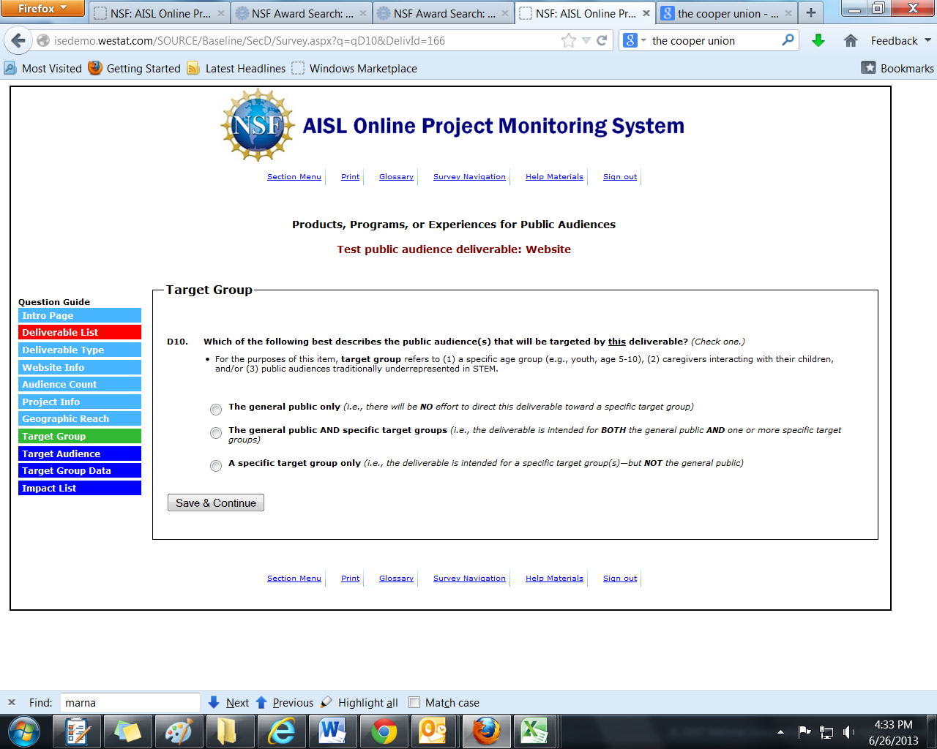
(ONLY PROJECTS THAT SELECT “THE GENERAL PUBLIC AND SPECIFIC TARGET GROUPS” OR “A SPECIFIC TARGET GROUP ONLY” IN D10 WILL ANSWER D10A-B; OTHERS WILL SKIP TO D10C)
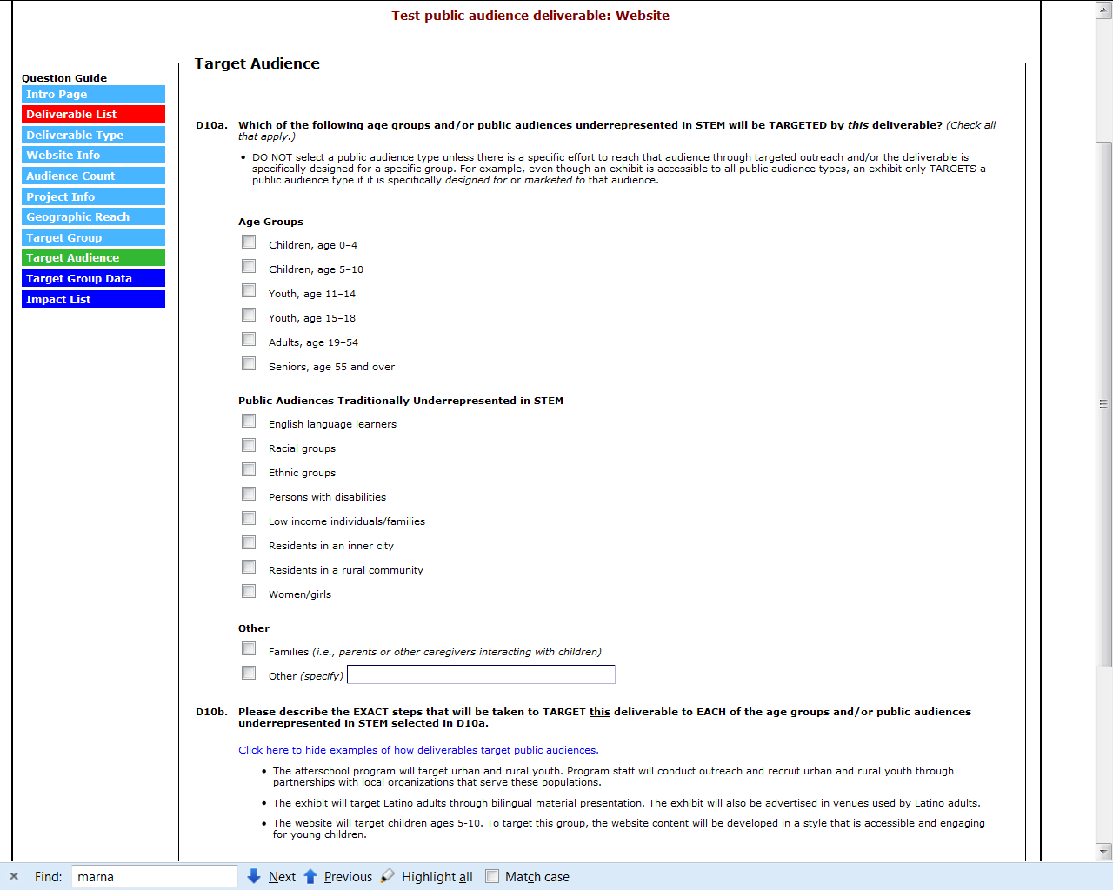
(CONTINUED ON NEXT PAGE)

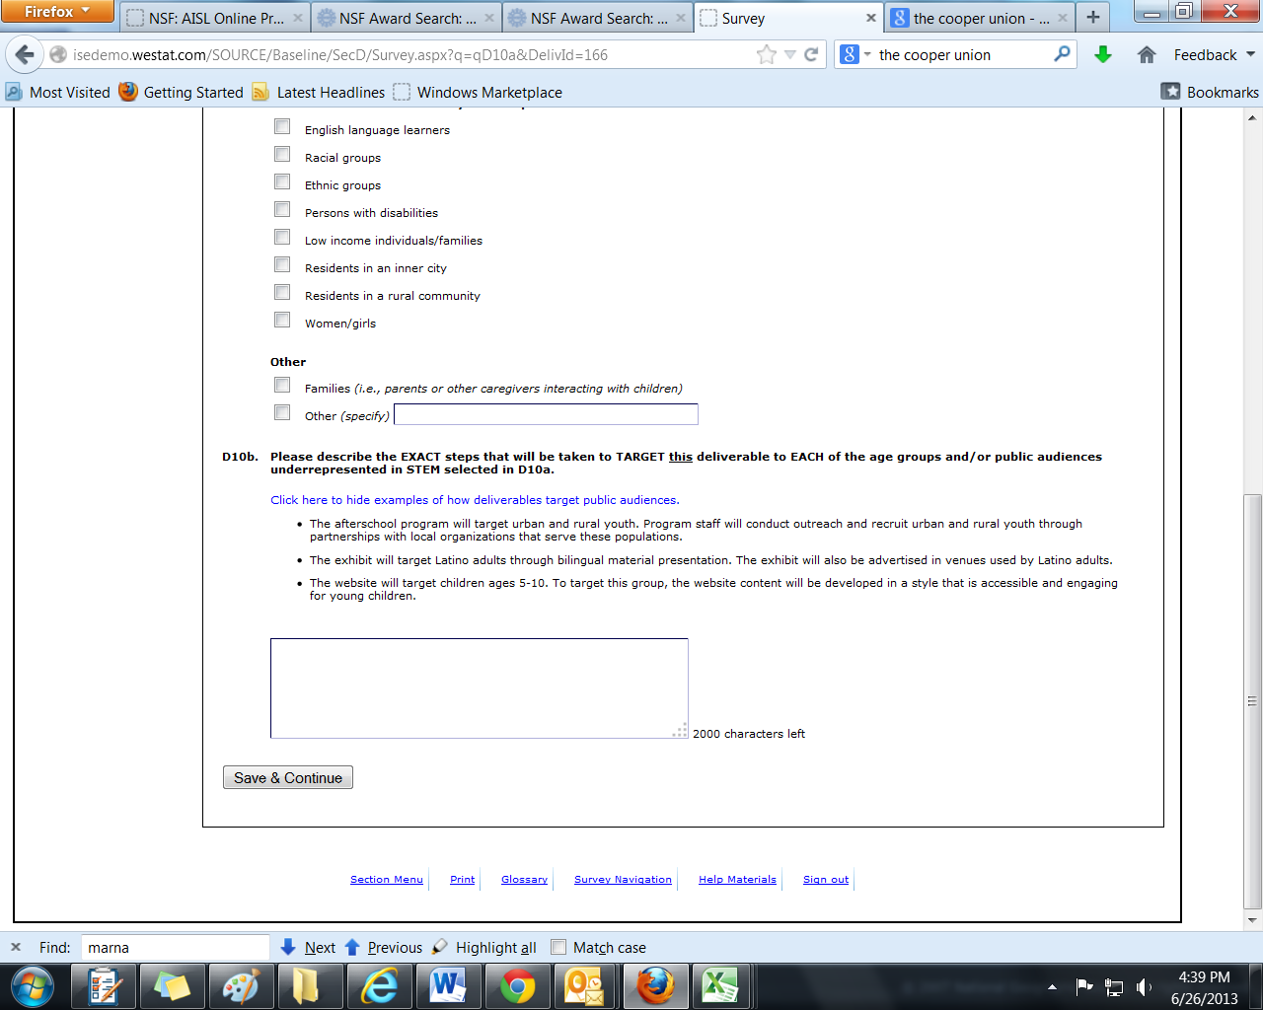

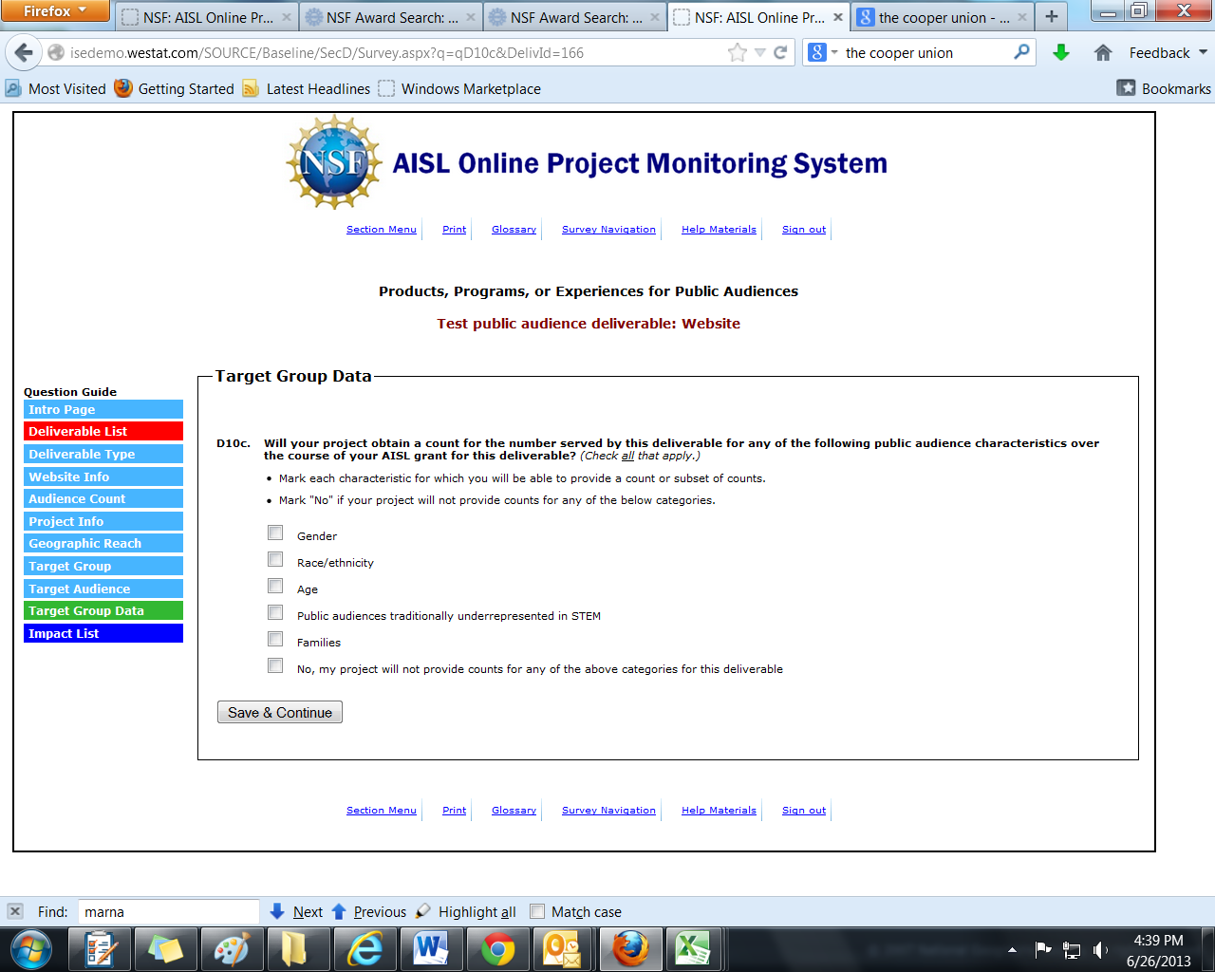

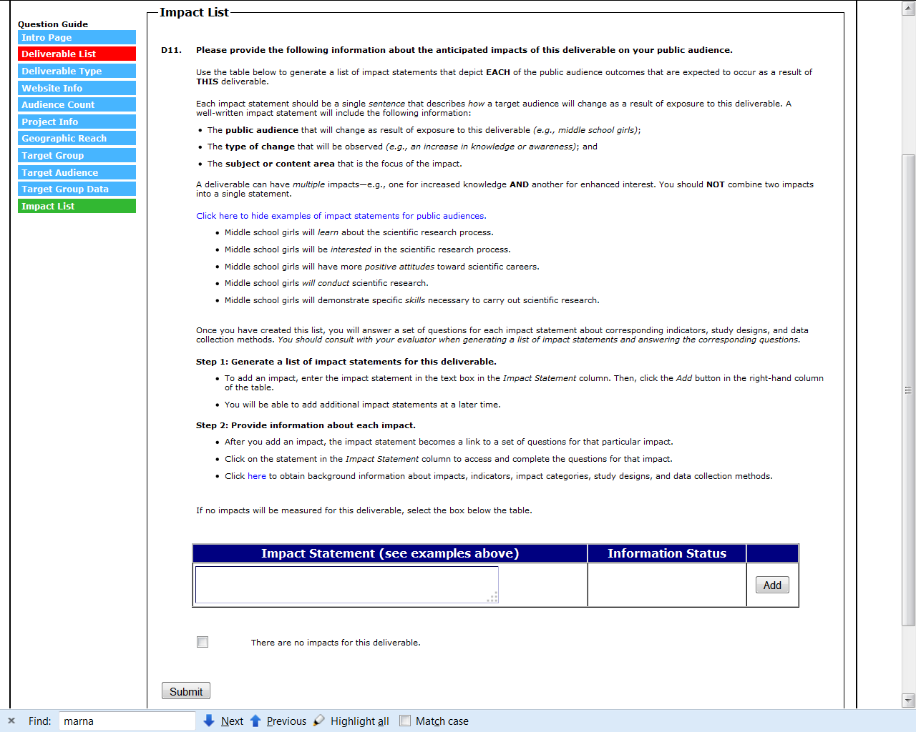
(FOR EACH IMPACT STATEMENT ENTERED IN THE “IMPACT STATEMENT” TABLE, ANSWER D11A-D11C OR D11A-D11D)
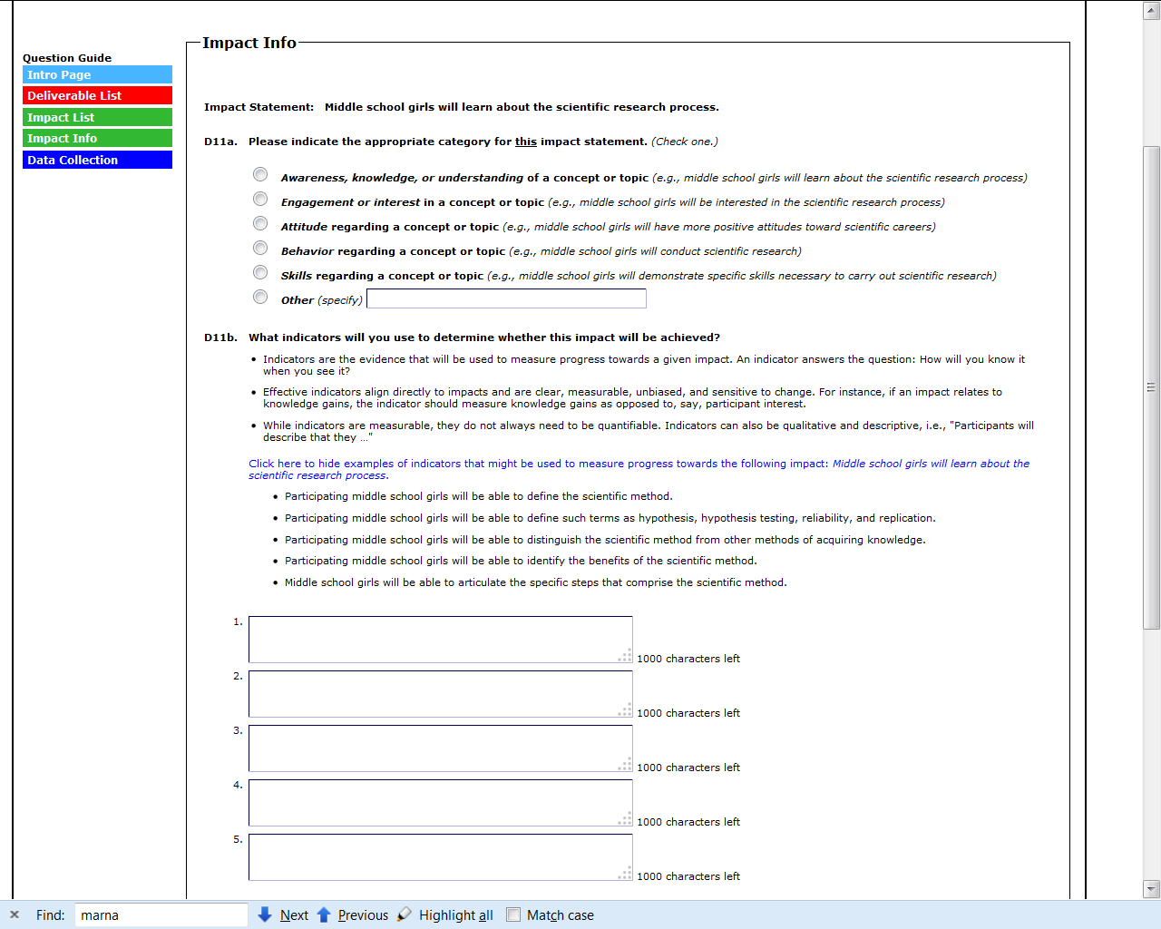
(CONTINUED ON NEXT PAGE)

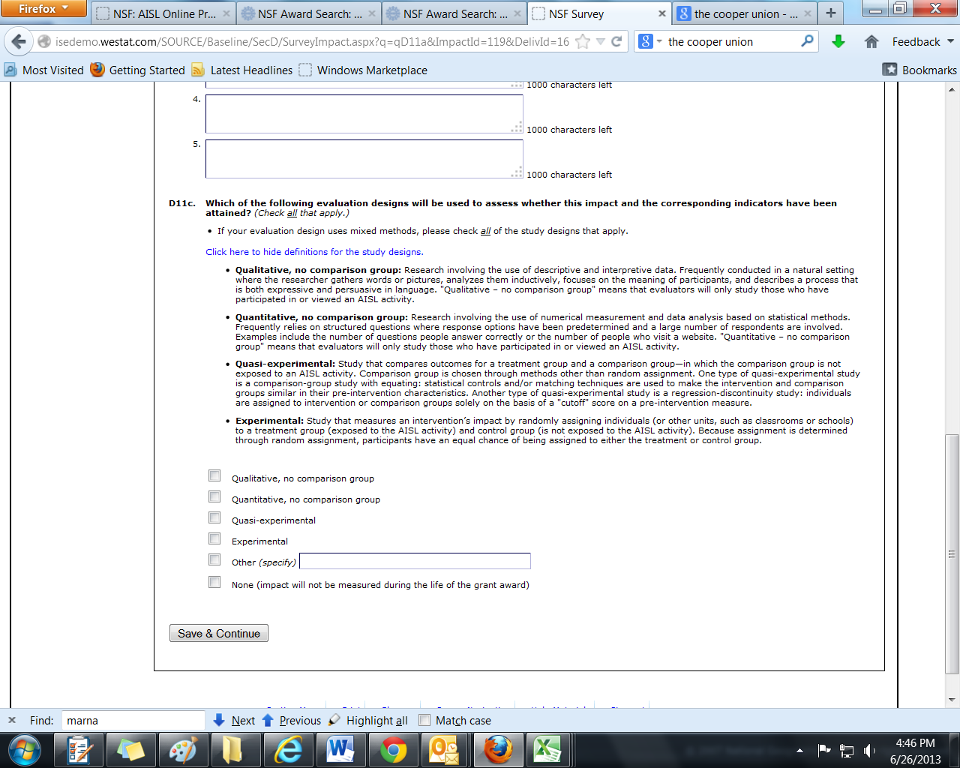

(D11D IS SKIPPED IF THE SELECTION IN D11C IS “NONE”)
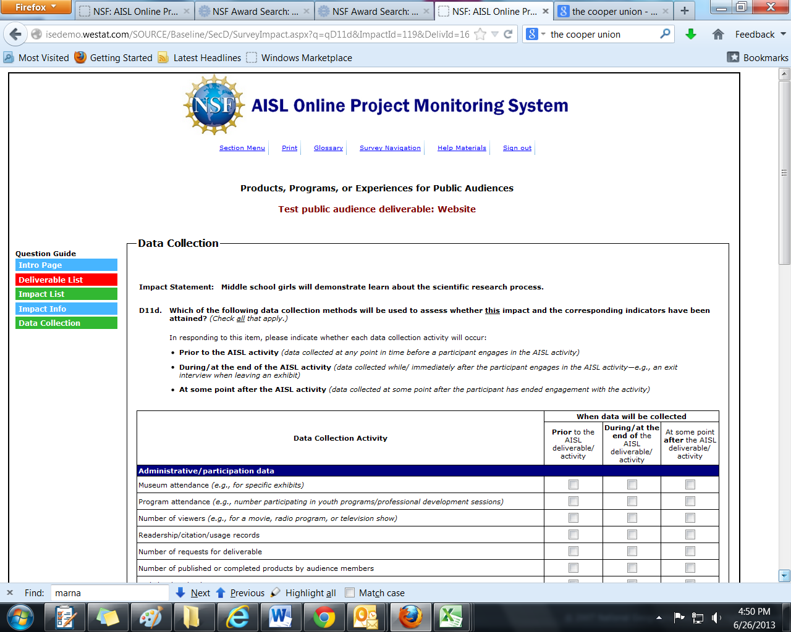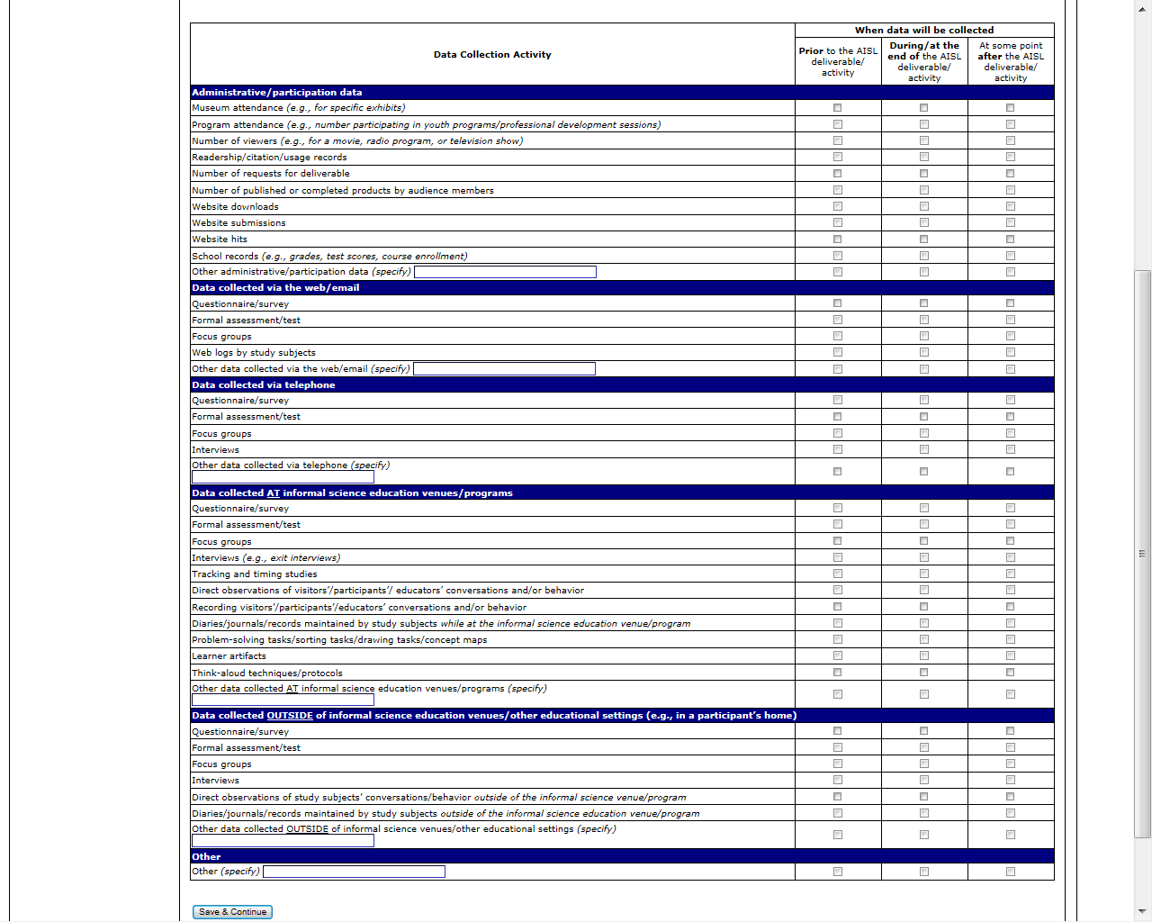

Section E: Products, Programs, or Experiences for Professional Audiences

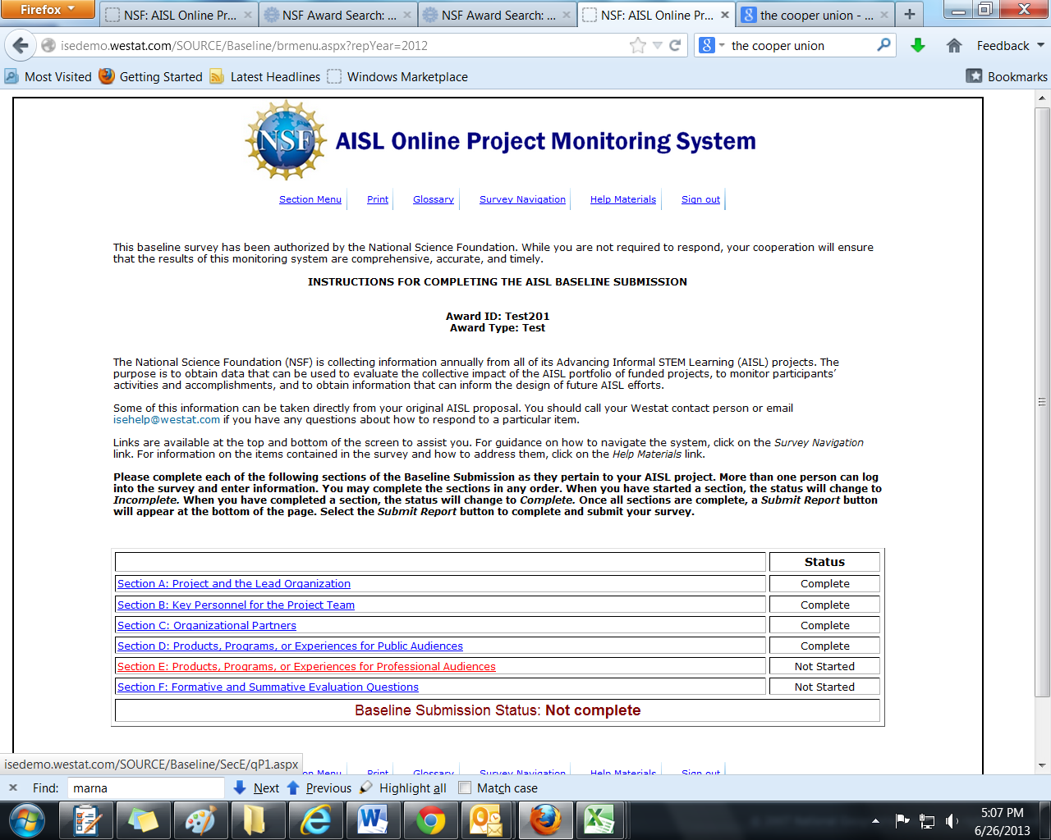

(SECTION E IS ONLY COMPLETED IF A PROJECT HAS AT LEAST ONE PROFESSIONAL AUDIENCE DELIVERABLE. IN E1, A SELECTION OF “YES” CONTINUES TO THE DELIVERABLE LIST SCREEN. A SELECTION OF “NO” RETURNS TO THE SECTION MENU.)
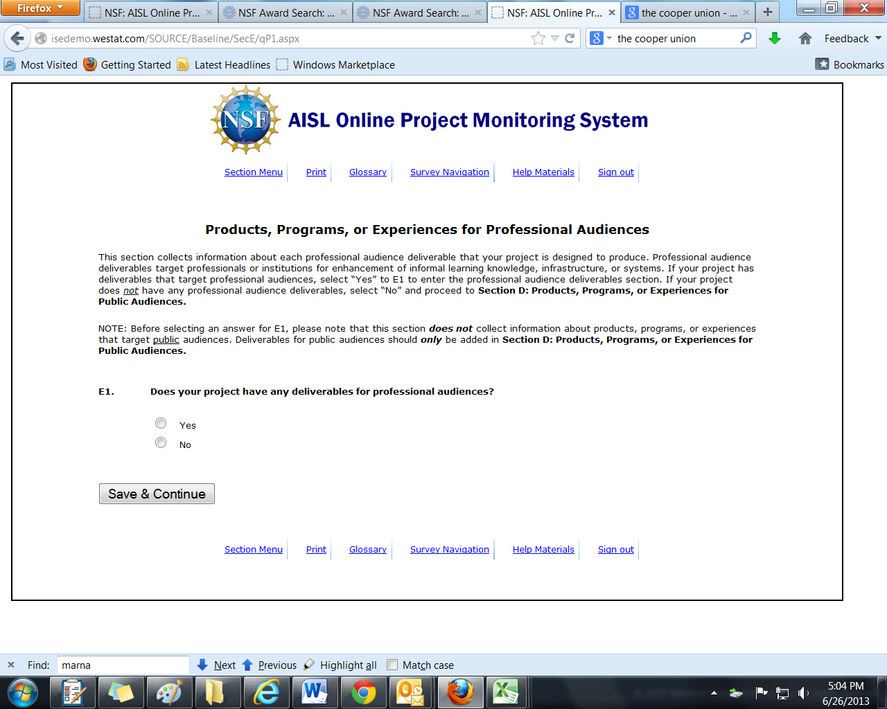

(SECTION E QUESTIONS ARE ANSWERED FOR EACH DELIVERABLE ENTERED IN THE DELIVERABLE TABLE)
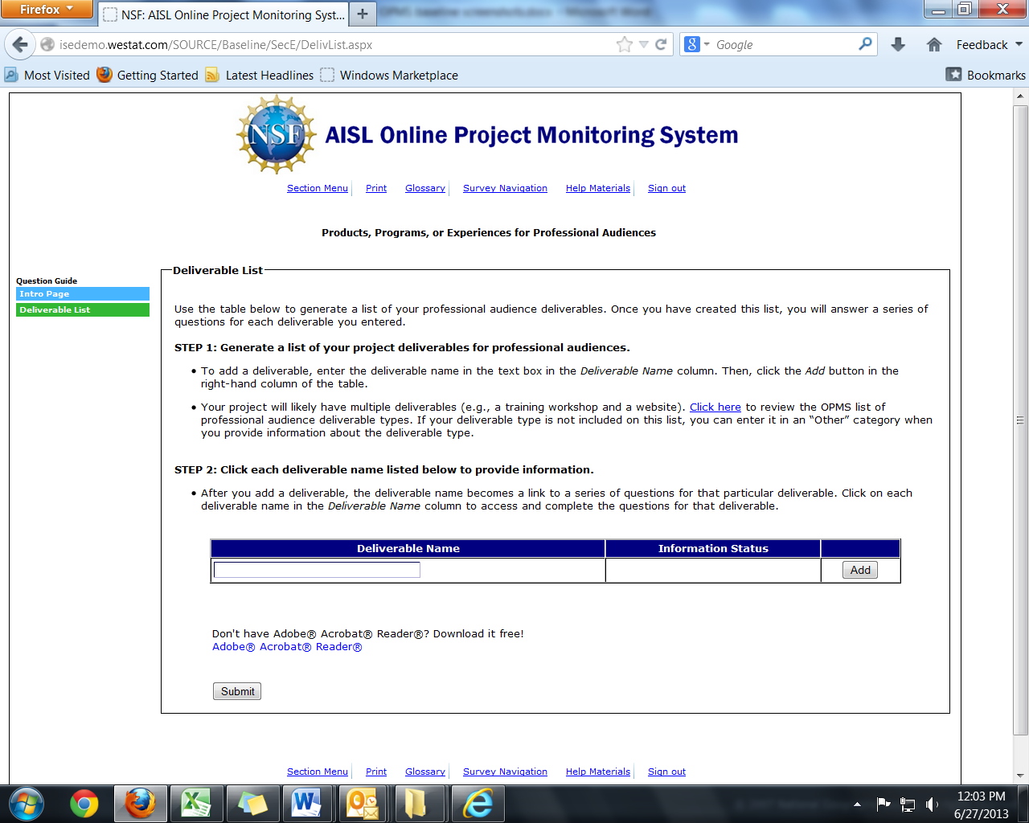

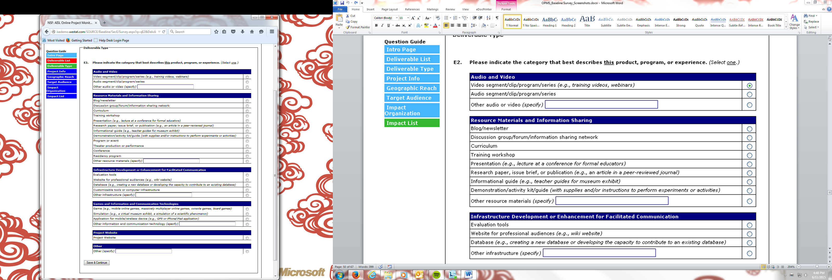

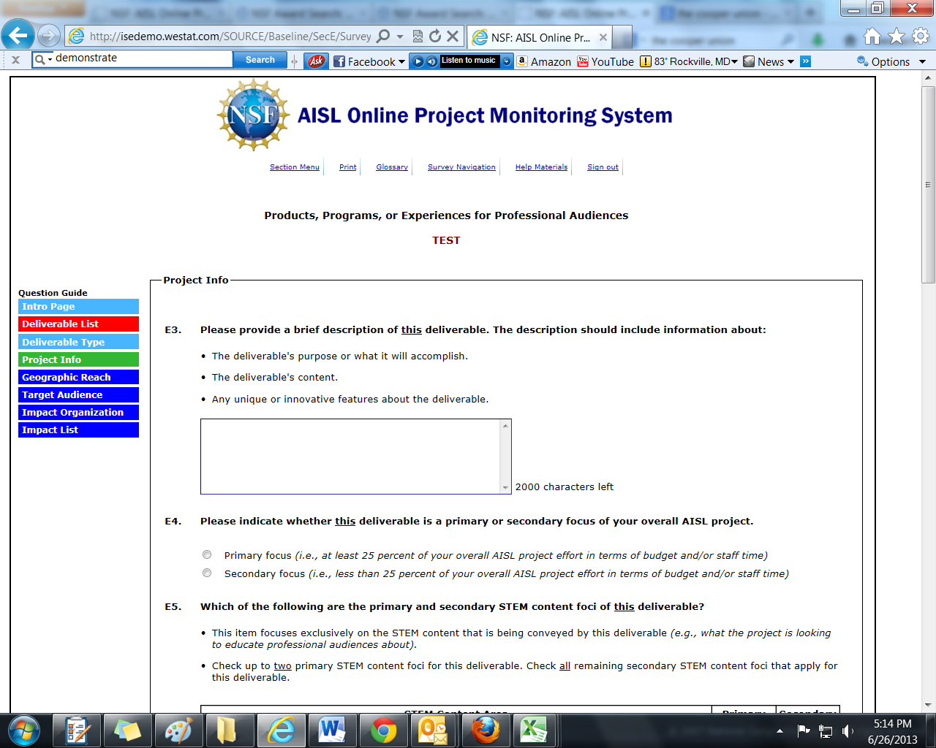
(CONTINUED ON NEXT PAGE)
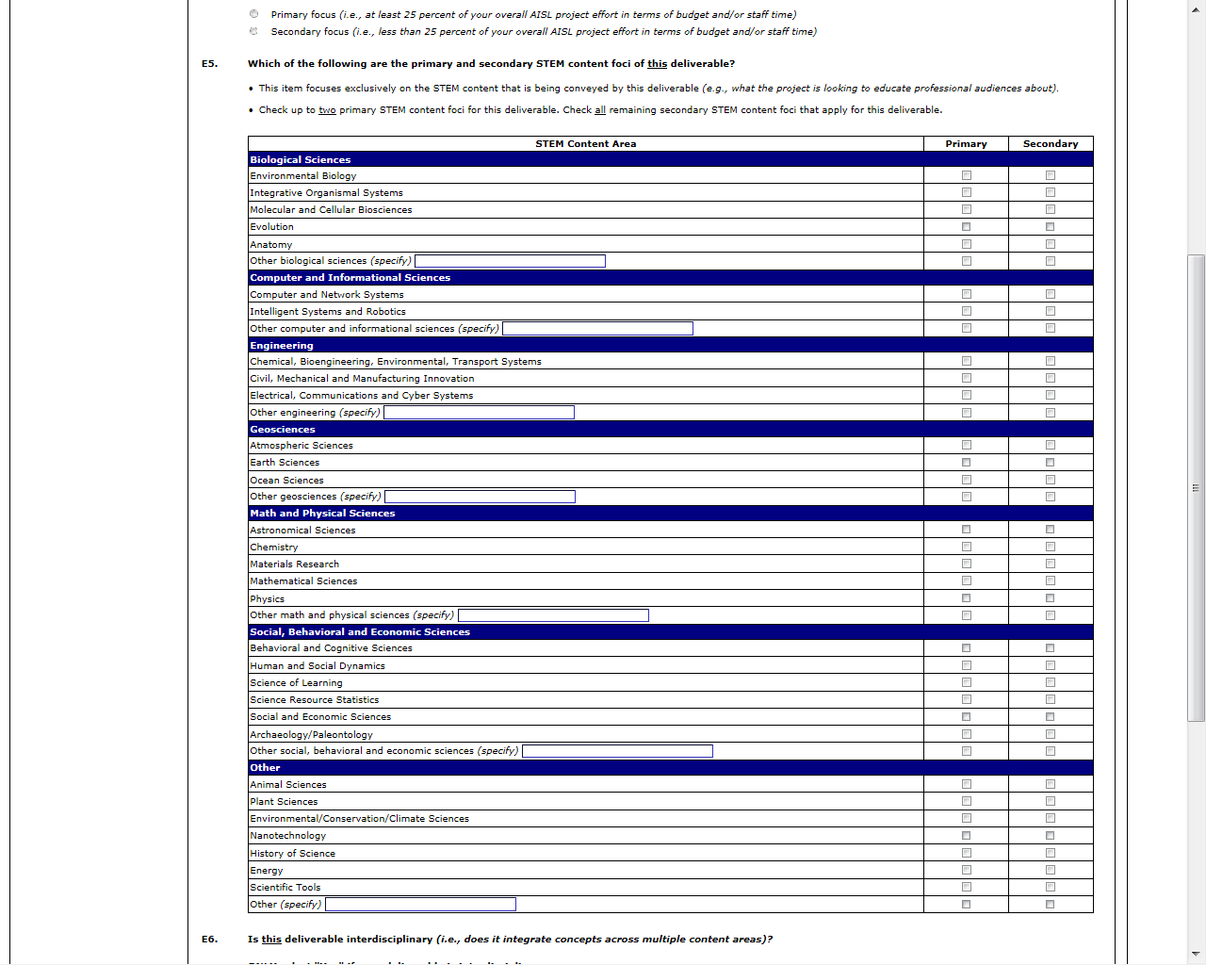
(CONTINUED ON NEXT PAGE)
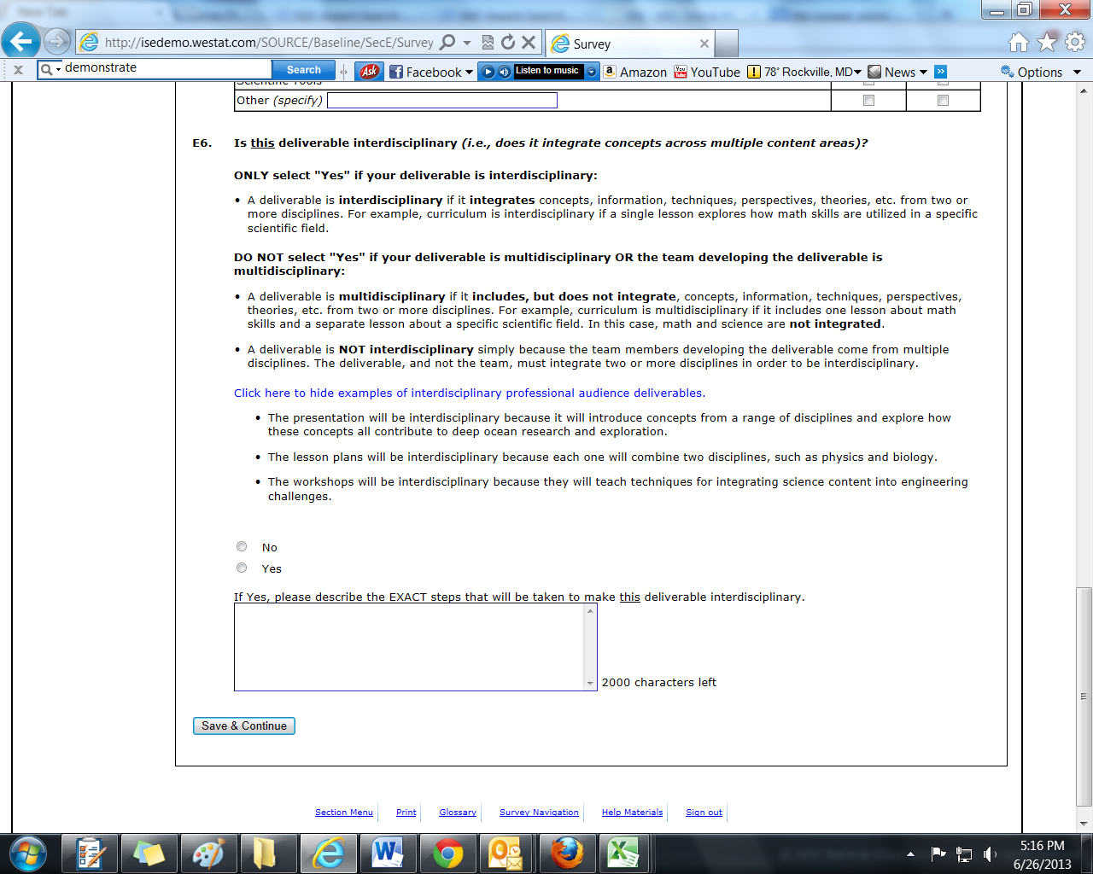
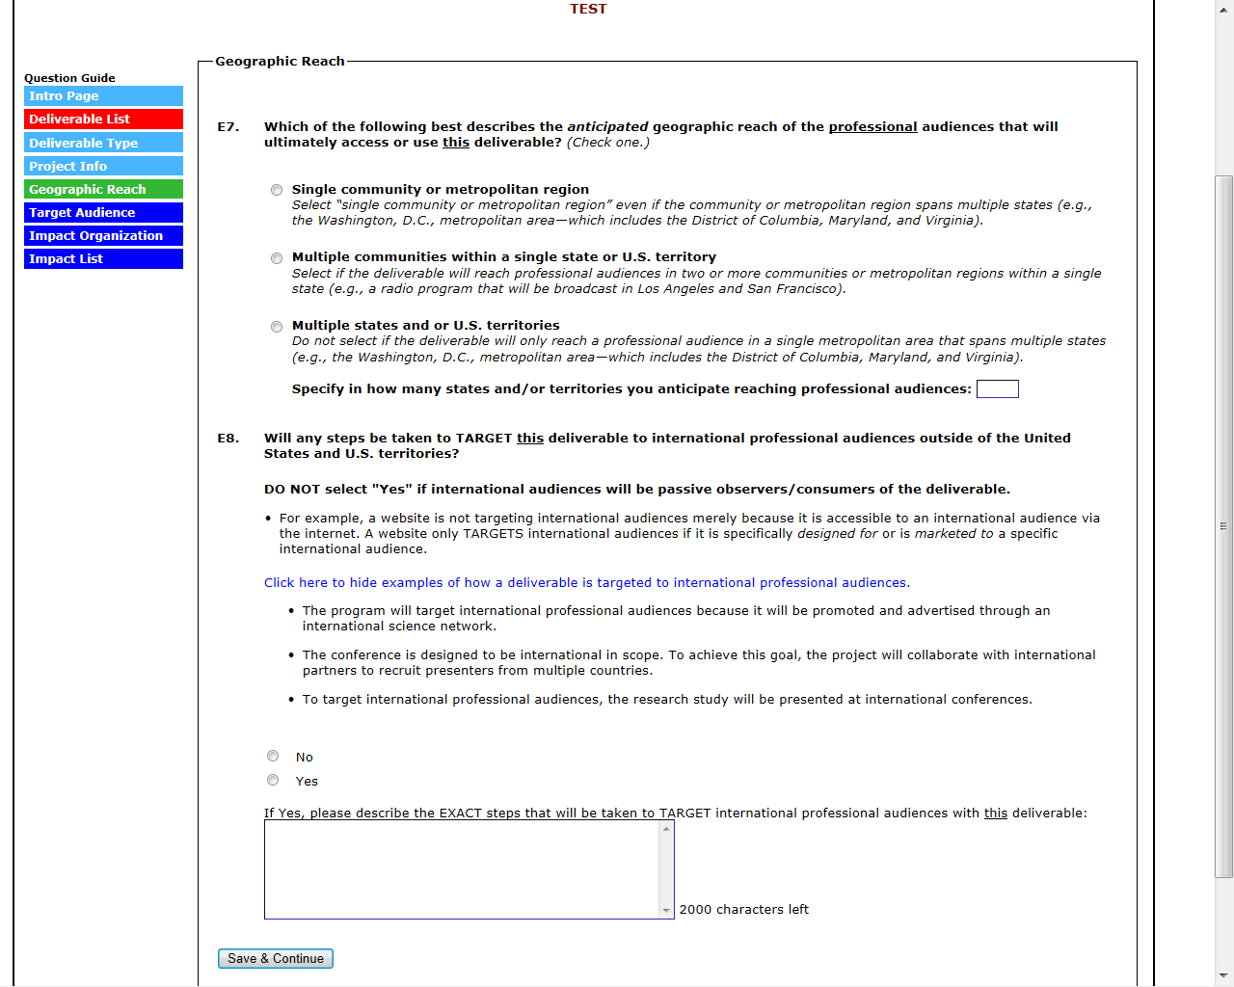

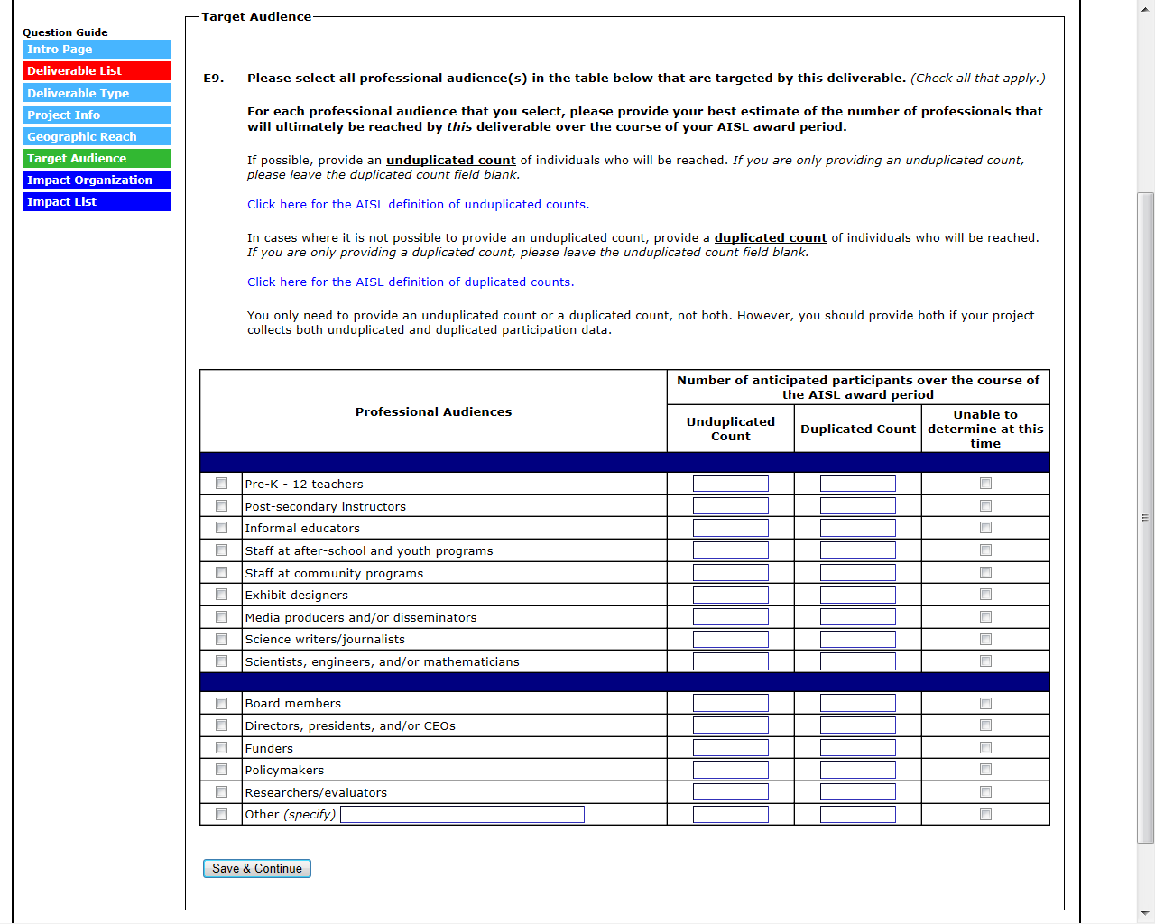
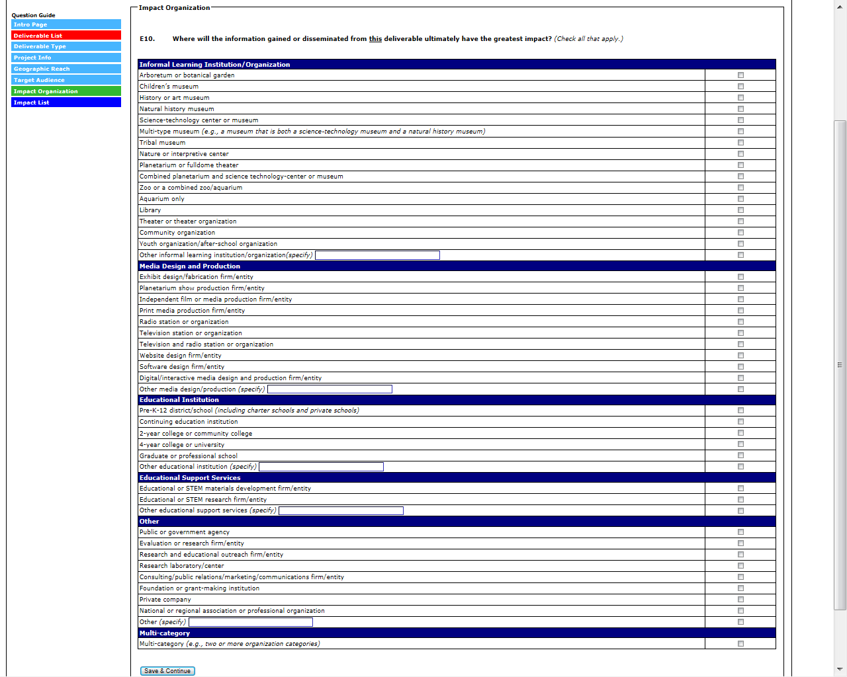

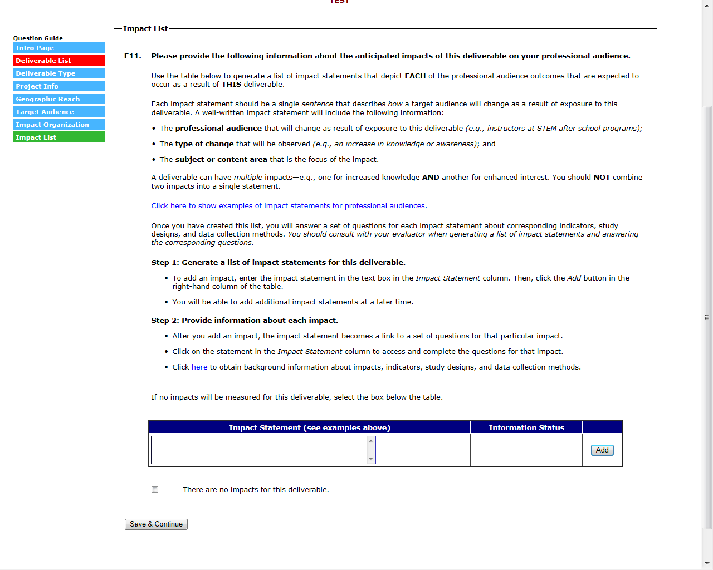
(FOR EACH IMPACT STATEMENT ENTERED IN THE “IMPACT STATEMENT” TABLE, ANSWER E11A-E11C OR E11A-E11D)

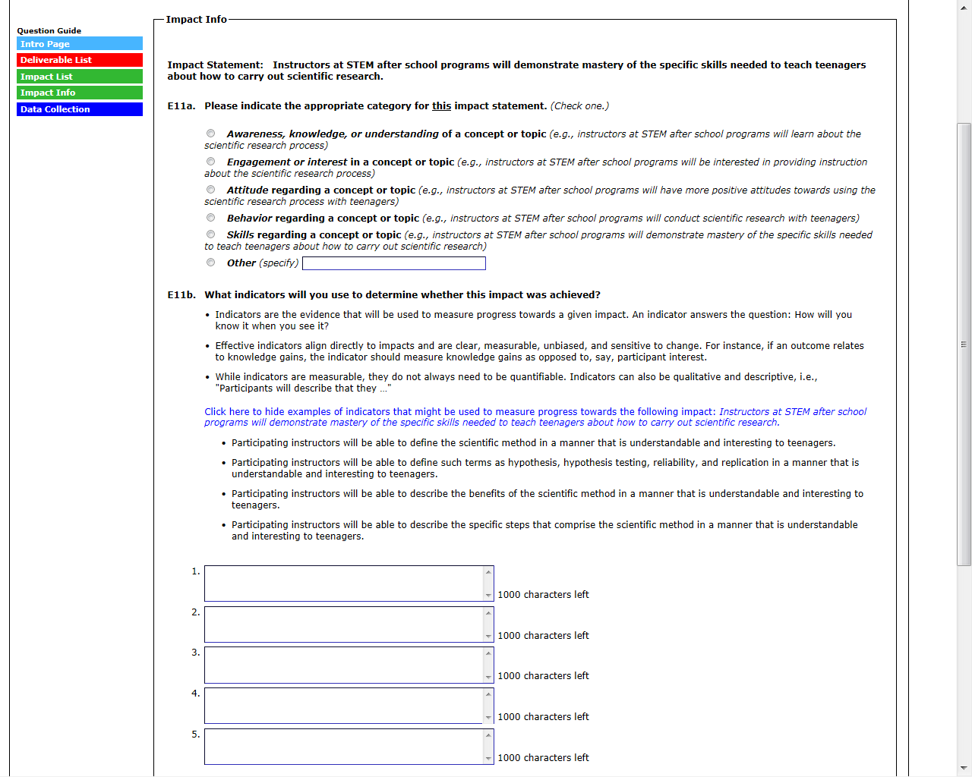

(CONTINUED ON NEXT PAGE)
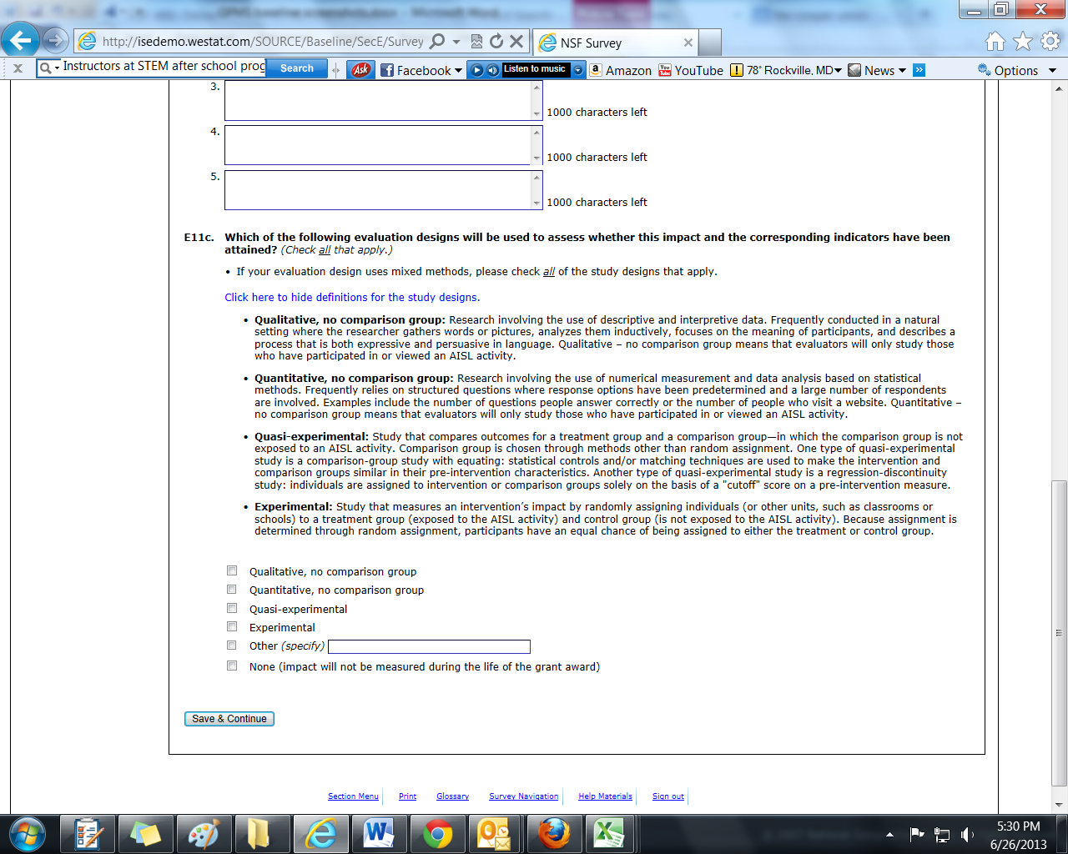
(E11D IS SKIPPED IF THE SELECTION IN E11C IS “NONE”)

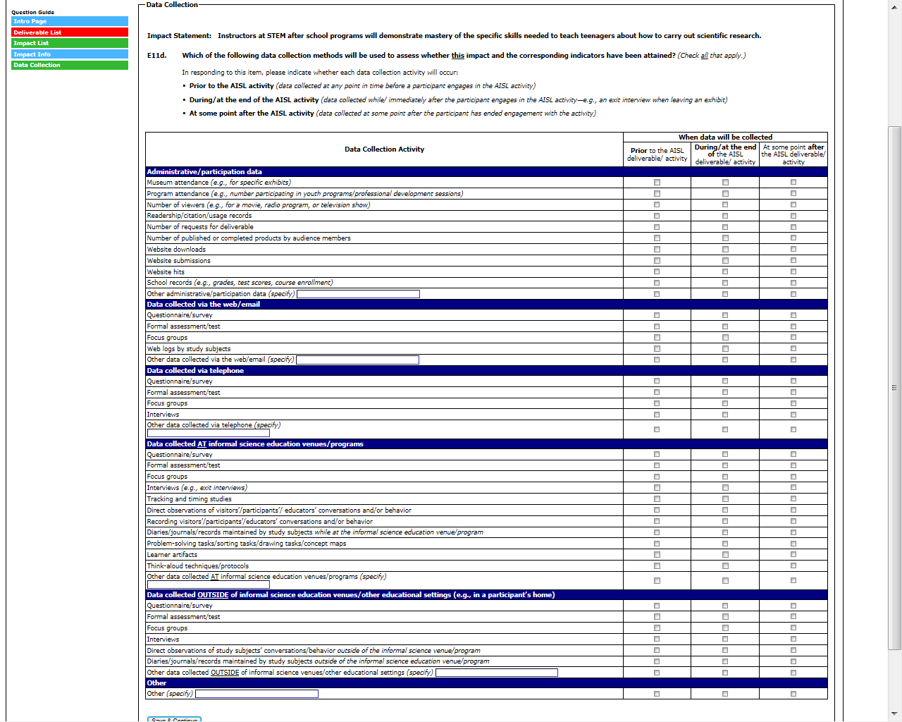

Section F: Formative and Summative Evaluation Questions

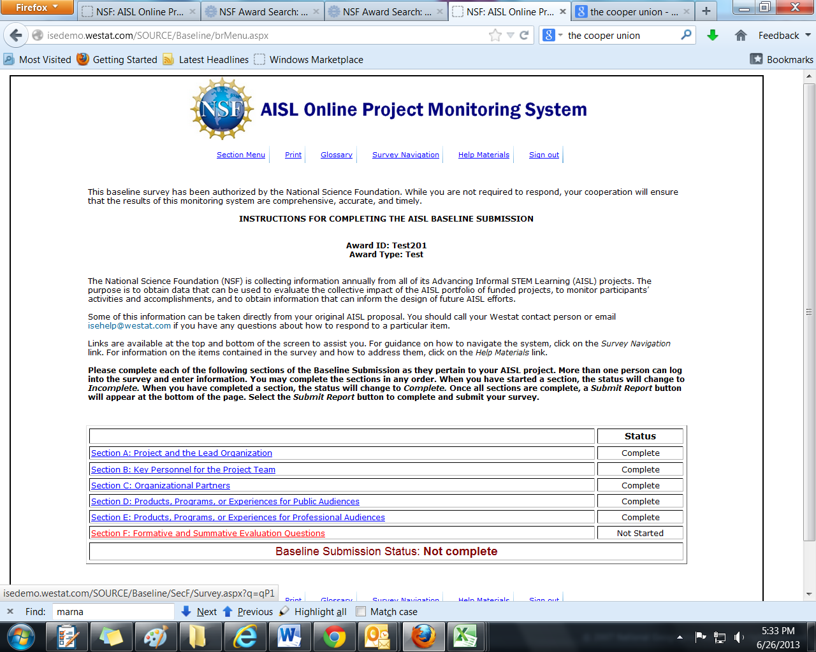

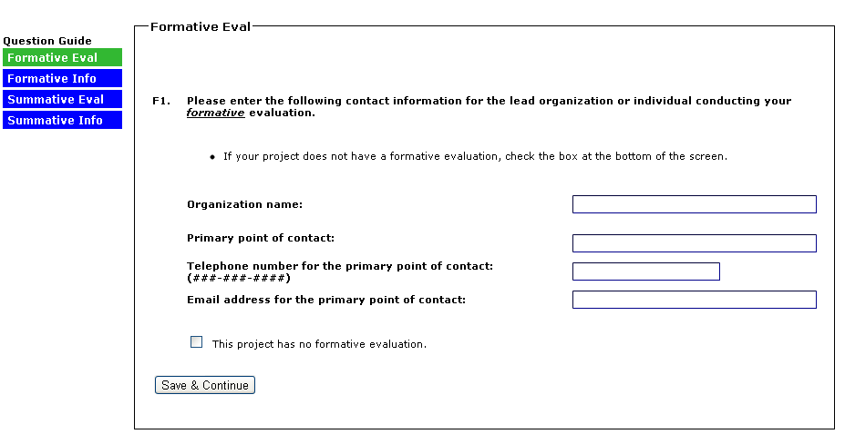
(SELECTING “THIS PROJECT HAS NO FORMATIVE EVALUATION” IN F1 WILL SKIP F2)
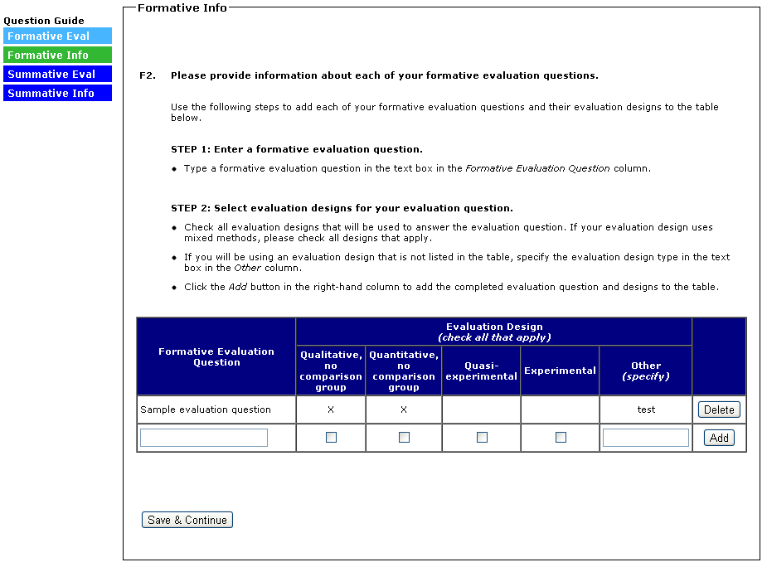
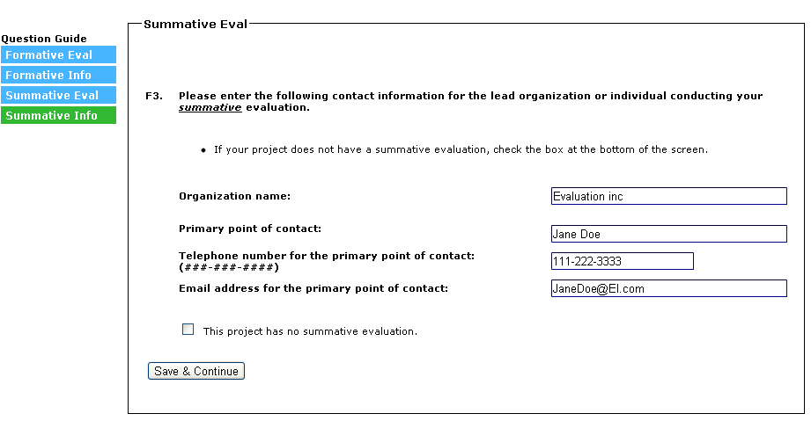
(SELECTING “THIS PROJECT HAS NO SUMMATIVE EVALUATION” WILL SKIP F4)
