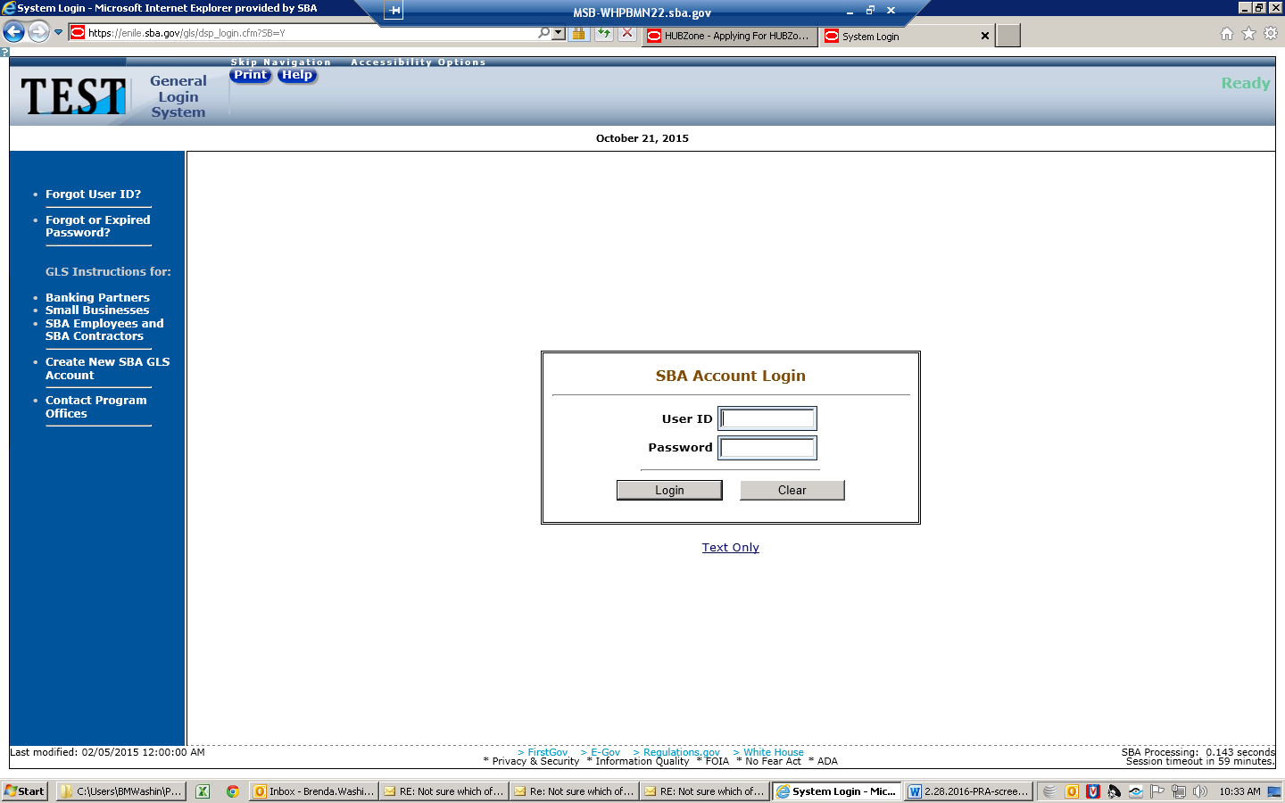

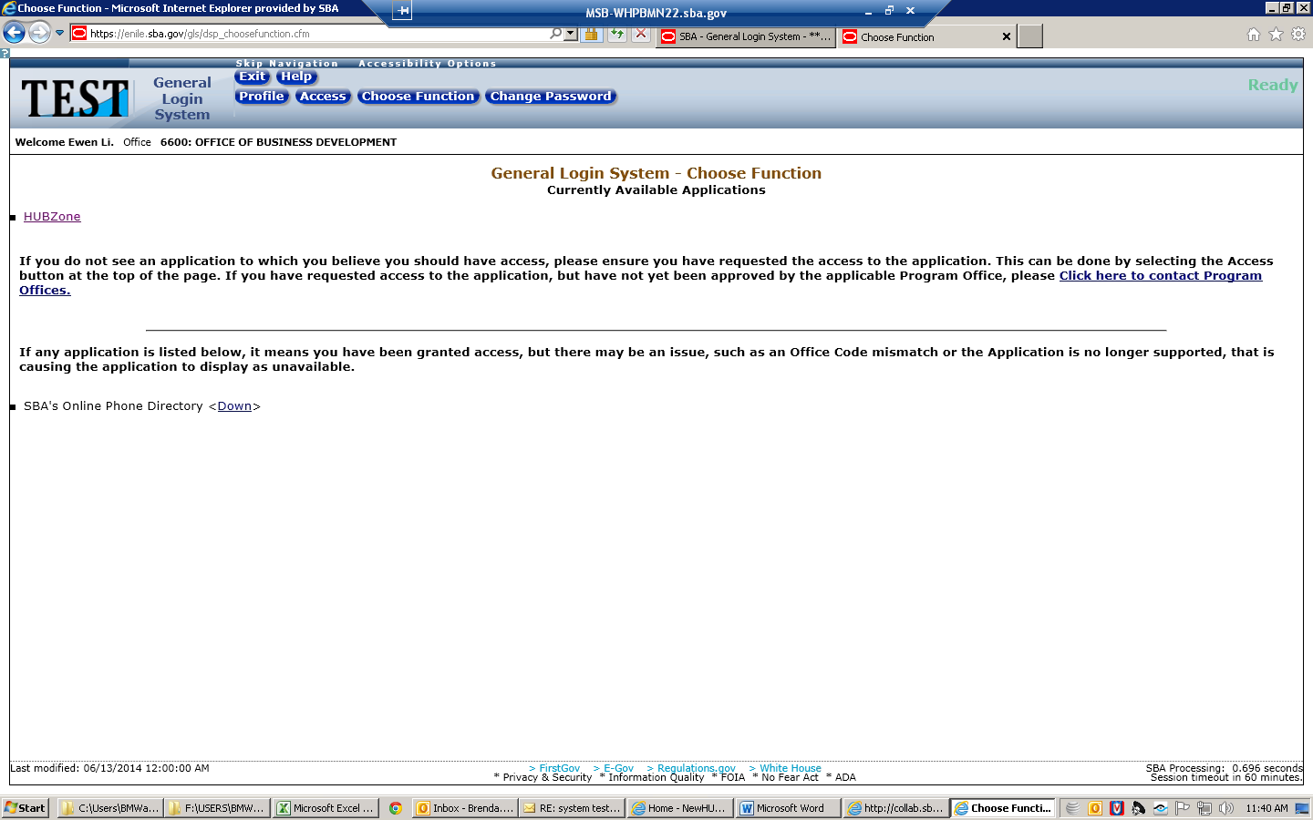

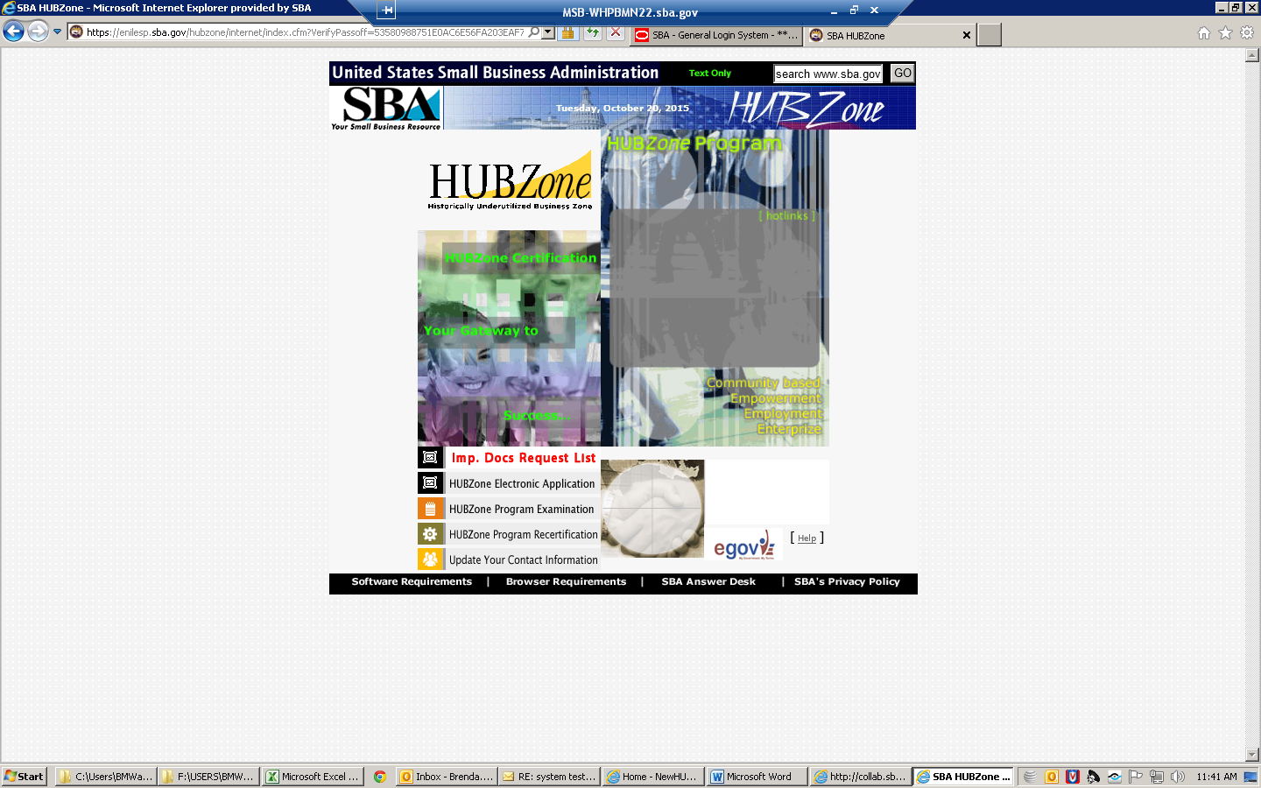

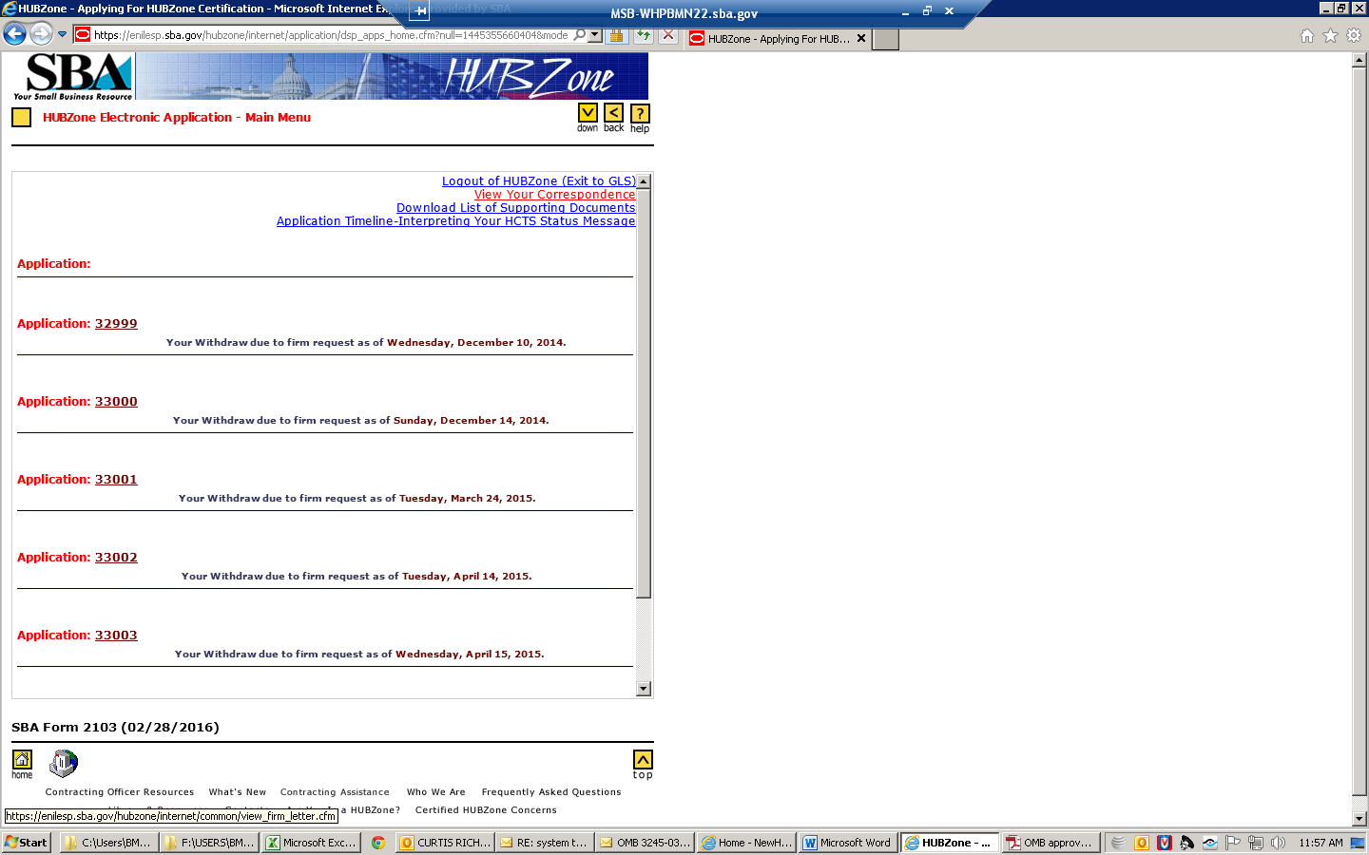

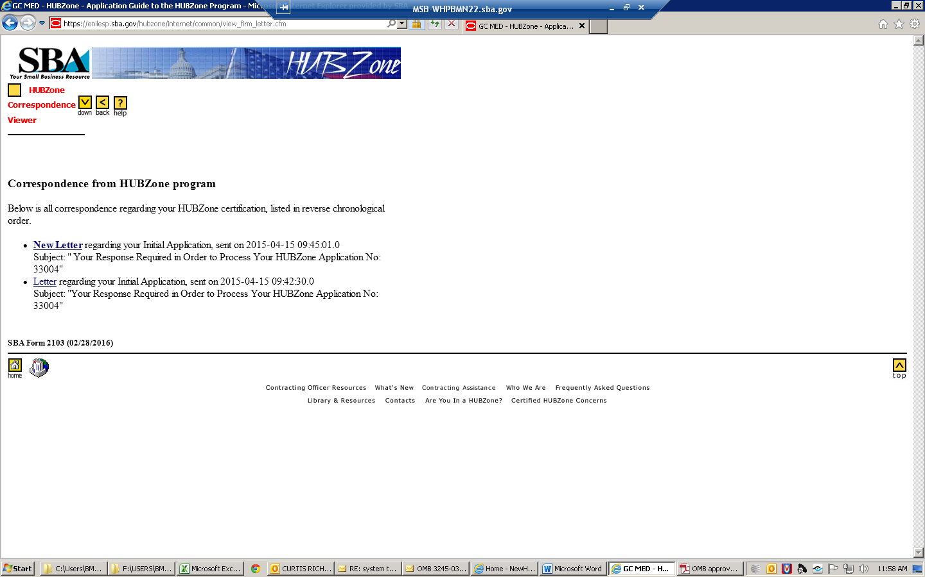

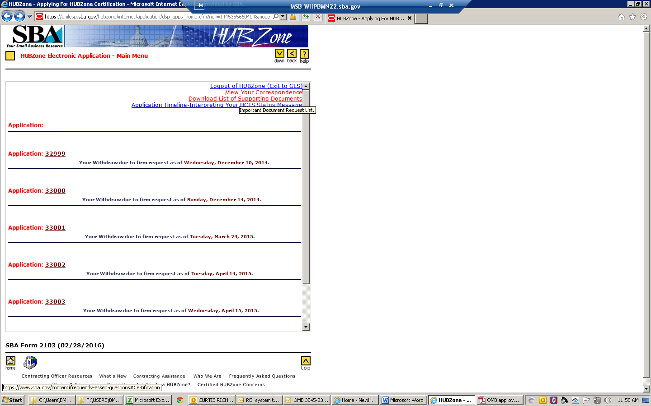

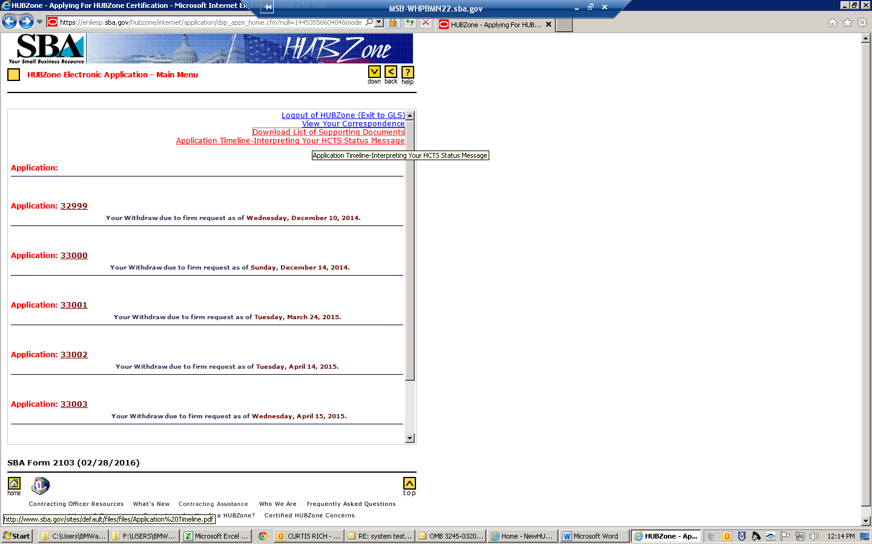
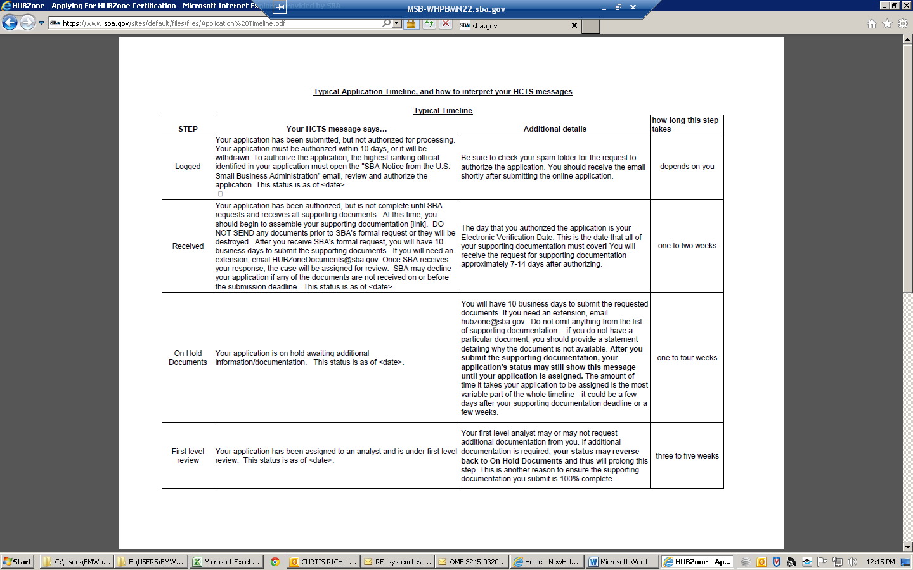
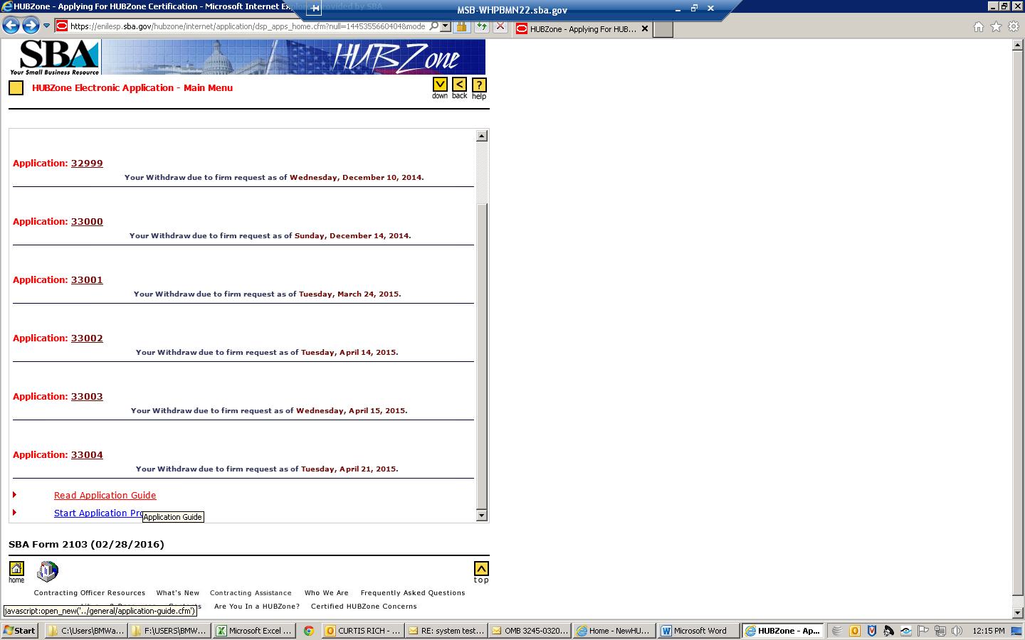

HUBZone Program Application Guide

% complete status bar | OMB Approval No. 3245-0320  Expiration Date: 02/28/2016
| 0%

CONTENTS
- Welcome
- Introduction
- Eligibility Requirements
- How The HUBZone Program Determines HUBZone Eligibility
- Starting the Electronic Application Process
- The Electronic Application
- Section A – Location in Qualified HUBZone
- Section B – General Business Information
- Section C – Ownership and Control
- Section D – Financial Information
- Section E – HUBZone Employment Statement
- Section F – Affiliation
- Notice of Verification
7. Completing the Application Process
8. CFR Regulation Link Site
9. Glossary
10. Confidential and Security considerations

1. Welcome
Welcome to the HUBZone Program Application Guide and thank you for your interest in applying for certification as a qualified HUBZone Small Business Concern. As you will notice, firm, business or company will be referenced throughout this document as a 'SBC' or simply as a 'concern’. This guide has been prepared to assist you with the application process. If you meet the eligibility requirements, the program offers excellent opportunities for your firm to participate in the Federal marketplace. It also offers your concern a unique opportunity to contribute to empowerment, economic development, and job growth in underserved communities. The HUBZone Program is “creating jobs where they are needed most”.

2. Introduction
SBA's HUBZone Program is in line with the efforts of both the Administration and Congress to promote economic development and employment growth in distressed areas by providing access to more Federal contracting opportunities. The final rule for the HUBZone Program was published on June 11, 1998, 63 FR 31896. The final Federal Acquisition Regulation was published on September 24, 1999 at 64 CFR 51830. Both documents have experienced updates since those issued dates. The imbedded links in the application access the more recent versions.

3. Eligibility Requirements
- To be eligible for the program a concern, except tribally-owned concerns, must meet ALL of the following criteria, at the time of application:
- It must be a small business by SBA standards;
- It must be owned and controlled at least 51% by U.S. citizens; wholly owned or owned in party by one or more Indian Tribal Governments or by a corporation that is wholly owned by one or more Indian Tribal Governments; an ANC owned and controlled by Natives or a direct or indirect subsidiary corporation, joint venture, or partnership of an ANC; wholly owned or owned in part by a CDC; or a small agricultural cooperative or a small business concern wholly owned or owned in part by one or more small agricultural cooperatives;
- Its principal office must be located within a 'Historically Underutilized Business Zone,' which includes lands considered Indian Country and military facilities closed by the Base Realignment and Closure Act; and
- At least 35% of its employees (total workforce regardless of where the employees work) must reside in a HUBZone. To fulfill the requirement that 35% of a HUBZone firm's employees reside in the HUBZone, employees must live in a primary residence within that area for at least 180 days or be a currently registered voter in that area.
- Existing businesses that choose to move to qualified areas are eligible. However, they must have moved their principal office to a qualified HUBZone area prior to submitting an application.
A "HUBZone" is an area that is located in one or more of the following:
The statute establishing the HUBZone Program directs the SBA to rely upon definitions provided by other Federal agencies to determine which areas qualify as HUBZones. Generally speaking, these determinations are arrived at after the collection of either income or employment data, and that data forms the basis for the calculations cited below:
A HUBZone may be one of the following:
A qualified census tract. The definition for Qualified Census Tract is based on an Internal Revenue Service provision for the low income housing tax credit program that is developed in conjunction with the U.S. Department of Housing and Urban Development (HUD). The Secretary of HUD designates Qualified Census Tracts by a notice published periodically in the Federal Register. Information on how data is compiled for the Qualified Census Tracts designation is available on the web at http://qct.huduser.org
A qualified county. The definition for qualified county is any county that, based on the most recent data available from the U.S. Census Bureau, is not located in a metropolitan statistical area and in which the median household income is less than 80 percent of the median household income for the entire non-metropolitan area of a state and/or any non-metropolitan county that, based on the most recent data available from the Bureau of Labor Statistics (BLS), has an unemployment rate that is not less than 140 percent of the state average unemployment rate or the national average unemployment rate. In addition, it includes any county not located in a metropolitan statistical area that contains a difficult development area.
A difficult development area. The definition of Difficult Development Area is similar to Qualified Census Tract in that it is based on an Internal Revenue Service provision for the low income housing tax credit program that is developed in conjunction with the U.S. Department of Housing and Urban Development (HUD). (NOTE: By virtue of legislation signed into law on Aug. 10, 2005, the application of the Difficult Development Area status for HUBZone consideration only applies to Alaska, Hawaii, and the U.S. territories and possessions, not the 48 contiguous states.) The Secretary of HUD designates Difficult Development Areas by a notice published periodically in the Federal Register.
- Information on how data is compiled for the Difficult Development Area designation is available on the web at http://qct.huduser.org
- Information on decennial census data used to determine the household income is available on the web at http://www.census.gov/main/www/cen2000.html
- Information in the local employment data used to determine the unemployment element is available on the web at http://www.bls.gov/lau/home.htm#data
A qualified Indian reservation. The definitions for qualified Indian reservations, which include lands covered by the phrase Indian Country, are those established and used by the Bureau of Indian Affairs. There is one exception, which applies to portions of the state of Oklahoma where HUBZone is using a definition arrived at by the Internal Revenue Service.
Information on Native American reservations and related information is available on the web at http://www.doi.gov/bureau-indian-affairs.html
Information on the Internal Revenue Service description for former Indian Reservations in Oklahoma is available on the web at http://www.irs.gov/newsroom/article/0,,id=99491,00.html
A former military base closed by the Base Realignment and Closure Act (BRAC). Congress determined that former military bases closed because of BRAC qualify for HUBZone status for a five-year period from the date of formal closure.
Redesignated Areas means any census tract or any non-metropolitan county that ceases to be a qualified HUBZone, except that such census tracts or non-metropolitan counties may be "redesignated areas" only until the later of:
(1) The date on which the Census Bureau publicly releases the first results from the 2010 decennial census; or
(2) Three years after the date on which the census tract or non-metropolitan county ceased to be so qualified. The date on which the census tract or non-metropolitan county ceases to be qualified is the date that the official

4. How The HUBZone Program Determines HUBZone Eligibility
You must submit an electronic application to be certified as a qualified HUBZone SBC. We estimate that it will take you about one hour to complete this application. Before you start, you should have the following information at hand, which SBA will require you provide after you have submitted your application:
- For Corporations: Corporate Bylaws and any amendments; Executed Stock Certificates (front & back); Stock Ledger or Register (This ledger or register should summarize all stock actions taken from issuance through transfer and or cancellation);
- For Limited Liability Company(s): copy of the firm's Articles of Organization along with the certificate with the SOS seal; Operating Agreement and any amendments;
- For Partnerships: Partnership Agreement and any amendments;
- For Sole Proprietors: Personal Tax Returns;
- Documents required for all applicant firms to determine ownership and control:
  - Certificate of Good Standing (This certificate can be obtained by contacting your applicable Secretary of State office; DBA (Doing Business As) Certificate, if applicable. If this document is not applicable, please note as such in writing. Failure to provide a response to this request will cause a delay in the processing of the application;
  - Business Tax Returns: Provide Federal Business Income Tax Returns for the applicant firm AND all of its affiliates identified in the application for the most recently available previous 3 years; NOTE EXCEPTION: Firms with a primary NAICS code which requires that the Small Business size determination be based on employees (vs. revenue) need only provide the most recently available yearly Federal Business Tax Return;
  - Personal Tax Returns for significant owners: Provide Federal Personal Income Tax Returns for the most recently available year for ALL owners of the firm who have 20% or more ownership of the firm, including all attachments and schedules. Also provide W2's for all individuals listed on the return. Please Note: If no one individual owns 20% or more, then the Personal Tax Returns need to be provided for each individual with ownership;
  - Proof of US Citizenship for owners: Provide any ONE of the following documents for enough firm owners who are US Citizens to demonstrate that the applicant firm is at least 51 percent owned and controlled by United States citizens: (Do NOT send Social Security cards.)
    - Birth certificate
    - Current valid U.S. Passport
    - Certificate of Naturalization
  - Information on any current bonding arrangements through a company or individual not formally recognized as a surety provider;
  - Information on any non-bank lender(s) who provides credit to the firm (should cover name and citizenship of creditor, and amount owed);
  - Information (name, address, kind of business etc.) about any other businesses that the owners, directors, or officers of your business own or manage; and,
  - Special licenses
- Other key ownership related documents: If your firm is a member of a franchise, provide a copy of the Franchise Agreement. If your firm is owned in part by an ESOP or Trust, provide a copy of the ESOP plan or Trust Agreement. If the firm has no such agreements; please indicate in writing that none of the above is applicable.
- Principal Office documents: Lease/rental agreement/deed and utility bill that covers the period of time including the electronic verification of your application. Examples include gas, electric, water, sewer or landline telephone. Cellular phone bills are NOT acceptable. If utilities are included with the rent and you cannot provide a land-line telephone bill, you must provide evidence that utilities are included with the rent, e.g., lease/rental agreement or signed affidavit from lessor indicating this is the case. Employee list that list employees that work for the firm at the time of electronic verification, including paid or unpaid owners, salaried or hourly-wage employees, and temporary workers. This listing must include for each individual:
  - Complete name of each employee and their primary work location, e.g., Principal Office, other firm location, OR jobsite - If the individual works at more than one location, select the location where the individual spends the single greatest portion of their time. (As an example, if an employee works 16 hours per week at the "Principal Office," 12 hours per week at an "other firm location," and 12 hours per week at a "job site," specify the Principal Office as the primary work location.)
    - NOTE: Except for certain concerns owned by Indian Tribal Governments, all other small businesses must have a principal office located in a qualified HUBZone. Firms that are owned in whole or in party by Indian Tribal Governments or corporations wholly owned by Indian tribal Governments, at the time of application. must either:
      - Maintain a principal office located in a HUBZone and ensure that at least 35% of its employees reside in a HUBZone; or
      - Certify that when performing a HUBZone contract, at least 35% of its employees engaged in performing that contract will reside within any Indian reservation governed by one or more of the Indian Tribal Government owners, or reside within any HUBZone adjoining such Indian reservation. A HUBZone and Indian reservation are adjoining when the two areas are next to and in contact with each other; and
      - The concern will "attempt to maintain" the applicable employment percentage stated above during the performance of any HUBZone contract it receives.
- Payroll records to determine the number of the firm's employee: Copy of your firm's official payroll record from a time period which covers the date of electronic verification and shows at a minimum the employee's name, number of hours worked for that pay period, and wages with taxes and adjustments. (Salaried employees who do not have hours worked specified are assumed to work 40 hours per week.) This payroll record must clearly show the pay period's beginning and end dates, not just the pay date. Do NOT submit a combined summary of all the pay periods. Each pay period will need to be provided on a separate payroll record.
  - Note that in order for us to consider a person working for your firm to be an employee, we must have evidence from your payroll records that the person works at least 40 hours in a month's time. All payroll records submitted must be for the time of electronic verification and PRIOR. For any employees working less than 40 hours in the payroll period which includes the date of electronic verification, you must also provide enough immediately previous payrolls to demonstrate that those employees work at least 40 hours in a month's time. As an example, if you have a weekly payroll system and an employee who works 10 hours the week of electronic verification, you would need to provide the 3 previous weekly payrolls in order to demonstrate that the person works 40 hours per month for a total of 4 weekly payrolls. The latest of these 4 contiguous payroll periods should include the date of application submission. Failure to provide payroll records meeting the above described requirements is a common cause of application denial - please review your payroll documents carefully and address any deficiencies before submission;
- Most recently available state unemployment tax filing and the most recently available federal employment quarterly report (Form 941- Employer's Quarterly Federal Tax Form). The state unemployment report must include the employee listing supporting the summary of wages;
- Identification/proof of residence for HUBZone residents: Copy of a VALID (unexpired) Department of Motor Vehicles driver's license, Department of Motor Vehicles Identification card, or voter's registration card for each of the firm's HUBZone resident employees. Do NOT send Social Security cards. The copy must be legible and show the employee's full name and address. If the address listed is no longer valid or is a PO Box, you must also provide a copy of a current lease agreement, mortgage statement, utility bill (not cell phone), or change of address card in the name of the individual which shows the HUBZone address where the individual resides. Failure to provide sufficient proof of HUBZone residency for employees could lead to your firm being proposed for decertification. Please ensure you review this documentation carefully to ensure it meets the above described requirements BEFORE submission.
- Certification form for:
  - HUBZone Program Certification for Applicants Owned by U.S. Citizens, ANCs or CDCs
  - HUBZone Program Certification for Applicants Owned by Indian Tribal Governments
  - HUBZone Program Certification for Applicants Owned by Small Agricultural Cooperatives

- This form must be signed, by an officer of the firm authorized to represent the applicant, notarized, and mailed in hardcopy after you submit your electronic application along with all supporting documentation. Note that regardless of how you choose to submit the above requested documentation, this form must be mailed in hard copy form. An email or faxed copy of the Program Certification Signature Sheet will NOT be accepted.

5. Starting the Electronic Application Process
When filing an electronic application, you must work through the application until it is fully complete, and it must be done in one single session. Once the application is electronically submitted, you will have a brief period during which you can edit the document by selecting the "Edit Application" button on the opening HUBZone Electronic Application – Main Menu page. The editing period ends when the SBA receives the electronic verification provided by a representative of the applicant concern. Once that verification is received, the electronic file is marked as "received" and can no longer be edited or accessed by the firm. When completing the application, at any point in the process, you can select Help, and get context-specific guidance. If you are in need of assistance please contact the HUBZone Program Office at HUBZone@sba.gov. There are several IMPORTANT registrations that must be completed before you can start the electronic application process:
DUN & BRADSTREET – Each headquarters and branch office must be registered so that it will have its own D&B ID number known as a Data Universal Numbering System, or D-U-N-S.
System for Award Management (SAM) – the firm’s Employer’s Identification Number/Tax Identification Number (EIN/TIN) must be registered. (NOTE- the principal office address that is applying for HUBZone certification must be entered in the SAM profile associated with DUNS appropriate for this specific physical location.)
Dynamic Small Business Search (DSBS) – DSBS profiles will reflect each firm's certification status. It is recommended to keep your profiles (SAM and DSBS page) up to date through the SAM web-site: https://www.sam.gov/portal/public/SAM/. At the SAM Web site, simply update your SAM profile and SAM will update the DSBS profile. (NOTE: edit updated data transferred from SAM to DSBS usually takes up to 24 hours after you have updated the SAM profile.)
Global Login System (GLS) – you must complete registration in this system for each individual that can update information to your concern. Once you have registered, then you must add the concern’s DUNS and EIN number(s).
Once all your registrations have been completed and you have received your USER IDs and PASSWORDS, then you are ready to start your electronic application for HUBZone certification.

6. The Electronic Application:
Section A – Location in Qualified HUBZone:
The information in this section of the application is required for HUBZone analysts to determine whether your firm's principal office is located in a HUBZone. The answers to most of these questions will be extracted automatically from the information you've already entered in the SBA's DSBS database. Review this section carefully. If it is inaccurate, you must return to the firm's profile in SAM and correct it. The concern's name as entered here should be exactly as it appears on your firm's legal instruments, such as articles of incorporation, business license, or partnership agreements and must not be a DBA or assumed fictitious name. Address information will be extracted automatically from what you enter on SBA's HUBZone Address Screen. It should be the correct street address of your firm's principal office. (Remember, your firm's principal office is the place where the greatest number of your employees, at a single location, performs their work.) If the information on this screen is inaccurate, you should return to the firm's SAM profile to correct it.
A determination on whether your firm's principal office is located in a HUBZone will be generated automatically by mapping software based on the information entered on the HUBZone Address Screen.
· HUBZone Principal Office Address
· Mailing Address
· Map Plot of principal office location
If the system states that your principal office is not located in a HUBZone but you believe that it is, you may provide information supporting your position and proceed with the application.
Section B – General Business Information:
In this section you are to answer some basic questions that will help determine how to process your application as efficiently and quickly as possible. Many of the questions have been filled in (see * below) based on information that was entered in the DSBS database. In most cases, the information that has been automatically filled in on Section B cannot be edited. If any of this information is incorrect, proceed to SAM or the HUBZone Address Screen to make corrections
· Business Name
· Employer's Identification Number /Taxpayer Identification Number *
· Point Of Contact
o Contact Prefix:
o Contact Name
o Contact Title
· Street Number
· Street Address *
· Business Phone Number
· Extension
· Business Fax Number
· e-mail Address
· Organizational Structure
· Date Business Established
· Briefly describe your firm's principal products and/or services
· North American Industrial Classification System (NAICS) code (primary)*
· State Business was Incorporated In
· Business Fiscal Year Ending Date:
· Brief description of the concern’s produce and/or services
· Is firm owned in whole or in part by an Indian tribal government or corporation wholly owned by an Indian tribal government
· Is concern owned in whole or in part by a Community Development Corporation
· Is concern an Alaskan Native Corporation (ANC) or direct or indirect subsidiary corporation, joint venture or partnership of an ANC
· Is concern a small agricultural cooperative or owned in whole or in part by a small agricultural cooperative
· Number of employees at the time of this application working at the PRINCIPAL OFFICE
· Number of employees at the time of this application working at other office locations
· Number of employees at the time of this application working at an off-site, contract specific job site
· Number of employees at the time of this application
· Average number of employees for past 12 months
· Number of employees who reside in a HUBZone at the time of this application
· Average annual receipts over the last three (3) years
· Is the applicant concern currently debarred, suspended, voluntarily excluded or otherwise rendered ineligible for procurement or non-procurement purposes from any department or agency of the Federal government
Section C – Ownership and Control:
One basic requirement for certification as a qualified HUBZone SBC is that your firm be at least 51% owned and controlled by U.S. Citizens. A citizen is defined as a person born or naturalized in the United States (companies that are owned in whole or in part by a federally recognized tribe, ANC, CDC or small agricultural coop would meet other ownership tests). In addition, individual affiliation questions allow us to determine whether your firm is affiliated with another concern by common ownership, management, or other relationship. To be certified as a qualified HUBZone SBC, your firm must be determined to be small under relevant SBA size standards. SBA's determination of your firm's size may be affected if it is "affiliated" with another firm by ownership or an interest in that firm. In general, SBA will find that concerns are affiliates of each other when one concern controls or has the power to control the other, or a third party or parties controls or has the power to control both. In making this determination, SBA considers factors such as ownership, management, previous relationships with or ties to another concern, and contractual relationships.
In this section we ask that you provide the following:
For corporations, enter the name of each stockholder (if the firm is owned by a tribe, ANC, CDC or small agricultural coop, or another business include the name(s) of these entities in this section as a stockholder) owning voting stock, each board member and each officer; for partnerships, enter the name of all general partners, each limited partner and each officer; for sole proprietorships, enter the name of the owner; and for limited liability companies, enter the name of each member and each manager.
· Individual's title or position.
· U.S. Citizenship?
· Does the applicant share facilities, equipment, or personnel with any other firm in which this individual has a financial interest or holds a management position?
o Business Name:
o Type of Interest:
· Is the individual currently debarred, suspended, voluntarily excluded or otherwise rendered ineligible for procurement or non-procurement purposes from any department or agency of the Federal Government?
· Date of Action
· Type of Action
· Agency Taking Action
Section D – Financial Information:
In this section of the application, we request that you give us a financial profile of your firm so that we can track and evaluate its performance in the HUBZone Program. Balance sheet information must be taken directly from financial statements for your firm's most recently ended fiscal year, and annual receipts, and net profit must be taken directly from your firm's Federal tax return for that year. Example: It is now March 1, 2000; your firm's most recently ended fiscal year closed on December 31, 1999. In this space, you would enter information for the year ended 12/31. These statements must be available for HUBZone analysts to review.
- Fiscal Year Ending Date (Date the concern’s accounting books are closed for the year)
- Tax Return Filing Date (Most Recent Federal Tax Return )
- Current Assets
- Fixed Assets
- Other Assets
- Total Assets
- Current Liabilities
- Long Term Liabilities
- Total Liabilities
- Net Worth
- Total Receipts
- Net Profit
Section E – HUBZone Employment Statement:
One of the four key requirements for certification as a qualified HUBZone SBC is that at least 35% of its employees reside in a HUBZone. For purposes of the HUBZone program:
- Employee means all individuals employed on a full-time, part-time, or other basis, so long as that individual works a minimum of 40 hours per month. This includes employees obtained from a temporary employee agency, leasing concern, or through a union agreement or co-employed pursuant to a professional employer organization agreement. SBA will consider the totality of the circumstances, including criteria used by the IRS for Federal income tax purposes and those set forth in SBA's Size Policy Statement No. 1, in determining whether individuals are employees of a concern. Volunteers (i.e., individuals who receive deferred compensation or no compensation, including no in-kind compensation, for work performed) are not considered employees. However, if an individual has an ownership interest in and works for the HUBZone SBC a minimum of 40 hours per month, that owner is considered an employee regardless of whether or not the individual receives compensation.
- An individual resides in a HUBZone if he or she lives in a primary residence at a place located in a HUBZone for at least 180 days, or as a currently registered voter, with intent to live there indefinitely.
You are required to use current employment records to research the resident status of your employees to ensure that at least 35% of your employees are HUBZone residents. You are further required to maintain records to document the percentage of HUBZone employees for a six-year period. The record must contain actual resident address(es). Post office boxes are not acceptable.
- You have researched the resident status of your employees and have determined that at least 35% of all individuals employed on a full-time, part-time, or other basis, so long as that individual works a minimum of 40 hours per month, are HUBZone residents. YES/NO
- You have calculated the percentage of HUBZone residents utilizing current employment records as of the date of this application and will ensure that these records and all other pertinent information are maintained to document that at least 35% of all individuals employed on a full-time, part-time, or other basis, so long as that individual works a minimum of 40 hours per month, are HUBZone residents. YES/NO
Section F – Affiliation:
To be certified as a qualified HUBZone SBC, your firm must be determined to be small under relevant SBA size standards. SBA's determination of your firm's size may be affected if it is "affiliated" with another firm by ownership or having an interest in that firm.
In general, SBA will find that concerns are affiliates of each other when one concern controls or has the power to control the other, or a third party or parties controls or has the power to control both. In making this determination, SBA considers factors such as ownership, management, previous relationships with or ties to another concern, and contractual relationships.
In this section, we ask that you tell us whether your firm has an ownership interest in another concern. If it does, you must provide identification and size information on that concern.
Affiliation information:
· Does the applicant own an interest in any other business?
· Does any other business own an interest in the applicant?
· Name of other concern
· Address of other concern
· City of other concern
· State of other concern
· Zip Code of other concern
· What percentage of voting stock, ownership, or management position of the concern does the applicant hold?
· Primary NAICS Code of other concern
· Size information for concern:
· Average number of employees of the firm for the past 12 months
· Average annual receipts of this concern for its most recently completed three fiscal years
Notice of Verification:
The SBA needs to verify that the information just entered through Internet Application Form was provided by an authorized company representative. To facilitate this process, the system is designed to automatically identify the highest-ranking officer named earlier in the 'Key Person' listing. You can choose to override this designation with another 'Key Person' by using the drop down menu, but this action will be recorded and may prompt an inquiry. You may also choose to identify someone other than a 'Key Person,' and this would be entered in section titled 'Other.' The responding executive will need to have your company’s GLS USER ID and password available. The e-mail notice they receive will provide a link back to the HUBZone Web page so that you will be able to provide the HUBZone application number and the authorizer’s email address so that you provide the electronic verification that allows us to process the application.

7. Completing the Application Process
After you have completed the electronic version of the application, the electronic application software will audit it and advise you of any incomplete or missing data. The system will alert you when supporting documentation is required to complete the application review. Once the electronic application has been transmitted an initial e-mail will be sent to the highest ranking individual of that firm or to the additional point of contact with a web link for response. The highest ranking individual or the additional point-of-contact has to verify and attest to the authenticity of the application for further processing by clicking on the link in the initial e-mail. You will have 10 days to give the electronic verification, or your application will not be processed. Until we receive the electronic verification we cannot process the application. Once your application has been assigned to an Analyst, the Analyst will contact you via e-mail or fax to request what supporting documentation(s) (outlined in Section 4 above) is needed to process the application. In addition, the firm will also be required to submit a signed and notarized signature sheet attesting that all information and documentation are true and correct. You will be given 10 days to submit the hard copy documents. All subsequent communications with you will be either by e-mail or fax. The certification staff of the HUBZone Program Office will review your application. All attempts will be to process the application within thirty calendar days (if practicable) from the date of receipt of the electronic verification and all required documents. If you want to check on your electronic application submission at any time, select Application Status and it will show the status of the application. Once an eligibility determination has been made, the firm will be notified in writing of the decision. At the same time, if it has been determined that your firm is a qualified HUBZone concern, it will be added to the 'List of Qualified HUBZone SBCs' and your firm's DSBS Page profile will reflect its HUBZone certification status. It is recommended to keep your profiles (SAM and DSBS Page) up to date through the SAM web-site: https://www.sam.gov/portal/public/SAM/. At the SAM Web site, simply update your SAM profile and SAM will update the DSBS profile. (NOTE: edit updated data transferred from SAM to DSBS usually takes up to 24 hours after you have updated the SAM profile.) Again, thank you for your interest in the HUBZone Program.
Good luck!
Start Application Process

8. CFR 13 Part 126 Guidance:
Subpart Section related to HUBZone certification:
o Subpart A – Provision of General Applicability (13 CFR 126.100 thru 126.103)
o Subpart B – Requirements to be a Qualified HUBZone SBC (13CFR 126.200 thru 126.309)
o Subpart E – Maintaining HUBZone Status (13 CFR 126.500 thru 126-504)

9. Glossary
Confidentiality
Administrator means the Administrator of the United States Small Business Administration (SBA).

AA/BD means SBA's Associate Administrator for Business Development.

AA/GC&BD means SBA's Associate Administrator for Government Contracting & Business Development

Agricultural commodity has the same meaning as in section 102 of the Agricultural Trade Act of 1978 (7 U.S.C. 5602).

Alaska Native Corporation (ANC) has the same meaning as the term "Native Corporation" in section 3 of the ANCSA, 43 U.S.C. 1602.

Alaska Native Village has the same meaning as the term "Native village" in section 3 of the ANCSA, 43 U.S.C. 1602. ANCSA means the Alaska Native Claims Settlement Act, as amended.

Attempt to maintain means making substantive and documented efforts such as written offers of employment, published advertisements seeking employees, and attendance at job fairs.

Base closure area means lands within the external boundaries of a military installation that were closed through a privatization process under the authority of: (1) The Defense Base Closure and Realignment Act of 1990 (part A of title XXIX of division B of Public Law 101-510; 10 U.S.C. 2687 note); (2) Title B of the Defense Authorization Amendments and Base Closure and Realignment Act (Pub. L. 100-526; 10 U.S.C. 2687 note); (3) 10 U.S.C. 2687; or (4) Any other provision of law authorizing or directing the Secretary of Defense or the Secretary of a military department to dispose of real property at the military installation for purposes relating to base closures of redevelopment, while retaining the authority to enter into a leaseback of all or a portion of the property for military use.

Certify means the process by which SBA determines that a HUBZone SBC is qualified for the HUBZone program and entitled to be included in SBA's "List of Qualified HUBZone SBCs."

Citizen means a person born or naturalized in the United States. SBA does not consider holders of permanent visas and resident aliens to be citizens.

Community Development Corporation (CDC) means a corporation that has received financial assistance under Part 1 of Subchapter A of the Community Economic Development Act of 1981, 42 U.S.C. 9805-9808.

Concern means a firm which satisfies the requirements in Sec. Sec.121.105 (a) and (b) of this title.

Contract opportunity means a situation in which a requirement for a procurement exists, none of the exclusions from Sec. 126.605 applies, and any applicable conditions in Sec. 126.607 are met.

Contracting Officer (CO) has the meaning given that term in 41 U.S.C. 423(f)(5), which defines a CO as a person who, by appointment in accordance with applicable regulations, has the authority to enter into a Federal agency procurement contract on behalf of the Government and to make determinations and findings with respect to such a contract.

County means the political subdivisions recognized as a county by a state or commonwealth or which is an equivalent political subdivision such as a parish, borough, independent city, or municipio, where such subdivisions are not subdivisions within counties.

County unemployment rate is the rate of unemployment for a county based on the most recent data available from the United States Department of Labor, Bureau of Labor Statistics. The appropriate data may be found in the DOL/BLS publication titled ``Supplement 2, Unemployment in States and Local Areas.'' This publication is available for public inspection at the Department of Labor, Bureau of Labor Statistics, Division of Local Area Unemployment Statistics located at 2 Massachusetts Ave., NE, Room 4675, Washington, D.C. 20212. A copy is also available at SBA, Office of HUBZone Program, Director, 409 3rd Street, SW, Washington D.C. 20416.

DAA/GC&BD means SBA's Deputy Associate Administrator for Government Contracting and Business Development.

D/HUBZone means SBA's Director for the HUBZone Program.

De-certify means the process by which SBA determines that a concern is no longer a qualified HUBZone SBC and removes that concern from its List.

Employee means all individuals employed on a full-time, part-time, or other basis, so long as that individual works a minimum of 40 hours per month. This includes employees obtained from a temporary employee agency, leasing concern, or through a union agreement or co-employed pursuant to a professional employer organization agreement. SBA will consider the totality of the circumstances, including criteria used by the IRS for Federal income tax purposes and those set forth in SBA's Size Policy Statement No. 1, in determining whether individuals are employees of a concern. Volunteers (i.e., individuals who receive deferred compensation or no compensation, including no in-kind compensation, for work performed) are not considered employees. However, if an individual has an ownership interest in and works for the HUBZone SBC a minimum of 40 hours per month, that owner is considered an employee regardless of whether or not the individual receives compensation.

HUBZone means a historically underutilized business zone, which is an area located within one or more:
(1) Qualified census tracts;
(2) Qualified non-metropolitan counties;
(3) Lands within the external boundaries of an Indian Reservation;
(4) Qualified base closure area (BRACs); or
(5) Redesignated area.

HUBZone small business concern (HUBZone SBC) means an SBC that is: (1) At least 51% owned and controlled by 1 or more persons, each of whom is a United States citizen; (2) An ANC owned and controlled by Natives (as determined pursuant to section 29(e) (1) of the ANCSA, 43 U.S.C. 626(e) (1)); (3) A direct or indirect subsidiary corporation, joint venture, or partnership of an ANC qualifying pursuant to section 29(e)(1) of the ANCSA, 43 U.S.C. 1626(e)(1)), if that subsidiary, joint venture, or partnership is owned and controlled by Natives (as determined pursuant to section 29(e)(2) of the ANCSA, 43 U.S.C. 1626(e)(2)); (4) Wholly owned by one or more Indian Tribal Governments or by a corporation that is wholly owned by one or more Indian Tribal Governments; (5) Owned in part by one or more Indian Tribal Governments or in part by a corporation that is wholly owned by one or more Indian Tribal Governments, if all other owners are either United States citizens or SBCs; (6) Wholly owned by a CDC or owned in part by one or more CDCs, if all other owners are either United States citizens or SBCs; or (7) A small agricultural cooperative organized or incorporated in the United States, wholly owned by one or more small agricultural cooperatives organized or incorporated in the United States or owned in part by one or more small agricultural cooperatives organized or incorporated in the United States, provided that all other owners are small business concerns or United States citizens.

Indian reservation: (1) Has the same meaning as the term "Indian country" in 18 U.S.C. 1151, except that such term does not include: (a) Any lands that are located within a State in which a tribe did not exercise governmental jurisdiction as of December 21, 2000, unless that tribe is recognized after that date by either an Act of Congress or pursuant to regulations of the Secretary of the Interior for the administrative recognition that an Indian group exists as an Indian tribe (25 CFR part 83); and (b) Lands taken into trust or acquired by an Indian tribe after December 21, 2000 if such lands are not located within the external boundaries of an Indian reservation or former reservation or are not contiguous to the lands held in trust or restricted status as of December 21, 2000; and (2) In the State of Oklahoma, means lands that: (a) Are within the jurisdictional areas of an Oklahoma Indian tribe (as determined by the Secretary of the Interior); and (b) Are recognized by the Secretary of the Interior as of December 21, 2000, as eligible for trust land status under 25 CFR part 151.

Indian Tribal Government means the governing body of any Indian tribe, band, nation, pueblo, or other organized group or community which is recognized as eligible for the special programs and services provided by the United States to Indians because of their status as Indians.

Interested party means any concern that submits an offer for a specific HUBZone sole source or set-aside contract, any concern that submitted an offer in full and open competition and its opportunity for award will be affected by a price evaluation preference given a qualified HUBZone SBC, the contracting activity's contracting officer, or SBA.

Lands within the external boundaries of an Indian reservation include all lands within the perimeter of an Indian reservation, whether tribally owned and governed or not. For example, land that is individually owned and located within the perimeter of an Indian reservation is "lands within the external boundaries of an Indian reservation." By contrast, an Indian-owned parcel of land that is located outside the perimeter of an Indian reservation is not "lands within the external boundaries of an Indian reservation."

List refers to the database of qualified HUBZone SBCs that SBA has certified.

Median household income has the meaning used by the Bureau of the Census, United States Department of Commerce, in its publication titled, ``1990 Census of Population, Social and Economic Characteristics,'' Report Number CP-2, pages B-14 and B-17. This publication is available for inspection at any local Federal Depository Library. For the location of a Federal Depository library, call toll-free (888) 293-6498 or contact the Bureau of the Census, Income Statistics Branch, Housing and Economic Statistics Division, Washington D.C. 20233-8500.

Metropolitan statistical area means an area as defined in section 143(k) (2) (B) of the Internal Revenue Code of 1986, (Title 26 of the United States Code).

Non-metropolitan has the meaning used by the Bureau of the Census, United States Department of Commerce, in its publication titled, "1990 Census of Population, Social and Economic Characteristics," Report Number CP-2, page A-9. This publication is available for inspection at any local Federal Depository Library. For the location of a Federal Depository Library, call toll-free (888) 293-6498 or contact the Bureau of the Census, Population Distribution Branch, Population Division, Washington, D.C. 20233-8800.

Person means a natural person.

Principal office means the location where the greatest number of the concern's employees, at any one location, performs their work. However, for those concerns whose "primary industry" (see 13 CFR 121.107) is service or construction (see 13 CFR 121.201), the determination of principal office excludes the concern's employees who perform the majority of their work at job-site locations to fulfill specific contract obligations.

Qualified base closure area means a base closure area for a period of 5 years either from December 8, 2004, or from the date of final base closure, whichever is later.

Qualified census tract has the meaning given that term in section 42(d) (5) (C) (ii) of the Internal Revenue Code of 1986.

Qualified HUBZone SBC means a HUBZone SBC that SBA certifies as qualified for federal contracting assistance under the HUBZone program.

Qualified non-metropolitan county means any county that was not located in a metropolitan statistical area at the time of the most recent census taken for purposes of selecting qualified census tracts under section 42(d)(5)(C)(ii) of the Internal Revenue Code of 1986, and in which:
(a) The median household income is less than 80% of the non-metropolitan State median household income, based on the most recent data available from the Bureau of the Census of the Department of Commerce; or
(b) The unemployment rate is not less than 140 percent of the average unemployment rate for the United States or for the State in which such county is located, whichever is less, based on the most recent data available from the Secretary of Labor; or
(c) Is located in a difficult development area, as designated by the Secretary Housing and Urban Development in accordance with section 42(d)(5) (c) (iii) of the Internal Revenue Code of 1986, within Alaska, Hawaii, or any other territory or possession of the United States outside the 48 contiguous states.

Redesignated area means any census tract or any non-metropolitan county that ceases to be a qualified HUBZone, except that such census tracts or non-metropolitan counties may be "redesignated areas" only until the later of: (1) The date on which the Census Bureau publicly releases the first results from the 2010 decennial census; (2) Three years after the date on which the census tract or non-metropolitan county ceased to be so qualified. The date on which the census tract or non-metropolitan county ceases to be qualified is the date that the official government data, which affects the eligibility of the HUBZone, is released to the public; or (3) or a county that includes a Difficult Development Area (DDA), as designated by HUD in accordance with section 42 of the Internal Revenue Code of 1986, within Alaska, Hawaii, or any territory or possession of the United States outside the 48 contiguous States.

Reside means to live in a primary residence at a place for at least 180 days, or as a currently registered voter, and with intent to live there indefinitely.

Small agricultural cooperative means an association (corporate or otherwise), comprised exclusively of other small agricultural cooperatives, small business concerns, or U.S. citizens, pursuant to the provisions of the Agricultural Marketing Act, 12 U.S.C. 1141j, whose size does not exceed the applicable size standard established in 13 CFR Part 121. In determining such size, an agricultural cooperative is treated as a "business concern" and its member shareholders are not considered affiliated with the cooperative by virtue of their membership in the cooperative.

Small business concern (SBC) means a concern that, with its affiliates, meets the size standard for its primary industry, pursuant to part 121 of this chapter.

Small disadvantaged business (SDB) means a concern that is small pursuant to part 121 of this chapter, is owned and controlled by one or more socially and economically disadvantaged individuals, tribes, ANCs, Native Hawaiian Organizations, or CDCs and has been certified pursuant to subpart A or B, part 124 of this chapter.

Statewide average unemployment rate is the rate based on the most recent data available from the Bureau of Labor Statistics, United States Department of Labor, Division of Local Area Unemployment Statistics, 2 Massachusetts Ave., NE., Room 4675, Washington, D.C. 20212. A copy is also available at SBA,

Office of D/HUB, 409 3rd Street, SW., Washington DC 20416.

10. Confidentiality and Security considerations:
You will access the application over the Internet using your Internet browser (Microsoft Internet Explorer 4.0 or greater web browser or other browsers). HUBZone has taken strong security measures to ensure that all submitted information remains confidential. When we receive your application, HUBZone's Electronic Information Security Systems will protect it.

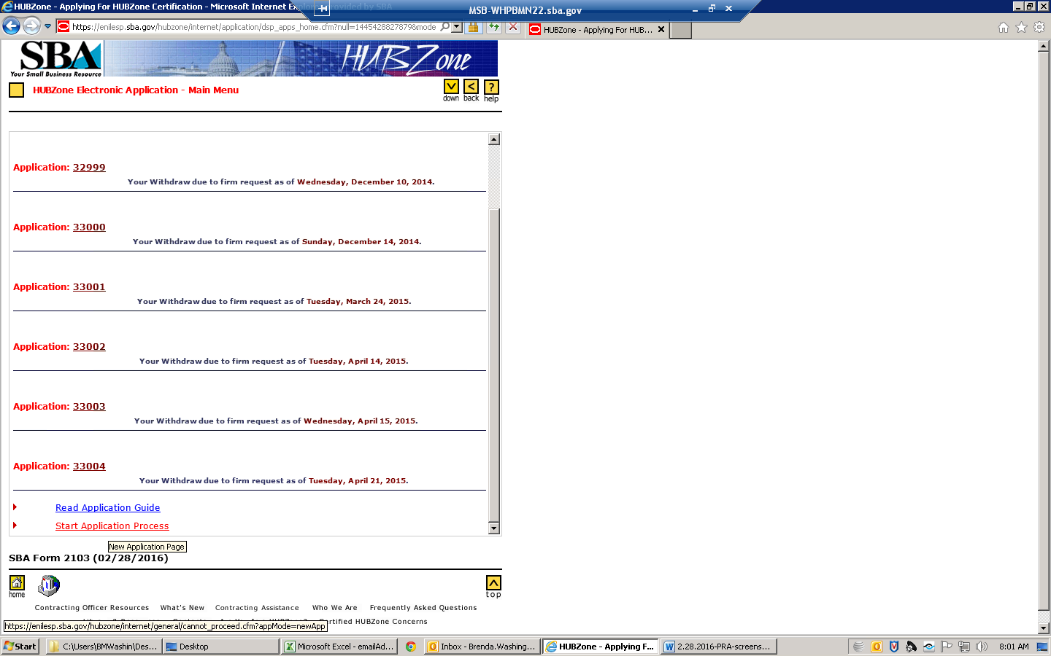

^{Please be advised}

ADVISORY
- SECURITY SETTINGS: Your 'Internet Service Provider' (ISP) or your internet browser may have the Security/Privacy settings preset to a level that might NOT allow the HUBZone System to perform correctly. Before you attempt to log in, please select this link 'How to verify my browser settings?' and make sure you have the right settings. After you establish that you have the right settings you may log in and complete the required steps.
- BROWSER REQUIREMENTS: This application was originally developed for use on Microsoft Internet Explorer or Netscape versions less than 6.x. It is currently being updated to work with more modern browsers, but please be aware that this website may experience some minor issues with other browers, such as Firefox, Safari, or versions of Netscape 6.x and above.
Our form uses Pop-Ups which are by default blocked by the Windows XP operating system. To enable our form to work correctly, please select this link ' Block Pop-up Windows with Internet Explorer ' and follow the instructions under "To change Pop-up Blocker settings."
To see/modify your Browser settings follow the instructions below:
  - For Internet Explorer Users: From your Internet Explorer's Tool Bar, select the Tools \ Internet Options \
    - Using the 'Security' TAB: Change the Security level to 'Default.'
    - Using the 'Privacy' TAB: Change the Privacy level to 'Medium.'
MORE HELP
    - After modifying the settings, close the browser and start over.

  - For Netscape Users: Using the Edit \ Preferences \ Privacy & Security \
    - Using the 'Cookies' option: Enable cookies for the origination web site only.
MORE HELP
    - After modifying the settings, close the browser and start over.

- If 'A' and/or 'C' do NOT apply in your case, then please talk to your 'Internet Service Provider' (ISP) and ask how the Security/Privacy settings can be changed to permit use of 'session variables' that are required for completion of this HUBZone Application.
- If 'A' and/or 'B' do NOT apply in your case, then please talk to your 'Network Administrator' and ask how the Security/Privacy settings can be changed to permit use of 'session variables' that are required for completion of this HUBZone Application.
NOTE: It is recommended that you revert back to your original 'Security/Privacy' settings after completing this HUBZone Application.

SBA Form 2103 (02/28/2016)

How to FIX the problem
From your Internet Explorer's (web browser) tool bar, select 'Tools \ Internet Options'
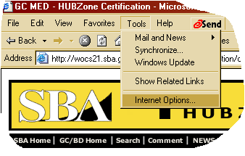
Next
From Internet Options, select 'Security' TAB.
Change the Security level to 'Default' or 'Medium.'
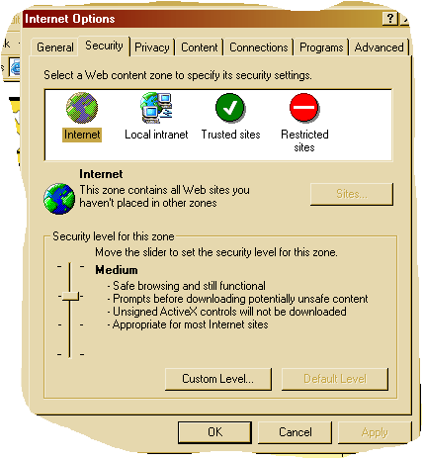
Next
From Internet Options, select 'Privacy' TAB.
Change the Privacy level to 'High', then select 'Apply' button and then select 'OK' button.
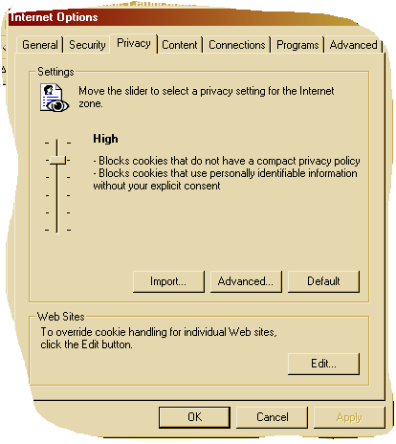
Close the Internet Explorer and start over.
If you are using NETSCAPE browser, see MORE HELP under 'How to FIX the problem.'

^{Please be advised}

MAP ADVISORY
The HUBZone online maps will, in some cases, display a different status than what the certification system's embedded maps will display. We are aware of this and are proceeding with a major update of the certification system to accommodate all the recent changes in HUBZone mapping brought about by geographical enhancements to the HUBZone Program.
IF YOU DO NOT AGREE WITH THE SYSTEM-GENERATED MAPPING PLACEMENT FOR A PARTICULAR ADDRESS , the certification system contains a text box that allows you to explain the reason for your disagreement. Your concern is entered as part of the certification form and you are encouraged to use that text box option. The HUBZone analyst staff routinely checks this element of the online certification form and will thoroughly research any expressed concern.
Thank you for your patience as we work to improve the HUBZone online certification form.

SBA Form 2103 (02/28/2016)

^{Start Application Process}

It is recommended that you read the HUBZone Program Guide and review all regulatory hot links in each section as you complete the application.
The HUBZone application involves FIVE [5] steps. Carefully follow each step.
Verify if in HUBZone Need help? | [ Optional Step ]
Part of the eligibility criteria of the program is that the concern's Principal Office be located in a qualified HUBZone and at least 35% of its employees reside in a HUBZone (except for tribally owned concerns). The principal office is defined as the location where the greatest number of the concern's employees at any one location perform their work. However, for those concerns whose "primary industry" (see 13 CFR 121.107) is service or construction (see 13 CFR 121.201), the determination of prinicipal office excludes the concern's employees who perform the majority of their work at job-site locations to fulfill specific contract obligations.
To determine if the concern's principal office is located in a HUBZone and if your employees reside in a HUBZone, you must:
- Select Verify if in HUBZone.
- Fill out the on-line form, which asks you for the street address, city, state and ZIP code of the location.
- Select Submit.
The system will automatically tell you if your business and/or your employee(s) are in an eligible area.
Please select 'Continue' button below and answer the questions that follow.

SBA Form 2103 (02/28/2016)

HUBZone Mapping

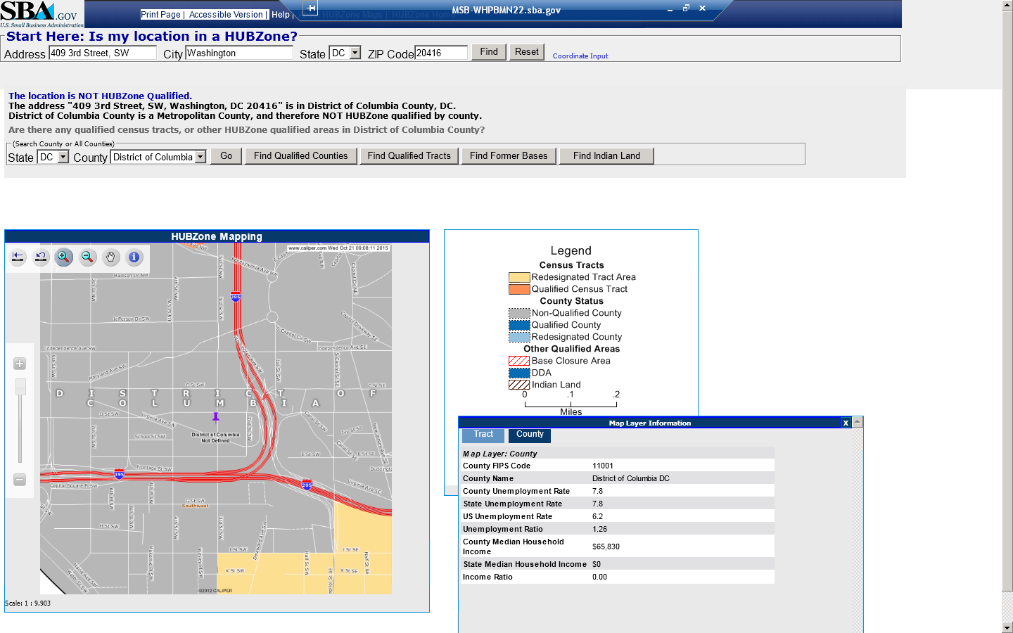

Apply For HUBZone Certification

I will be guiding you through the application process.
However, before we start, please read the following:
Any sensitive information collected in this application is necessary to determine if the business concern applying for HUBZone Certification complies with statutory and regulatory requirements.
It is recommended that you carefully review the following information before you begin.
- HUBZone Program Application Guide
- Small Business Size Standard Information
- Ownership & Control Information
- Affiliation Information
- Financial Information
Note: By selecting an item, you will be presented with text explaining the requirement.
You MUST complete this application in a single session. While entering data into the application, you must be connected to the Internet. The clock on each application page displays the time remaining for you to complete that page before the session times out. You must complete the page before it times out. Incomplete applications cannot be saved.
Are you ready to proceed with your application?

SBA Form 2103 (02/28/2016)

Identifying Business Location(s)

Not Completed Completed Current | OMB Approval No. 3245-0320  Expiration Date: 02/28/2016
Move cursor over a task to see name of the task.
Identifying Business Location(s)
1 | 2 | 3 | 4 | 5 | 6 | 7 | 8 | 9 | 10 | 11 | 12 | 13 | 14 | 15 | 16 | 17

Identifying Business Location(s):
Based on your concern's EIN, we have identified that your concern has the following location(s).
No | DUNS No | Address
1 | 363701553 | 102 Peachtree St Suite 1001  Atlanta GA 30303
NOTE:
If any of the locations listed above do not represent any of your offices, please Contact pronet@sba.gov to correct your concern's profile(s) before resuming your response process.
Question:
Does your concern have locations other than the ones listed above (excluding temporary job-sites for construction and service industries)?

YES NO

SBA Form 2103 (02/28/2016)

Registering Other Business Location(s) in SAM

Not Completed Completed Current | OMB Approval No. 3245-0320  Expiration Date: 02/28/2016
1 | 2 | 3 | 4 | 5 | 6 | 7 | 8 | 9 | 10 | 11 | 12 | 13 | 14 | 15 | 16 | 17

Register ALL office location(s) in SAM & DSBS for your Business Concern:
- In order to complete the HUBZone Application ALL locations(s) for your business concern (excluding job sites for construction and service industries) MUST be registered and active (profile must be updated at least every 12 months) in SAM & DSBS.
- You have indicated that you do NOT have ALL location(s) for your business registered in SAM & DSBS.
- At this time you can set up a SAM and DSBS profile information one at a time by following the instructions below:
DO THE FOLLOWING:
In SAM:
- Use the DUNs number for each business' location to register the new profile(s).
- If you meet the criteria, identify your concern as a 'Small Business Concern.'
- Provide only 2012 NAICS Code(s) in your DSBS and SAM Registration.
Need Help in Selecting your 2012 NAICS?
- Towards the end of the SAM registration process, if the business has been determined to be a 'Small Business Concern', you will be prompted to enter some supplemental information for DSBS.
In DSBS :
- On DSBS, please make sure you identify a 2012 NAICS Code as your Primary NAICS.
- When you have finished entering DSBS information, you may 'Return to HUBZone' and proceed.

• Repeat the above steps until ALL your office location(s) are registered in SAM & DSBS.
Please Note :
- By clicking the button below you will exit the SBA website completely and will be redirected to the SAM website
- Your HUBZone certification session will be ended
- After completing your SAM registration, please wait at least 24 hours before attempting to restart your application for HUBZone status
Register in SAM

SBA Form 2103 (02/28/2016)

Top of Form

SBA Registration Assistance:
Web: https://www.sam.gov/portal/public/SAM/
Email: pronet@sba.gov
SAM customer service contact information:
US Calls: 866-606-8220
International Calls: 334-206-7828
DSN: 866-606-8220
www.fsd.gov

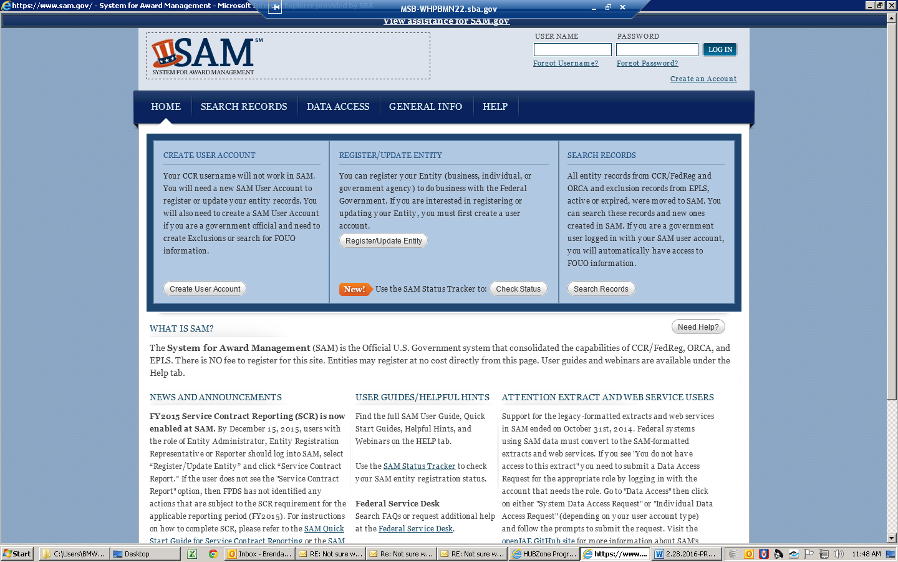

Identifying Business Location(s)

Not Completed Completed Current | OMB Approval No. 3245-0320  Expiration Date: 02/28/2016
Move cursor over a task to see name of the task.
Identifying Business Location(s)
1 | 2 | 3 | 4 | 5 | 6 | 7 | 8 | 9 | 10 | 11 | 12 | 13 | 14 | 15 | 16 | 17

Identifying Business Location(s):
Based on your concern's EIN, we have identified that your concern has the following location(s).
No | DUNS No | Address
1 | 363701553 | 102 Peachtree St Suite 1001  Atlanta GA 30303
NOTE:
If any of the locations listed above do not represent any of your offices, please Contact pronet@sba.gov to correct your concern's profile(s) before resuming your response process.
Question:
Does your concern have locations other than the ones listed above (excluding temporary job-sites for construction and service industries)?

YES NO

SBA Form 2103 (02/28/2016)

^{Determining Principal Office}

Not Completed Completed Current | OMB Approval No. 3245-0320  Expiration Date: 02/28/2016
Move cursor over a task to see name of the task.
1 | 2 | 3 | 4 | 5 | 6 | 7 | 8 | 9 | 10 | 11 | 12 | 13 | 14 | 15 | 16 | 17

Collect Employees(s) at each Business Location:
Instruction:
Please enter the number of individuals employed on a full-time, part-time, or other basis, so long as that individual works a minimum of 40 hours per month, at EACH of the following locations. This includes employees obtained from a temporary employee agency, leasing concern, or through a union agreement or co-employed pursuant to a professional employer organization agreement. SBA will consider the totality of the circumstances, including criteria used by the IRS for Federal income tax purposes and those set forth in SBA's Size Policy Statement No. 1, in determining whether individuals are employees of a concern. Volunteers ( i.e., individuals who receive deferred compensation or no compensation, including no in-kind compensation, for work performed) are not considered employees. However, if an individual has an ownership interest in and works for the HUBZone SBC a minimum of 40 hours per month, that owner is considered an employee regardless of whether or not the individual receives compensation.
NOTE: The location(s) listed below should NOT account for any employee(s) that perform the majority of their work at job-site locations to fulfill specific contract obligations.
No | DUNS No | Address | Number of Employees
1 | 363701553 | 102 Peachtree St Suite 1001  Atlanta GA 30303
How many employees of your concern perform the majority of their work at job-site locations?

SBA Form 2103 (02/28/2016)

Confirmation of Principal Office

Not Completed Completed Current | OMB Approval No. 3245-0320  Expiration Date: 02/28/2016
Move cursor over a task to see name of the task.
1 | 2 | 3 | 4 | 5 | 6 | 7 | 8 | 9 | 10 | 11 | 12 | 13 | 14 | 15 | 16 | 17

Identifying Principal Office:
Determination of Principal Office:
Based on the number of employees supplied for each location on the previous page, it was determined that the Principal Office location where the greatest number of employees perform their work, is at the location with DUNS No: 363701553.
The location with this DUNS is your concern's Principal Office.
If this is correct, please select the 'Continue' button below to proceed.
If this is not correct, please select the 'Previous Question' button below to correct your response.
No | DUNS No | Address | No of Employees
1 | 363701553 | 102 Peachtree St Suite 1001  Atlanta GA 30303 | 10
Number of employees of your concern who perform the majority of their work at job-site locations: |  |  | 0
TOTAL number of employees: |  |  | 10

SBA Form 2103 (02/28/2016)

HUBZone Internet Application Form

Not Completed Completed Current | OMB Approval No. 3245-0320  Expiration Date: 02/28/2016
Move cursor over a task to see name of the task.
1 | 2 | 3 | 4 | 5 | 6 | 7 | 8 | 9 | 10 | 11 | 12 | 13 | 14 | 15 | 16 | 17

Please verify the BUSINESS NAME below and carefully answer the QUESTION that follows:

Legal Business Name* | 'Akima Infrastructure Services, LLC'
*Note:
Only the firm's legal business name may be used to apply for HUBZone certification. SBA will not accept applications submitted using "doing business as" (DBAs) or assumed fictitious name.
Question:
Does the business name appearing above operate out of the Principal Office for your HUBZone Application?
If the information above is correct, please click 'YES' to continue with your SBA application.

SBA Form 2103 (02/28/2016)

^{HUBZone Online Certification}

Not Completed Completed Current | OMB Approval No. 3245-0320  Expiration Date: 02/28/2016
Move cursor over a task to see name of the task.
1 | 2 | 3 | 4 | 5 | 6 | 7 | 8 | 9 | 10 | 11 | 12 | 13 | 14 | 15 | 16 | 17

Please Update your SAM profile with Business Name
Need to correct Business Name?
Address: | Street: 102 Peachtree St, Suite 1001  City: Atlanta  State: GA ZIP: 30303
Instructions:
- Select the 'Update Profile in SAM and Dynamic Small Business Search Page' button below.
- You will be automatically directed to the SAM web site. When you get there, enter the appropriate name in the "Business Name" field.
- Ensure that your profile has the following:
  - a '2012 NAICS' which represents your primary business in your SAM profile. Need Help in Selecting your 2012 NAICS?
  - complete and correct address. Your address in the profile is as displayed above.
- Save your changes.
- Wait 24 hours to allow us to process this information, then come back to the HUBZone web site at www.sba.gov/hubzone to re-start the HUBZone application process.
Update Profile in SAM

SBA Form 2103 (02/28/2016)

HUBZone Internet Application Form

Not Completed Completed Current | OMB Approval No. 3245-0320  Expiration Date: 02/28/2016
Move cursor over a task to see name of the task.
1 | 2 | 3 | 4 | 5 | 6 | 7 | 8 | 9 | 10 | 11 | 12 | 13 | 14 | 15 | 16 | 17

Please verify the BUSINESS NAME below and carefully answer the QUESTION that follows:

Legal Business Name* | 'Akima Infrastructure Services, LLC'
*Note:
Only the firm's legal business name may be used to apply for HUBZone certification. SBA will not accept applications submitted using "doing business as" (DBAs) or assumed fictitious name.
Question:
Does the business name appearing above operate out of the Principal Office for your HUBZone Application?
If the information above is correct, please click 'YES' to continue with your SBA application.

SBA Form 2103 (02/28/2016)

^{HUBZone Online Certification}

Not Completed Completed Current | OMB Approval No. 3245-0320  Expiration Date: 02/28/2016
Move cursor over a task to see name of the task.
1 | 2 | 3 | 4 | 5 | 6 | 7 | 8 | 9 | 10 | 11 | 12 | 13 | 14 | 15 | 16 | 17

Please verify the ADDRESS below and carefully answer the QUESTIONS that follow:
Business Name: | Akima Infrastructure Services, LLC
Address: | Street: 102 Peachtree St, Suite 1001  City: Atlanta  State: GA ZIP: 30303
Dynamic Small Business Search (DSBS) Status: | ACTIVE
Question:
Does the address appearing above represent the Principal Office of Akima Infrastructure Services, LLC?

SBA Form 2103 (02/28/2016)

^{HUBZone Online Certification}

Not Completed Completed Current | OMB Approval No. 3245-0320  Expiration Date: 02/28/2016
Move cursor over a task to see name of the task.
Identifying Business Location(s)
1 | 2 | 3 | 4 | 5 | 6 | 7 | 8 | 9 | 10 | 11 | 12 | 13 | 14 | 15 | 16 | 17

Principal Office:
Question:
Based on the employment information you provided the address is your principal location. Is the employment information correct?
No profile representing Principal Office:
What's the problem?
It is a requirement that the Business Concern Applying for HUBZone Certification must use the Dynamic Small Business Page Information that represents the Principal Office. Since you stated that you do not have Dynamic Small Business Page Information that represents your Principal Office, you must register a new profile in SAM and Dynamic Small Business Page now.
How to Proceed?
Select the 'Register New Profile in SAM and DSBS' button below. It takes you back to Step 2 (Register in Dynamic Small Business Search (DSBS)) of the HUBZone Application Process. Carefully follow the instructions there and register a new profile in SAM and Dynamic Small Business Page with another DUNS number

^{HUBZone Online Certification}

Not Completed Completed Current | OMB Approval No. 3245-0320  Expiration Date: 02/28/2016
Move cursor over a task to see name of the task.
Determination of Principal Office
1 | 2 | 3 | 4 | 5 | 6 | 7 | 8 | 9 | 10 | 11 | 12 | 13 | 14 | 15 | 16 | 17

Please verify the ADDRESS below and carefully answer the QUESTIONS that follow:
Business Name: | Akima Infrastructure Services, LLC
Address: | Street: 102 Peachtree St, Suite 1001  City: Atlanta  State: GA ZIP: 30303
Dynamic Small Business Search (DSBS) Status: | ACTIVE
Question:
Does the address appearing above represent the Principal Office of Akima Infrastructure Services, LLC?

SBA Form 2103 (02/28/2016)

^{HUBZone Online Certification}

Not Completed Completed Current | OMB Approval No. 3245-0320  Expiration Date: 02/28/2016
Move cursor over a task to see name of the task.
1 | 2 | 3 | 4 | 5 | 6 | 7 | 8 | 9 | 10 | 11 | 12 | 13 | 14 | 15 | 16 | 17

Verification of DUNS and additional information for this address:
DUNS number for this address: | 363701553
Tax ID: | 202887430
CAGE | 29086
Question:
Does the DUNS number appearing above represent your Principal Office?
If yes, select the 'Continue' button below and proceed. If not, return to your GLS account and make sure the correct DUNS for the principal office is reported. If you need assistance with displaying the correct DUNS in your GLS profile, please contact itsecurity@sba.gov. However, if you require assistance with DSBS, please contact 202-205-9984 or email pronet@sba.gov.

SBA Form 2103 (02/28/2016)

^{HUBZone Online Certification}

Not Completed Completed Current | OMB Approval No. 3245-0320  Expiration Date: 02/28/2016
Move cursor over a task to see name of the task.
1 | 2 | 3 | 4 | 5 | 6 | 7 | 8 | 9 | 10 | 11 | 12 | 13 | 14 | 15 | 16 | 17

NAICS Code:
Primary NAICS Code in  SBA Registration Page Information: | 541330'Engineering Services', effective year - '2012'
NAICS Code Size Standard based on 'Average Annual Receipts' See 121.104 : | $14,000,000.00
Question:
Does the 'Primary NAICS Code', its description and size standard appearing above represent the Primary Industry (See 121.107) of "Akima Infrastructure Services, LLC"?

SBA Form 2103 (02/28/2016)

NAICS Code Problem:
We have found a problem with your Primary NAICS Code.
How to proceed?
In order to help resolve this problem, please thoroughly read the detailed questions to follow and respond accordingly.

Question:
Have you updated your profile in SAM with a 2012 NAICS that represents your Primary Industry? See 121.107

NAICS Code Problem:
Primary NAICS Code in  Dynamic Small Business Search Page Information: |  | 541330 does NOT represent your Primary Industry
NAICS Code Problem!
What's the problem?
Although you indicated in the last question that you have updated your SAM profile with a 2012 NAICS Code that represents your primary industry, but that has not been identified in your Dynamic Small Business Search Page Information as your Primary NAICS.
How to proceed?
Select the 'Identify Primary NAICS in Dynamic Small Business Search Page' button below, then carefully read and respond to instructions on the following page and identify a 2012 NAICS Code as your Primary NAICS Code in Dynamic Small Business Search Page.

SBA Form 2103 (02/28/2016)

^{HUBZone Online Certification}

Not Completed Completed Current | OMB Approval No. 3245-0320  Expiration Date: 02/28/2016
Move cursor over a task to see name of the task.
SECTION B - General Business Information
1 | 2 | 3 | 4 | 5 | 6 | 7 | 8 | 9 | 10 | 11 | 12 | 13 | 14 | 15 | 16 | 17

NAICS Code:
Primary NAICS Code in  SBA Registration Page Information: | 541330'Engineering Services', effective year - '2012'
NAICS Code Size Standard based on 'Average Annual Receipts' See 121.104 : | $14,000,000.00
Question:
Does the 'Primary NAICS Code', its description and size standard appearing above represent the Primary Industry (See 121.107) of "Akima Infrastructure Services, LLC"?

SBA Form 2103 (02/28/2016)

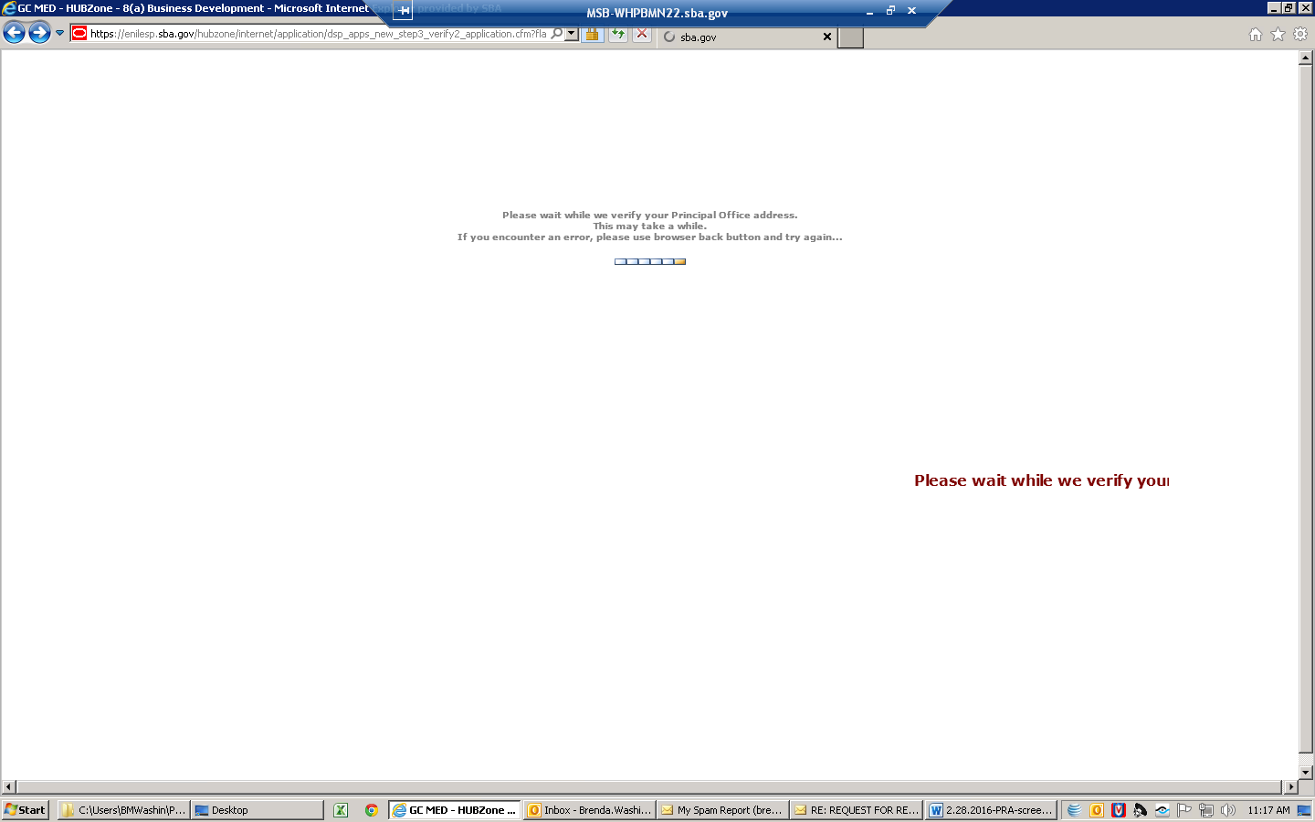

HUBZone Certification - Verification Statement

Not Completed Completed Current | OMB Approval No. 3245-0320  Expiration Date: 02/28/2016
Move cursor over a task to see name of the task.
1 | 2 | 3 | 4 | 5 | 6 | 7 | 8 | 9 | 10 | 11 | 12 | 13 | 14 | 15 | 16 | 17

Authorization:
Note: Click the following highlighted link to review the SBA regulations (13 Code of Federal Regulations, Part 126, Subpart B) for applying to the HUBZone Program.
Question:
Are you an authorized officer that can obligate the ' Business Concern Applying for HUBZone Certification' to the participation requirements of the HUBZone Program?

SBA Form 2103 (02/28/2016)

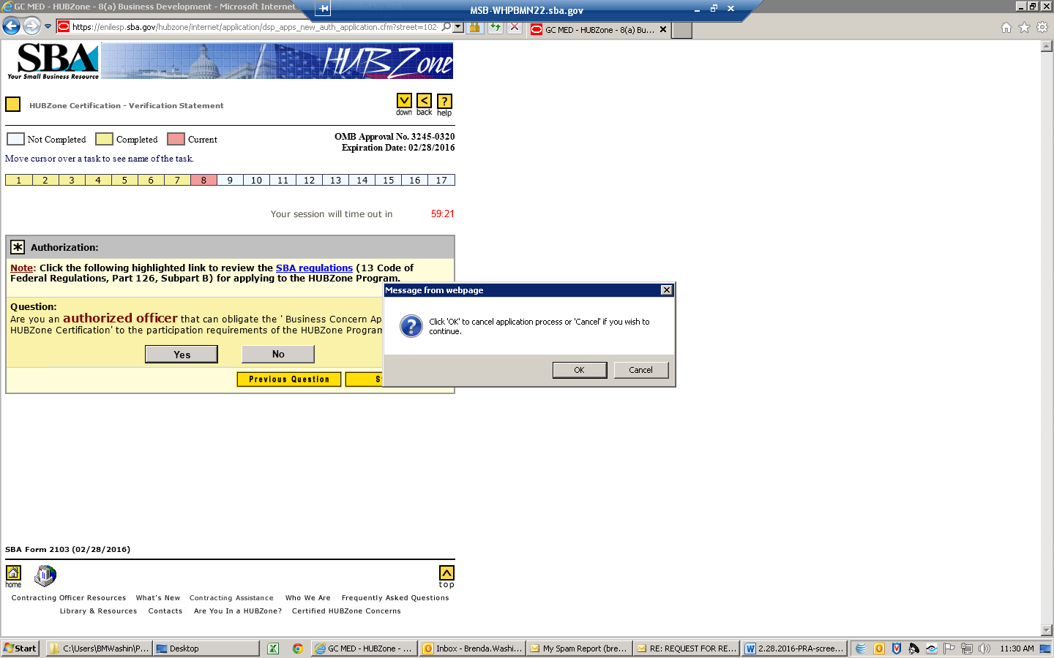

^{Declaration Statement - Page Ι}

Not Completed Completed Current | OMB Approval No. 3245-0320  Expiration Date: 02/28/2016
Move cursor over a task to see name of the task.
Identifying Business Location(s)
1 | 2 | 3 | 4 | 5 | 6 | 7 | 8 | 9 | 10 | 11 | 12 | 13 | 14 | 15 | 16 | 17

Please certify the following:
I certify that, to the best of my knowledge, the following information is accurate and that my position as an officer of the applicant firm with the 'Business Concern Applying for HUBZone Certification' allows me to legally represent this small business concern for the purpose of applying for certification to the HUBZone Program:
OK, now we need to collect some information from you as the person filling out these forms.
Contact Information for Person Entering the Application Data:
Initial Point-of-Contact Name:
Prefix | First | MI | Last | Suffix Jr,Sr etc.

Title or Position:
Phone No: | - - | Ext.:
E-mail Address:

Navigation Links:> Ι|

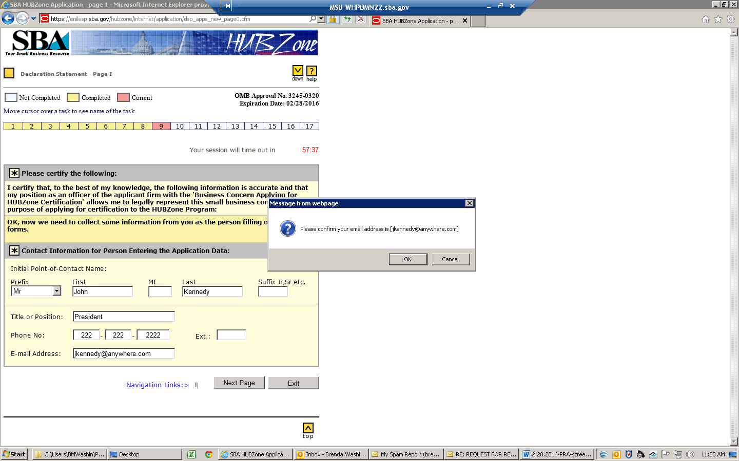

HUBZone Online Certification - Page 1

Not Completed Completed Current | OMB Approval No. 3245-0320  Expiration Date: 02/28/2016
1 | 2 | 3 | 4 | 5 | 6 | 7 | 8 | 9 | 10 | 11 | 12 | 13 | 14 | 15 | 16 | 17

SECTION A - LOCATION IN QUALIFIED HUBZone
Required Principle Office (download checklist and review and provide Principle Office supporting documents). The list of documents is available to view and download at What supporting documents will I need to submit? inside the Certification section.

we have determined the following for the geographical location of the principal office address of "Akima Infrastructure Services, LLC"
• Located in a qualified census tract?  • track number: 13121011900 | Yes
• Located in a qualified non-metropolitan County based on income? | No
• Located in a qualified non-metropolitan County based on unemployment? | No
• Located within the external boundary of a Federally recognized Indian reservation? | No
• Located within the Difficult Development Area? | No
• Located within the BRAC Former Military Base? | No
• Located in a redesignated area? | No
Edit the mailing address of "Akima Infrastructure Services, LLC" if different from its principal office address
Address, line1: | Address, line2: | City:
State: | ZIP Code:  -

SECTION B - GENERAL BUSINESS INFORMATION - Contact Person:
Contact Name: | Prefix | First | MI | Last
Title: |  |  | Phone No: (999) 999 9999 - - Ext.
E-mail: |  |  | Fax No: (999) 999 9999 - - Ext.

Navigation Links:> Ι | 1 |

HUBZone OnLine Certification - Page 2

Not Completed Completed Current | OMB Approval No. 3245-0320  Expiration Date: 02/28/2016
Move cursor over a task to see name of the task.
HUBZone Status determination of your Principal Office address.
1 | 2 | 3 | 4 | 5 | 6 | 7 | 8 | 9 | 10 | 11 | 12 | 13 | 14 | 15 | 16 | 17

SECTION B - GENERAL BUSINESS INFORMATION - Continued
Organizational Structure: | For Profit  Non Profit  (This option is allowed for "Small Agricultural Cooperatives" only) See 121.105(a) & (b)
Business Established:  Date: (mm/dd/yyyy) State: | Business Fiscal Year Ending:  (mm/dd)
Description of principal products and/or services of "Akima Infrastructure Services, LLC":  Please do not enter more than 255 charaters. | characters left:

Primary NAICS Code details:
Primary NAICS Code:541330  Effective Year: 2012 | Size:  Limited to $14,000,000.00 by 'Average Annual Receipts' See 121.104 | Description:  Engineering Services
Ownership by other entities:
Is "Akima Infrastructure Services, LLC" wholly owned by one or more Indian Tribal Governments; wholly owned by a corporation that is wholly owned by one or more Indian Tribal Governments; and/or owned in part by one or more Indian Tribal Governments and all other owners are either United States citizens or small business concerns? See 126.200(a) |  |  | Yes  No
If yes, at the time of this submission does the firm:  - Maintain a principal office located in a HUBZone and ensure that at least 35% of its employees reside in a HUBZone  Or:  - Certify that when performing a HUBZone contract, at least 35% of its employees engaged in performing that contract will reside within any Indian reservation governed by one or more of the Indian Tribal Government owners, or reside within any HUBZone adjoining such Indian reservation. A HUBZone and Indian reservation are adjoining when the two areas are next to and in contact with each other, AND;  - The concern will "attempt to maintain" (See 126.103) that applicable employment percentage stated above during the performance of any HUBZone contract it receive. |  |  | Yes  No  Yes  No

Is "Akima Infrastructure Services, LLC" wholly owned by a Community Development Corporation (CDC) or owned in part by one or more CDCs and all other owners are either U.S. citizens or small businesses? | Yes  No
Is "Akima Infrastructure Services, LLC" an Alaskan Native Corporation (ANC) owned and controlled by Natives (determined pursuant to section 29(e)(1) of the ANCSA); or a direct or indirect subsidiary corporation, joint venture, or partnership of an ANC qualifying pursuant to section 29(e)(1) of ANCSA, if that subsidiary, joint venture, or partnership is owned and controlled by Natives (determined pursuant section 29(e)(2)) of the ANCSA)? | Yes  No
Is "Akima Infrastructure Services, LLC" Applying for HUBZone Certification as a small agricultural cooperative organized or incorporated in the United States, a concern wholly owned by one or more small agricultural cooperatives organized or incorporated in the United States or owned in part by one or more small agricultural cooperatives organized or incorporated in the United States provided all other owners are either U.S. citizens or small businesses? | Yes  No
Size and HUBZone Residency Information:
Size and HUBZone Residency Information: (download checklist and review and provide Size & Affiliation & 35% supporting documents. The list of documents is available to view and download at What supporting documents will I need to submit? inside the Certification section.
Number of individuals employed by "Akima Infrastructure Services, LLC" on a full-time, part-time, or other basis, so long as that individual works a minimum of 40 hours per month, at time of application:
Sum of number of employees of your concern at each office location and the number of employees of your concern who work at off-site, contract specific location(s) See 126.103
Number of individuals employed by "Akima Infrastructure Services, LLC" on a full-time, part-time, or other basis, so long as that individual works a minimum of 40 hours per month, who reside in a HUBZone at time of application: See 126.103
Average number of employees on the payroll of "Akima Infrastructure Services, LLC" during the last 12 calendar months: See 121.106
Average Annual Receipts for "Akima Infrastructure Services, LLC" over its last three Fiscal Years: See 121.104 | $
Debarment information:
Is "Akima Infrastructure Services, LLC" currently debarred, suspended, voluntarily excluded or otherwise rendered ineligible by any department or agency of the Federal Government? | Yes  No
If 'yes' to the above question, provide the following information for each such instance:
Need Help ?

Date of Action: | Type of Action: | Agency Taking Action:

Navigation Links:> Ι | 1 |

BACK NEXT PAGE EXIT

HUBZone OnLine Certification - Page 3

Not Completed Completed Current | OMB Approval No. 3245-0320  Expiration Date: 02/28/2016
Move cursor over a task to see name of the task.
Legal Business Name Verification
1 | 2 | 3 | 4 | 5 | 6 | 7 | 8 | 9 | 10 | 11 | 12 | 13 | 14 | 15 | 16 | 17

SECTION C- OWNERSHIP AND CONTROL - PARTNERSHIP
Ownership & Control (download checklist and review and provide all ownership & control supporting documents). The list of documents is available to view and download at What supporting documents will I need to submit? inside the Certification section.
This section must be completed using the current company information. "Akima Infrastructure Services, LLC" (the Business Concern Applying for HUBZone Certification) is responsible for ensuring that all pertinent information is maintained and available to support and verify all persons (126.201) who own and maintain a controlling interest in "Akima Infrastructure Services, LLC". (126.202)
Note: With the exception of the following, all Business Concerns applying for HUBZone certification must be at least 51% owned and controlled by persons who are U.S. Citizens. All business concerns applying for HUBZone certification must be:
- An ANC owned and controlled by Natives or a direct or indirect subsidiary corporation, joint venture, or partnership of an ANC qualifying pursuant to section 29(e)(1) of the ANCSA,
- A Business Concern wholly owned by one or more Indian Tribal Governments, or by a corporation that is wholly owned by one or more Indian Tribal Governments,
- A Business Concern owned in part by one or more Indian Tribal Governments or in part by a corporation that is wholly owned by one or more Indian Tribal Governments, if all other owners are either United States citizens or SBCs,
- A Business Concern wholly owned by a CDC or owned in part by one or more CDCs, if all other owners are either United States citizens or SBCs.
- A small agricultural cooperative organized or incorporated in the United States or wholly owned by one or more small agricultural cooperatives organized or incorporated in the United States or owned in part by one or more small agricultural cooperatives organized or incorporated in the United States, provided that all other owners are small business concerns or United States citizens.
You must still complete the following information for each "individual" that is currently a stockholder, owner, director or officer of the business concern seeking certification into the program.
For ALL limited partners, for ALL general partners and for ALL officers of "Akima Infrastructure Services, LLC", provide the information below
If there is more than one, select the ' Next Individual ' button at the bottom and enter the requested information.
Please start by identifying the highest ranking individual in the organization, proceeding to the next highest ranking and so on for all individuals.
Individual(s):
Name: | First |  | MI | Last
 | Title |  | E-mail Address
Select all that apply to this individual: | *Must select at least one!  General Partner  Limited Partner  Officer |  |  | U.S. Citizenship: | Yes  No
Individual's interest in other business:
Does this individual have a financial interest or hold a management position in any other business? |  |  |  |  | Yes  No
Does "Akima Infrastructure Services, LLC" share facilities, equipment, or personnel with any other business in which this individual has a financial interest or holds a management position? |  |  |  |  | Yes  No
If 'Yes' to either of the above two questions, provide the following information for each of such business (Warning: Do not enter company more than once!)
Need Help ?

Business name: |  | Title or Position: | % of Ownership
Street: |  | City: | State: | ZIP Code:  -
Average Number of employees for the last 12 months
Average Annual Revenue for this business over the last three Fiscal Years See 121.104
Individual debarment information:
Is this individual currently debarred, suspended, voluntarily excluded or otherwise rendered ineligible by any department or agency of the Federal Government? |  |  |  |  | Yes  No
If 'yes' to the above question, provide the following information for each such instance:
Need Help ?

Date of Action: | Type of Action: | Agency Taking Action:

Navigation Links:> Ι | 1 | 2 | 3 |

HUBZone Online Certification - Page 4

Not Completed Completed Current | OMB Approval No. 3245-0320  Expiration Date: 02/28/2016
Move cursor over a task to see name of the task.
1 | 2 | 3 | 4 | 5 | 6 | 7 | 8 | 9 | 10 | 11 | 12 | 13 | 14 | 15 | 16 | 17

SECTION C - OWNERSHIP AND CONTROL - PARTNERSHIP- Continued - 4
Are at least 51% of Partners of "Akima Infrastructure Services, LLC" U.S. Citizens? |  |  |  | Yes  No
SECTION D - FINANCIAL INFORMATION
Required Financial Information (download checklist and review and provide financial supporting documents). The list of documents is available to view and download at What supporting documents will I need to submit? inside the Certification section. The following must be taken from the most recently filed Federal Tax Return for "Akima Infrastructure Services, LLC".
Last Fiscal Year Date:  (mm/dd/yyyy) |  | Tax Return Filing Date:  (mm/dd/yyyy)
Total Receipts:  $  Note: DO NOT use commas or dollar sign. |  | Net Profit:  $  Note: DO NOT use commas or dollar sign.
The following balance sheet information must be taken from the most recent, official financial statements of "Akima Infrastructure Services, LLC"
Current Assets:  $ | Fixed Assets:  $ | Other Assets:  $ | Total Assets:  $
Current Liabilities:  $ | Long-term Liabilities:  $ | Total Liabilities:  $ | Net Worth:  $
If for any reason, you are unable to provide  complete financial information, please explain why: | characters left:
Please do not enter more than 255 charaters.
SECTION E - HUBZone EMPLOYMENT - INDIVIDUAL EMPLOYMENT DATA
Required HUBZone Employment Information (download checklist and review and provide financial supporting documents). The list of documents is available to view and download at What supporting documents will I need to submit? inside the Certification section. The question below refers to each individual employee who currently works for your business. In calculating the percentage of employees who are HUBZone residents, you must include all individuals employed on a full-time, part-time, or other basis, so long as that individual works a minimum of 40 hours per month.13 CFR Section 126.103 Further, in verifying employee residence, be sure to use the actual resident addresses: post office boxes are not acceptable.
"Akima Infrastructure Services, LLC" has researched the resident status of its employees and has determined that at least 35% of all individuals employed on a full-time, part-time, or other basis, so long as that individual works a minimum of 40 hours per month, are HUBZone residents. |  |  |  | Yes  No
"Akima Infrastructure Services, LLC" has calculated the percentage of HUBZone residents utilizing current employment records as of the date of this application and will ensure that these records and all other pertinent information are maintained to document that at least 35% of all individuals employed on a full-time, part-time, or other basis, so long as that individual works a minimum of 40 hours per month, are HUBZone residents. |  |  |  | Yes  No
SECTION F - AFFILIATION
Required HUBZone Affiliation Information (download checklist and review and provide financial supporting documents). The list of documents is available to view and download at What supporting documents will I need to submit? inside the Certification section. In order to determine the affiliation (as defined pursuant to 13 CFR Section 121.103) of "Akima Infrastructure Services, LLC", please answer the following two questions below:
Note:
An affiliation with other entity(ies) can be established by virtue of one or more of the following:
• Joint Venture agreement(s)
• Franchise or License agreement(s)
• Stock Holding, Partnership, Membership or Ownership
• Identity of Interest
• Sharing of Equipment/Facilities/Employees
• Sharing or use of Special license(s) required for operation of "Akima Infrastructure Services, LLC"
• Bonding Assistance Indemnification or guarantee to "Akima Infrastructure Services, LLC"
• Other contractual relationships
Does "Akima Infrastructure Services, LLC" have one or more affiliation interest(s) listed 13 CFR Section 121.103 in any other business? |  |  |  | Yes  No
Does any other entity(ies) have one or more affiliation interest(s) listed 13 CFR 121.103in "Akima Infrastructure Services, LLC"? |  |  |  | Yes  No
If 'Yes,' to either of the above questions, give the details of each such entity on the next page.
Navigation Links:> Ι | 1 | 2 | 3 | 4|

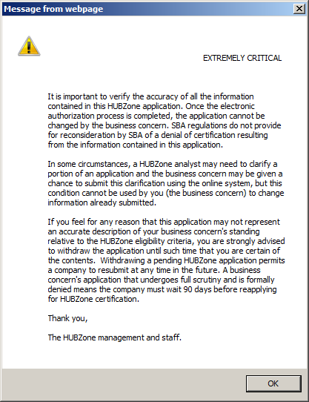

HUBZone Online Certification - Page II

Not Completed Completed Current | OMB Approval No. 3245-0320  Expiration Date: 02/28/2016
Move cursor over a task to see name of the task.
SECTION F - Affiliation
1 | 2 | 3 | 4 | 5 | 6 | 7 | 8 | 9 | 10 | 11 | 12 | 13 | 14 | 15 | 16 | 17

Top of Form
Bottom of Form

Top of Form
Notice of Verification
The SBA will need to verify your ability to represent "Akima Infrastructure Services, LLC" for HUBZone certification. To facilitate this process, the system is designed to automatically identify the highest-ranking officer named earlier in Section C of this application. You can choose to override this designation with another 'Key Person,' that is an officer, by using the drop down menu, but this action will be recorded and may prompt an inquiry. You may also choose to identify someone other than a 'Key Person,' and this would be entered in the section titled 'Other.'
Please be advised that you must submit the required documents within 10 business days. If your documents are not received, the application will be withdrawn. If the application is withdrawn, you will be able to start a new application. Here is the list of documents that you'll need to provide SBA for the application review and determination process. For more information on the following list of documents click the more info link below.
Documents Checklist for Partnership:
more Info
PRINCIPAL OFFICE
- Lease/Rental Agreement/Deed
- Utility Bill
- Firm Location List
35% HUBZONE RESIDENCY
- Payroll Records
- Identification/ Proof of Residence for HUBZone Residents
- HUBZone Map of HUBZone Residents' Addresses
- State and Federal Unemployment Filings
- Employee List
- Contractor List (if applicable)
AFFILIATION AND SIZE
- Business Tax Returns
- Personal Tax Returns for Significant Owners
OWNERSHIP AND CONTROL
- Proof of Citizenship for firms at least 51% owned by US Citizen
- Partnership Documents
- DBA (Doing Business As) Certificate, if applicable
- Partnership Agreement and any amendments
- Other key ownership documents
SIGNATURE SHEET
- Signed HUBZone Program Certification Signature Sheet
ATTEMPT TO MAINTAIN (FOR RECERTIFICATIONS, PROGRAM EXAMS AND PROTESTS ONLY)
- Evidence that firm is attempting to maintain the 35% requirement
Identify the person that can verify that you have the authority to submit this form on behalf of the Firm (Additional Point of Contact):
The responding officer will need to have the SBA Customer password for "Akima Infrastructure Services, LLC" and his/her e-mail address available. The e-mail notice he/she receives will provide the HUBZone application number automatically.
Key Person List
Other:
Contact Name:
First | MI | Last | Suffix Jr,Sr etc.
Title
Phone Number |  | - - Ext.
E-mail Address
Bottom of Form

HUBZone OnLine Certification Summary Page 1

Not Completed Completed Current | OMB Approval No. 3245-0320  Expiration Date: 02/28/2016
Move cursor over a task to see name of the task.
Verification of DUNS and additional information.
1 | 2 | 3 | 4 | 5 | 6 | 7 | 8 | 9 | 10 | 11 | 12 | 13 | 14 | 15 | 16 | 17

What happened?
- You have successfully completed steps 1 to 3 of the HUBZone Electronic Application.
- Carefully read this page and follow instructions for next action. We strongly suggest you PRINT this page using the 'File-Print' option of your internet browser and retain it for your records.
Potential Decline Factor(s)
We have determined that the following factors can cause your application to be 'Declined.' Carefully review the following Potential Decline Factor(s).
- Section E-35% employees HUBZone residency requirement not researched
What else is there to do?
- Please be advised that you must submit the required documents within 10 business days. If your documents are not received, the application will be withdrawn. If the application is withdrawn, you will be able to start a new application. To view and download the checklist and supporting documents for your company please go to What supporting documents will I need to submit? inside the Certification section.
- Please proceed to the next page and complete steps 4 & 5, in order to complete your application.
We strongly suggest you print this page for your records and proceed to the next page for the next steps in completing the application
To proceed to the next steps, select the 'next page' button below.

HUBZone OnLine Certification Summary Page 2

Not Completed Completed Current | OMB Approval No. 3245-0320  Expiration Date: 02/28/2016
Move cursor over a task to see name of the task.
SECTION A - Contact Information for Person Entering the Application Data
SECTION B - General Business Information
1 | 2 | 3 | 4 | 5 | 6 | 7 | 8 | 9 | 10 | 11 | 12 | 13 | 14 | 15 | 16 | 17

Download COMPLETED Application
- Your HUBZone Application has been submitted. The application number is 33007
- You must now view your COMPLETED application and make sure that all the information appearing is accurate.
- You can 'Edit Your Application' as many times as you want before responding to the 'Electronic Verification.' Once we receive the Electronic Verification, we will not allow you to make further edits to the application.
- To view your COMPLETED application, click the 'display my application' button below. We strongly recommend you Save & Print the Application for your records.

Check List
- Have you printed out your completed application? If not, print and retain it now for your records.
- In order for us to further proceed with your application, you must ensure that the officer of the applicant firm identified by you in Step 3 completes the 'Electronic Verification' process using the information provided in the E-mail notification sent to him/her. If this is not done within 10 calendar days, your application will be 'Deleted.'
- Please be advised that you must submit the required documents within 10 business days. If your documents are not received, the application will be withdrawn. If the application is withdrawn, you will be able to start a new application. Click Download Checklist to view and download the checklist of the required documents.
- Click FINISH to proceed.

SBA Form 2103 (02/28/2016)

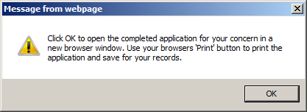

^{Thank You}

Not Completed Completed Current | OMB Approval No. 3245-0320  Expiration Date: 02/28/2016
Move cursor over a task to see name of the task.
SECTION B - General Business Information
1 | 2 | 3 | 4 | 5 | 6 | 7 | 8 | 9 | 10 | 11 | 12 | 13 | 14 | 15 | 16 | 17

- You have successfully submitted your application for HUBZone certification.
- You may visit our website at
- You may visit our website at HUBZone Electronic Application - Main Menu at any time and use the following options.
  - Edit Your Application*
  - Check Application Status
  - Cancel Your Application
- If additional information/clarification is required, we will email/fax the request to the individual listed as the point of contact in the application.
- Please be advised that you must submit the required documents within 10 business days. If your documents are not received, the application will be withdrawn. If the application is withdrawn, you will be able to start a new application. You may find the list of documents for your company by going to What supporting documents will I need to submit? inside the Certification section.
NOTE:
You may cancel the application at any time before we receive the Electronic Verification response allowing us to proceed with your application or if you receive a "System Rejected" message or if you feel that you have made a mistake in the application. You are welcome to re-submit a new application for re-evaluation.
*You can 'Edit Your Application ' as many times as you want before responding to the 'Electronic Verification.' Once we receive the Electronic Verification, we will not allow you to make further edits to the application.
SBA Form 2103 (02/28/2016)

PLEASE NOTE: You are not required to respond to any collection of information unless it displays a currently valid OMB approval number. The number for this collection of information is 3245-0320. The estimated time for completing this collection of information depends on whether you are submitting an initial application, recertifying or responding to an examination. We estimate 3 hours for an application; 1 hour for re-certifications; and 3 hours for examinations.

Comments on these estimated times should be sent to U.S. Small Business Administration, Chief/AIB, 409 3rd St., S.W., Washington, D.C. 20416 and Desk Officer for the Small Business Administration, Office of Management and Budget, New Executive Office Building, Room 10202, Washington, D.C. 20503.

