Section A: Justification

- Explain the circumstances that make the collection of information necessary. Identify any legal or administrative requirements that necessitate the collection. Attach a copy of the appropriate section of each statute and regulation mandating or authorizing the collection of information.

The Peace Corps Office of Third Goal and Returned Volunteer Services office (3GL) has two primary duties: aiding returning and recently returned Peace Corps Volunteers with transition back to the United States; and supporting the Third Goal of Peace Corps, which is to promote a better understanding of other peoples on the part of Americans. This authority is outlined in two sections of the Peace Corps Act. 22 U.S.C. § 2517 states “In order to further the goal of the Peace Corps, as set forth in section 2501 of this title, relating to the promotion of a better understanding of other peoples on the part of the American people, the Director, utilizing the authorities under section 2509 (a)(1) of this title and other provisions of law, shall, as appropriate, encourage, facilitate, and assist activities carried out by former volunteers in furtherance of such goal and the efforts of agencies, organizations, and other individuals to support or assist in former volunteers carrying out such activities.” 22 USC 2504(k) provides: “In order to assure that the skills and experience which former volunteers have derived from their training and their service abroad are best utilized in the national interest, the [Peace Corps Director] may, in cooperation with agencies of the United States, private employers, educational institutions, and other entities of the United States, undertake programs under which volunteers would be counseled with respect to opportunities for further education and employment.”

To better serve the Returned Volunteer population and support the Third Goal, 3GL has developed an RPCV Portal that allows Returned Peace Corps Volunteers (RPCVs) to update their contact information, share stories, request official documentation, view their service history, and enroll in outreach and marketing campaigns. The RPCV Portal can only be accessed by Volunteers who have completed their Peace Corps service; neither current Volunteers, Trainees, applicants nor other members of the public will be able to access the system.

To build a robust alumni network, it is essential that Peace Corps maintains accurate and up-to-date contact information for RPCVs. RPCVs can access their contact record in Returned Peace Corps Volunteer database securely through the RPCV Portal, and are able to make changes and submit requests at their convenience. Changes made through the RPCV Portal are reflected
immediately in the database. The RPCV Portal also allows RPCVs to access Peace Corps information and services outside of business hours, and does not require staff time to manually verify or process these requests.

- Indicate how, by whom, and for what purpose the information is to be used. Except for a new collection, indicate the actual use the agency has made of the information received from the current collection.

The updated contact information collected in the RPCV Portal will be used for outreach and support purposes, along with managing subscriptions for Peace Corps newsletters. The updated contact information and subscription requests will be used by the following offices for the following reasons.

- Office of Third Goal and Returned Volunteer Services to promote career services, Third Goal events and contests, and monthly newsletters
- Office of Communications to send press releases, program updates, and for the press office to reach out to individual RPCVs.
- Peace Corps Response to send vacancy announcements and information about short term volunteer assignments, as well as monthly newsletters.
- Office of Volunteer Recruitment and Selection to solicit RPCVs to help with recruitment events.
- Office of Strategic Partnerships to reach out to potential donors and provide various program updates.
“Requests for certifications” will be used to help expedite a request for the Peace Corps to certify that an individual served as a Peace Corps Volunteer, as well as for other official Peace Corps documentation. The information entered in the RPCV Portal will only be accessible by staff who have a business need for RPCV contact information, and who have been approved by The Office of Third Goal and Returned Volunteer Services.

- Describe whether, and to what extent, the collection of information involves the use of automated, electronic, mechanical, or other technological collection techniques or other forms of information technology, e.g., permitting electronic submission of responses, and the basis for the decision for adopting this means of collection. Also describe any consideration of using information technology to reduce burden.

Previously, 3GL relied on a web-based form to collect address and email updates. This form required the RPCV to enter their complete service information, name, birthday and in addition to any changes to contact information. Due to a lack of verification and standardization using the form, each request might contain several errors, and no report was sent to the RPCV to allow them to quickly correct incorrectly entered information. Furthermore, each request was received as an individual email and required staff to manually enter the information by copying and pasting each line from the email into the database.

The RPCV Portal greatly reduces Peace Corps staff time needed to process address changes, and allows the RPCV to return at their convenience and update the information as it changes, rather than waiting for it to be processed on the Peace Corps’ end.

To gain access to the RPCV Portal, a user must first navigate to the RPCV Portal landing page, which is located in the Resources for Returned Volunteers section of the Peace Corps website (www.peacecorps.gov). The RPCV then requests an invitation code by providing their first and last name, birthdate, country of service and the year they completed their service (COS year). The information is matched automatically using information contained in the Former Peace Corps Volunteer and Staff Database (PC-18). Once the information has been confirmed, the RPCV will receive by email an invitation code to join the RPCV Portal. The invitation code allows the RPCV to create a username and password, which allows them to return at their convenience to update their preferences, request documentation, manage subscriptions, and access any of the other features available in the RPCV Portal. Updates made in the RPCV Portal are immediately available in the backend database (PC-18), and can be used immediately by staff members with access.

- Describe efforts to identify duplication. Show specifically why any similar information already available cannot be used or modified for use for the purposes described in Item 2 above.

Peace Corps has reviewed the RPCV Portal form in order to avoid and identify duplications. The RPCV Portal reduces duplication of efforts by consolidating information collection from RPCVs in one location, and eliminating the need to ask for verification information on several separate collection sources.

- If the collection of information impacts small businesses or other small entities (Item 5 of OMB Form 83-I), describe any methods used to minimize burden.

This collection of information does not impact small business or other small entities.

- Describe the consequence to Federal program or policy activities if the collection is not conducted or is conducted less frequently, as well as any technical or legal obstacles to reducing burden.

This information collection is entirely voluntary for RPCVs, and is collected at the RPCV’s convenience. It is only collected once for each respondent. Once the information is collected and the respondent may edit details as needed.

- Explain any special circumstances that would cause an information collection to be conducted in a manner:

* requiring respondents to report information to the agency more often than quarterly;
* requiring respondents to prepare a written response to a collection of information in fewer than 30 days after receipt of it;
* requiring respondents to submit more than an original and two copies of any document;
* requiring respondents to retain records, other than health, medical, government contract, grant-in-aid, or tax records, for more than three years;
* in connection with a statistical survey, that is not designed to produce valid and reliable results that can be generalized to the universe of study;
* requiring the use of a statistical data classification that has not been reviewed and approved by OMB;
* that includes a pledge of confidentiality that is not supported by authority established in statute or regulation, that is not supported by disclosure and data security policies that are consistent with the pledge, or which unnecessarily impedes sharing of data with other agencies for compatible confidential use; or
* requiring respondents to submit proprietary trade secrets, or other confidential information unless the agency can demonstrate that it has instituted procedures to protect the information's confidentiality to the extent permitted by law.

No special circumstances exist that require the information collection to be conducted in a manner inconsistent with the guidelines in 5 CFR 1320.6.

8. If applicable, provide a copy and identify the date and page number of publication in the Federal Register of the agency's notice, required by 5 CFR 1320.8(d), soliciting comments on the information collection prior to submission to OMB. Summarize public comments received in response to that notice and describe actions taken by the agency in response to these comments. Specifically address comments received on cost and hour burden.

Describe efforts to consult with persons outside the agency to obtain their views on the availability of data, frequency of collection, the clarity of instructions and recordkeeping, disclosure, or reporting format (if any), and on the data elements to be recorded, disclosed, or reported.

Consultation with representatives of those from whom information is to be obtained or those who must compile records should occur at least once every 3 years - even if the collection of information activity is the same as in prior periods. There may be circumstances that may preclude consultation in a specific situation. These circumstances should be explained.

The agency’s 60- Day notice was published in the Federal Register on December 10, 2015, 80 FR 76714. No public comments were received during the 60-day period; however, we did receive questions which we uploaded. The 30- Day notice was published on March 7, 2016, 81 FR 11844

Question below.

I have some questions about the proposal posted in the
Federal Register. . They may reflect my overall ignorance.

Where do we post our comments about the proposed RPCV Portal?

There are a number of hours necessary for operation in the first year. Will the work be contracted out or will additional staff be hired?

The initial development was completed using staff already onboard at Peace Corps. Additional features are being worked on by both external contractors and current staff that has already been working on enhancements to the backend database for the RPCV Portal.

I don't understand why the OMB is involved. Wouldn't this be a budget issue?

Since we are collecting additional information that is additional to what is necessary to identify the person we must follow the Paperwork Reduction Act.

I didn't see any new regulations proposed?

No new regulations are proposed.

Why is a "robust network of RPCVs needed"?

To better inform RPCVs about the state of the Agency, to share opportunities to promote the Third Goal, Career Services, Peace Corps Response positions and new initiatives it is essential that Peace Corps has up-to-date contact information for its alumni. By strengthening the network of RPCVs, Peace Corps can strengthen fundraising efforts, identify new employment opportunities for returned Volunteers, increasing or helping in recruitment efforts, and provide services to the RPCV community (such as certifications of service) quickly and easily to the community.

In what "marketing" is Peace Corps proposing to involve
RPCVs?

No new marketing campaigns that will involve RPCVs. Marketing refers to sharing our resources, newsletters and updates with RPCVs that are interested in receiving these messages. The idea of “marketing” is that we are marketing the services offered by Peace Corps for RPCVs.

Will the NPCA be able to access this information?

Currently Peace Corps is not able to share contact information with any external organization, so the information will not be shared with NPCA at this time.

What will be the privacy controls available?

The RPCV Portal is entirely voluntary, however we are adding the ability to opt-out of any marketing emails, and all programs or new features in the RPCV portal will be entirely opt-in.

With whom will Peace Corps share this information?

No information will be shared using this system. Updated records will be used for outreach
.
- Explain any decision to provide any payment or gift to respondents, other than remuneration of contractors or grantees.
No payments or gifts are provided to respondents.

- Describe any assurance of confidentiality provided to respondents and the basis for the assurance in statute, regulation, or agency policy.
There is no assurance of confidentiality provided to respondents. The information is covered by the Privacy Act. The information is stored in Peace Corps’ Systems of Records, PC-18 Former Peace Corps Volunteer and Staff Database.

11. Provide additional justification for any questions of a sensitive nature, such as sexual behavior and attitudes, religious beliefs, and other matters that are commonly considered private. This justification should include the reasons why the agency considers the questions necessary, the specific uses to be made of the information, the explanation to be given to persons from whom the information is requested, and any steps to be taken to obtain their consent.

The RPCV Portal does not request information to be given regarding sexual behavior or attitude, religious beliefs, or any other matters that are commonly considered private.

12. Provide estimates of the hour burden of the collection of information. The statement should:

* Indicate the number of respondents, frequency of response, annual hour burden, and an explanation of how the burden was estimated. Unless directed to do so, agencies should not conduct special surveys to obtain information on which to base hour burden estimates. Consultation with a sample (fewer than 10) of potential respondents is desirable. If the hour burden on respondents is expected to vary widely because of differences in activity, size, or complexity, show the range of estimated hour burden, and explain the reasons for the variance. Generally, estimates should not include burden hours for customary and usual business practices.
* If this request for approval covers more than one form, provide separate hour burden estimates for each form and aggregate the hour burdens in Item 13 of OMB Form 83-I.

* Provide estimates of annualized cost to respondents for the hour burdens for collections of information, identifying and using appropriate wage rate categories. The cost of contracting out or paying outside parties for information collection activities should not be included here. Instead, this cost should be included in Item 13.
.

Estimated burden (hours) of the collection of information:

  - Number of Respondents (first year) 50,000
  - Number of Respondents (annually) 3,000
  - Frequency of response: 2 times
  - Completion time: 5 minutes
  - Annual burden hours (first year): 8,333 hours
  - Annual burden hours (annually) 500 hours

The burden was calculated by assuming 50,000 RPCVs will login to the RPCV Portal twice annually during the first year; and that it takes approximately 5 minutes to create an account and update contact information. The 5 minute approximation was calculated by having several Returned Peace Corps Volunteers that are current Peace Corps staff work through the process and reporting the time it takes back to The Office of Third Goal. Having 50,000 RPCVs access the service twice annually, with a 5 minute completion time per visit results in a burden of 500,000 minutes in a year, or 8,333 hours. After the first year, an estimated 3,000 RPCVs will access the portal, resulting in a burden of 500 hours annually after the first year.

13. Provide an estimate for the total annual cost burden to respondents or record keepers resulting from the collection of information. (Do not include the cost of any hour burden shown in Items 12 and 14).

* The cost estimate should be split into two components: (a) a total capital and start-up cost component (annualized over its expected useful life) and (b) a total operation and maintenance and purchase of services component. The estimates should take into account costs associated with generating, maintaining, and disclosing or providing the information. Include descriptions of methods used to estimate major cost factors including system and technology acquisition, expected useful life of capital equipment, the discount rate(s), and the time period over which costs will be incurred. Capital and start-up costs include, among other items, preparations for collecting information such as purchasing computers and software; monitoring, sampling, drilling and testing equipment; and record storage facilities.
* If cost estimates are expected to vary widely, agencies should present ranges of cost burdens and explain the reasons for the variance. The cost of purchasing or contracting out information collections services should be a part of this cost burden estimate. In developing cost burden estimates, agencies may consult with a sample of respondents (fewer than 10), utilize the 60-day pre-OMB submission public comment process and use 10/95 existing economic or regulatory impact analysis associated with the rulemaking containing the information collection, as appropriate.
* Generally, estimates should not include purchases of equipment or services, or portions thereof, made: (1) prior to October 1, 1995, (2) to achieve regulatory compliance with requirements not associated with the information collection, (3) for reasons other than to provide information or keep records for the government or (4) as part of customary and usual business or private practices.

The RPCV Portal is web based, and can be accessed freely by returned Peace Corps Volunteers. There are no startup costs to the respondents to use the system.

- Provide estimates of annualized costs to the Federal government. Also, provide a description of the method used to estimate cost, which should include quantification of hours, operational expenses (such as equipment, overhead, printing, and support staff), and any other expense that would not have been incurred without this collection of information. Agencies may also aggregate cost estimates from Items 12, 13, and 14 in a single table.

The estimated start up costs are as follows:

Purchase of AdxStudio Portal plugin software - $10,000. This is a onetime cost, and is not purchased annually.

The server required to host AdxStudio cost is $10,000. This is the cost of the agency to stand up a standalone server to host the RPCV Portal. This is a onetime cost.

The RPCV Portal requires periodic maintenance and updates, which will amount to less than 100 staff hours a year. Maintenance and updates will be performed by an IT Specialist, located in the Office of the Chief Information Officer at Peace Corps Headquarters. The grade and salary of this position is listed as FP-3 grade, step 1 with an annual salary of approximately $83,000.

Labor cost
100 hours/ 2087 hours per year = 0.05% of a IT Specialist;
0.05% of IT specialist’s salary * $83,000 annual salary (FP-3)

Total annual costs to the Federal government over three years is: $10,816

- Explain the reasons for any program changes or adjustments reported in Items 13 or 14 of the OMB Form 83-I.

N/A.
16. For collections of information whose results will be published, outline plans for tabulation and publication. Address any complex analytical techniques that will be used. Provide the time schedule for the entire project, including beginning and ending dates of the collection of information, completion of report, publication dates, and other actions.

Peace Corps does not intend to publish the enrollment information. Collection of information for the RPCV Portal does not employ statistical methods. The RPCV Portal is intended for continuous use.

17. If seeking approval to not display the expiration date for OMB approval of the information collection, explain the reasons that display would be inappropriate.

The Agency is not seeking approval to conceal or omit the expiration date for OMB approval of the information collection.

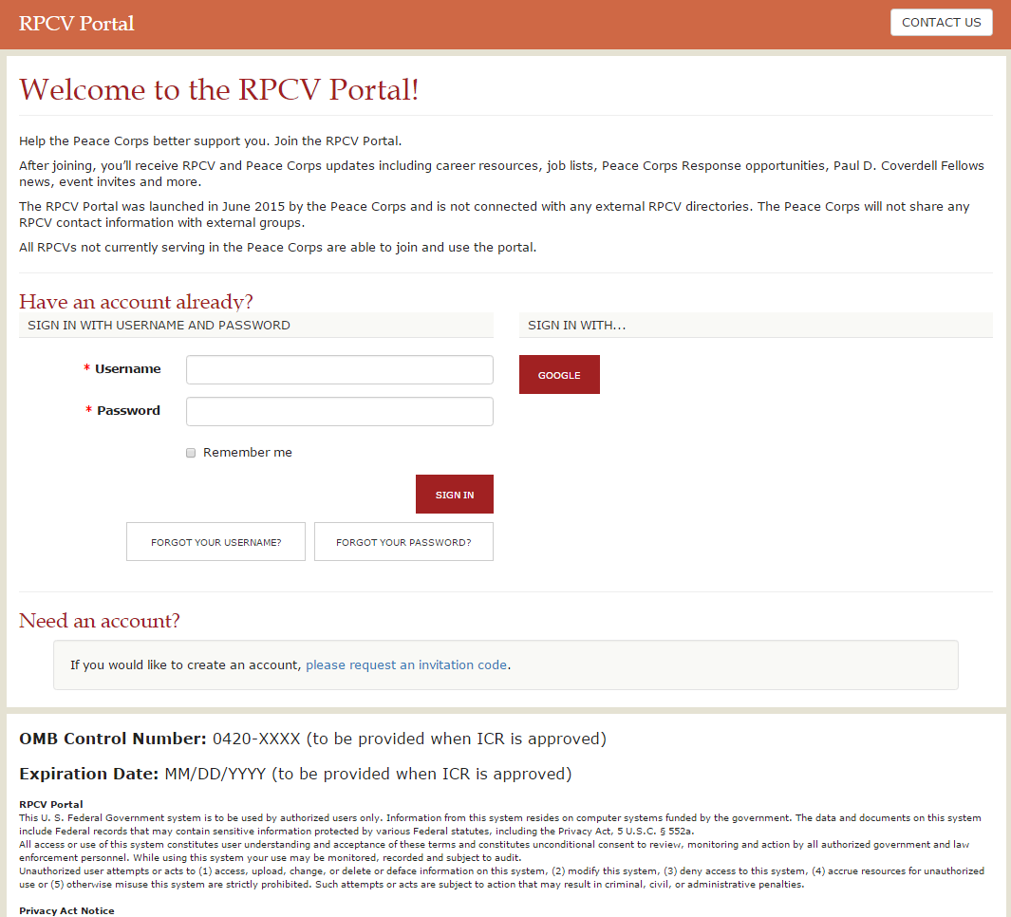

18. Explain each exception to the certification statement identified in Item 19, "Certification for Paperwork Reduction Act Submissions," of OMB Form 83-I.

The agency is able to certify compliance with all provisions under Item 19 of OMB Form 83-I.

Section B: Collection of Information Employing Statistical Methods

The collection of information does not employ statistical methods.

