Alaska Saltwater Sport Fishing Charter Business Survey

2015 Season

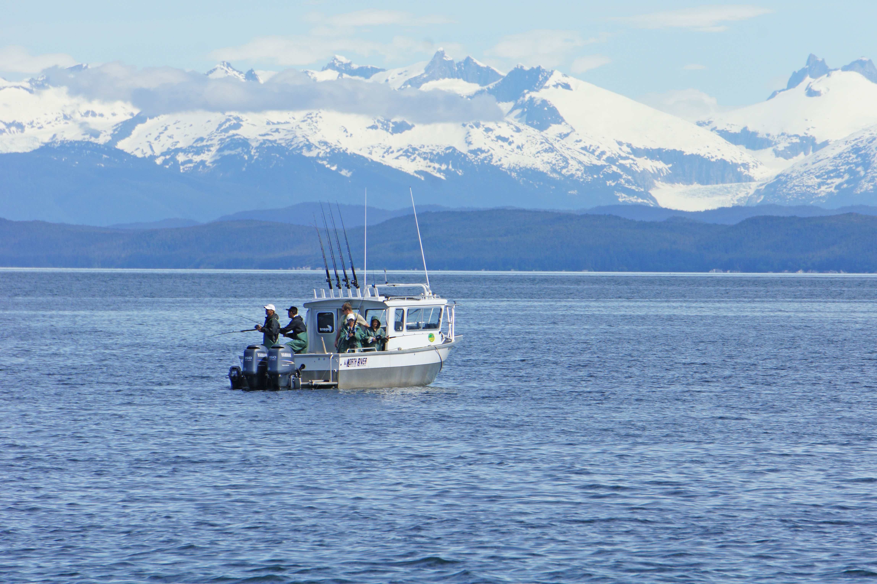
Photo credit: R. Yamada

This survey is funded by the National Oceanic and Atmospheric Administration, a U.S. government agency charged with making decisions about halibut management.

Public reporting burden for this collection of information is estimated at 90 minutes, including time for reviewing instructions, reviewing existing data sources, gathering and maintaining the data needed, and completing and reviewing the collection of information. Notwithstanding any other provision of the law, no person is required to respond to, nor shall any person be subject to a penalty for failure to comply with, a collection of information subject to the requirements of the Paperwork Reduction Act, unless that collection of information displays a currently valid OMB Control Number.
OMB Control No. 0648-0647
Expiration Date: XXXX XX, 201X

SURVEY INSTRUCTIONS
This is a voluntary survey.
- Your responses to the survey questions should reflect information about your saltwater sport fishing charter business.
- If you have questions or anything is unclear, please contact Geana Tyler at the Pacific States Marine Fisheries Commission, (888) 421-4251.
- If you are unable to answer the question, please write why you are unable to answer in the margin (for example, information is unavailable).

RESPONDENT IDENTIFICATION

All questions relate to you and the sport fishing charter business you licensed during 2015.

A1 What are the business name and license number of your business as listed on the ADF&G Sport Fish Business Owner license?
__________________________________ | ___________________________________
Sport fish business name | ADF&G sport fish business owner license number

A2 Please list the DMV-issued Alaska Vessel Number or U.S. Coast Guard Vessel Documentation Number for all (or up to 10) active vessels that this business operated during the 2015 season and indicate if the vessel was owned by the business or if it was leased from another person or business. Include only saltwater vessels for which your business incurred expenses and/or received revenue.

Vessel license number | Owned | Leased
Vessel 1: _____________________________
Vessel 2: _____________________________
Vessel 3: _____________________________
Vessel 4: _____________________________
Vessel 5: _____________________________
Vessel 6: _____________________________
Vessel 7: _____________________________
Vessel 8: _____________________________
Vessel 9: _____________________________
Vessel 10: _____________________________

EMPLOYMENT IN 2015

The next few questions are about employment and compensation of vessel operators and licensed guides, deckhands and other crew members, and other individuals employed by this business in 2015.

For these questions:
- The early shoulder season refers to the period from April 1 to mid-June.
- The main season refers to the period from mid-June to mid-August.
- The late shoulder season is from mid-August to the end of September.
- The off-season is the period from October through March.

B1 How many individuals worked for the business primarily as hired vessel operators and/or licensed sport fishing guides during each period in 2015, not including owners of this business? For each period, please report the number of individuals who worked full-time and part-time separately.

 | Early shoulder | Main season | Late shoulder | Off-season
Full-time (at least 35 hours per week during most of the period)………….. | _______ | _______ | _______ | _______
Part-time (less than 35 hours per week during most of the period)……. | _______ | _______ | _______ | _______

B2 How many individuals worked for the business primarily as hired deckhands or other on-board crew during each period in 2015, not including owners of this business? For each period, please report the number of individuals who worked full-time and part-time separately.

 | Early shoulder | Main season | Late shoulder | Off-season
Full-time (at least 35 hours per week during most of the period)………….. | _______ | _______ | _______ | _______
Part-time (less than 35 hours per week during most of the period)……. | _______ | _______ | _______ | _______

B3 How many individuals were hired and worked for the business primarily on-shore during each period in 2015 (examples: business manager, guest services, administrative employees, etc)? Do not include independent contractors that provide the same service to multiple businesses, or owners of this business. For each period, please report the number of individuals who worked full-time and part-time separately.

 | Early shoulder | Main season | Late shoulder | Off-season
Full-time (at least 35 hours per week during most of the period)…………. | _______ | _______ | _______ | _______
Part-time (less than 35 hours per week during most of the period)……. | _______ | _______ | _______ | _______

B4 For work performed in 2015, how much did you pay in total to hired vessel operators and guides, deckhands and other crew, and on-shore employees? Include only payment of wages and other monetary compensation; do not include non-wage benefits (for example, health insurance), other payroll expenses (for example, unemployment insurance), or any payments to owners of this business.

Worker type | Total payments
Vessel operators/guides………………… | $ ________________________
Deckhands and other on-board crew…… | $ ________________________
On-shore employees……………………. | $ ________________________

B5 What forms of compensation were used for hired vessel operators and guides, deckhands and other crew, and on-shore employees in 2015? For each worker type, please check the box for each form of compensation that was used to pay one or more individuals, not including owners of this business. Check all that apply.

Worker type | Daily/ hourly wage | Salary | Revenue share | Other (please describe)
Vessel operators/guides |  |  |  |  | __________________
Deckhands and other on-board crew……….. |  |  |  |  | __________________
On-shore workers……. |  |  |  |  | __________________

YOUR 2015 FISHING TRIP OFFERINGS AND SERVICES

C1 During 2015, which of the following trip types did you offer? Check all that apply.

Fishing only
Combination fishing and hunting
Combination fishing and dedicated eco-tour/wildlife-viewing
Eco-tour/wildlife viewing only (no fishing)
Outfitting (example: saltwater fishing gear rental)
- Game transport
- General transportation/water taxi (no outfitting/game transport)
- Event-hosting services
- Research or oil spill monitoring and response
Other, please describe: _________________________________________________
___________________________________________________________________

C2 Many businesses offer saltwater fishing trips targeting multiple species (“combination fishing trips”). During 2015, what was the average price per person and the full boat price (chartering the whole boat independent of the number of clients) that you charged clients for the following types of combination fishing trips you may have advertised offering? If you did not advertise or offer, please check the “Not offered” box.

Type of combination fishing trip | Not offered | Average price per person | Full boat price
Two-species combination fishing trips
“Half day” trip……………………………...... |  | $_________ | $_________
“Three-quarter day” trip………………………. |  | $_________ | $_________
“Full day” trip…………………………............ |  | $_________ | $_________
“Overnight” trip…………................................. |  | $_________ | $_________
“Multi-day” trip………………………………. |  | $_________ | $_________
Multiple-species combination fishing trip (more than two species)
“Half day” trip……………………………...... |  | $_________ | $_________
“Three-quarter day” trip………………………. |  | $_________ | $_________
“Full day” trip…………………………............ |  | $_________ | $_________
“Overnight” trip…………................................. |  | $_________ | $_________
“Multi-day” trip………………………………. |  | $_________ | $_________

C3 During 2015, what was the average price per person and the full boat price (chartering the whole boat independent of the number of clients) that you charged clients for halibut, king salmon, silver salmon, or other saltwater species fishing trips targeting a single species that you may have advertised offering? If you did not advertise or offer, please check the “Not offered” box.

Type of fishing trip |  | Not offered |  | Average price per person |  | Full boat price
Halibut fishing trips
“Half day” trip……………………………...... |  |  | $_________ |  | $_________
“Three-quarter day” trip………………………. |  |  | $_________ |  | $_________
“Full day” trip…………………………............ |  |  | $_________ |  | $_________
“Overnight” trip…………................................. |  |  | $_________ |  | $_________
“Multi-day” trip………………………………. |  |  | $_________ |  | $_________
King or silver salmon fishing trips
“Half day” trip……………………………...... |  |  | $_________ |  | $_________
“Three-quarter day” trip………………………. |  |  | $_________ |  | $_________
“Full day” trip…………………………............ |  |  | $_________ |  | $_________
“Overnight” trip…………................................. |  |  | $_________ |  | $_________
“Multi-day” trip………………………………. |  |  | $_________ |  | $_________
Other saltwater species fishing trips
“Half day” trip……………………………...... |  |  | $_________ |  | $_________
“Three-quarter day” trip………………………. |  |  | $_________ |  | $_________
“Full day” trip…………………………............ |  |  | $_________ |  | $_________
“Overnight” trip…………................................. |  |  | $_________ |  | $_________
“Multi-day” trip………………………………. |  |  | $_________ |  | $_________

C4 Of the following fishing-related services, which did you typically include as part of each saltwater fishing package you offered in 2015, which were offered for an added fee, and which were not offered? For services offered for an additional fee, please indicate how much the fee is per person. If a fee is not charged on a per person basis, please write in the basis for the fee (examples: $10/trip, $10/pound) in the margin.

Fishing-related services | Not offered | Included in one or more trip package? | Charge an added  fee? | Amount of added fee per person (indicate if fee is charged on other basis)
Long-distance fishing locations (including fuel surcharge)……………. |  |  |  | $_________
Fish cleaning (head/gut)……………… |  |  |  | $_________
Fish cleaning (skinning, scaling, filleting, etc)………………………….. |  |  |  | $_________
Packing and shipping…………………. |  |  |  | $_________
Transport to/from charter vessel……… |  |  |  | $_________
On-shore lodging……………………... |  |  |  | $_________
On-vessel lodging…………………….. |  |  |  | $_________
Cooked meals (breakfast/lunch/dinner) |  |  |  | $_________
Beverages/snacks……………………... |  |  |  | $_________
Bait………………………………......... |  |  |  | $_________
Ice…………………………………….. |  |  |  | $_________
Fishing gear………………………… |  |  |  | $_________
Other gear…………………………….. |  |  |  | $_________
Souvenirs/keepsakes………………….. |  |  |  | $_________
Other (please describe): _______________________________ |  |  |  | $_________

C5 During 2015, did you offer paid lodging to visitors that were not customers of the charter business?

Yes
No
C6 What sales and revenue were generated from your charter business in 2015? For each source of revenue, please indicate the number of units sold and total revenue received.

Revenue source | Number of units sold | Total revenue
Charter trips reported in charter logbook – payment received directly from client… | _______ total clients (seats sold)  _______ total trips | $ ___________
Charter trips reported in charter logbook – payment received from booking agent or other service……………… | _______ total clients (seats sold)  _______ total trips | $ ___________
Non-fishing charter trips – not reported in charter logbook (examples: transport, hunting-only, eco-tours)……………… | _______ total clients  _______ total trips | $ ___________
Client referrals/booking commission revenue…………. | _______ total client referrals/bookings | $ ___________
Federal Charter Halibut Permit (CHP) sales………………….. | _______ total endorsements sold | $ ___________
Federal Charter Halibut Permit (CHP)leases………………….. | _______ total endorsements leased | $ ___________

Note: If you have a printed rate sheet, brochure, or other promotional material for your business that describes saltwater charter services offered and prices, please enclose a copy with your completed survey in the return envelope.
YOUR COSTS IN 2015

The next questions ask about your business’ operating costs, excluding the wages paid to employees reported in Section B. The questions are organized to make it easy to use federal tax return information and other common financial records to answer them.

- Question D1 requests information on business expenses that are generally deductible for federal tax purposes and are likely calculated with information from your federal tax return. Expenses typically based on individual charter trips are listed separately from those for other goods and services that contribute to general business overhead.

- Question D2 requests estimated costs related to major assets used by your business. These may include payments you make that are not deductible for federal tax purposes, so it may be necessary to use mortgage or checking account statements, in addition to your federal tax return, to help you estimate these costs.

D1 How much did your business pay during 2015 for goods and services listed in the table below?

Expense type | Amount paid
Charter trip operating expenses
Vessel fuel…………………………………………………………………….. |  | $___________
Fish handling, processing, packaging, and shipping…………………………. | $___________
Broker or agent referral/commission fees…………………………………….. | $___________
Vessel cleaning……………………………………………………………….. | $___________
Supplies (examples: ice, bait, food and beverage)…………………………… | $___________
Other vessel or trip operating expenses………………………………………. | $___________
Guided angler fish (GAF) leases…………………………………………… | $___________
General overhead expenses
Non-wage payroll costs, including health insurance and other employee benefits…… |  | $___________
Utilities, including telephone and internet service…………………………… | $___________
Repair and maintenance expenses……………………………………………. | $___________
Insurance (vessel, hull, property & indemnity, liability, etc., excluding health insurance)…..….. | $___________
Travel, meals, and entertainment (include transportation and per diem costs  for employee or crew if paid by business, and trade show/marketing-related travel)… | $___________
Office and general supplies…………………………………………………… | $___________
Legal and professional services, accounting, and advertising………………... | $___________
Financial services (merchant and bank fees) and mortgage interest payments. | $___________
Taxes and licensing fees……………………………………………………… | $___________
Vehicle fuel costs……………………………………………………………... | $___________
Other general overhead expenses…………………………………………….. | $___________
D2 How much did you pay to purchase, improve, or use the items listed below? To help us distinguish annual expenditures from new long-term investments, please estimate separate amounts paid in 2015 for:

- Cash payments in 2015: total rental/lease payments, purchases and improvements fully paid for during 2015, and loan payments on purchases and improvements financed during or before 2015

- New investments in 2015: total investment costs financed by loans issued during 2015, including loan principal, taxes and fees, and down payment amount

Item | Cash  payments | New investments
Vehicles, machinery, and equipment
Vessel(s) and major vessel-related equipment………… | $____________ | $____________
Vehicles (car/truck)……………………………………. | $____________ | $____________
Fishing gear, tackle, personal safety equipment……….. | $____________ | $____________
Other machinery and equipment……………………….. | $____________ | $____________
Buildings, land and other real estate
Moorage/slip, boatyard and equipment storage space..... | $____________ | $____________
Office space, lodging, and other shore-side facilities...... | $____________ | $____________
Transferable fishing permits and licenses…………….. | $____________ | $____________
Other business-related property and assets…………... | $____________ | $____________

YOUR CLIENTS IN 2015

E1 During 2015, about what percentage of your clients were return customers or personal referrals from previous customers? Check the box of the best answer.

None | 1-25% | 26-50% | 51-75% | 75-99% | 100%

E2 During 2015, about what percentage of your clients booked their trips one month or more in advance? Check the box of the best answer.

None | 1-25% | 26-50% | 51-75% | 75-99% | 100%

E3 During 2015, about what percentage of your clients booked their trips less than 48 hours in advance? Check the box of the best answer.

None | 1-25% | 26-50% | 51-75% | 75-99% | 100%

E4 During 2015, about what percentage of your clients were booked independently, through a cruise ship, through a specialty charter booking service, or through a general travel agent? For each type of booking, check the box of the best answer.

Independent bookings
None | 1-25% | 26-50% | 51-75% | 75-99% | 100%
Cruise ship-based booking
None | 1-25% | 26-50% | 51-75% | 75-99% | 100%
Specialty charter booking service (or charter business)
None | 1-25% | 26-50% | 51-75% | 75-99% | 100%
General travel agent (or other booking service)
None | 1-25% | 26-50% | 51-75% | 75-99% | 100%

OTHER BUSINESS AND HOUSEHOLD INFORMATION

F1 Is your business structured as a C corporation? A C corporation is taxed separately from its owners.

Yes skip to the end of the survey
No continue to F2

F2 Which of the following business structures best describes your business? Check the best answer.

Sole proprietorship
Limited liability partnership (LLP), Limited liability company (LLC), or S Corporation
Other: _______________________________________________

F3 Please indicate the total percentage ownership share of this business held by you and other members of your household during 2015. Your household includes family members and others who share your residence. Do not include family members that have their own residence outside of yours.

My household’s ownership share: __________%

F4 During 2015, how many members of your household, including yourself, worked for the business as vessel operators and guides, deckhands and other crew, and in work based primarily on-shore? If an individual did more than one job, include them in the count for the job they did the most.

____ Vessel operators/guides
____ Deckhands and other on-board crew
____ On-shore work

F5 During 2015, about what percentage of your total annual household income was earned from this business? Check the best answer.

None | 1-25% | 26-50% | 51-75% | 75-99% | 100%

F6 Which of the following best describes what you did during the 2014-15 off-season? Check all that apply.

Continued work related to your charter business, including travel outside of Alaska
Worked in Alaska in a commercial fishing-related job not related to your charter business
Worked in Alaska in a non-fishing related job
Lived in Alaska, but did not work
Worked outside of Alaska in a recreational or commercial fishing-related job not related to your charter business
Worked outside of Alaska in a non-fishing related job
Lived outside of Alaska, but did not work

_____________________________________________________________________________

Do you have any comments in general or about how your charter business has been affected in the last 5 years or will likely be impacted in the next five years, either positively or negatively? Please use the space below or attach separate sheets to provide us your comments.

YOUR PARTICIPATION IS GREATLY APPRECIATED!

