Security Cooperation-Training Management System Entry Screens
Contents
Student Information Entry 2
Basic Information: 2
Student and Authorized Dependent Medical Billing Information: 3
Student Passport and VISA Information: 3
Authorized Dependent Information: 3
Student Language Scores: 4
Student Arrival Information 4
Student Biographical Information: 5
Student Career and Prominent Position Information: 6
Student Progress: 7
Student Academic Report Upload: 8
Counter Terrorism Fellowship Program Nomination: 9
Other Information 10
Team After Action Summary: 10
Security Cooperation Training Manager Point of Contact Information: 10
IMSO Point of Contact Information: 11

Student Information Entry

Basic Information:
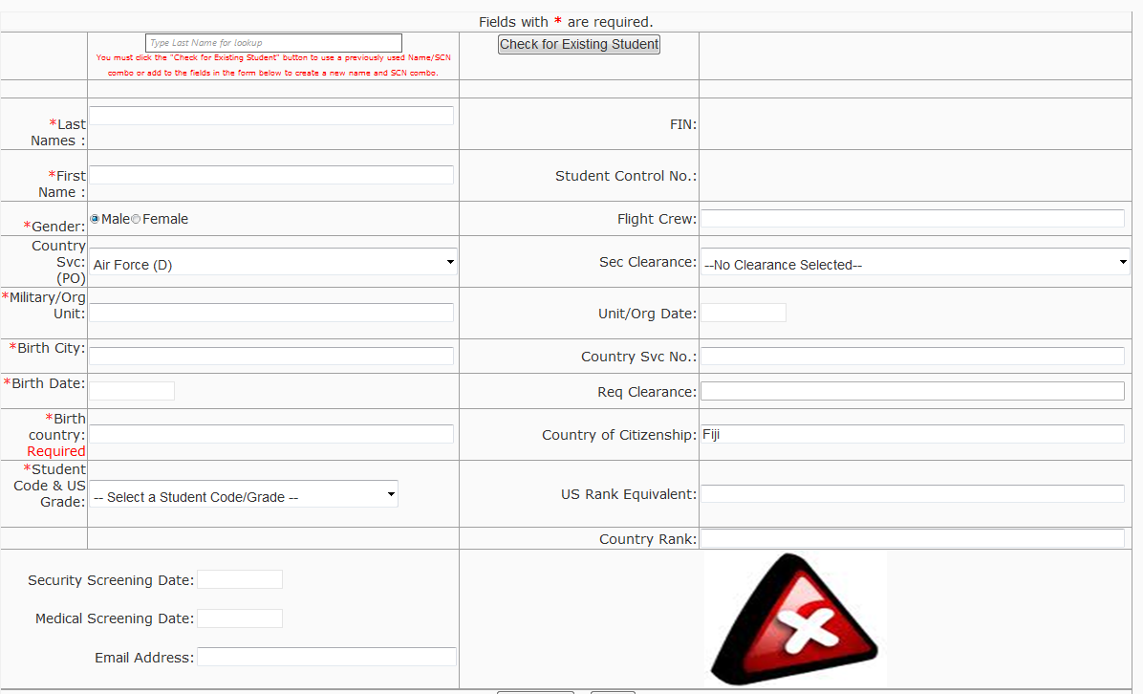

Student and Authorized Dependent Medical Billing Information:
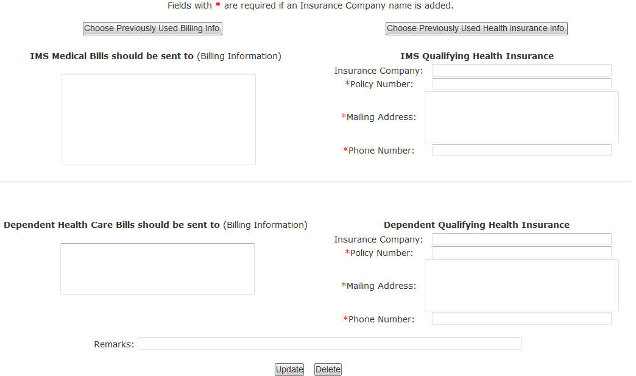

Student Passport and VISA Information:
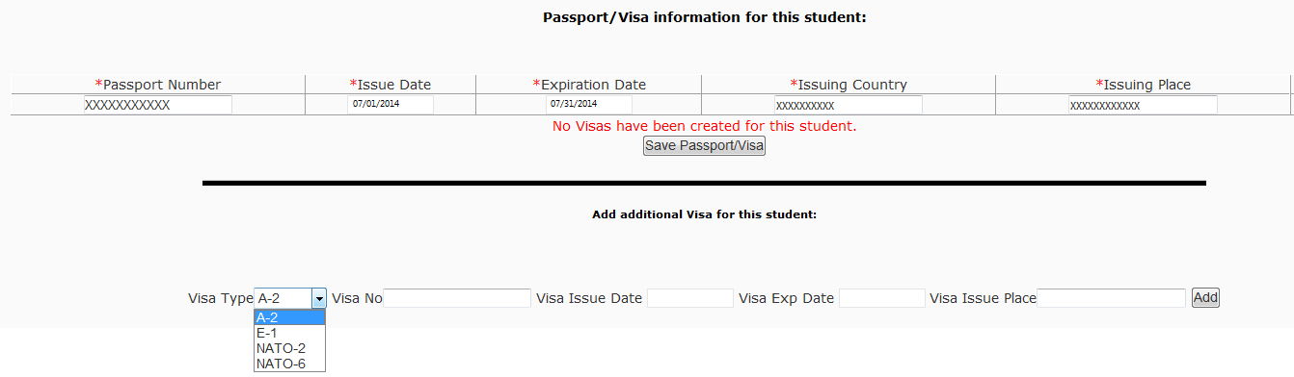

Authorized Dependent Information:
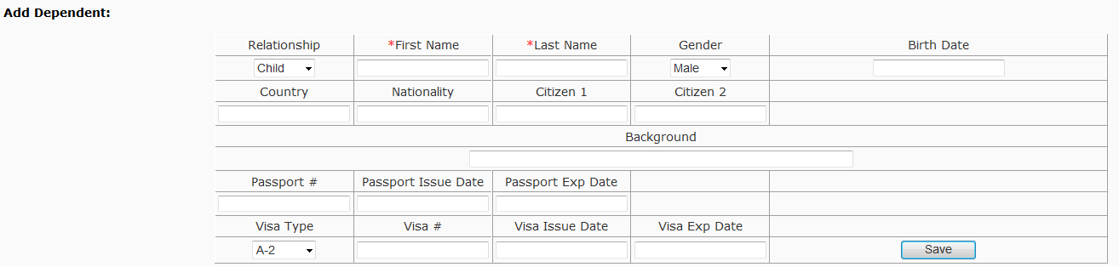

Student Language Scores:
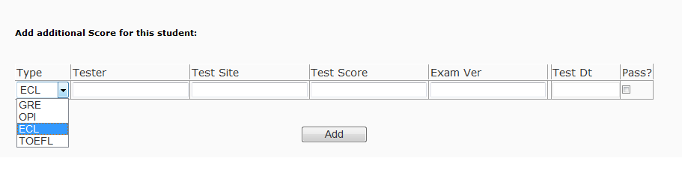

Student Arrival Information
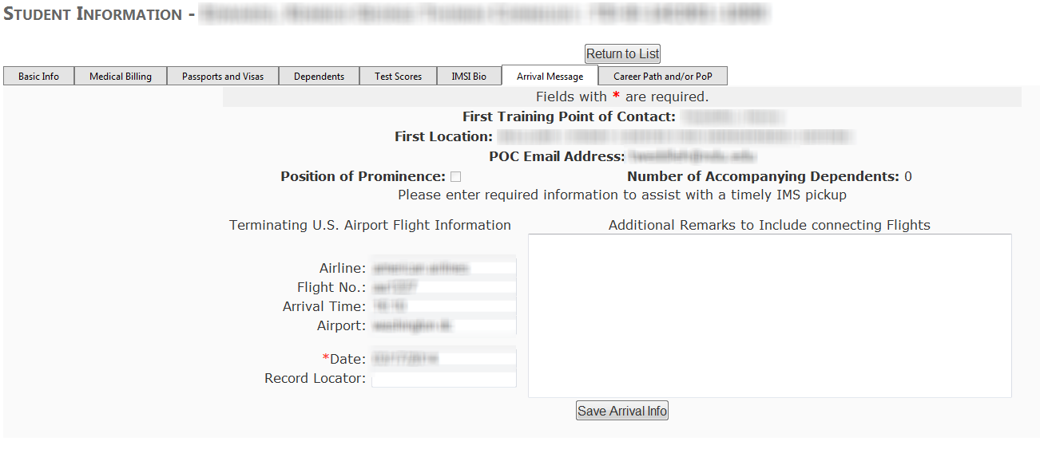

Student Biographical Information:
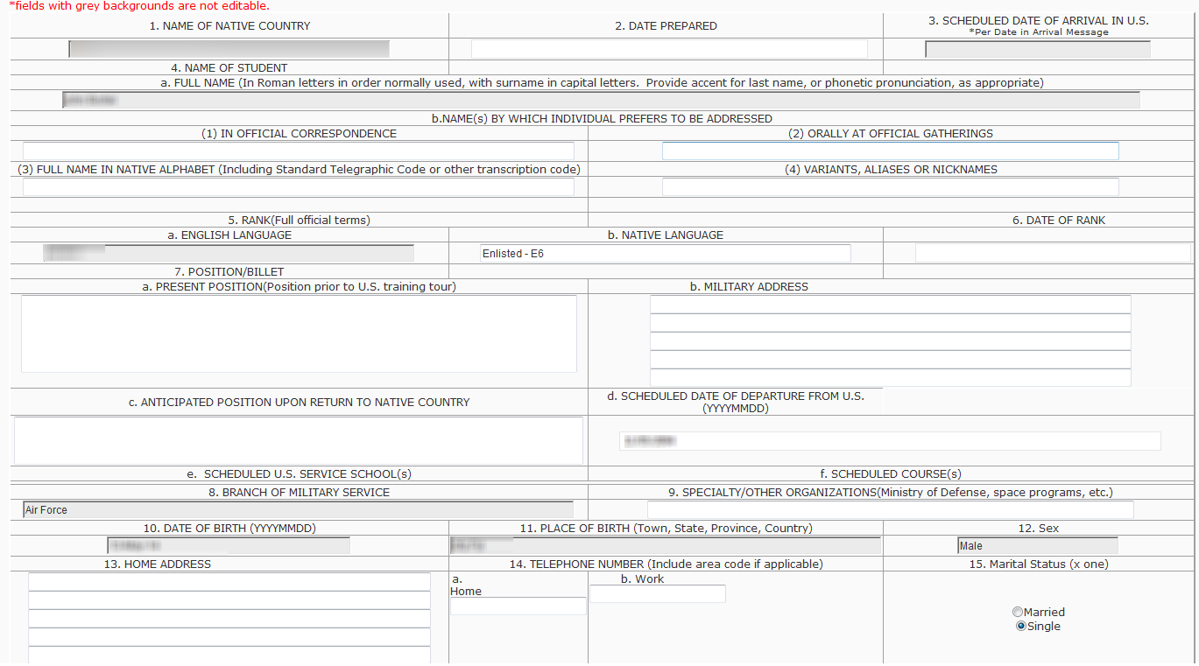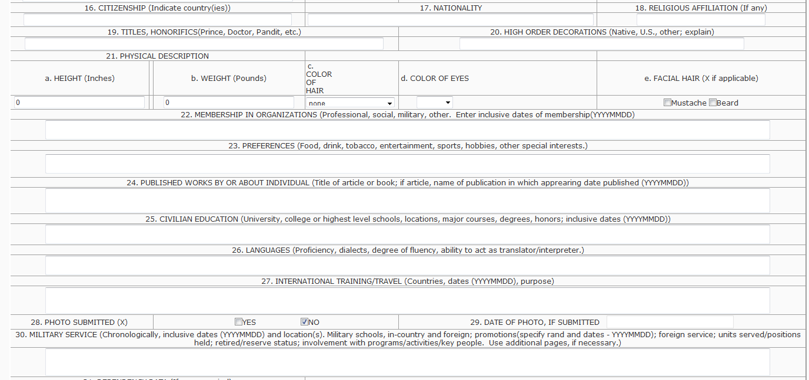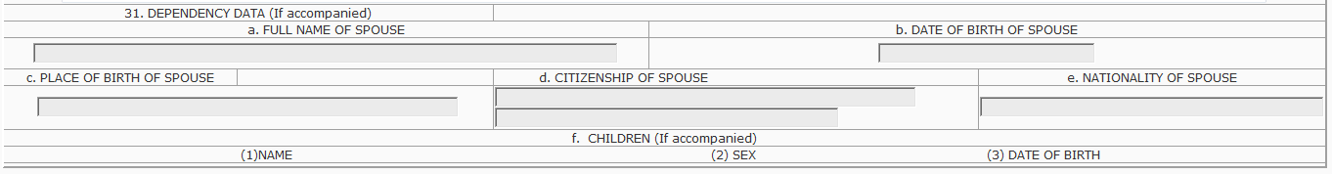

Student Career and Prominent Position Information:
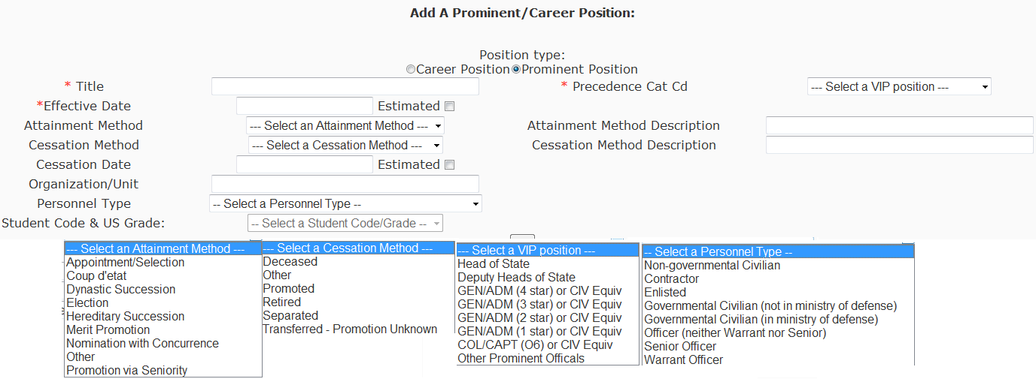

Student Progress:
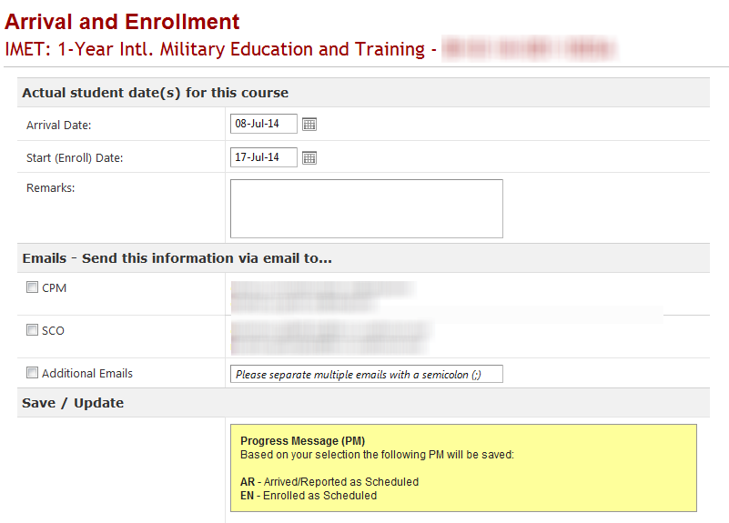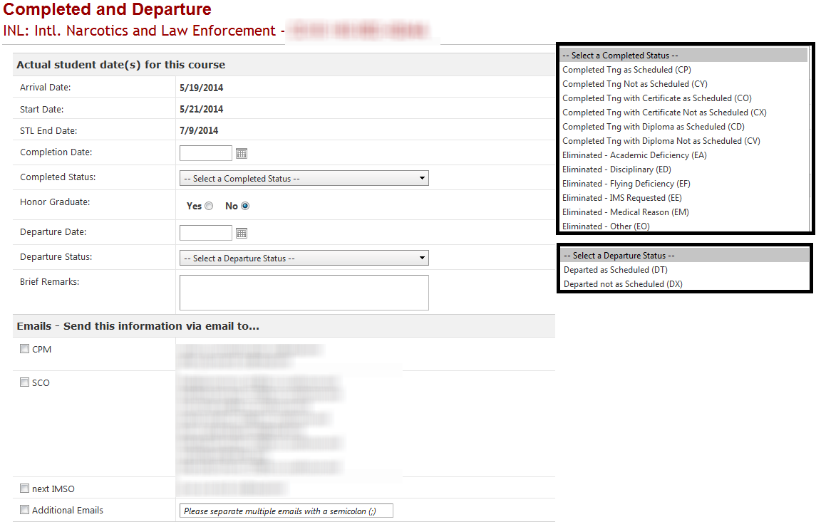
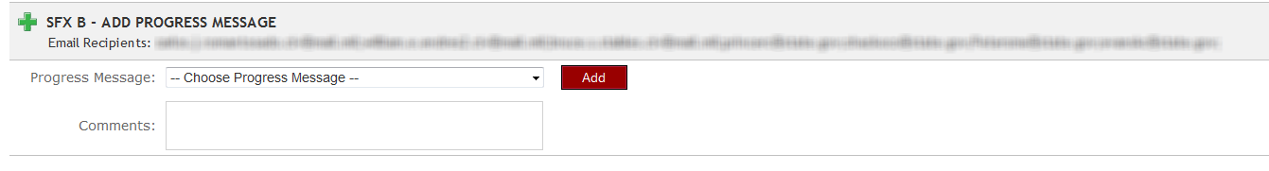
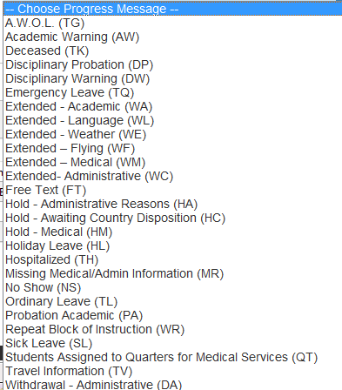

Student Academic Report Upload:
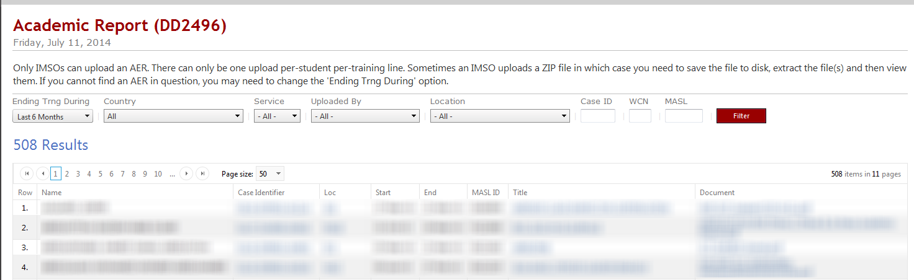

Counter Terrorism Fellowship Program Nomination:
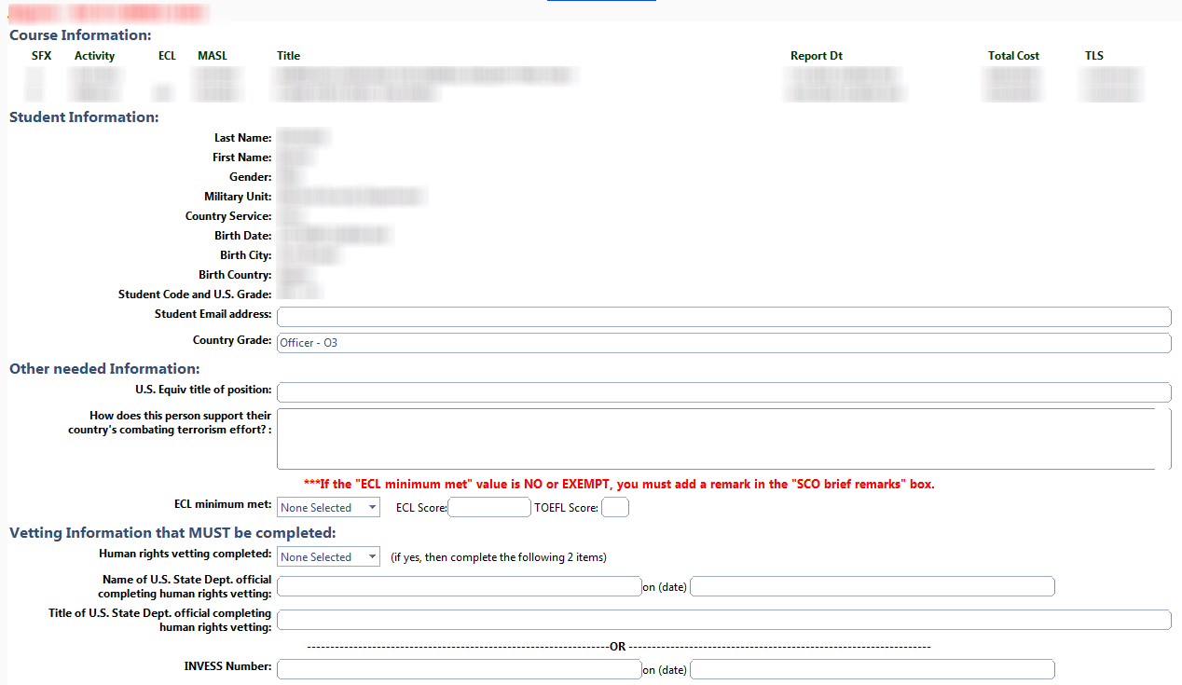
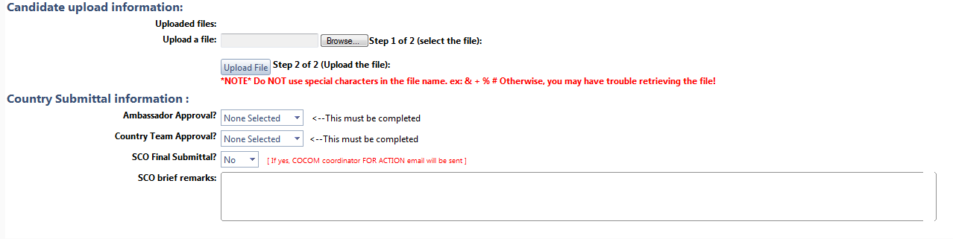

Other Information

Team After Action Summary:
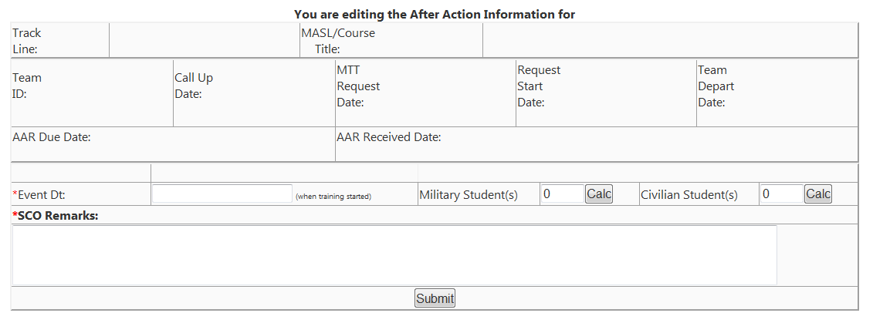

Security Cooperation Training Manager Point of Contact Information:
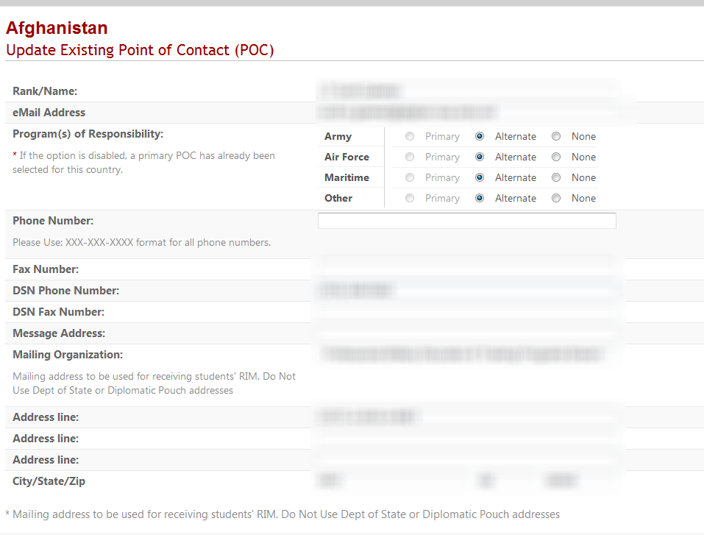

IMSO Point of Contact Information:
