ATTACHMENT 3a: SOCIAL MEDIA ADS

Social Media Ads for Evaluation of the Fresh Empire Campaign on Tobacco (EFECT)

Social Media Ads
[6 total images will be rotated in this ad. Text will be the same as in the ads below for all ads, only images will change.]

Facebook Ad

Twitter Ad 1

Twitter Ad 2
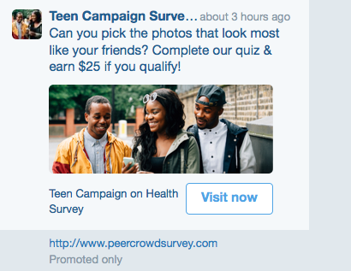

Twitter Ad 3

6 Images for Social Media Ads

Image 1 for Social Media Ads

Image 2 for Social Media Ads

Image 3 for Social Media Ads

Image 4 for Social Media Ads

Image 5 for Social Media Ads

Image 6 for Social Media Ads

