Attachment G: Screen Shots

OHSN Import Template:
URL for Download: http://www.cdc.gov/niosh/topics/ohsn/documentation.html
Under the heading “Facility Tools”, you will find the link for downloading the OHSN Import Template.
You may then choose either the “Required Only” MS Excel file, which includes all ten data fields necessary for OHSN
participation, or the “Required and Optional Fields” MS Excel file based on your needs.
To directly enter data injury data and other information into the MS Excel file, the user may use the drop-down
options as shown below:
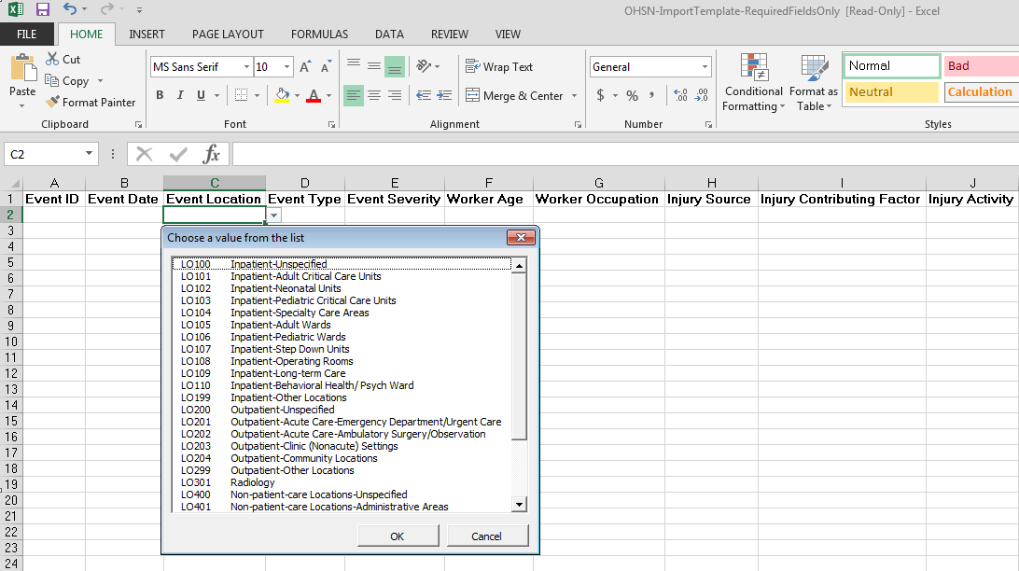
OHSN Conversion Tool:
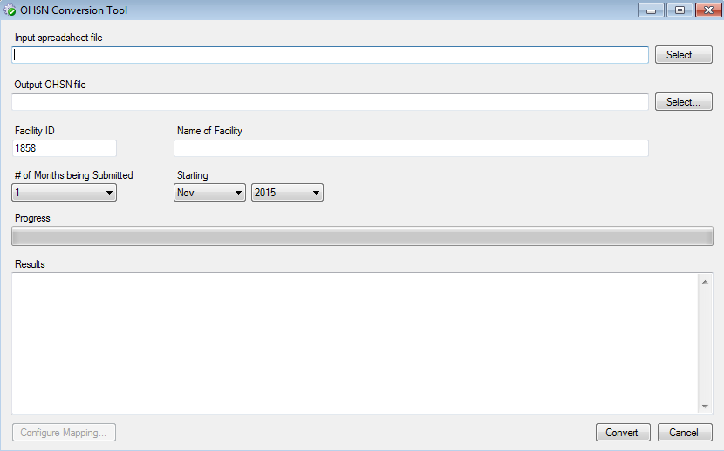
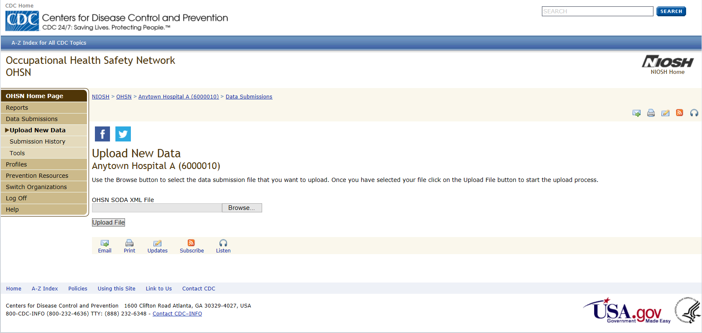
URL: http://www.cdc.gov/niosh/topics/ohsn/documentation.html
Under the heading “Facility Tools”, you will find the link for downloading the OHSN Conversion Tool.
The Conversion Tool allows users to convert their data into the proper XML file needed for upload into the OHSN System.
OHSN Upload XML File Page:
URL for Log On: https://wwwn.cdc.gov/NIOSH-OHSN/User/LogOn
The user may enter their newly created XML file in the “Upload New Data” tab of “Data Submissions”
for upload into the OHSN system.

