Instructions for completing the template for the AIRS performance measures

**General:** Performance measures are not expected to reflect all activities and accomplishments of the awardees. Awardees are encouraged to develop additional state-specific performance measures and to provide additional detail in the narrative part of their annual report. All measures have room for comments.

**A. Health Care Reform Opportunities**

This should be a short list (4-6) of opportunities that the state asthma program (SAP) identified through an inventory of health care reform activities and projects in the state and that it intends to explore during the following year. It is expected that some of these opportunities may not prove productive while others may.

* Please update your list of opportunities to reflect the status of program activities as of the end of the funding year.
* Priorities may change from year to year but the awardees are asked to track the status of the different opportunities over time. Thus, status for many items might be “exploring” or “planning” during year one and may be “discontinued”,” implementing” or “monitoring” in subsequent years.
* There are drop-down menus for
  + The type of organization or activity that the opportunity involves (eg Federally Qualified Health Centers or State Primary Care Association, State Health Department Committees, Medicaid Managed Care Organizations etc.)
  + Status (exploring, planning, implementing, monitoring, discontinued).
* If the opportunity is related to or encompasses multiple organizations from the drop down list, please select “Other” and identify the organizations in column D (Description of "Other" type of opportunity).

**B. High-level meetings**

* Please update your list of meetings to reflect the status of program activities as of the end of the funding year.
* Note that there is a checklist for desired outcome of the collaboration or relationship as well as a checklist for individual meeting outcome
* There is a menu for the level of the proposed outcome (state, county, district, local, n/a, other)
* Please include **title (not name) of who represented the State Asthma Program**  (may also be a higher level state official such as the chronic disease program manager if they are representing the asthma program)
* Similarly, include the title (not name) of main high-level decision maker(s). Those considered high-level decision makers are context relevant but must have the ability to influence multiple settings.
  + Examples of high-level decision maker include:
    - State health department medical directors and commissioners
    - Federally Qualified Health Centers (FQHC) network chief operating officer
    - Clinical director of state primary care association and state hospital association
    - State Medicaid director
    - State and national legislators
    - Head of school nurses association
* Sector(s) represented by the high-level decision makers should be checked ( for ease of aggregation)
* If multiple meetings are conducted with the same high-level decision makers and have the same meeting outcomes and desired outcome of collaboration, multiple dates can be entered on one line in column AG. Separate dates with a semi-colon.

**C. School Enrollment Covered by Formal Agreements**

* In the column labeled “Name or Brief Description of Agreement” we anticipate responses such as:
  + MOU to train school nurses in teaching asthma self-management education.
  + Letter of agreement to refer students without a provider to a partnering FQHC.
  + MOA to provide training for coaches and other school personnel.
* If the state asthma program (SAP) has multiple types of agreements with different schools or districts, list each agreement on a separate row.
* In the columns labeled “Name or Brief Description of Agreement” and “School/District/Other Entity Name” if the SAP has the same agreement with multiple schools or districts, please indicate the number but DO NOT list all.
  + Example: Same agreement with 36 schools – list available upon request
* Note that “total enrollment” refers to all students, not just students with asthma. If the agreement is with a school-based health center, include all the schools served by that health center when calculating total enrollment.
* If available, indicate the percent of students receiving free or reduced lunch and the percent of students with asthma in participating schools.

**D. Please note that, based on feedback from our internal work group and state partners, performance measure D (as it appeared in the FOA) was dropped**

**E. Alignment between program activities on burden data**

A map is preferred. If a table or chart is used, be sure to include the entire state. Please see below for two examples of maps submitted by awardees. Please update your maps/tables to reflect the status of program activities as of the end of the funding year.

* If submitting multiple maps, charts, or tables use a separate line in the reporting spreadsheet for each.
* The document itself should be submitted to the project officer. In the reporting spreadsheet, please indicate if the document has already been submitted to the project officer.
* Brief rationale for selection of sites (or gaps in coverage) should be included
* When showing the overlap of areas of need and activities, distinguish currently implemented activities from those in the planning stage
* Activities that are carried out and supported independent of the state asthma program may be included but should be identified as such.
* Please label maps appropriately: Include an informative title, indicate source and time period for the data, and indicate overlap between program activities and asthma burden.

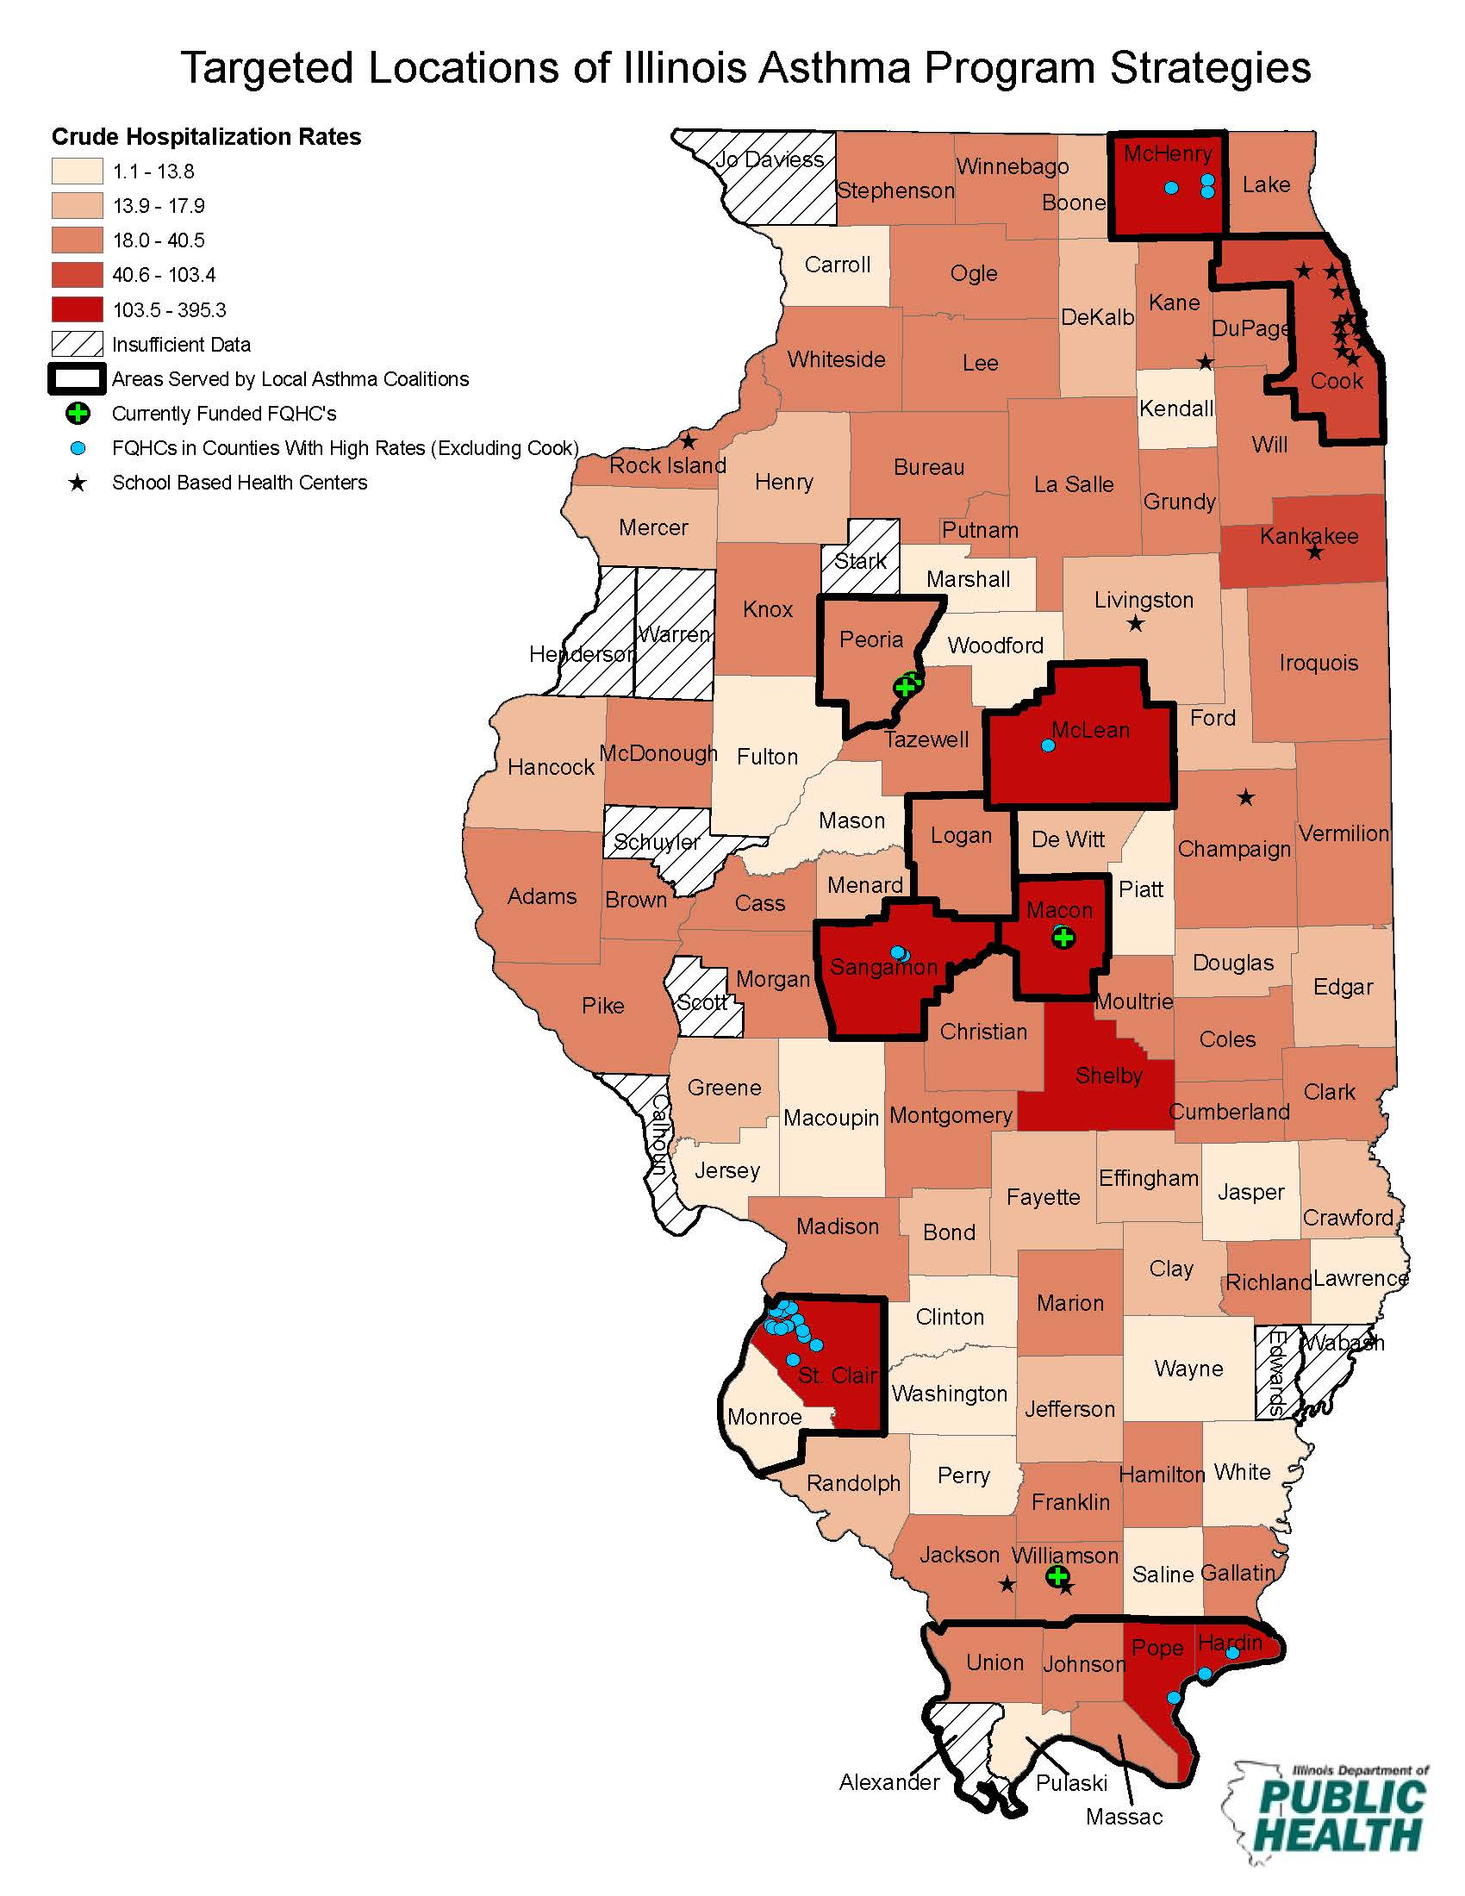

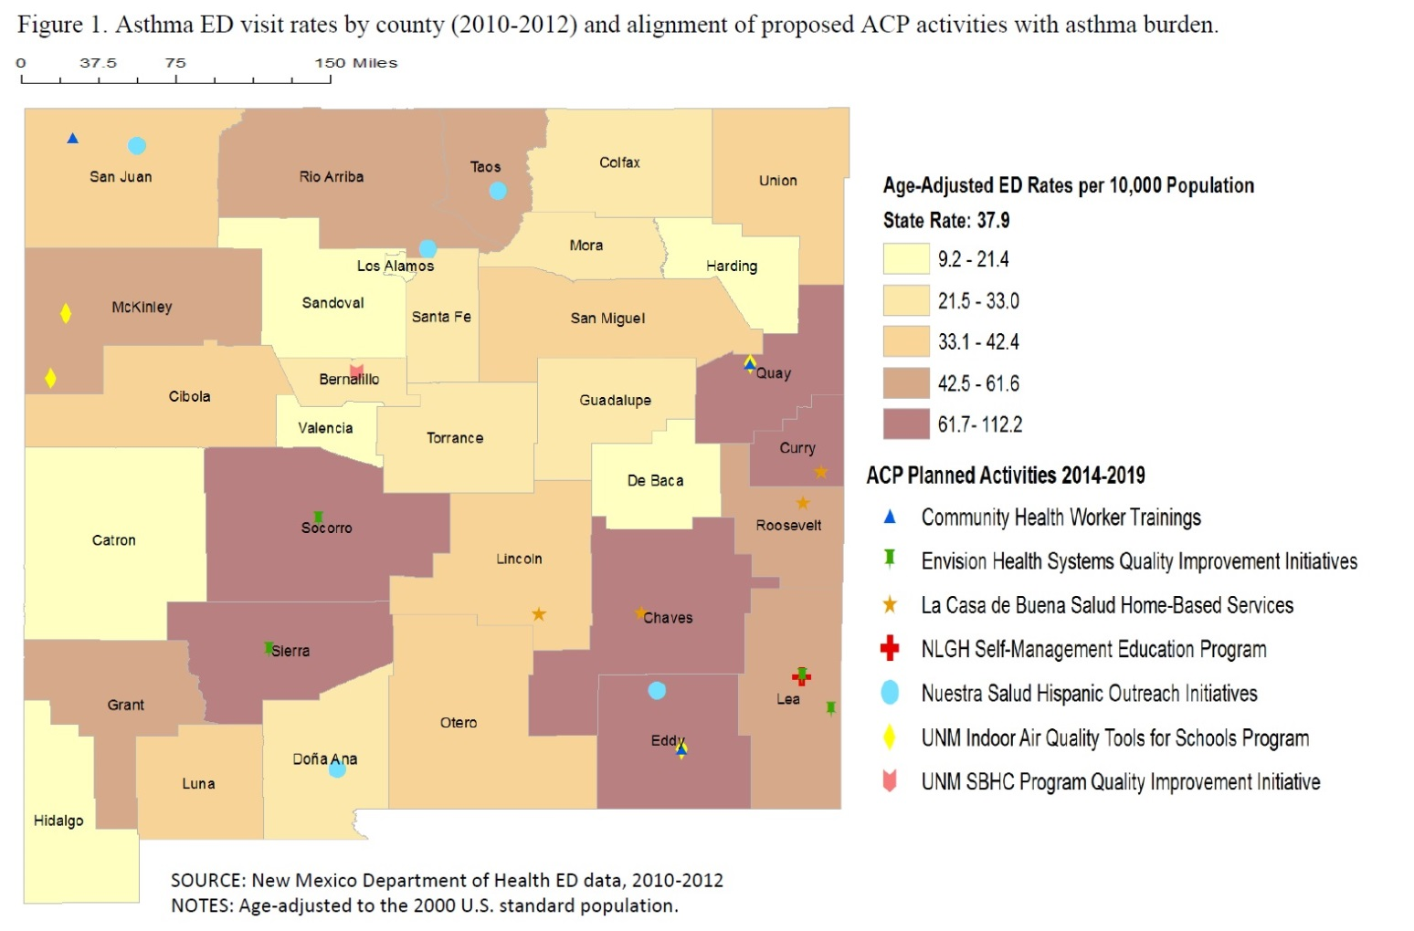

**F. Use of evaluation findings**

Performance measure F is an opportunity to document how you have used evaluation findings to make program improvements or arrive at important decisions. Completing this measure requires you to revisit your evaluation action plans or findings, thus ensuring that important information isn’t overlooked.

To complete measure F, describe the actions taken during the designated reporting period that were based on evaluation findings, regardless of when the evaluation was done. Include only those actions or changes that have been implemented and that you believe have had or will have a valuable impact on your program. You may borrow or summarize from your action plan.

* **Types of action taken:** From the drop down menu (column C), categorize the action(s) taken. If an evaluation resulted in multiple actions taken, list each action on a separate line. Provide enough detail so that it is clear why you selected a particular category. Review the information to ensure the alignment of findings and actions.
  + Specific improvements to interventions: Select if the evaluation identified specific changes that were made to enhance the operations of a service or health system intervention.
  + Sustain intervention: Select if the evaluation confirmed the success of a program, such that it was sustained.
  + Expand intervention: Select if the evaluation confirmed the success of a program, such that it was expanded to other areas/populations.
  + Accountability: Select if the evaluation was primarily used to document or justify the program’s investment of resources/funding. An explanation of the entity (ies) needing such information should be described in comments.
  + Address policy gap/issues: Select if the evaluation identified areas in need of policy enhancement.
  + Enhance surveillance systems or reports: Select if the evaluation identified changes to surveillance systems or information products produced and disseminated using surveillance data.
  + Increase collaboration: Select if the evaluation resulted in changes to coalition operations (e.g., communications) or operating structures (e.g., workgroups, taskforces) that optimized interactive work.
  + Expand partnerships: Select if the evaluation identified and prompted inclusion of new partners or new areas for collaborations.
  + Revise program plans: Select if the evaluation prompted revisions to the overall asthma program’s plans (i.e., change priorities, defund interventions).
  + Change funding: Select if evaluation resulted in reallocation of funds or resources.
  + Other: Select if the evaluation use does not fit in the above categories. Please describe use.
* **Actual programmatic action:** Describe all decisions or actions taken that were considered valuable or useful to your program, partners, or stakeholders.
* Clearly describe how the evaluation findings contributed to the decision or action.
* Include current or completed actions. Note: Do **not** report anticipated plans or actions (if implementation has not occurred).
* To be thorough, revisit recent reports, presentations, or other relevant documents to identify any actions or decisions that may have resulted (directly or indirectly) from the evaluation.
* **Recommended programmatic actions based on findings:** Clearly describe how the findings logically led to the recommendations or decisions
* **Evaluation finding(s) that led to action:** Summarize the evaluation’s significant finding(s).Provide enough detail to give context to the “recommendations” section.
* Note that actions may be based on multiple findings, or findings from different evaluations (i.e., the same action addresses multiple recommendations). Use the comment column for additional explanation.
* **Main evaluation question(s) that produced findings:**  Record the main evaluation question(s) addressed by the finding(s) i.e., the relevant, overarching evaluation question(s), not a specific question(s) on a survey instrument or interview guide.

**G. Self-management Education**

As defined in the profiles, a participant is a person with asthma. For measures G and H a caregiver can be counted as a proxy for the person with asthma. A caregiver is a person who is the parent, guardian or other person responsible for the care of, and who acts as a proxy for, a person with asthma who is unable (because of young age or other condition) to take responsibility for his/her own asthma self-management. **If BOTH a person with asthma and a caregiver are trained, this counts as one participant for reporting purposes.**

* List the partner (or partners) delivering intensive asthma self-management education.
  + If the same intensive asthma self-management education curriculum is delivered by multiple partners, list each partner in a separate row.
  + If the same partner delivers multiple intensive asthma self-management education curricula, list each curriculum and partner in a separate row.
* Examples of contributions of the SAP include: evaluation incentives or assistance, curriculum materials, personnel time
* Select the test used to measure asthma control from the drop down menu
  + ACT: Asthma Control Test
  + cACT: Childhood Asthma Control Test
  + ATAQ: Asthma Therapy Assessment Questionnaire
  + ACQ: Asthma Control Questionnaire
  + TRACK: Test for Respiratory and Asthma Control in Kids

**H. Demonstration of basic asthma self-management knowledge and skills**

Columns containing “0” indicate that information will be automatically copied from the previous spreadsheet.

**I. Referral to a primary care or specialty care provider**

Columns containing “0” indicate that information will be automatically copied from the previous spreadsheet.

* Participants receiving care for asthma from a primary or specialty care provider (allergist or pulmonologist) at the time of enrollment should be excluded from this measure.
* If the “number attending at least 60% of sessions who are without a PCP at enrollment” is 0, enter “0” and proceed to measure K.
* Examples of “Brief description of referral process to PCP or specialty care” include:
  + Participant is provided a generic list of local providers
  + Recommendations are customized to participants’ coverage, preference, and geographic area
  + Appointment scheduled
* If participants are referred to multiple types of providers, select “Other” and indicate in the “Description of "Other" type of provider” column

**J. Asthma policies**

* List all major asthma-related policies in place for which the state asthma program had a clear role. This is defined as “influenced” in the profile.
  + Influenced:Provided data, information, tools, resources, or other assistance
* Policies not related to educational or housing agencies should not be reported here but can be reported in state-specific performance measures or in the narrative section of the annual report
* There are drop down menus for
  + Funding year
  + Education or housing policy
  + Focus of policy (smoking/tobacco related, increasing access to asthma meds in school, improving knowledge/skills among students/parents, etc.) See the table below for the type of policies falling under each category. The table has been revised to more clearly define the types of policies falling under each category.
    - The revised spreadsheet includes “smoking/tobacco” as a separate category
  + Level (state, county, district, local, n/a, other)
  + Status (in development, policy passed or adopted only, policy implemented, policy adoption evaluated, etc.)
* Group(s) affected by the policy might include age groups, schools grades, type of residents in multiunit housing, etc.
* Consolidate similar policies implemented in different locations to the extent possible aggregating by focus of policy (e.g. smoke-free policies in multi-unit housing). Under name of agency adopting the policy you can list something like “12 housing districts – list available upon request” and under Policy Effective date insert the range by years.

|  |  |
| --- | --- |
| Sample Policies and How They Can be Categorized | |
| Category of Policy | Type of policies in this category |
| 1. Improve access to asthma/allergy medication in school | • Physician's written instructions for medication on file  • Students' rights to self-carry/self-administer asthma/anaphylaxis medication  • Medication policies that provide resources, guidelines, and parameters |
| 2. Improve documentation of student asthma/allergy information in schools | •Identify and maintain records for students with chronic conditions  • Update health records regularly  • Maintain asthma/allergy incident reports  • Maintain a health history form for each student  • Identify/track all students with asthma diagnosis |
| 3. Improve asthma management plans in schools | • Standard emergency protocols for asthma/anaphylaxis  • Explicit asthma/anaphylaxis management programs with policies, procedures, and resources  • Use of an asthma action plan for all students with asthma |
| 4. Increase health services capacity in schools | • Nurse-to-student ratio  • Nurse coverage at schools  • Case management for students with chronic conditions |
| 5. Improve awareness/knowledge among school staff/all students | • Asthma education for school personnel, including emergency response  • State funding for staff training on asthma/allergy programs, policies, and procedures  • Inclusion of asthma/allergy in the health curriculum for all students |
| 6. Improve awareness/knowledge among people with asthma, parents | • Policies to include asthma education during home visits conducted by other programs  • Asthma education for students, including self-management |
| 7. Improve IAQ (excluding smoking/tobacco) | • IAQ management policies (including HVAC; HEPA filters; carpeting; pesticide use; dampness; mold; maintenance and repairs, cleaning; and integrated pest management)  • State funding/resources for technical IAQ assistance  • Use of integrated pest management (IPM) techniques/banning of pesticides inside schools when students are present  • Integrated pest management in multi-unit housing |
| 8. Improve outdoor air quality (excluding smoking/tobacco) | • Notification of students with asthma, parents, etc. of upcoming pesticide applications  • Limiting bus idling time; implementing/promoting diesel school bus engine retrofitting program |
| 9. Smoking/tobacco | • No smoking policies in multi-unit housing  • Prohibition of smoking/tobacco in school buildings, buses, and school-related functions and on school grounds  • Tobacco use cessation services  • Health education curriculum includes tobacco use prevention component |
| 10. Other |  |
| Table adapted from: Lynn, Oppenheimer, and Zimmer *Using public policy to improve outcomes for asthmatic children in schools.* J Allergy Clin Immunol Dec 2014 | |

**K. Use of long-term control medication**

Columns containing “0” indicate that information will be automatically copied from the previous spreadsheet.

* If information on change in adherence is not available for some participants included in “Number of participants attending at least 60% of sessions who, on enrollment, had poorly controlled asthma and were using long-term control medication less than 7 days per week” indicate that this information is unavailable and for how many participants in the “Comments” column

**L. Improved asthma control**

Columns containing “0” indicate that information will be automatically copied from the previous spreadsheet.

* If information on change in asthma control is not available for some participants included in “Number of participants with poorly controlled asthma on enrollment who reported well-controlled asthma one month or more after attending at least 60% of sessions” indicate that this information is unavailable and for how many participants in the “Comments” column

**M. Reduction in hospitalizations and ED visits**

This is a supplemental measure and is not required.

* For this measure we are asking for the combined total of hospitalizations and ED visits in column H. You may also report them separately in column I for hospitalizations and column J for ED visits.
* List the partner (or partners) delivering intensive asthma self-management education.
  + If the same intensive asthma self-management education curriculum is delivered by multiple partners, list each partner in a separate row.
  + If the same partner delivers multiple intensive asthma self-management education curricula, list each curriculum and partner in a separate row.
* In column H, indicate the number attending at least 60% of sessions who had any asthma-related hospitalizations or ED visits in the 12 months prior to enrollment who report a reduction in these events 12 following the program
* If available, indicate the “Number attending at least 60% of sessions who had any asthma-related hospitalizations in the 12 months prior to enrollment who report a reduction in hospitalizations 12 months after the program”
  + Note: this column refers to a reduction in hospitalizations only
* If available, indicate the “Number attending at least 60% of sessions who had any asthma-related ED visits in the 12 months prior to enrollment who report a reduction in ED visits 12 months after the program”
  + Note: This column refers to a reduction in ED visits only
* Select from the drop down menu to indicate the source of information on hospitalizations/ED visits

**N. QI Processes in HC organizations**

* A “Brief description of population served by the HCO” may include for example percent Medicaid, percent employer-based coverage, percent health exchange, etc.

**O. Team-based approach in health care organizations**

* Select the type of HCO from the drop-down menu
* List the name of the HCO
* Provide a brief description of the population served by the HCO
  + This can include racial/ethnic characteristics, percent of population covered by Medicaid, etc.
* Describe the composition of teams and roles of team members
  + E.g. Physician, RN, pharmacist, CHW, care coordinator and role of each team member
* Describe the method of sharing information among team members
  + E.g. regular meetings, documentation in charts, faxed reports, telephone conversations, dedicated electronic platform
* Describe the role of state asthma program in influencing the organization
  + This could include providing data, information, tools, resources or assistance that was critical to the partner taking action. If the state had no influence, do not report.
* If available, describe the measures taken by the HCO to ensure cultural appropriateness

**P: Plans reimburse for ASME and home visits**

For this measure, only include health plans that have begun reimbursing for intensive asthma-self management education and/or home visits during this FOA.

* List the name of the health plan
* Select the type of plan from the drop-down menu
* Indicate the services covered or reimbursed by selecting from the drop-down menu
* Provide a more detailed description of the services in the following column
  + For example, curriculum used, type of provider, number of visits, supplies and materials provided, etc.
* Indicate eligibility for services by selecting from the drop-down menu
  + If multiple eligibility criteria are used, select the “Other” option and describe in the following column
* If services are contracted, indicate the amount of reimbursement
  + This can include a dollar amount or percent reimbursement
* Describe the role of state asthma program in influencing the health plan
  + This could include providing data, information, tools, resources or assistance that was critical to the partner taking action. If the state had no influence, do not report.

**Q: HC organizations implement and improve referral systems**

For this measure, only include health care organizations that have implemented or improved referral systems during this FOA.

* Select the type of HCO from the drop-down menu
* List the name of the HCO
* Describe the referral process and services referred to
  + Services referred to can include intensive asthma self-management education, home-based trigger reduction services, or both
  + Examples of the referral process can include dedicated electronic platform, automatic scheduling, care coordinator, etc.
* If available, describe the assessment of referral timeliness and completion
* Provide a brief description of population served by the HCO
  + This can include racial/ethnic characteristics, percent of population covered by Medicaid, etc.
* Describe the role of state asthma program in influencing the organization
  + This could include providing data, information, tools, resources or assistance that was critical to the partner taking action. If the state had no influence, do not report.

**R. Referrals from HC organizations**

* Columns containing “0” indicate that information will be automatically copied from the previous spreadsheet.
* Information for this measure should be collected on the intake sheet unless there is a sole source of referrals.

**S: Health care utilization in populations served by partnering health care organizations and health plans**

* Select the type of HCO or health plan from the drop-down menu
* List the name of the HCO or health plan
* Describe the comprehensive asthma control services (CACS) provided
* Indicate if state asthma program had some influence on the HCO's or health plan's approach to asthma care by selecting from the drop-down menu
* If “yes” describe state asthma program's influence on the HCO's or health plan's approach to asthma care
  + For example, this could include providing data, information, tools, resources or assistance that was critical to the partner taking action
* Describe other outcomes (if any) tracked by HCOs or health plans that are implementing CACS
  + For example, asthma control, school absenteeism, medication adherence, etc.
* Describe the actual changes in asthma-related hospitalizations and/or ED visits reported. Include all results, whether showing decrease, increase, or no change.